Tutorial 1.1
Question 1: What is free electron? How can you classify materials based on conductivity?

Question 2: What are valance band and conduction band? What is the significance of the energy bands in semiconductor materials?

Question 3: What is hole? How a hole can be transmitted to conduct current in a semiconductor?

Question 4: What is doping? What is the importance of doping?

Question 5: What happens when a p type and an n type materials are joined together?

Question 6: What happen to a pn junction if you bias it in forward or reverse direction?

Question 7: How can you identify the p and n terminal of a diode?

Question 8: What is rectifier? How many types of rectifiers are there?

Question 9: What is half wave rectifier? Discuss the construction and principle of operation of a typical diode half wave rectifier.

Question 10: What is rectifier efficiency? Evaluate the efficiency of a typical half wave rectifier.

Problem 1:
- Determine the forward voltage and forward current for the diode in Figure 1(a) for each of the diode models. Also, find the voltage across the limiting resistor for each case. Assume r’_{d} = 10 Ω at the determined value of forward current and the barrier potential of the diode is 0.7 V
- Determine the reverse voltage and reverse current for the diode in Figure 1(b) for each of the diode models. Also, find the voltage across the limiting resistor in each case. Assume I_{R} = 1 μA
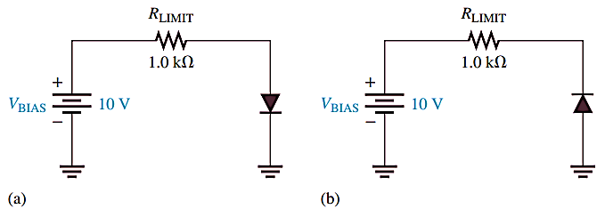
Figure 1

Problem 2: For the series diode configuration as shown, determine V_{D}, V_{R}, and I_{D}.
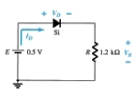

Problem 3: For the series diode configuration as shown, determine V_{O} and I_{D}.
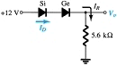

Problem 4: For the series diode configuration as shown, Determine ID, VD2, and Vo.
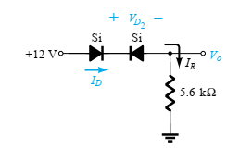

Problem 5: Determine Vo, I1, ID1, and ID2 for the parallel diode configuration as shown below:


