Tutorial 2.1

Question 1: What is a transistor? How a transistor can amplify a signal? Discuss some common applications of a transistor.

Question 2: What is CB, CE and CC configuration? Compare the performance of CB, CE and CC transistor operation.

Question 3: Explain the input and output VI characteristics of CB/CE configuration.

Question 4: What is DC load line? What is its importance?

Question 5: What is early effect?

Question 6: What is DC biasing? What is the importance of dc biasing?

Question 7: What is load line and operating point/ Q point? What is the importance of operating point?

Question 8: What is fixed/base bias circuit (voltage divider/emitter bias)? How can you determine the maximum input current (I_{b}) fluctuation in a typical fixed bias circuit?

Question 9: What are the advantages and disadvantages of fixed biasing (voltage divider/emitter bias)?

Question 10: What are the effects of Vcc, Rc and Ib in case of fixed bias circuit (voltage divider/emitter bias)?

Problem 1: Sketch collector curves for the following circuit for I_{b} = 5 µA to 25 µA with 5µA increments. Assume β = 100 and V_{CE} does not exceed breakdown.
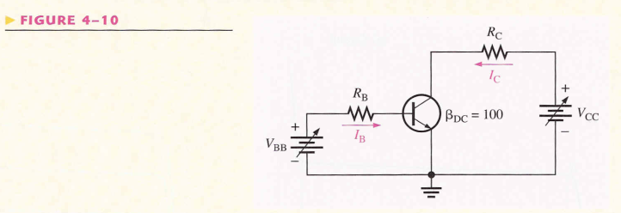

Problem 2:
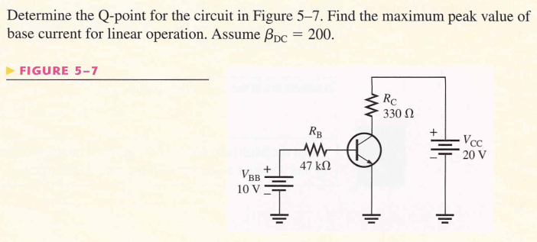
Problem 3:
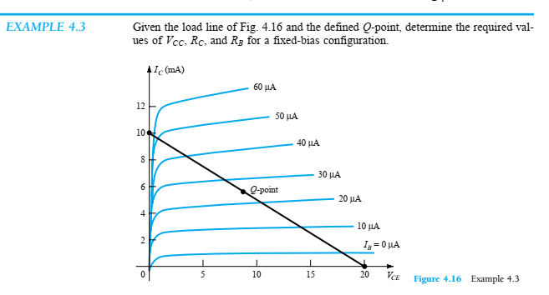

Problem 4:

