Tutorial 2_3
Question 1: What happened to an amplifier output waveform if you do not choose DC biasing properly?

Question 2: How can you determine the overall voltage gain of a CE amplifier with voltage divider bias?

Question 3: Determine the expression for power gain of a CE/CB/CC amplifier circuit with AC analysis.

Question 4: Draw the re model for a bjt in common emitter/CB/CC connection and find out the values of all components in the model.

Question 5: What are the advantages and disadvantages of emitter resistance (R_{E}) in a CE amplifier circuit? How you can optimize the R_{E} value?

Problem 1: Find the following parameters:
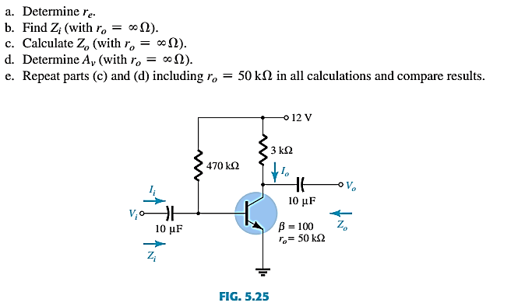

Problem 2: Find out the following parameters:
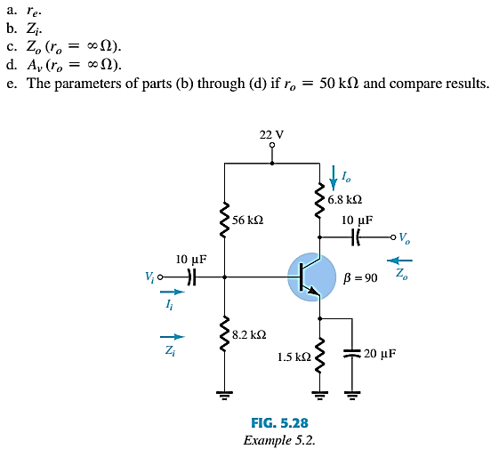

Problem 3:
Find the input resistance, voltage gain, current gain and power gain for the amplifier in Figure 1. β_{ac} = 250.
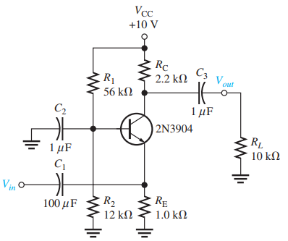
Figure 1

Problem 4:
Determine the total input resistance of the emitter-follower in Figure 2. Also find the voltage gain, current gain, and power gain in terms of power delivered to the load R_{L}. Assume β_{ac} = 175 and that the capacitive reactances are negligible at the frequency of operation.
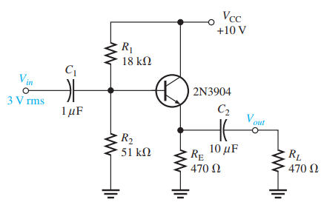
Figure 2

Problem 5:
Determine the signal voltage at the base of the transistor if a 10 mv rms source with 300 ohm source resistance is applied in the input terminal. The emitter current Ie measured is 3.8 mA.
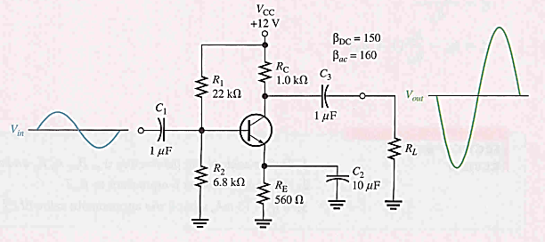

Problem 6:


