description of cOURSEWORK

OFFICE OF ACADEMIC AFFAIRS
Reference No.: XMUM.OAA - 100/2/8-V2.0
Effective Date: 23 APRIL 2018
Course Code | G0191
Course Name | Face Recognition With Machine Learning
Lecturer | WANG HAN
Academic Session | 202302
Assessment Title | PCA in face recognition

- Introduction/ Situation/ Background Information

- Course Learning Outcomes (CLO) covered
At the end of this assessment, students are able to:

CLO 1 | Analyse PCA (Principal Component Analysis)
CLO 2 | Discover the concept of PCA in Face Recognition
CLO 3 | Associate basics of Classification methods
CLO4 | Build the knowledge of PCA and classification into human face recognition

- University Policy on Academic Misconduct

- Academic misconduct is a serious offense in Xiamen University Malaysia. It can be defined as any of the following:
- Plagiarism is submitting or presenting someone else’s work, words, ideas, data or information as your own intentionally or unintentionally. This includes incorporating published and unpublished material, whether in manuscript, printed or electronic form into your work without acknowledging the source (the person and the work).
- Collusion is two or more people collaborating on a piece of work (in part or whole) which is intended to be wholly individual and passed it off as own individual work.
- Cheating is an act of dishonesty or fraud in order to gain an unfair advantage in an assessment. This includes using or attempting to use, or assisting another to use materials that are prohibited or inappropriate, commissioning work from a third party, falsifying data, or breaching any examination rules.

- All the assessment submitted must be the outcome of the student. Any form of academic misconduct is a serious offense which will be penalised by being given a zero mark for the entire assessment in question or part of the assessment in question. If there is more than one guilty party as in the case of collusion, both you and your collusion partner(s) will be subjected to the same penalty.

- Instruction to Students
See section F.

- Evaluation Breakdown
No. | Component Title | Percentage (%)
 | REPORT | 50
 | PRESENTATION | 10
 | TOTAL | 60

- Task(s)

Description of project:

Design and implement a human face recognition system that can recognize a person. You may collect 100+ faces from your group and others and build the face database with the PCA approach. For training, the face images are typically from 100x100 to 300x250.

The face detection algorithm from OpenCV/Python/MATLAB/C++ can be called, providing face location and size. The detected faces will be resized to the same size as you did during the training process. You may use image enhancement techniques to improve face image quality. The pre-processed face will then be fed into the recognition program that you have designed for recognition.

Assessment:

1. The database should contain a minimum of 100 faces, one mark will be deducted for one face short. Each cropped face image should be named with the person’s name. Or an index file can be used to identify each face.
2. The database must have more than 20 people.
3. During the demonstration/presentation, you should show the ability of face recognition of the program with PCA. For example, by giving a new face (not trained in the database), the program should be able to tell the name of this face. Note that error is allowed.
4. Maximum of 5 images are allowed for each team member.
5. The CA comprises of one report for each team (up to 4 per team). The report should have details of the algorithm design/list/test results, and performance analysis. There is no page limit. Everyone must submit the report via Moodle.

APPENDIX 1
Marking Rubrics

Component Title |  |  |  |  | Percentage (%)
Criteria | Score and Descriptors |  |  |  |  | Weight (%) | Marks
Criteria | Excellent  (5) | Good  (4) | Average  (3) | Need Improvement  (2) | Poor  (1) | Weight (%) | Marks
Introduction | 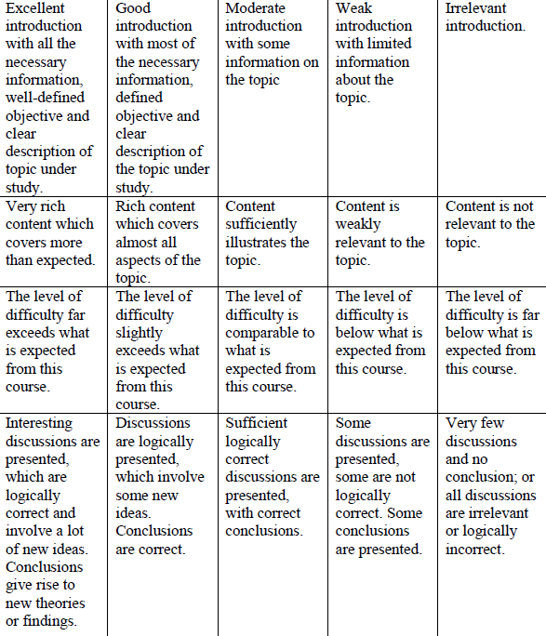 |  |  |  |  | 25 | 25
Content |  |  |  |  |  | 25 | 25
Difficulty Level |  |  |  |  |  | 25 | 25
Discussion and Conclusion |  |  |  |  |  | 25 | 25
TOTAL |  |  |  |  |  | 100 | 100
Note to students: Please print out and attach this appendix together with the submission of coursework

