
Course Code | : | COM 105
Course Name | : | Engineering Physics (I)
Lecturer | : | Dr Ng Zi Neng
Academic Session | : | 2022-04
Assessment Title | : | Assignment 1
Submission Due Date | : | 09/05/2021 Monday 6pm (Malaysian time)
Prepared by
Prepared by | : | Student ID | Student Name
Date Received | :
Feedback from Lecturer:

Mark:

Own Work Declaration

I/We hereby understand my/our work would be checked for plagiarism or other misconduct, and the softcopy would be saved for future comparison(s).

I/We hereby confirm that all the references or sources of citations have been correctly listed or presented and I/we clearly understand the serious consequence caused by any intentional or unintentional misconduct.

This work is not made on any work of other students (past or present), and it has not been submitted to any other courses or institutions before.

Signature:

Date:

Instructions: Assignment 1 has 7 questions that adds up to a total of 100 marks, this is equivalent to 5% of the total coursework mark. Only handwritten solution is accepted, include all working steps in your solution. Sign and write your name/ID on top of each solution sheet. Use this document as your cover page and paste your scanned solution directly into this document, below each question. Remember to fill in your details and sign the declaration form. Save this document as PDF and rename it as COM105_Assignment1_studentID.pdf before submission. Submission link is available on Moodle's Week 7's tab.

- On a parking lot, car A is 18.0 m from car B, in the direction 31.0° south of east. While car C is 43.0 m from car B, in the direction 40.0° north of east. Solve for the distance between car A and car C. (10 marks)
Paste your solution here

- Given two vectors A = -4.00i + 7.00j and B = -5.00i + 2.00j. (10 marks)
  - Compute the vector product A × B using determinant evaluation. (5 marks)
  - Sketch the magnitude and direction of A, B and the vector product in a coordinate system. (5 marks)
Paste your solution here

- Figure 1 represents the velocity vs. time graph of a motorcycle in a 1D motion. (20 marks)
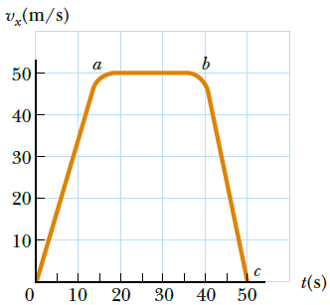
Figure 1
- Compute the total distance travelled from the graph. (3 marks)
- Compute the distance travelled between the times t = 10 s and t = 40 s? (3 marks)
- Sketch a graph of its acceleration vs. time between t = 0 and t = 50 s. (6 marks)
- Construct an equation for displacement x as a function of time for each phase of the motion, represented by (i) 0a, (ii) ab, (iii) bc. (6 marks)
- Solve for the average velocity of the car between t = 0 and t = 50 s? (2 marks)
Paste your solution here

- A car decelerates as it approaches a sharp horizontal turn, from 90.0 km/h to 50.0 km/h in the 15.0 s that it takes to round the bend. The radius of the curve is 150 m. Solve for the acceleration (magnitude and direction) at the moment the train speed reaches 50.0 km/h. Assume it continues to slow down at this time at the same rate. (15 marks)

- Xiaoming is in a car race with Jiahui. Xiaoming accelerates at the rate of (3.00i - 2.00j) m/s², while Jiahui accelerates at (1.00i + 3.00j) m/s². They both start from rest at the origin of an xy coordinate system. After 5.00 s: (15 marks)
  - Compute Xiaoming’s speed with respect to Jiahui. (7 marks)
  - Solve for their distance apart. (6 marks)
  - Compute Xiaoming’s acceleration relative to Jiahui. (2 marks)

- A 3.00-kg block starts from rest at the top of a 30.0° incline and slides a distance of 2.00 m down the incline in 1.50 s. Solve the followings: (15 marks)
  - The magnitude of the acceleration of the block. (3 marks)
  - The coefficient of kinetic friction between block and plane. (5 marks)
  - The friction force acting on the block. (3 marks)
  - The speed of the block after it has slid 2.00 m. (4 marks)

- A car rounds a banked curve as in Figure 2. The radius of curvature of the road is R, the banking angle is θ, and the coefficient of static friction is μ_{s}. (15 marks)
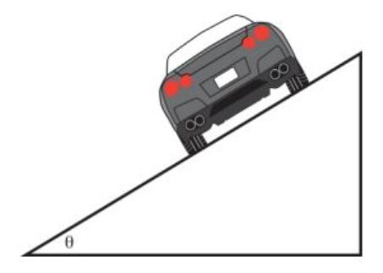
Figure 2
  - Construct the equation for V_{min} and V_{max} that the car can have without slipping up or down the road. (8 marks)
  - Solve for the range of speeds possible if R = 100 m, θ = 10.0°, and μ_{s} = 0.100 (slippery conditions)? (4 marks)
  - With the same R, θ, and μ_{s} from part (b), solve for the minimum value for μ_{s} such that the minimum speed is zero. (3 marks)

