
OFFICE OF ACADEMIC AFFAIRS
Reference No. : XMUM.OAA - 100/2/8-V3.0
Effective Date : 1 JUNE 2023

DESCRIPTION OF COURSEWORK

Course Code | EEE406
Course Name | Power Systems Analysis
Lecturer | Dr Abdul Rashid Abdul Rahman
Academic Session | 09/2025
Assessment Title | Laboratory 1 - Power flow studies using Gauss-Seidel Method

A. Introduction/ Situation/ Background Information
Objectives
To perform power flow studies using Gauss-Seidel method for the given tasks.
Pre-Laboratory
Knowledge on power flow and familiarity with PowerWorld Simulator software is very important prior to conducting this laboratory. Therefore, students should complete the Pre-Laboratory steps below:
1. Study the power flow analysis through lecture notes or reference book.
2. Install the PowerWorld Simulator software.
3. Learn on how to use PowerWorld Simulator software from “PowerWorld Simulator Quick Guide Ver 5” .
Watch related tutorial video at powerworld.com or youtube.com websites for better understanding on using PowerWorld Simulator software.

B. Course Learning Outcomes (CLO) covered
At the end of this assessment, students are able to:
CLO 1 Analyze transmission system and power flow with Gauss-Seidel and Newton-Raphson methods.

D. Instruction to Students
This is a group of four (4) or five (5) students’s laboratory to be completed in 2 weeks.
Simulation files (PowerWorld’s Simulator pwb and pwd files) should be submitted with the report using filename “Lab1Report” in softcopy (PDF) for every task that should follow the following format:
1. Introduction
2. Methodology
3. Results and Discussion
Due Date: 26th December 2025 (Week 13).

Software Tool: PowerWorld Simulator software.
E. Evaluation Breakdown

No. | Component Title | Percentage  (%)
1. | Draw the two-busbar per unit representation using appropriate base  values. Include all components: generator, transformers, transmission line, and convert the load to per unit. Clearly identify Bus 1 (generator) and  Bus 2 (load). | 20
2. | Perform manual calculation for THREE (3) iterations using Gauss-Seidel method to solve bus voltages. Show step-by-step workings, assumptions, and evaluate your results. | 30
3. | Develop the two-busbar per unit system in PowerWorld. Simulate using Gauss-Seidel method for THREE (3) iterations. Capture the one-line  diagram and load flow results. Compare and discuss with manual results for every iteration. | 30
4. | Comment on findings from manual and simulation results. Discuss the power transferred on a single transmission line and identify key  parameters that affect the ability to transfer real and reactive power over long distances. | 20
 | TOTAL | 100

F. Task(s)

1. For the system shown, draw the two-busbar per unit representation by choosing appropriate base values. Consider Bus 1 to be at the Generator and Bus 2 to be at the Load point. Consider the resistances and reactances of all components, such as Generator, Transformers, Transmission Lines to be present between these two buses. Load should be converted to per unit terms and should be connected beyond Bus number 2.
2. Carry out calculations showing three iterations for finding the voltages at the two busbars. Consider appropriate assumptions and show your calculations step-by-step.
3. Verify the voltages in PowerWorld by simulating the two-busbar per unit system and capture the outputs (one-line diagram and load flow results). What are the voltage values in actual quantities (kV)?
4. Comment on your findings and comment on the power transferred on a single transmission line, i.e., what are the parameters that affect the ability of a transmission line to transfer bulk real and reactive powers over long distances?
5. Display your simulation steps and results in the report along with your discussion.

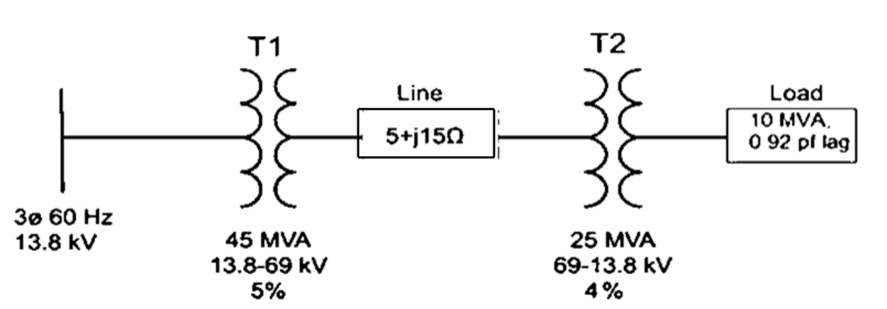

Figure 1. One line diagram of power system

APPENDIX 1

MARKING RUBRICS

Componen  t Title | Power flow studies using Gauss-Seidel and Newton- Raphson |  |  |  |  | Percentage  (%)
Criteria | Score and Descriptors |  |  |  |  |  | Weight  (%) | Marks
Criteria | Excellent  (5) | Good  (4) | Average  (3) | Need  Improvement  (2) |  | Poor  (1) | Weight  (%) | Marks
System  design | 100%  reliable and unique  isolated  network  topology  design and using logical  parameters  of industry data | 80% reliable and unique isolated  network  topology  design and using logical  parameters of industry data | 60% reliable and unique isolated  network  topology  design and using logical  parameters of industry data | 40% reliable and unique isolated  network  topology  design and using logical  parameters of industry data |  | plagiarized isolated  network topology design | 2
Manual  calculatio n  to solve the  voltages using  Gauss- Seidel  method | 100% detail steps of  calculation shown with  comprehensi vely and  correctly evaluated | 80% detail steps of  calculation shown with  comprehensi vely and  correctly evaluated | 60% detail steps of  calculation shown with  comprehensi vely and  correctly evaluated | 40% detail steps of  calculation shown with  comprehensi vely and  correctly evaluated |  | less than  40% detail  steps of  calculation  shown with  comprehensiv ely and  correctly evaluated | 3
PowerWo rld  Simulator  simulation using  Gauss- Seidel  method | 100% detail simulation  conducted  and  compared  with manual calculation for every  iteration | 80% detail simulation  conducted  and  compared  with manual calculation for every  iteration | 60% detail simulation  conducted  and  compared  with manual calculation for every  iteration | 40% detail simulation  conducted  and  compared  with manual calculation for every  iteration |  | less than  40% detail simulation  conducted  and  compared  with manual calculation for every  iteration | 3
Overall  power  flow  results  discussion | 100% detail overall  power flow results being discussed. | 80% detail overall  power flow results being discussed. | 60% detail overall  power flow results being discussed. | 40% detail overall  power flow results being discussed. |  | less than  40% detail overall  power flow results being discussed. | 2
 |  |  |  |  |  | TOTAL
Note to students: Please include the marking rubric when submitting your coursework.

