
XIAMEN UNIVERSITY MALAYSIA
ONLINE FINAL EXAMINATION
Course Code: | COM102
Course Name: | Programming Language C
Question Paper Setter: | Wang Yiju
Academic Session: | 2021/09 | Question Paper: | A B
Total No. of Pages: | 4 | Time Allocated: | 2 hours
Additional Materials: | -
Apparatus Allowed: | -

INSTRUCTIONS TO CANDIDATES

- This paper consists of 1 Section(s):
Section A: | 5 | question(s)
Answer all questions.
- Please follow the requirement of each section and type in all the corresponding answers on the downloadable answer book provided.

- Communication between candidates in any means is forbidden. Answers must be entirely individual candidate’s independent effort. If you are found sharing your solutions with other candidates, or suspected of doing so, you would be penalized accordingly.

(Student ID: Full Name: )

Section A (100 marks)
Coding

Question 1 [CO1-PO1:C2](20 marks) (2 marks each)
Correct the errors in each of the following statements. (Please write the correct one on your paper sheet.)
- printf( "The value is %d\n", &number );
- scanf( "%d%d", &number1, number2 );
- if ( c < 10 );{
printf( "C is less than 10\n" );
}
- if ( c => 10 ) {
printf( "C is greater than or equal to 10\n" );
}
- printf( "The sum of %c and %c is %c /n", x, y );
- a + b = sum;
- print( "The product is &d\n," x * y );
- scanf( "%d, %d, %d", &x &y &z );
- int x = 1, product;
while ( x <= 5 ) {
product *= x;
++x;
}
- While ( x <= 10 )
total =+ x;
++x;

Question 2 [CO2-PO2:C4](20 marks)
Complete the following coding to
- key in 10 integers from keyboard;
- print the integers between 1 and 10;
- count the number of the integers between 1 and 10 (1 and 10 are included) and print it; and
- if the number of the integers between 1 and 10 is less than 3, print “Just few!” on the computer screen; if the number of the integers between 1 and 10 is more than 6, print “So many!”; and in all any other cases, print “Exaclty!”.
#include <stdio.h>
struct data{
$$⋮$$
};
int main()
{
$$⋮$$
}
Examples of the results are as follow. Please solve the problem with structure(s) and follow the input and output format of the results as shown below.
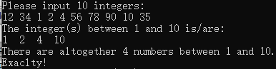
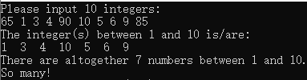
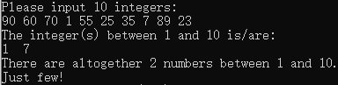

Question 3 [CO2-PO2:C4](20 marks)
Complete the following coding to
- key in a limited length string with the enter as ending, and show how many characters in the string;
- reverse the above string and display the reversed one; and
- combine the original string keyed in from keyboard and its reverse to be a new string and display it.
#include <stdio.h>
#define SIZE 1000
int main()
{
char string[SIZE];
$$⋮$$
}
Examples of the results are as follow. Please solve the problem with array(s) and without function call(s) and follow the input and output format of the results as shown below.
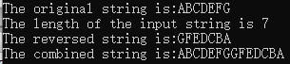
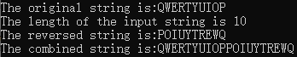

Question 4 [CO3-PO3:C3](20 marks)
Write a complete program to key in an integer from keyboard and print the shortest sequence of consecutive (continuous) prime numbers (starting from 2), so that the summation of this sequence is larger than the input integer. Examples of the results are as follow. Please solve the problem with the function call(s) using pass-by-reference, and follow the input and output format of the results as shown below.

Question 5 [CO3-PO3:C3](20 marks)
Write a complete program to:
- key in 2 different integers from keyboard, assuming that the 2 integers are both greater than 1 and the first integer is less than the second integer;
- display all the palindrome numbers between the above 2 integers; and
- show how many palindrome numbers between the above 2 integers.
Examples of the results are as follow. Please solve the problem with the function call(s) using pass-by-value and having 2 arguments (One represents the first integer and the other represents the second integer input from the keyboard respectively), and follow the input and output format of the results as shown below. (Hint: A palindromic number is a number (such as 16461) that remains the same when its digits are reversed.)
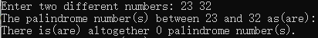

- END OF PAPER -

