

XIAMEN UNIVERSITY MALAYSIA ONLINE QUIZ

Course Code: | COM102
Course Name: | Programming in language C
Question Paper Setter: | Wang Yiju
Academic Session: | 2021/09 | Question Paper: | A ☑ B □
Total No. of Pages: | 1 | Time Allocated: | 2 hours
Additional Materials:
Apparatus Allowed:

INSTRUCTIONS TO CANDIDATES
- This paper consists of 1 Section(s):

Section A: | 2 | question(s)
Answer ALL questions in section A.
- Read the above information carefully to ensure you have the correct and complete question paper.
- Please follow the requirement of each section and write down all the corresponding answers on the answer book provided.
- Candidates are required to hand in both question paper and answer book to the invigilator before leaving the examination room (including all blank or used papers, if applicable).

DO NOT TURN OVER THIS PAGE UNTIL INSTRUCTED TO DO SO.
(Student ID: Full Name: )

Section A (100 marks)

Coding

Question 1 (50 marks) (Each program with 25 marks)
Write a program to read in two positive integers n and r from the keyboard (where n is the length of the series to be printed and r is the ratio), and print an equal-ratio series with the ratio of r (starting from r), which is given by
.
Please solve the same problem with 2 different programs. One program is with the function call using pass-by-reference, and the other one is without the function call. Examples of the results are as follow. Please follow the input and output format of the results as shown below. (Note: the function pow() in <math.h> is NOT allowed to be used.)
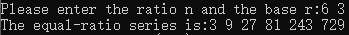

Question 2 (50 marks) (Each program with 25 marks)
Write a complete program to key in 10 integers from keyboard, and show how many times of 100 you have keyed in on your monitor. Please solve the same problem with 2 different programs. One program is with the function call using pass-by-value, and the other one is without the function call. Examples of the results are as follow. Please follow the input and output format of the results as shown below.
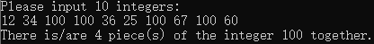
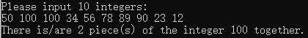

- END OF PAPER -

