Tutorial 2_2
Question 1: What is voltage divider biasing? Why this is widely used?

Question 2: What are the advantages and disadvantages of voltage divider biasing?

Question 3: Compare the performance of different types of biasing circuits.

Question 4: How emitter resistance can improve the stability of the circuit?

Problem 1:
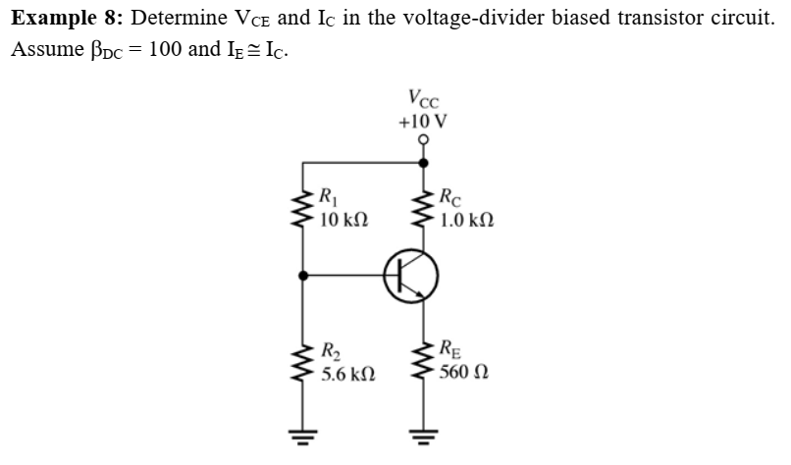

Problem 2:
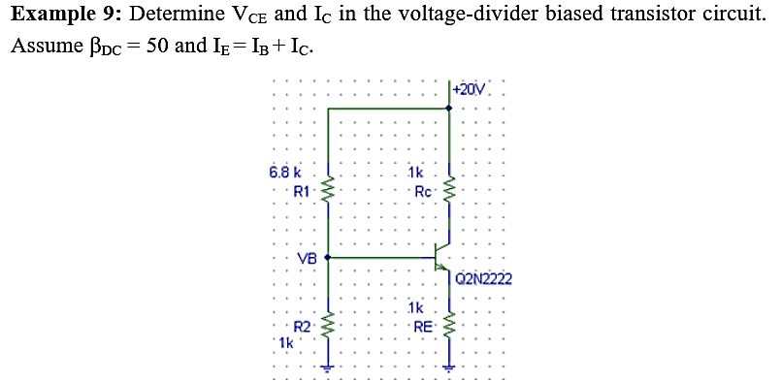

Problem 3:

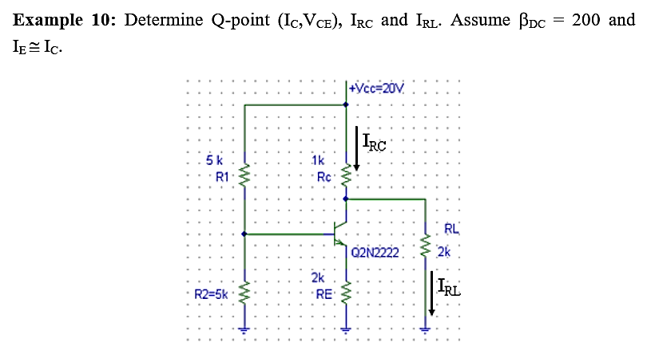

Problem 4: Draw the loadline for the circuit:
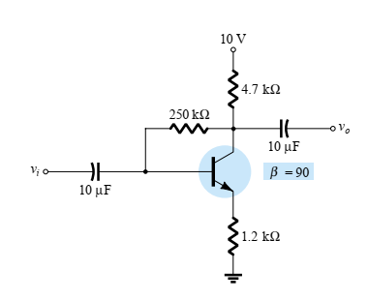

Problem 5: Determine the base current Ib and collector voltage Vc of the following circuit:
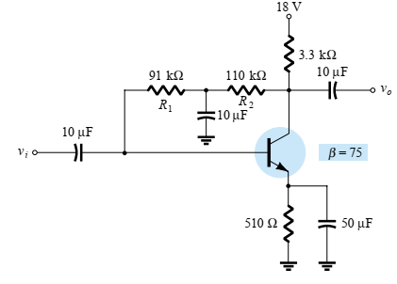

Problem 6: Determine the Vcb and Ib for the circuit:
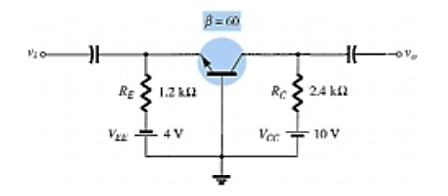

Problem 7: Complete the circuit values based on the information given:


