Experiment 2: Modeling of 200 Watt Solar Power in MATLAB/Simulink

SOFTWARE
MATLAB Simulink

PROCEDURE
- Load Simulink by simply typing “simulink” at the MATLAB prompt. Once simulink has loaded, create a new model by going to File, New → Blank Model (or alternatively press CTRL+N). Next, begin placing components on the empty window.
- Click Library Browser
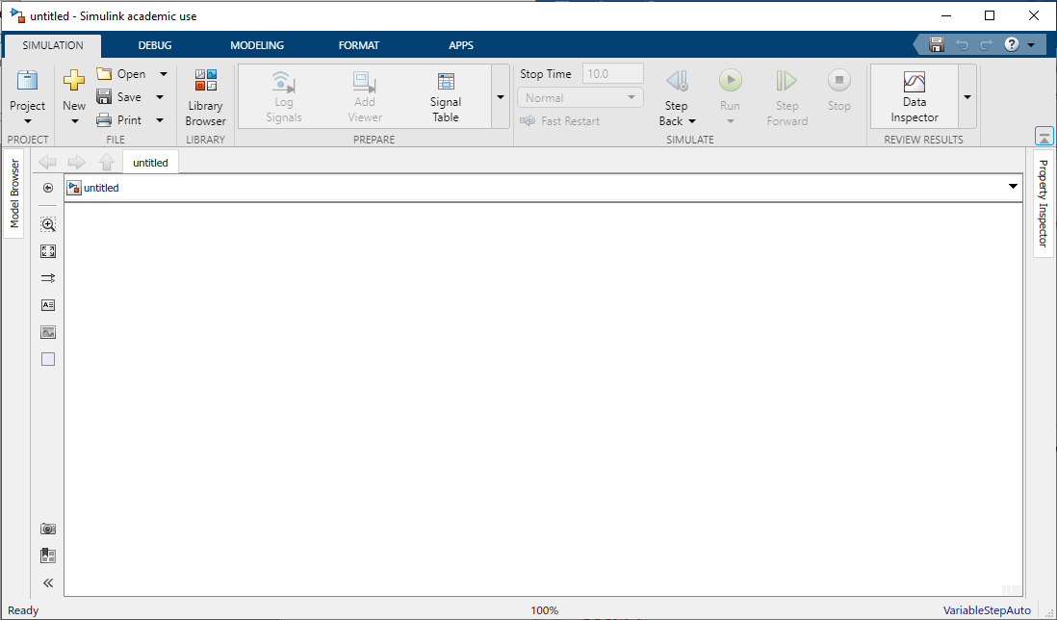
- Click Simscape > Electrical > Specialized Power Systems > Renewables > Solar> PV Array. Right click and select add block to model (or alternatively press CTRL+I)
- Double click at PV Array. Change the parameter based on Table 1

Table 1 200Watt Solar PV Parameter
Parameter | Rated Value
Rated Power | 200W
Voltage at Maximum Power (Vmp) | 26.4V
Current at Maximum Power (imp) | 7.58V
Open Circuit Voltage (Voc) | 32.9 V
Short Circuit Current (Isc) | 8.21A
Total Number of Cells in Series (Ncell) | 54
Total Number of cells in Parallel | 1

- Click Library Browser >Commonly Used Blocks> Constant. Click Constant and add block to model.
- Rename the Constant block to Irradiance and connect it to Irradiance (Ir) of PV Array block. Change the constant value to 1000W/m2.
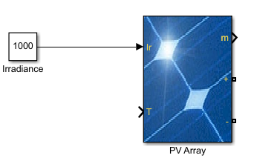
- Click Library Browser >Commonly Used Blocks> Constant. Right click Constant and add block to model.
- Rename the Constant block to ‘Temperature’ and connect it to Temperature (T) of PV Array block. Change the constant value to 25deg.
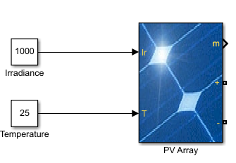
- Click Library Browser >Simscape>Electrical>Specialized Power Systems>Fundamental Blocks>Elements> Series RLC Branch. Right click and add block to model.
- Connect the Series RLC Branch to positive terminal of PV Array
- Double click the Series RLC Branch block. Change branch type to R and Resistance value. Click OK.
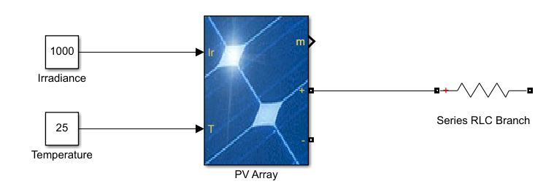
- Click Library Browser >Simscape>Electrical>Specialized Power Systems>Fundamental Blocks>Elements>Ground. Right click and add block to model. Connect Ground to the Series RLC Branch block.
- Click Library Browser >Simscape>Electrical>Specialized Power Systems>Fundamental Blocks>Elements>Ground. Right click and add block to model. Connect Ground to negative terminal of PV Array block.
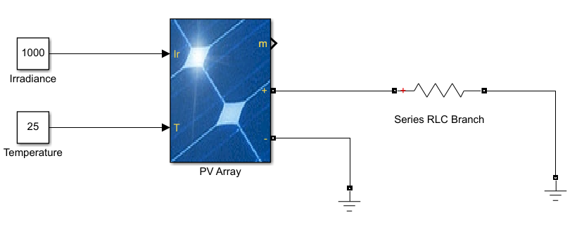
- Click Library Browser >Simscape>Electrical>Specialized Power Systems>Fundamental Blocks>Measurement>Current Measurement. Right click and add block to model.
- Click Library Browser >Simscape>Electrical>Specialized Power Systems>Fundamental Blocks>Measurement>Voltage Measurement. Right click and add block to model.
- Connect both Current Measurement and Voltage Measurement block to the circuit.
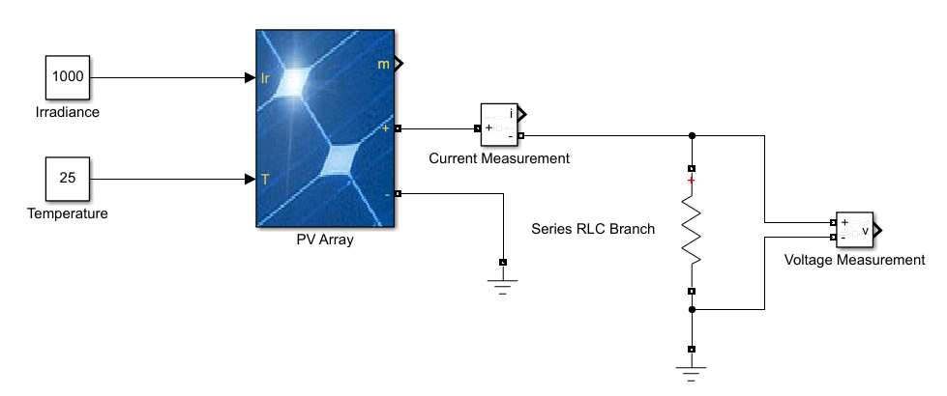
- Click Library Browser >Simulink>Sink>Scope. Right click and add block to model.
- Click Library Browser >Simulink>Sink>Display Right click and add block to model
- Connect both Scope and Display to Voltage Measurement block.
- Click Library Browser >Simulink>Sink>Scope. Right click and add block to model.
- Click Library Browser >Simulink>Sink>Display Right click and add block to model
- Connect both Scope and Display to Current Measurement block.
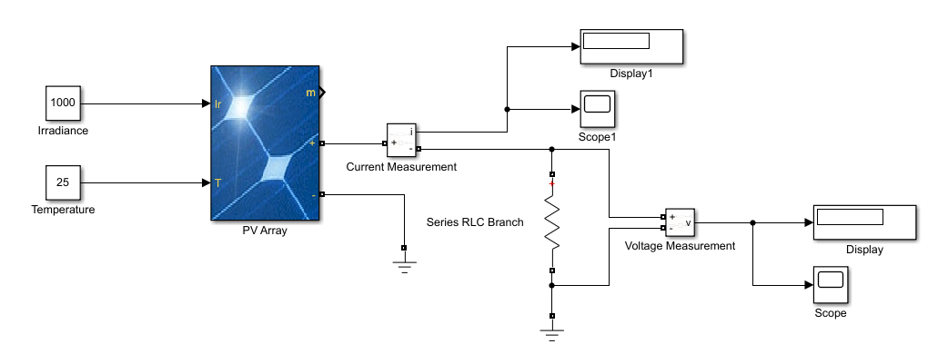
- Click Library Browser >Simscape>Electrical>Specialized Power Systems>Fundamental Blocks>powergui. Right click and add block to model.
- Click run.

