description of cOURSEWORK

OFFICE OF ACADEMIC AFFAIRS
Reference No. : XMUM.OAA - 100/2/8-V2.0
Effective Date : 23 APRIL 2018
Course Code | EEE203
Course Name | Instrumentation
Lecturer | Wang Yiju
Academic Session | 2022/09
Assessment Title | Assignment

- Introduction/ Situation/ Background Information
This assignment aims to make student understand some important terms well, such as error, precision, accuracy, sensitivity; and to know statistical analysis methods of measured quantities well.

- Course Learning Outcomes (CLO) covered
At the end of this assessment, students are able to:
CLO 1 Analyze electrical measuring instruments via error theory.
CLO 2 Design simple apparatus that improves measurement precision and accuracy

- University Policy on Academic Misconduct

- Academic misconduct is a serious offense in Xiamen University Malaysia. It can be defined as any of the following:
- Plagiarism is submitting or presenting someone else’s work, words, ideas, data or information as your own intentionally or unintentionally. This includes incorporating published and unpublished material, whether in manuscript, printed or electronic form into your work without acknowledging the source (the person and the work).
- Collusion is two or more people collaborating on a piece of work (in part or whole) which is intended to be wholly individual and passed it off as own individual work.
- Cheating is an act of dishonesty or fraud in order to gain an unfair advantage in an assessment. This includes using or attempting to use, or assisting another to use materials that are prohibited or inappropriate, commissioning work from a third party, falsifying data, or breaching any examination rules.

- All the assessment submitted must be the outcome of the student. Any form of academic misconduct is a serious offense which will be penalized by being given a zero mark for the entire assessment in question or part of the assessment in question. If there is more than one guilty party as in the case of collusion, both you and your collusion partner(s) will be subjected to the same penalty.

- Instruction to Students
Submission type: Softcopy (PDF)
Submission due date: December 15, 2022 (Week13 Thursday)

- Evaluation Breakdown
No. | Component Title | Percentage (%)
 | Assignment | 20%
 | TOTAL | 20%

- Task(s)

Section A [30 marks]
Foundation
- [10 marks] Give the number of significant figures for each number
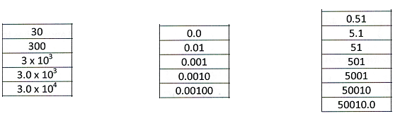
- [10 marks] A digital thermometer is used to measure the boiling point of water (100.0°C). The measurement is repeated 5 times and following readings are obtained: 99.9, 101.2, 100.5, 100.8, 100.1. Determine the accuracy, the precision and the bias of the thermometer.
- [10 marks] A moving-coil ammeter has a fixed shunt of 0.02Ω. With a coil resistance of R=1000Ω and a potential difference of 500mV across it. Full-scale deflection is obtained. To what shunted current does it correspond? Calculate the value of R to give full-scale deflection when shunted current I is 10A and 75A, respectively.

Section B [20 marks]
Analysis
- [10 marks] A 50V range voltmeter is connected across the terminals A and B of the circuit shown in Fig.1. Find the reading of the voltmeter under open circuit and loaded conditions Find the accuracy and the loading error. The voltmeter has a resistance of 1000 kΩ.
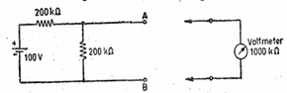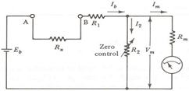
Fig.1 Fig.2
- [10 marks] An ohmmeter as shown in Fig.2 with Eb =1.5V, R1 = 15kΩ, Rm = R2 = 50Ω and IFSD = 50µA. Calculate,
- Rx at 0.5FSD,
- when Eb = 1.2V what is the value of R2 to get full-scale current and
- when Eb = 1.2V what is the value of Rx at half-scale current.
Section C [50 marks]
Synthesis

- [10 marks] A Maxwell's inductance comparison bridge is shown in Fig.3. Arm ab consists of a coil with inductance L1 and resistance r1 in series with a non-inductive resistance R. Arm bc and dc are each a non-inductive resistance of 100Ω. Arm ad consists of standard variable inductor L of resistance 32.7Ω. Balance is obtained when L=47.8mH and R= 1 .36 Ω. Find the resistance and inductance of coil in arm ab.

- [10 marks] A Maxwell's capacitance bridge shown in Fig.4 is used to measure an unknown inductance in comparison with capacitance. The various values at balance: R2=400Ω; R3=600Ω; R4=1000Ω; C4=0.5μF. Calculate values of R1 and L1. Calculate also the value of storage (Q) factor of coil if frequency is 1000Hz.

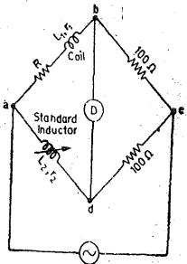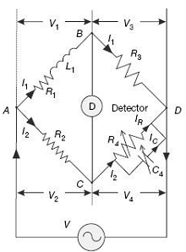
Fig.3 Fig.4

- [10 marks] An inductance of 0.22H and 20Ω resistance is measured by comparison with a fixed standard 0.1H and 40Ω resistance. They are connected as shown in Fig.5. The unknown inductance is in arm ab and the standard inductance is arm bc, a resistance of 750Ω is connected in arm cd and a resistance whose amount is not known is in arm da. Find the resistance of arm da and show any necessary and practical additions required to achieve both resistive and inductive balance.

- [10 marks] The arms of a five node bridge are as follows in Fig.6:
arm ab: an unknown impedance (R1, L1) in series with a non-variable inductive resistor r1.
arm bc: a non-inductive resistor R3=100Ω,
arm cd: anon-inductive resistor R4=200Ω,
arm da: a non-inductive resistor R2=250Ω,
arm de: a variable non-inductive resistor r,
arm ec: a loss less capacitor C=1µF,
and arm be: a detector.
An a.c. supply is connected between a and c.
Calculate the resistance and inductance R1, L1 when under balance conditions r1=43.1Ω and r=229.7Ω.

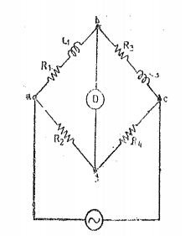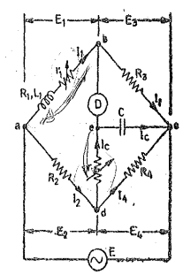
Fig.5 Fig.6

- [10 marks] The four arms of a bridge in Fig.7 are:
arm ab: an imperfect capacitor C1 with an equivalent series resistance of r1,
arm be: a non-inductive resistance R3,
arm cd: a non-inductive resistance R4,
arm da: an imperfect capacitor C2 with an equivalent resistance of r2 in series with a resistance R2.
A supply of 450Hz is given between terminal a and c and the detector is connected between b and d. At balance: R2=4.8Ω, R3=2000Ω, R4=2850Ω and C2=0.5µF and r2=0.4Ω.
Calculate the value of C1 and r1 and also of the dissipating factor for this capacitor.
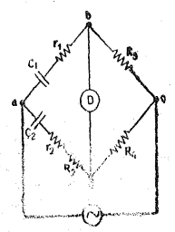
Fig.7

