description of cOURSEWORK

OFFICE OF ACADEMIC AFFAIRS
Reference No. : XMUM.OAA - 100/2/8-V3.0
Effective Date : 1 JUNE 2023
Course Code | EEE423
Course Name | Power System Protection
Lecturer | Ir Dr Ab Halim Bin Abu Bakar
Academic Session | 04/2025
Assessment Title | Assignment 1: The Overcurrent Setting

- Introduction/ Situation/ Background Information
The technology development has significant impact on protection of power system

- Course Learning Outcomes (CLO) covered
At the end of this assessment, students are able to:
CLO 3 Evaluate the grading analysis of protection relay.

- University Policy on Academic Misconduct
- Academic misconduct is a serious offense in Xiamen University Malaysia. It can be defined as any of the following:
- Plagiarism is submitting or presenting someone else’s work, words, ideas, data or information as your own intentionally or unintentionally. This includes incorporating published and unpublished material, whether in manuscript, printed or electronic form into your work without acknowledging the source (the person and the work).
- Collusion is two or more people collaborating on a piece of work (in part or whole) which is intended to be wholly individual and passed it off as own individual work.
- Cheating is an act of dishonesty or fraud in order to gain an unfair advantage in an assessment. This includes using or attempting to use, or assisting another to use materials that are prohibited or inappropriate, commissioning work from a third party, falsifying data, or breaching any examination rules.
- All assessments submitted must be the student’s own work, without any materials generated by AI tools, including direct copying and pasting of text or paraphrasing. Any form of academic misconduct, including using prohibited materials or inappropriate assistance, is a serious offense and will result in a zero mark for the entire assessment or part of it. If there is more than one guilty party, such as in case of collusion, all parties involved will receive the same penalty.

- Instruction to Students
For the system shown below, design the complete OC protection using the IDMT relay. Determine the CT ratio, PMS and TMS at all locations

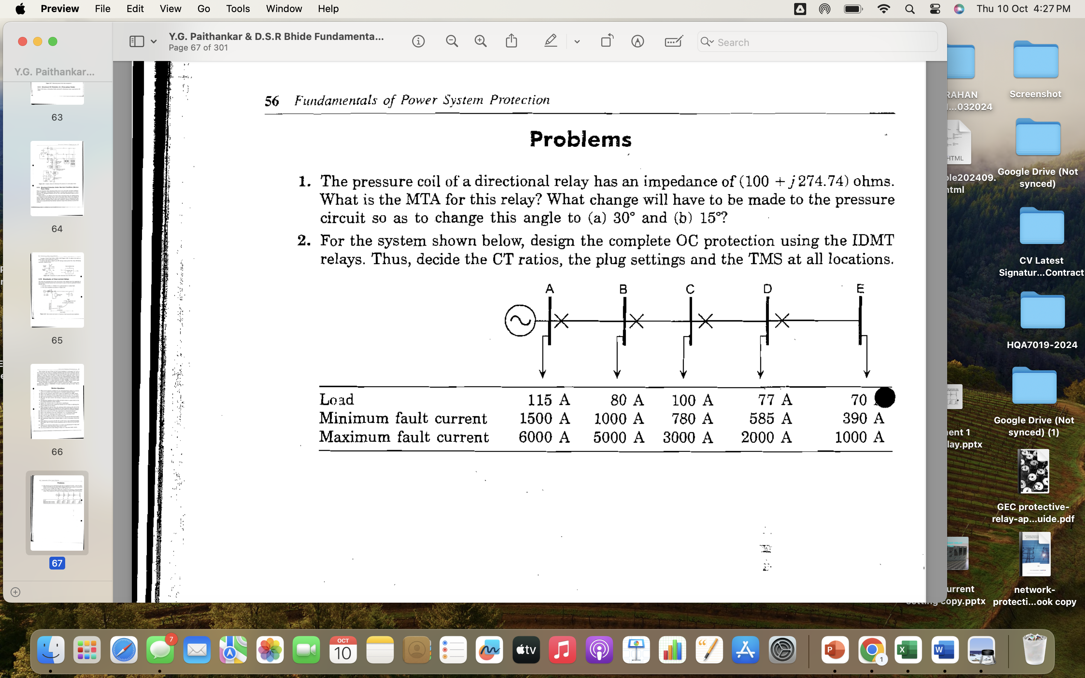

Given:
Table 1: System data
Substation | A | B | C | D
Total Load at the Substation | 420A | 300A | 130A | 50A
Minimum Fault Current | 3920A | 2860A | 2003A | 1192A
Maximum Fault Current | 7850A | 4500A | 2690A | 1395A

- Evaluation Breakdown
No. | Component Title | Percentage (%)
 | Understanding of topics | 10
 | Information | 20
 | Use of facts/statistics | 20
 | Analysis | 20
 | Organization | 10
 | Report Writing | 20

- Task(s)
- The calculation should summarize the main points before presenting a solid conclusion
- Cite and include a list of all resources or references used in your calculation

APPENDIX 1
Marking Rubrics

Component Title | The Distance Protection Setting |  |  |  | Percentage (%)
Criteria | Score and Descriptors |  |  |  |  | Weight (%) | Marks
Criteria | Excellent  (5) | Good  (4) | Average  (3) | Need Improvement  (2) | Poor  (1)
Understanding of Topic | Excellent understanding of the main points of topic in depth | Good understanding of the n main point of the topic | Satisfactory understanding of the main points of the topic | Poor understanding of the main points of the topic | Not able to understand the main point of the topic | 10
Information | All information presented was clear and thorough | Most information presented was clear and thorough | Most information presented was clear but not thorough | Some information was clear but there were some minor inaccuracies | Information had some major inaccuracies or was not clear | 20
Use of Facts/Statistics | Every major point was well supported with several relevant facts, statistic and/or examples | Every major was adequately supported with relevant facts statistics and/or examples | Every major was supported with facts statistics and/or examples but the relevancy of some was questionable | Some points were supported with relevant acts statistics and/or examples | All points were not supported with relevant acts statistics and/or examples | 20
Analysis | All arguments were relevant with strong evidence | Most arguments were relevant with moderate evidence | Several arguments were relevant with sufficient evidence | Most arguments were irrelevant and weak evidence | All arguments are irrelevant and no evidence | 20
Organisation | All arguments were clearly related to an idea and well organized in logical order  Opening statement engages the interest of audience and closing statement leaves no unanswered issues and resonates with the audience. | Most arguments were clearly related to an idea and well organized in logical order  Opening statement engages the interest of audience and closing statement summarizes many arguments | Some arguments were clearly related to an idea and well organized in logical order  Opening statement outlines or lists argument but does not generate interest and close statement briefly restates the ideas offered in the opening statement | Most arguments were not clearly related to an idea and organized in logical order  Opening statement minimally outlines arguments and closing statement does not reflect remarks | Arguments were not related to an idea.  Opening statement has no outlines arguments and closing statement does not reflect remarks | 10
Report Writing | 100% detail overall protection concept discussed for method adopted | 80% detail overall protection concept discussed for method adopted | 60% detail overall protection concept discussed for method adopted | 40% detail overall protection concept discussed for method adopted | Less than 40% detail overall protection concept discussed for method adopted | 20
TOTAL |  |  |  |  |  |  | 100

