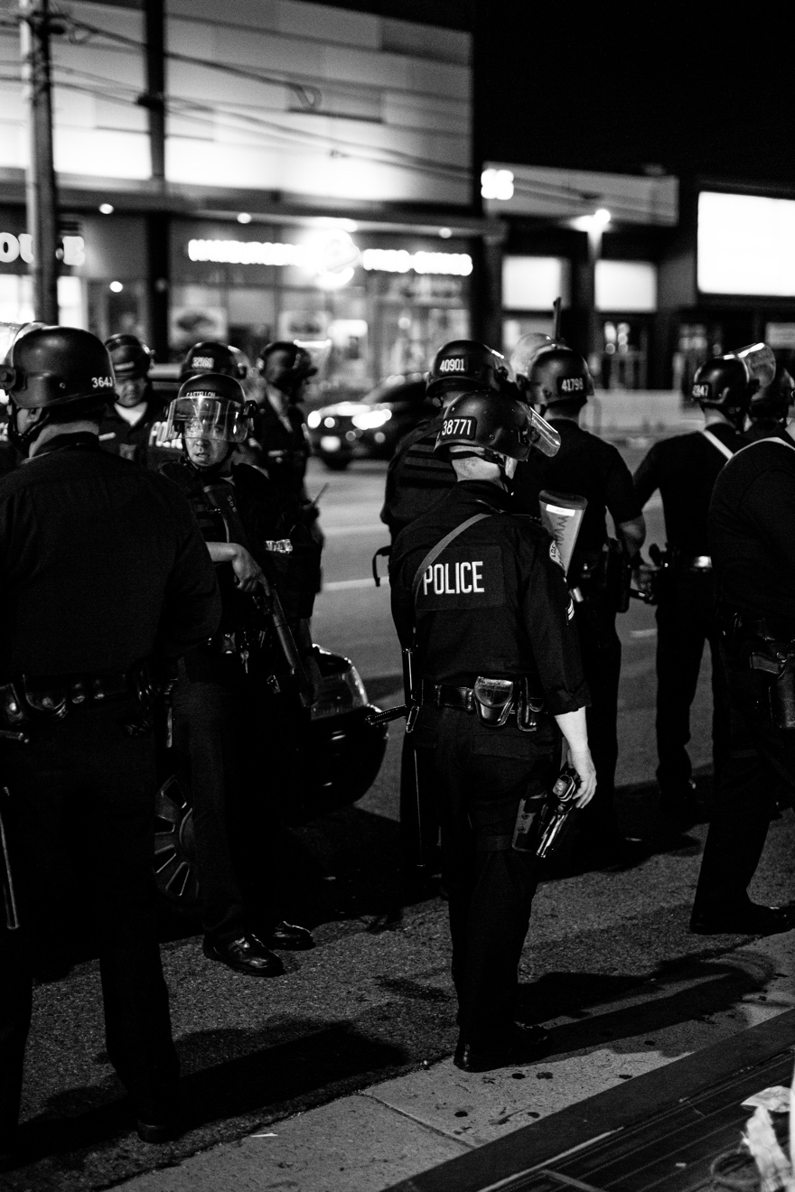

Photo by Andrew "Donovan" Valdivia on Unsplash

Design of an interactive data analysis tool

Visualization Practical Work

Universidad Politécnica de Madrid | Big Data - Data Visualization | January 2021

Camarena Torres, Lucas

Marín Estañ, Ana

Rodrigo Lacave, Blanca

# Content

Problem Characterization in the Application Comain 1

Data and Task Abstractions 1

Data Abstractions 1

Task Abstractions 1

Interaction and visual encoding 1

Algorithmic implementation 1

Results 1

Conclusion 1

References 2

Appendix 1. How to run the code 3

# Problem Characterization in the Application Comain

Violent encounters with police represent a significant cause of morbidity and mortality in the USA [1]. And, over the past five years there has been no reduction in the racial disparity in fatal police shooting victims despite increased use of body cameras and closer media scrutiny, according to a new report by researchers at Yale and the University of Pennsylvania [2].

In 2015, *The Washington Post* began to log every fatal shooting by an on-duty police officer in the United States. In five years, more than 5,000 thousand shootings recorded [3]. The data used in this project was obtained from Kaggle [4]. However, the selected dataset is a preprocessed version to the *The Washington Post*'s dataset [3].

# Data and Task Abstractions

## Data Abstractions

## Task Abstractions

For each visualization that is presented in the application, it is necessary to make a description of the task abstraction, including its actions and targets.

### Geographical exploration

For these three visualizations, new information is produced: shooting frequencies, grouped by states or cities are obtained.

#### Shooting city distribution

In which urban areas are police shootings more frequent?

**Actions**: Besides the shooting frequency for the cities, new information is produced: the cities' location (longitude and altitude) are added. The aim of this question is to explore identify US urban areas in which police shootings are more frequent.

**Targets**: these actions are applied over the -geographical- distribution of the shooting frequency.

#### Victim's profile

Does the state in which the shooting occurred influence the profile of the victim?

**Actions**: This task involves the shooting frequency in each state as well as the victims' demographic features. With these two, users can explore the proportion of victims of a particular profile across the states. Therefore, new knowledge is produced. The aim of this visualization is to summarize the data geographically and to find patterns, clusters.

**Targets**: these actions are applied over the -geographical- distribution of the shooting frequency as well as the attributes corresponding to the victims' demographics.

# Interaction and visual encoding

### Geographical exploration

#### Shooting city distribution

In which urban areas are police shootings more frequent?

**Visual encoding**:

For this idiom, the data used are an ordinal, quantitative attribute and geometry data (a map). These data are represented through a bubble map where the position of each bubble is the location of the city, and its diameter corresponds to the number of shootings.

**Interaction:**

The users can filter the year interval of the shootings that is represented. When the user hovers a bubble, the city name, state and number of shootings can be consulted. Moreover the map can be zoomed in an out, and can be downloaded as PNG.

#### Victim's profile

Does the state in which the shooting occurred influence the profile of the victim?

**Visual encoding**:

This idiom also involves several attributes regarding the victim's demographics (race and gender, categorical; age, quantitative) used to filter the number of shootings. It also involves geometry data. In this case, state location.

Therefore, the selected representation is a choropleth, where the color intensity that fills each state corresponds to the relative frequency of shootings with that victim profile:

$$\frac{shootings with X victims demographics (gender, race, age) in state Y}{shootings in state Y}$$

**Interaction:**

This idiom allows users to filter the victims' demographic features (gender, race, age range) to filter the results. When the user hovers a state, the name, and % of victims can be consulted. Moreover the map can be zoomed in an out, and can be downloaded as PNG.

# Algorithmic implementation

For the creation of new information (like season attributes and locations) *lubridate* and *maps* packages were required. Moreover, some were needed for data wrangling libraries, like *tidyverse* or *plyr*.

Regarding the geographic exploration idiom implementation, the package *plotly* is used.

# Results

### Geographical exploration

#### Shooting city distribution

The resulting bubble map shows the shooting distribution across US cities. When filtering the years to 2017-2019, it can be seen that the Rocky Mountain and Midwest areas have had less shootings than the coastal areas (West East and Gulf coast areas) .

#### Victim's profile

The resulting choropleth map presents the relative proportion of victims with the selected demographic features. In this example: Black males, between 30 and 50. It can be seen that the shooting percentages if victims with those features is considerably higher in the east half of the country than in the west. The opposite happens with Hispanic males with the same age range: where the areas with higher percentages are the West coast and the west half of the Gulf Coast.

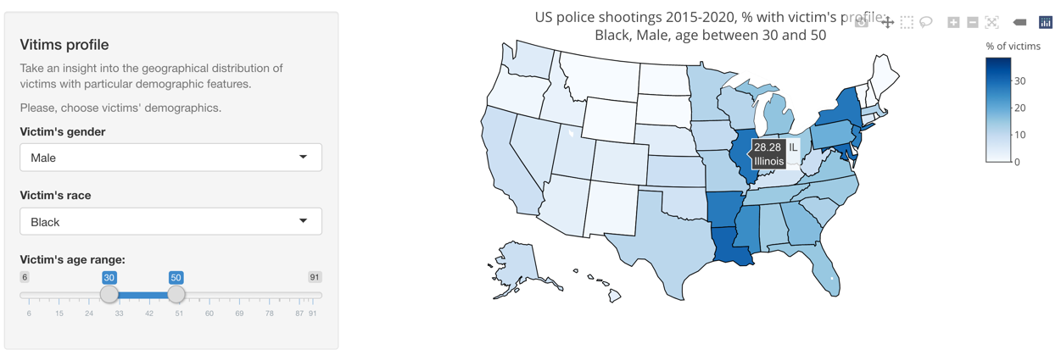

# Conclusion

# References

[1] F. Edwards, H. Lee, and M. Esposito, “Risk of being killed by police use of force in the United States by age, race–ethnicity, and sex,” *Proc. Natl. Acad. Sci. U. S. A.*, vol. 116, no. 34, pp. 16793–16798, Aug. 2019.

[2] E. Lett, E. N. Asabor, T. Corbin, and D. Boatright, “Racial inequity in fatal US police shootings, 2015-2020,” *J. Epidemiol. Community Health*, Oct. 2020.

[3] “Police shootings database 2015-2021 - Washington Post.” [Online]. Available: https://www.washingtonpost.com/graphics/investigations/police-shootings-database/. [Accessed: 21-Jan-2021].

[4] “US Police Shootings | Kaggle.” [Online]. Available: https://www.kaggle.com/ahsen1330/us-police-shootings/notebooks. [Accessed: 21-Jan-2021].

# Appendix 1. How to run the code