Objective:
The main goal of this project is to formulate safe, biocompatible, and bioresorbable oxidized coatings for Mg-alloy medical implants with improved corrosion resistance and mechanical properties. More specifically, we are investigating the effects of implementing nanoparticles in Plasma Electrolyte Oxidation (PEO) coatings.

Project goals to be achieved simultaneously:
- Machine and sand Mg-ZK60 alloys into smaller consistent coupons
- Investigate the PEO coating procedure for Mg-ZK60 alloys.
- Coat the Mg alloys with select coatings
  - Test the coated Mg-ZK60 alloys for corrosion resistance and surface characteristics (in vitro).
  - Collaborate with UARK to run biological testing on the samples
Points to be studied (each can be a publication):
- The significance of Hyrdroxapatite (HA) and Graphene Oxide (GO) nanoparticles on the mechanical and corrosion properties of PEO coatings for Mg-ZK60 alloys in vitro.
  - HA, GO, and HA + GO hybrid coating solutions will be observed
- The effects of various coating current densities on the mechanical and corrosion properties of PEO coatings for Mg-ZK60 alloys in vitro
  - Low, medium, and high current density coating solutions will be observed
- The combination of current density and nanoparticles to yield the most favorable corrosion resistance characteristics
- Simulation and comparison of related studies for PEO coatings of Mg alloys involving HA and GO nanoparticles. (The Mg-ZK60 alloy is chosen for this project as it is readily available and biocompatible)

2. Experimental Work:

2.1. Sample Preparation:

2.1.1. Samples Machining:
- Coupons will be machined in the KSU – Marietta campus workshops with one size for all tests
- Dimensions: (Fill, need to get from lab)

2.1.2. Sanding:
- Sanding is done on coupons before coating to remove the oxidized layer and other contaminants
- Coupons will be sanded using increasing grit sandpaper from 500 to 2000 grit sandpaper
- Sandpaper must be wetted during sanding to prevent airborne dust and to act as lubricant for smoother sanding
- 500 grit sandpaper for flattening uneven surfaces and edges (~60 seconds per face)
- 1000 grit sandpaper for moderate polishing (~60 seconds per face)
- 2000 grit sandpaper for a final flush and mirror like finish (~60 seconds per face)

2.1.3. Coating:
- Coating will be done for every sample tested and will consist of a single oxidized layer produced through plasma-electrolytic oxidation
- Base Electrolyte Solution: 3 g/L (NaPO₃)₆ + 8 g/L KF·2H₂O, pH 11 (NaOH)
  - HA solution: 2g/L HA
  - GO solution: 2g/L GO
  - HA + GO solution: 1g/L HA + 1g/L GO (or equivalent)

2.1.4. PEO:
- Parameters:
  - Current Density: Low (25 mA/cm²), Medium (50 mA/cm²), High (75 mA/cm²)
  - PEO treatment time (10 min)
  - Pulse frequency (5000 Hz) and duty cycle (50%)
  - Electrolyte temperature (recorded, keep as constant as possible)

2.1.5. Epoxy (if applicable):
- Epoxy is applied to coupons used for electrochemical testing with only one face exposed

2.2. Sample Testing:
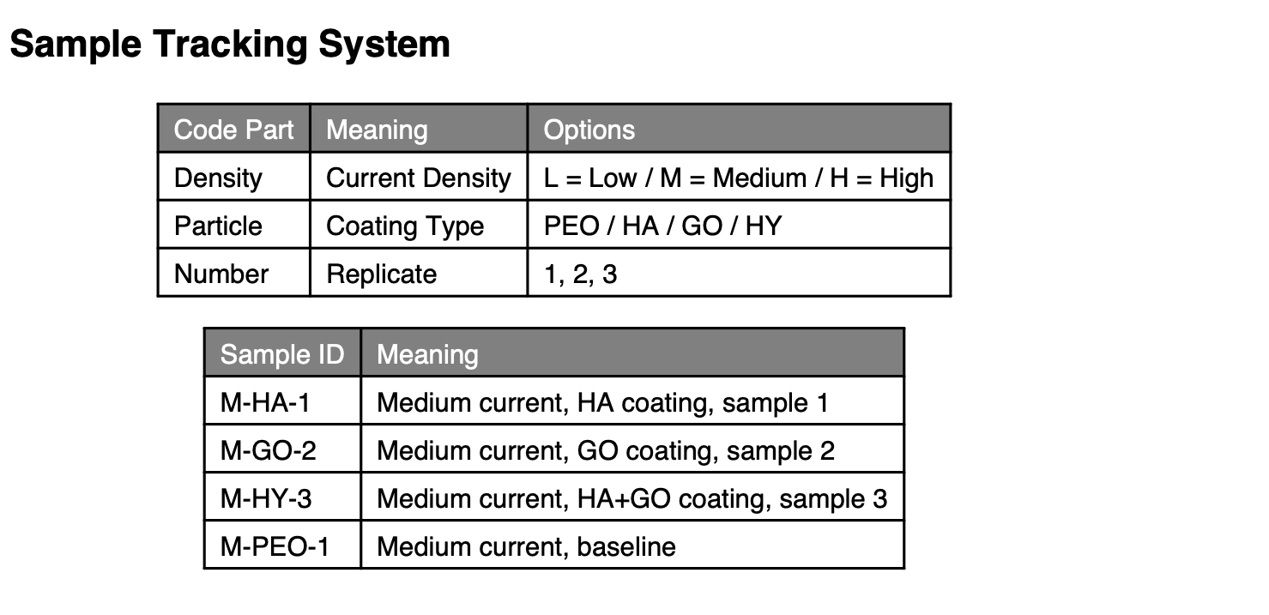We have two treatment factors: (i) current density and (ii) coating. The levels for each treatment are “L”, “M”, or “H” and “PEO”, “HA”, “GO”, and “HY” respectively. So, we will have a total of 13 groups.
- Uncoated
- L current density and PEO coating
- M current density and PEO coating
- H current density and PEO coating
- L current density and HA coating
- M current density and HA coating
- H current density and HA coating
- L current density and GO coating
- M current density and GO coating
- H current density and GO coating
- L current density and HY coating
- M current density and HY coating
- H current density and HY coating

2.2.1. Electrochemical Corrosion:
Electrochemical corrosion testing is conducted with the Gamry Potentiostat model 1010 and the given setup immersed in Hank’s solution for the SBF:
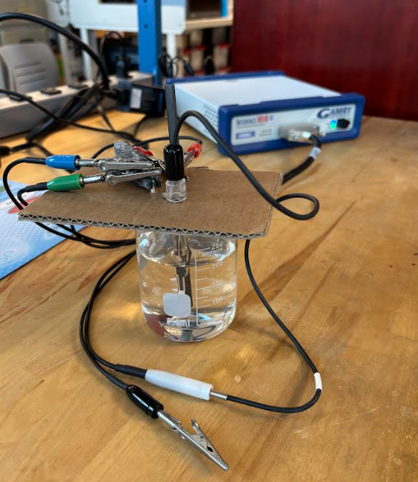

2.2.1.1. Electrochemical Impedance Spectroscopy (EIS):
- For all 13 samples; Uncoated, (L-PEO), (M-PEO), (H-PEO), (L-HA), (M-HA), (H-HA), (L-GO), (M-GO), (H-GO), (L-HY), (M-HY), (H-HY)
- A non-destructive method that measures an electrochemical systems response to a small-amplitude AC signal over a wide range of frequencies and records Bode and Nyquist plots
(Log(Z) & phase shift vs. Log(Z) and imaginary Z vs. real Z, respectively).
- Sample size diameter = 15 mm and thickness = 3 mm
- Parameters for the Gamry Potentiostat Model 1010: (Area is variable) 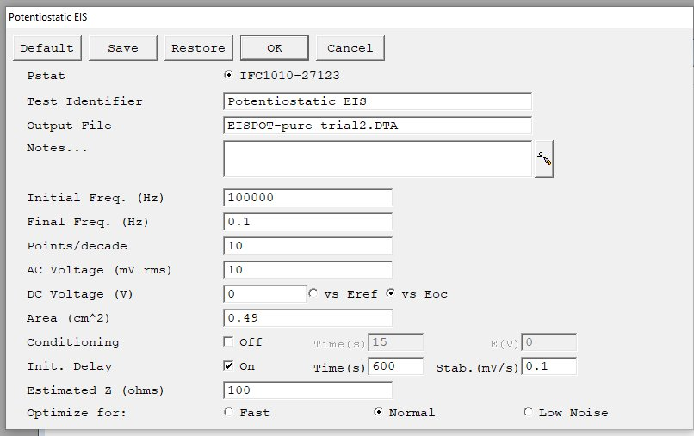
- The significance of this test is to analyze the complex electrochemical system of each fabricated sample and to simplify them into an equivalent circuit based off Bode and Nyquist plots for improved comparison.

2.2.1.2. Potentiodynamic Polarization (PDP):
- Conducted immediately after EIS for the same sample for all samples
- A destructive method that measures the corrosion potential of an electrochemical system over an applied DC current and produces a Tafel curve (E vs. I).
- Parameters for the Gamry Potentiostat Model 1010: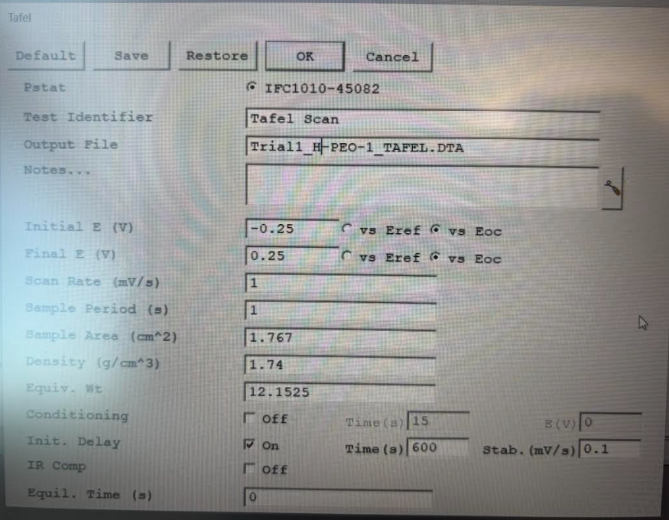
- The significance of this test is to identify the corrosion current and corrosion potential of each fabricated sample for improved comparison

2.2.2. Immersion Testing:

2.2.2.1. Hydrogen Evolution:
- For all 13 samples; Uncoated, (L-PEO), (M-PEO), (H-PEO), (L-HA), (M-HA), (H-HA), (L-GO), (M-GO), (H-GO), (L-HY), (M-HY), (H-HY)
- Hank solution will be used as the simulated body fluid for every sample’s immersion testing with the Hydrogen evolution setup
- Sample size diameter = 15 mm and thickness = 3 mm
- The tested will be conducted for 2-week timeframe, running in the incubator at a temperature of 37°C
- The significance of this study is to characterize the corrosion rate of the different samples under different coatings and current densities
- The setup of the hydrogen evolution system is as shown in the figure below:
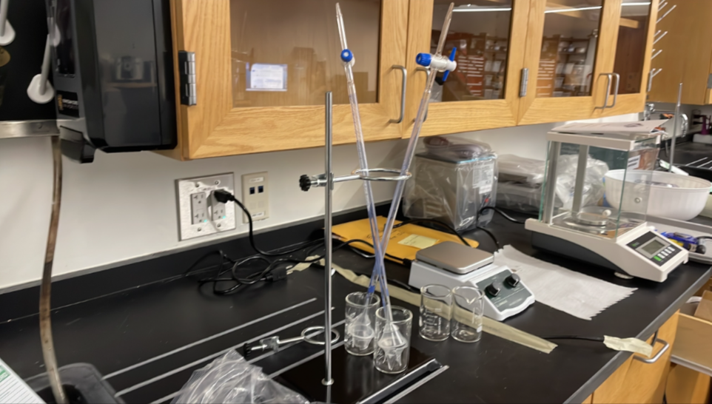

2.2.2.2. Mass Loss Measurement:
- Measure the mass of the coupon prior to placement in the incubator
- After the immersion testing with the H2 Evolution system, measure the mass of the coupon using the scale

2.2.2.3. pH monitoring:
- Note down the pH of the solution with the coupon prior to placement in the incubator
- Following the immersion testing, measure pH of the solution the coupon was placed in

2.2.3. Surface Characteristics:

2.2.3.1. Optical microscopy and/or SEM:
- Optical microscopy utilizes light and lensed magnification and SEM utilizes focused electron beams to analyzing microstructures, surface structures, and contaminants
- The significance of this is to observe the surface morphology of the coated samples and to relate these properties to observed corrosion and mechanical performance
- Coated samples will be observed as is to prevent tampering with coating surface characteristics

2.2.3.2. Surface roughness measurements:
- Quantifying the microscopic peaks and valleys on a materials surface using contact or optical methods

2.2.3.3. Microhardness:
- For all 13 coated samples; Uncoated, (L-PEO), (M-PEO), (H-PEO), (L-HA), (M-HA), (H-HA), (L-GO), (M-GO), (H-GO), (L-HY), (M-HY), (H-HY)
- We will test the hardness of a coupon at a microscopic level using a diamond indenter

2.2.3.4. Adhesion strength:
- A method where an adhesive agent is placed and dried between the sample surface and a dolly upon which an applied tensile force is slowly increased until the bond breaks
- The significance of this is to determine the extent to which the oxide coating is bonded to the Mg-ZK60 substrate and how that strength varies amongst the coating parameters

2.2.3.5. Coating thickness measurements (KSU or UARK):
- Measurement of the thickness of coating on the surface of the coupon

2.2.3.6. XRD phase analysis (KSU or UARK):
- Scan sample with x-ray diffractometer and match the resulting peaks against reference database.
- This determines he specific crystalline structures and chemical compounds present in your material

2.2.4. Cytotoxicity testing:
- Cytoxicity testing will be conducted by collaborators at UARK
- For all 12 coated samples; (L-PEO), (M-PEO), (H-PEO), (L-HA), (M-HA), (H-HA), (L-GO), (M-GO), (H-GO), (L-HY), (M-HY), (H-HY)
- These procedures expose cultured cells to material samples and test for indicated levels of toxicity

2.2.4.1. Cell viability measurements:
- Gather results through the cytotoxicity testing

2.2.4.2. Surface wettability analysis (contact angle measurements):
- A method to test a material’s hydrophilicity which is significant for determining in vivo interactions

3. References:
- Guo, Ziwei, Zehui Yang, Yongnan Chen, et al. 2022. “One-Step Plasma Electrolytic Oxidation with Graphene Oxide for Ultra-Low Porosity Corrosion-Resistant TiO2 Coatings.” Applied Surface Science 594 (August). https://doi.org/10.1016/j.apsusc.2022.153477.
- Heimann, Robert B. 2021. “Magnesium Alloys for Biomedical Application: Advanced Corrosion Control through Surface Coating.” Surface and Coatings Technology 405 (January). https://doi.org/10.1016/j.surfcoat.2020.126521.
- Ma, Huijuan, Yanhong Gu, Shujing Liu, Juntie Che, and Dawei Yang. 2017. “Local Corrosion Behavior and Model of Micro-Arc Oxidation HA Coating on AZ31 Magnesium Alloy.” Surface and Coatings Technology 331 (December): 179–88. https://doi.org/10.1016/j.surfcoat.2017.10.053.
- Shang, Wei, Fang Wu, Yuanyuan Wang, Amin Rabiei Baboukani, Yuqing Wen, and Jiqiong Jiang. 2020. “Corrosion Resistance of Micro-Arc Oxidation/Graphene Oxide Composite Coatings on Magnesium Alloys.” ACS Omega 5 (13): 7262–70. https://doi.org/10.1021/acsomega.9b04060.
- Tang, Hui, and Yang Gao. 2016. “Preparation and Characterization of Hydroxyapatite Containing Coating on AZ31 Magnesium Alloy by Micro-Arc Oxidation.” Journal of Alloys and Compounds 688: 699–708. https://doi.org/10.1016/j.jallcom.2016.07.079.
- Tang, Hui, Yu Han, Tao Wu, et al. 2017. “Synthesis and Properties of Hydroxyapatite-Containing Coating on AZ31 Magnesium Alloy by Micro-Arc Oxidation.” Applied Surface Science 400 (April): 391–404. https://doi.org/10.1016/j.apsusc.2016.12.216.
- Yu, Huijun, Qing Dong, Jinhe Dou, Yaokun Pan, and Chuanzhong Chen. 2016. “Structure and in Vitro Bioactivity of Ceramic Coatings on Magnesium Alloys by Microarc Oxidation.” Applied Surface Science 388 (December): 114–19. https://doi.org/10.1016/j.apsusc.2016.03.028.
- Zhu, Bowu, Shimeng Wang, Lei Wang, Yang Yang, Jun Liang, and Baocheng Cao. 2017. “Preparation of Hydroxyapatite/Tannic Acid Coating to Enhance the Corrosion Resistance and Cytocompatibility of AZ31 Magnesium Alloys.” Coatings 7 (7). https://doi.org/10.3390/coatings7070105.

