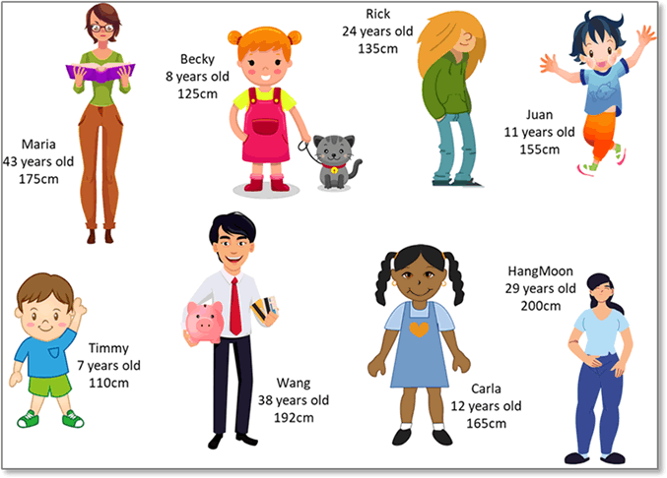

Exercise 1: Fill in the blanks (To Be)

Complete the sentences using the correct form of the verb to be or to have.

1. Maria ___ 43 years old.
2. Carla ___ curly hair and a blue dress.
3. Maria ___ glasses and a book.
4. Becky and Carla ___ girls.
5. Rick ___ long, messy hair.
6. Juan ___ 11 years old and ___ happy.
7. HangMoon ___ the tallest person in the picture.
8. Timmy ___ younger than Becky.
9. Becky ___ two pigtails and a pink dress.
10. Timmy ___ short, light brown hair.
11. Rick ___ 24 years old and ___ short.
12. Wang ___ very tall; he ___ 192 cm.
13. Wang ___ a piggy bank in his hand.
14. Juan ___ short black hair and a blue outfit.

Exercise 3: True or False

Read the sentences and write True or False.

1. ( ) Maria has short hair.

2. ( ) Rick is taller than Wang.

3. ( ) Juan is 11 years old.

4. ( ) Carla has straight hair.

5. ( ) HangMoon is the shortest person in the picture.

6. ( ) Becky has a pet cat.

7. ( ) Wang is younger than Maria.

Exercise 4: Describe a Person

Write a short description of three people from the picture using to be and to have. Example:

Example:

"Becky is 8 years old. She is short. She has red hair and pigtails. She has a pink dress and a small gray cat."

Exercise 5: Answer the Questions (To Be & To Have)

Answer the following questions using complete sentences.

1. How old is Maria?

2. Who is the tallest person in the picture?

3. Is Wang taller than Rick?

4. What color is Becky’s dress?

5. Does Timmy have long hair?

6. What does Maria have in her hands?

7. Who has a pet?

8. Is Carla shorter than Juan?

9. How old is HangMoon?

10. Does Rick have short or long hair?

Exercise 6: Make Questions (To Be & To Have)

Look at the answers and write the correct question.

1. Question: ________________?

Answer: Becky is 8 years old.

2. Question: ________________?

Answer: Wang is 192 cm tall.

3. Question: ________________?

Answer: No, Rick is not tall. He is short.

4. Question: ________________?

Answer: Yes, Carla has curly hair.

5. Question: ________________?

Answer: Timmy has short, light brown hair.

6. Question: ________________?

Answer: Juan is wearing a blue outfit.

7. Question: ________________?

Answer: No, Maria doesn’t have a pet.

Exercise 7: Matching Questions and Answers

Match the questions with the correct answers.

1. Who is 38 years old?

2. Does Rick have short hair?

3. What does Becky have?

4. How tall is HangMoon?

5. Is Carla younger than Juan?

6. Who has glasses?

7. What color is Wang’s tie?

A. No, Carla is older than Juan.

B. HangMoon is 200 cm tall.

C. Wang is 38 years old.

D. No, Rick has long hair.

E. Becky has a pink dress and a pet cat.

F. Maria has glasses.

G. Wang’s tie is red.

Exercise 8: Compare the People

Answer using complete sentences and the correct form of to be or to have.

1. Who is taller, Maria or Carla?

2. Who is older, Rick or Wang?

3. Does Becky have longer hair than Carla?

4. Who has the shortest hair?

5. Is Timmy taller than Rick?

6. Does HangMoon have long or short hair?

7. Who has the longest hair in the picture?