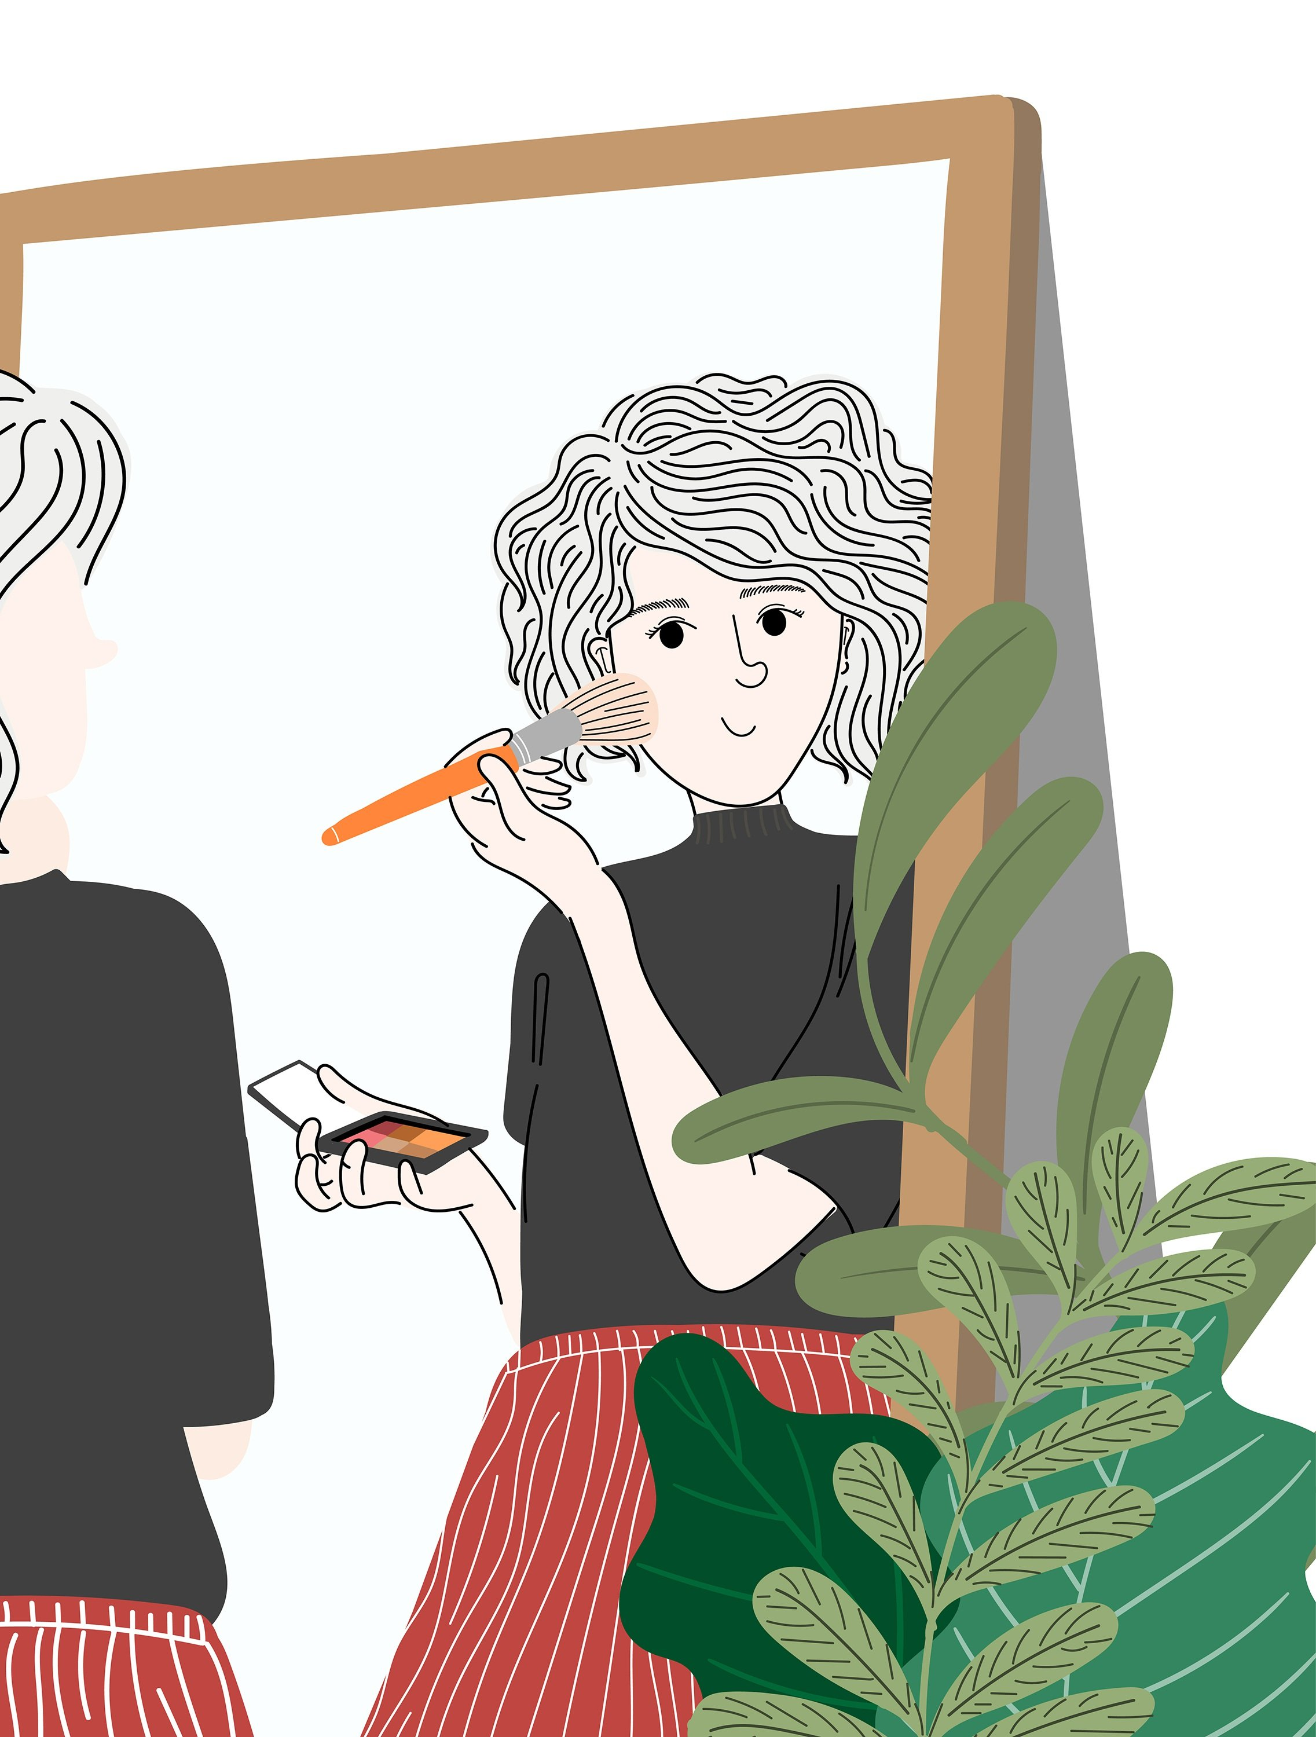

The mirror and the princess

Every morning the mirror and the princess meet for a conversation.

Mirror: You wake up early! **I’m sure, you want to talk to me**.

Princess: Hello my favourite mirror, how are you today?

Mirror: Hello dear princess, better as never, and you?

Princess: **I am very good**. I am beautiful as always.

Mirror: **Yes, you are my darling**. You are a princess!

Princess: of course, **I am the most beautiful princess in the entire universe**. Don’t you believe it?

Mirror: **Yes, I do**, you have an impressing beauty. Don’t doubt it.

Princess: Never. Thanks my favourite mirror, **you always make me feel good**.

Exercise:

Read and understand the text.

1. Rewrite the text, but put the texts in bold in negative, the orange texts in interrogative, and the blue text in affirmative.