Topic: Seasons of the year

Season is a period of the year distinguished by special climate changes.

What do you see?

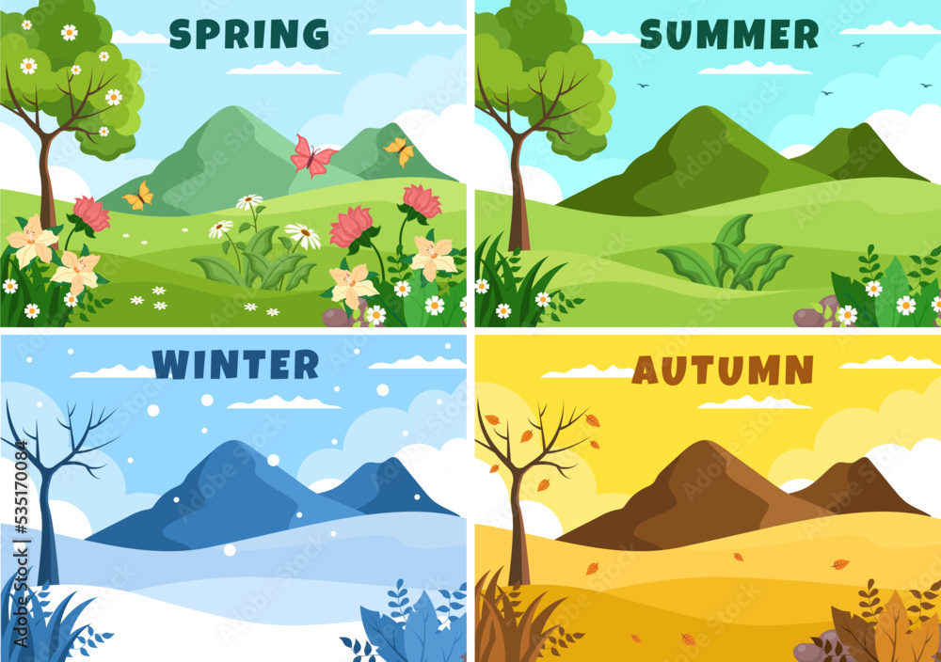

There are four seasons in a year:

* Spring
* Summer
* Winter
* Autumn

Spring

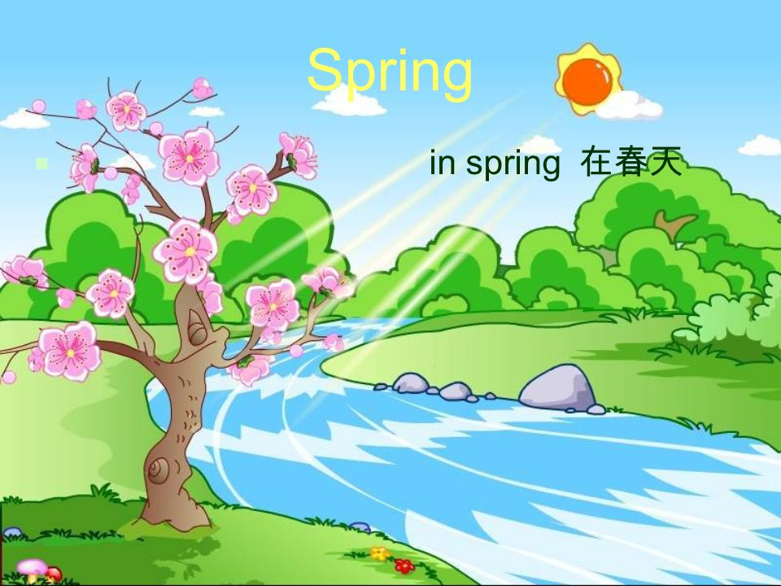

* In spring the flowers bloom, it rains, the weather is warm

**Summer**

What is the weather like in summer?

In summer it’s hot and sunny.

**What do you see in the picture?**

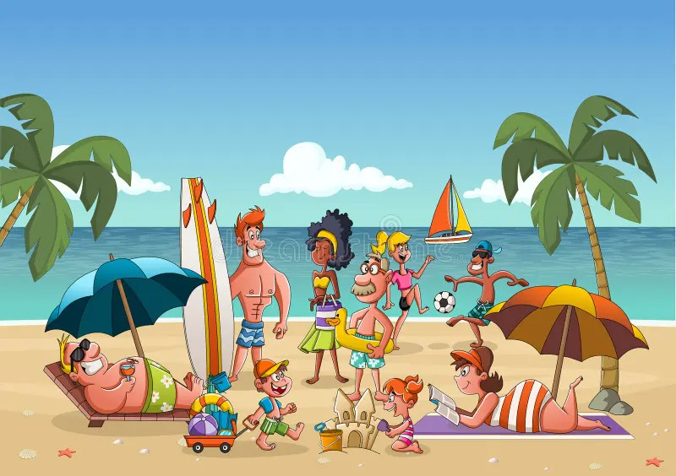

* In summer, people go to the beach.
* People wear sunglasses, T-shirts and shorts.
* People like ice-cream and the streets are often crowded.

Winter

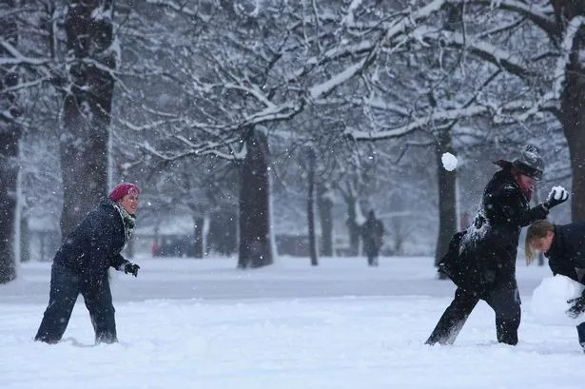

What’s the weather like in winter?

* In winter is very cold
* In some places it’s snowy, the snow falls.
* People wear coats and boots
* People prefer to staying home and like taking tea.

**Autumn**

**What is the weather like in Autumn?**

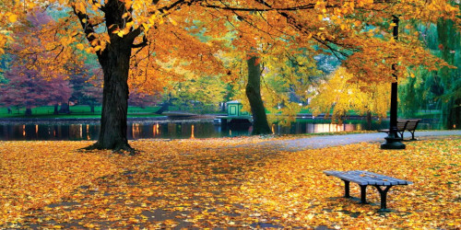

* It’s cool and windy
* Leaves fall from trees
* People wear sweaters.

Exercises

1. Fill in the Blanks (Weather and Activities)

Complete the sentences with the correct word:(snowy, swim, windy, flowers, hot, jacket)

1. In winter, it’s __________.

2. I wear a __________ in the cold weather.

3. In spring, __________ bloom.

4. In autumn, it’s often __________.

5. In summer, people __________ in the sea.

6. It’s very __________ in summer.

2. What Season Is It? (Reading Comprehension)

Read and write the correct season: (spring, summer, autumn, winter)

1. I wear boots and a scarf. It’s very cold.

→ ___________________

3. The leaves turn orange and fall.

→ ___________________

3. We go to the beach and eat ice cream.

→ ___________________

4. It’s warm and rainy. There are many flowers.

→ ___________________

4. Write a short text about your favorite summer including:

* Why you like it
* What you often do in the season
* What you wear
* Where you like to go
* What you like to eat.