Topic: Clock: hours and minutes

## Como perguntar as horas

1. What time is it?

a.m e p.m sao siglas usadas para indicar horários no sistema de 12 horas. a.m significa ante meridiem (antes do meio dia) ex: 08:00 a.m.

e p.m significa post meridiem (depois do meio dia) ex: 08:00 p.m (20 horas)

1. What’s the time?
2. Do you have time now?

## Como dizer as horas

### Horas exatas

10:00 – It’s ten / it’s ten o’clock / it’s ten sharp / it’s ten p.m or a.m.

03:00 – It’s three / it’s three o’clock / it’s three sharp / it’s p.m or a.m.

### Horas e minutos

1. Usando ‘past’e ‘to’
2. Past (passaou / passaram) : É usado até 30 minutos

Ex: 12:05 – It’s five past twelve (passaram 5 minutos das 12 horas)

1. To (para) : é usado acima dos 30 minutos

Ex: 12:40 – It’s twenty to thirteen (20 minutos para as 13)

1. Nao se usa o ‘e’ entre as horas e minutos

Ex: 15:20 – it’s fifteen twenty

EX: 08:30 – it’s eight thirty

1. A quarter (um quarto) : usa-se quando passam ou faltam 15 minutos de uma certa hora.

Ex: 10:15 – it’s a quarter past ten.

Ex: 10:45 – its’s a quarter to eleven.

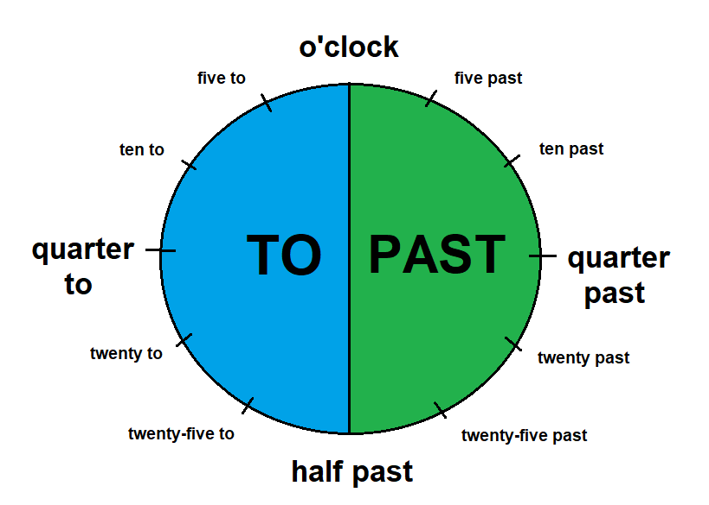

Exercises

1. Escreva correctamente usando ‘past e to’ as horas em ingles
2. 07:30 __________
3. 01:45 __________
4. 04:25 __________
5. 20:10 __________
6. 15:50 __________
7. Coloque em números as horas abaixo
8. It’s ten to five ______
9. It’s a quarter past eleven ______
10. It’s half past eight ______
11. It’s twenty to thirteen ______
12. It’s twenty-five to eighteen ______

