

|  |
| --- |
| PrototypeRemisesMdQ |
| 30/12/14 17:50 |
| **Author:** John Doe  **File name:** PrototypeRemisesMdQ.vp  **Version** 1.0 |

|  |
| --- |
| Site Map |
|  |

|  |
| --- |
|  |

01. Site Map / PrototypeRemisesMdQ 

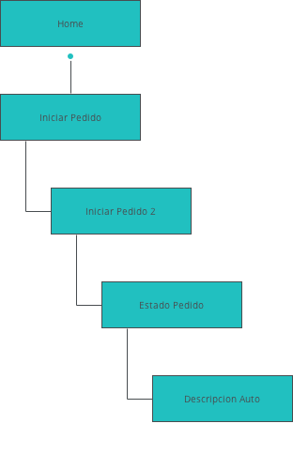

|  |
| --- |
| Screens |
|  |

|  |
| --- |
|  |

02. Screens / PrototypeRemisesMdQ 

Descripcion Auto

|  |
| --- |
|  |

02. Screens / PrototypeRemisesMdQ 

Estado Pedido

|  |
| --- |
|  |

Interactions

|  |  |
| --- | --- |
| 1 | **on Click:** goes to Home 🡪 |
| 2 | **on Click:** goes to Descripcion Auto 🡪 |

02. Screens / PrototypeRemisesMdQ 

Home

|  |
| --- |
|  |

Interactions

|  |  |
| --- | --- |
| 3 | **on Click:** goes to Iniciar Pedido 🡪 |

02. Screens / PrototypeRemisesMdQ 

Iniciar Pedido

|  |
| --- |
|  |

Interactions

|  |  |
| --- | --- |
| 4 | **on Click:** goes to Iniciar Pedido 2 🡪 |

02. Screens / PrototypeRemisesMdQ 

Iniciar Pedido 2

|  |
| --- |
|  |

Interactions

|  |  |
| --- | --- |
| 5 | **on Click:** goes to Estado Pedido 🡪 |

02. Screens / PrototypeRemisesMdQ 

Registracion

|  |
| --- |
|  |

|  |
| --- |
| Templates |
|  |

|  |
| --- |
|  |

03. Templates / PrototypeRemisesMdQ 

Template 1

|  |
| --- |
|  |

|  |
| --- |
| Scenarios |
|  |

|  |
| --- |
|  |

04. Scenarios / PrototypeRemisesMdQ 

default

|  |
| --- |
|  |