|  |  |  |  |  |  |  |  |  |  |
| --- | --- | --- | --- | --- | --- | --- | --- | --- | --- |
| Type of request | URL | Parameter name | Requesting type | | MIME Type | | | Description | |
|  | Request input type | Response  output type |  |
| Administration | /admin/sha1 | accessToken | POST | application/x-www-form-urlencoded | | | text/json | | Request to get an input string hashed using sha1. |
| /admin/properties | sha1 | GET | | | application/x-www-form-urlencoded | | application/json | Request to get parameters of nerd.properties and nerd_service.properties formatted in html table. |
| /admin/property/{name} | name | GET | | |  | | application/json | Get a property with name = {name} |
| /admin/properties | accessToken | POST | | | application/x-ww-form-urlencoded | | application/json | Add new property. |
| /admin/property/{name} | Name | PUT | | |  | | application/json | Set a new property with name = {name} |

|  |  |  |  |  |  |  |  |
| --- | --- | --- | --- | --- | --- | --- | --- |
| Type of request | URL | Requesting type | Parameter name | MIME Type | | | Description |
| Request input type | Response output type |
| Language  identification | /language | GET,POST | text | multipart/form-data | | application/json | Identify the language of a fragment of text.  Answer: JSON with identified language (ISO 639-1) and confidence score:  {"lang":"en","conf":1} |

|  |  |  |  |  |  |  |  |
| --- | --- | --- | --- | --- | --- | --- | --- |
| Type of request | URL | Requesting type | Parameter name | MIME Type | | | Description |
| Request input type | Response output type |
| Sentence segmentation | /segmentation | GET, POST | text | multipart/form-data | | application/json | Segment a text into sentences.  Answer: JSON with offsets for each sentences:  { "sentences" : [  { "offsetStart" : 0, "offsetEnd" : 6 },  { "offsetStart" : 6, "offsetEnd" : 21 }  ]  } |

|  |  |  |  |  |  |  |  |
| --- | --- | --- | --- | --- | --- | --- | --- |
| Type of request | URL | Requesting type | Parameter name | MIME Type | | | Description |
| Request input type | Response output type |
| Term lookup | /lookup/term/{value} | GET | N/A | N/A | | Based on Accept header  application/json or application/xml | *for getting all ambiguous concepts associated to a single term.* |

|  |  |  |  |  |  |  |  |
| --- | --- | --- | --- | --- | --- | --- | --- |
| Type of request | URL | Requesting type | Parameter name | MIME Type | | | Description |
| Request input type | Response output type |
| Fetch concept | /kb/concept/{value} | GET | N/A | N/A | | Based on Accept header  application/json or application/xml | *The the information about the specific concept* |

|  |  |  |  |  |  |  |  |
| --- | --- | --- | --- | --- | --- | --- | --- |
| Type of request | URL | Requesting type | Parameter name | MIME Type | | | Description |
| Request input type | Response output type |
| Named Entity Recognition and Disambiguation | /process/nerd/text | POST | text  nbest  sentence  customisation | String  boolean  boolean  boolean  String | | application/json | Perform a Named Entity Recognition and Disambiguation on a text: identify entities and classify them in term of NER types and, when possible, subtypes. Entity resolution against Wikipedia |
| Named Entity Recognition | /process/ner/text | POST | text  nbest  sentence  customisation | String  boolean  boolean  boolean  String | | application/json | Perform a Named Entity Recognition and Disambiguation on a text: identify entities and classify them in term of NER types and, when possible, subtypes. Entity resolution against Wikipedia & FreeBase. |

|  |  |  |  |  |  |  |  |
| --- | --- | --- | --- | --- | --- | --- | --- |
| Type of request | URL | Requesting type | Parameter name | MIME Type | | | Description |
| Request input type | Response output type |
| Named Entity Recognition and Disambiguation | /process/nerd/query | GET, POST | query | application/json | | application/json | Perform a Named Entity Recognition and Disambiguation on a text: identify entities and classify them in term of NER types and, when possible, subtypes. Entity resolution against Wikipedia & FreeBase. |

|  |  |  |  |  |  |  |  |
| --- | --- | --- | --- | --- | --- | --- | --- |
| Type of request | URL | Requesting type | Parameter name | MIME Type | | | Description |
| Request input type | Response output type |
| List the existing customisations | /customisations | GET | N/A | N/A | | application/json | Return the list of existing customisations as a JSON array of customisation names. |
| Get the information of a customisation | /customisation/{profile} | GET | N/A | N/A | | application/json | Return the JSON profile of an existing customisation identified by its name as path parameter. |
| Create a customisation | /customisation/{profile} | POST | multipart/form-data | application/json | | application/json | Create a customisation as defined in the input JSON, named following the path parameter.  The JSON profile specifies a context via the combination of a list of Wikipedia article IDs, FreeBase entity mid and text fragments. A text describing informally the customisation can be added optionally. |
| Extend a customisation | /customisation/{profile} | PUT | profile | application/json | | application/json | Extend the definition of a customisation named following the path parameter by additional context information.  The additional context is given by the combination of a list of Wikipedia article IDs, FreeBase entity mid and text fragments, which will be merged with the existing one. A text describing informally the customisation can be added optionally |
| Delete a customisation | /customisation/{name} | DELETE | name |  | | application/json | Delete an existing customisation identified by its name provided as path parameter. |

The JSON profile of a customisation to be sent to the server for creation and extension has the following structure:

{

"wikipedia" : [4764461, 51499, 1014346],

"freebase": ["/m/0cm2xh", "/m/0dl4z", "/m/02kxg_", "/m/06v9th"],

"texts": ["World War I (WWI or WW1 or World War One), also known as the First World War or the Great War, was a global war centred in Europe that began on 28 July 1914 and lasted until 11 November 1918.", "The war drew in all the world's economic great powers, which were assembled in two opposing alliances: the Allies (based on the Triple Entente of the United Kingdom, France and the Russian Empire) and the Central Powers of Germany and Austria-Hungary."],

"description" : "Customisation for World War 1 domain"

}

*Name* is the identifier of the customisation. The context will be build based on Wikipedia articles, FreeBase entities and raw texts, which are all optional. Wikipedia articles are expressed as an array of Wikipedia page ID. FreeBase entities are given as an array of mid (the FreeBase Machine IDs). Finally, texts are represented as an array of raw text segments.

**Response status codes**

|  |  |
| --- | --- |
| HTTP Status Code | Reason |
| 200 | Successful operation. |
| 400 | Wrong request. |
| 404 | Indicates that the customisation resource was not found. |
| 500 | Indicate an internal service error. |

In case of error status, the service returns a JSON object with an error message.

> curl -X POST 'http://localhost:8090/service/createNERDCustomisation/ww1' -d '{"wikipedia" : [4764461]}'

> curl -X GET http://localhost:8090/service/NERDCustomisations

> ["ww1"]

> curl -X GET http://localhost:8090/service/getNERDCustomisation/ww1

> { "name" : "ww1", "wikipedia" : [ 4764461] }

# REST API response examples

It is possible to view the service response with the Web Service console as shown by Figure 6.1.

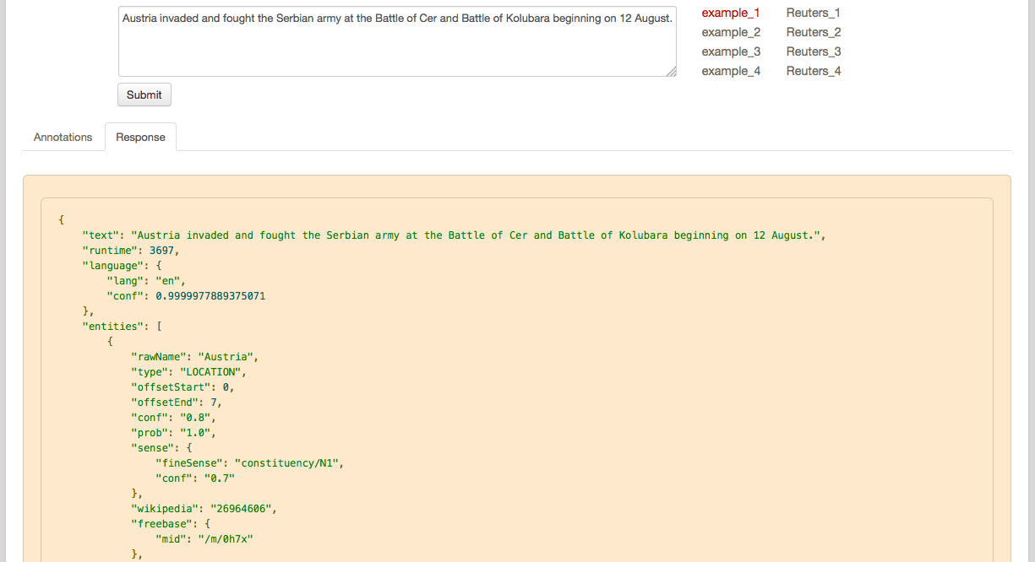

Fig 6.1: Viewing service response

**Named Entity Recognition service:**

**Input**:

**Output**:

...