**LuccME – Model Manager**

The model manager is a tool to help the LuccME users to build their models.

Through an intuitive way, the modeler provides the information required for their application, without caring about the programming syntax.

This tool does not limit you, if you want to you can build your models directly via the editor of your choice.





**Opening the Model Manager**

Below is the main Model Manager window, through it you can access the functionality of this manager such as:

* Create a new model.
* Opening a model generated by this tool.
* Select the display language (Portuguese or English).

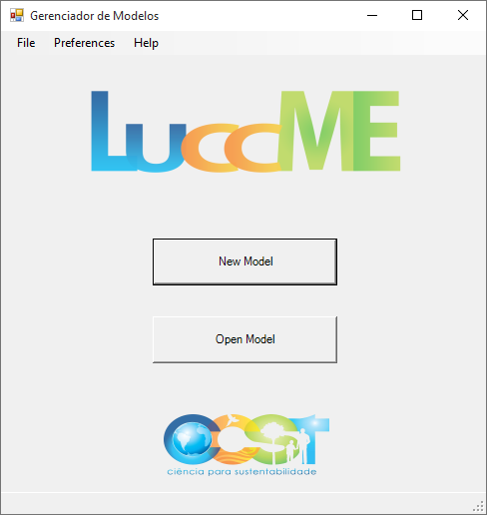

Figure 1: Main Window

**Creating a New Model**

There are two ways to access the form to create a new model:

1. Through the New Model button:

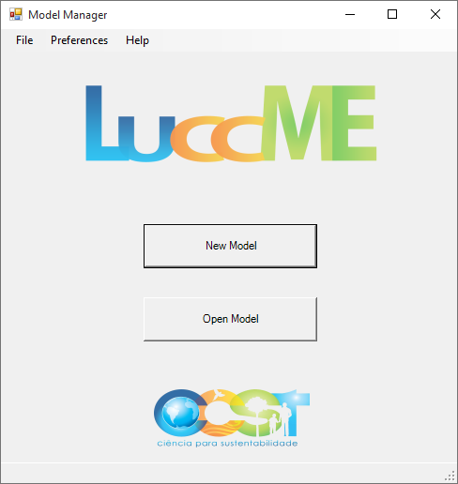

Figure 1: New Model Button

1. Via the Main Menu:

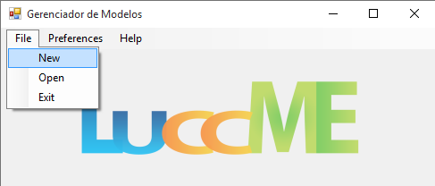

Figure 2: Main Menu - File > New

Once selected, the model creation window opens with some default values that should be changed to meet the application you want to create.

These values are only to give an idea to the data type that must contain in each field.

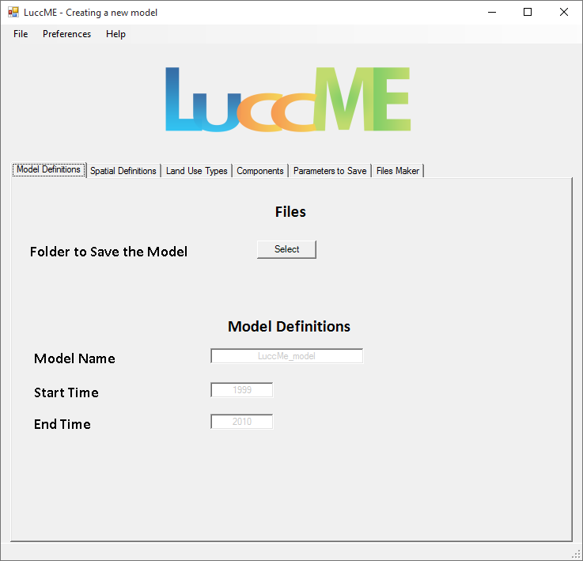

Figura 3: Creating a new model Window

As can be seen the model creating window is divided into parts, according to the types of data that must be present in the model.

**Model Definitions**

In this section, the macro data from a model must be defined:

1. Place where the files are saved.
2. Model name.
3. Year to start the simulation.
4. Year to end the simulation.

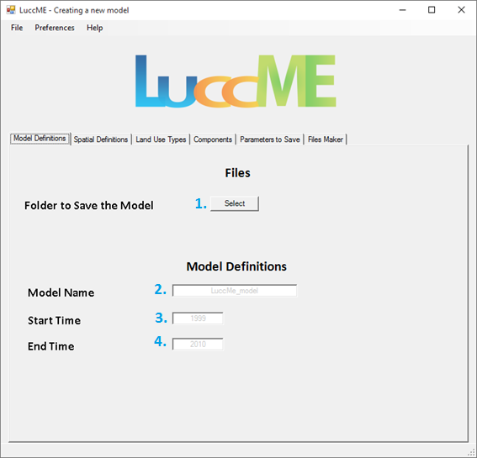

Figure 1: Model Definitions

After clicking in Select, to select a folder where the model will be saved, a window for choose this folder, will shows:

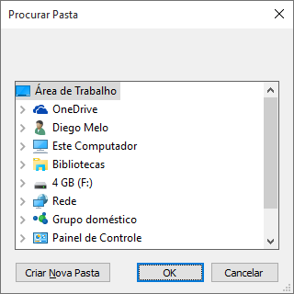

Figure 2: Widow to select folder

After selecting the folder where the file is saved, the selected address will be displayed to the user:

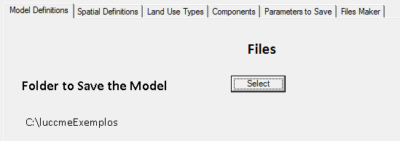

Figure 3: Showing the folder address

**Spatial Definitions**

In this section, you should define the data related to the database to be used:

1. Which database will be used
   1. Access Database – Select the database file.
   2. MySQL database - Set values to access the database.
2. The Theme name.
3. The size of the cell.

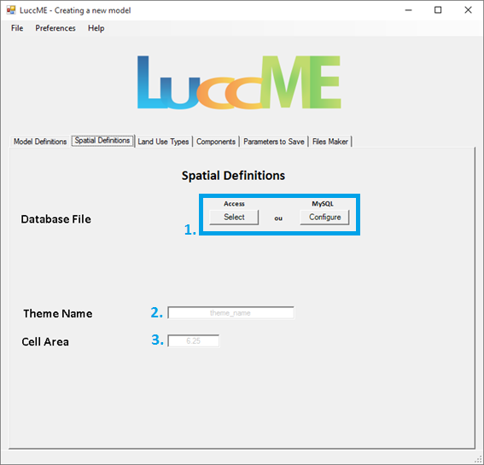

Figure 1: Spatial Definitions

**Database**

In order to use an Access database, the user must choose the Select button under Access. After clicking the Select button, a database select file window appears.

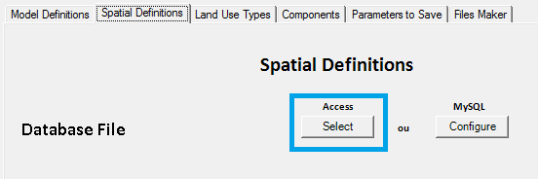

Figure 1: Select Access database file button

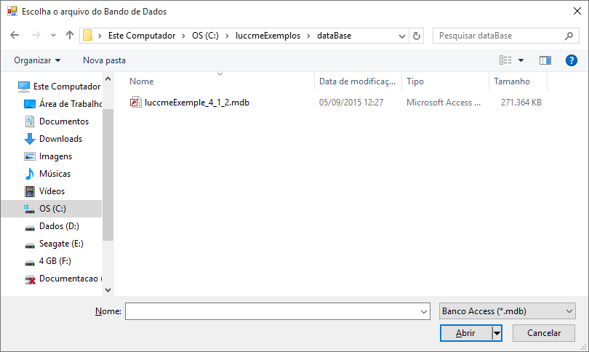

Figure 2: Select Access database file window

After select the database file, a confirmation will appears to the user:

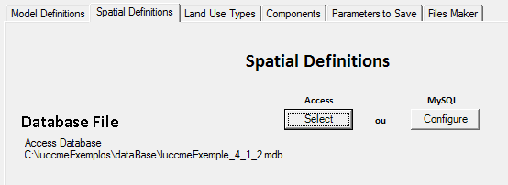

Figure 3: Access database confirmation

If you choose to use a MySQL database, its configuration can be accessed through the Configure button under MySQL. After clicking, a database configuration window appears.

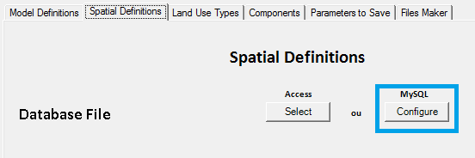

Figure 4: Configure MySQL database button

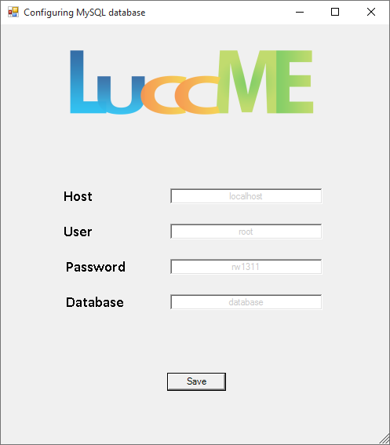

Figure 5: MySQL database configuration windows

After save the configuration of the database access data a confirmation will appears to the user:

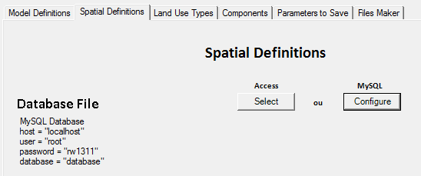

Figure 6: MySQL data confirmation

**Land Use Types**

In this section, you must inform the land use types that you will use in your application.

The static types should also be informed as Types of Land Use No Data.

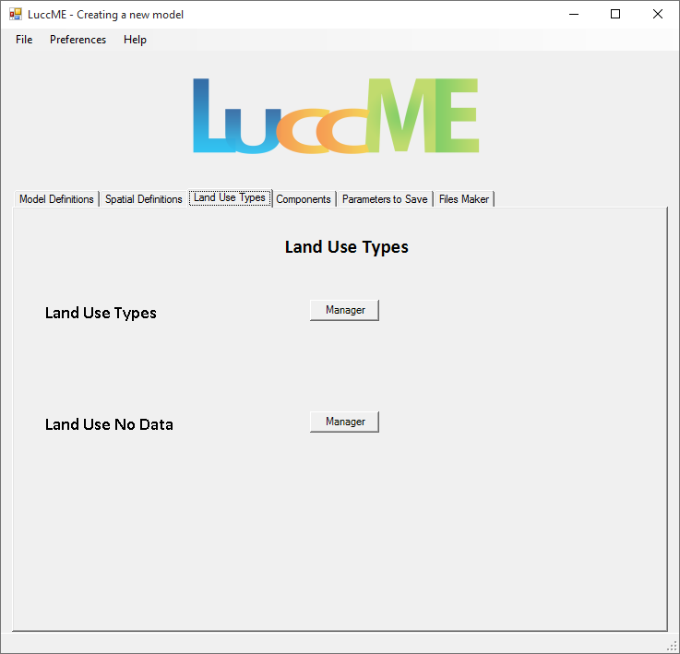

Figure 1: Land Use Types

In order to add the Land Use Types the user must click in **Manager** in front of Land Use Types.

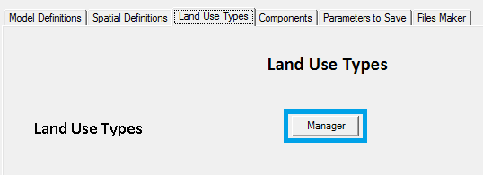

Figure 2: Manager button – Land Use Types

After click the Land Use Types management window will appears:

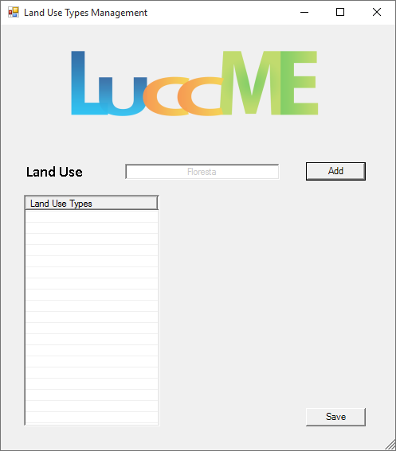

Figure 3: Land Use Types Management window

The Land Use Type can be:

1. Add
2. Remove
3. Order
4. Save

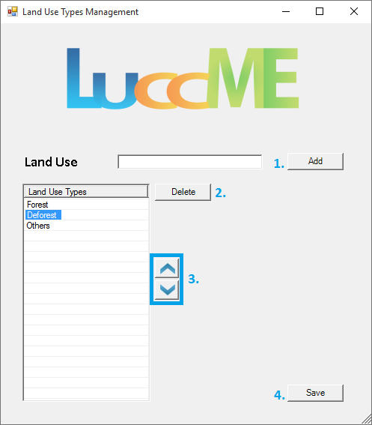

Figure 4: Land Use Types Management

Note that some features are only visible when a Land Use Type is selected (difference between Figures 1 and 4).

After save the data a confirmation appears to the user:

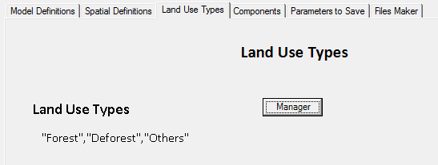

Figure 5: Land Use Types confirmation

In order to add the Land Use No Data, *which Land Use Type is static*, the user must click in Manager in front of Land Use No Data.

Note that the Land Use Types will come pre-populated if the Land Use Types are already defined, the user just simply remove the use types that are not static.

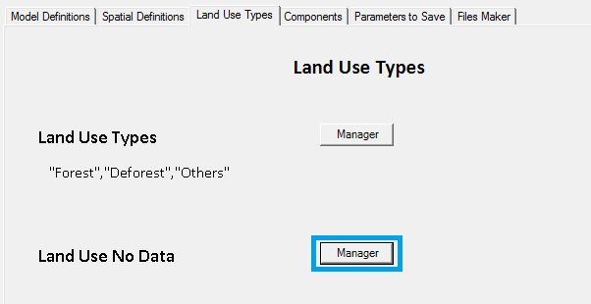

Figure 6: Manager Button – Land Use Types

The same management applied to the Land Use Types applies to the Land Use No Data.

After save the data a confirmation will appear to the user:

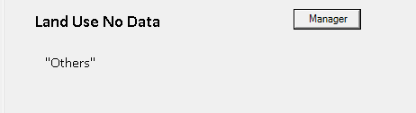

Figure 7: Land Use No Data confirmation

**Components**

In this section, the user have to choose which of the available components to use on the model according to its need.

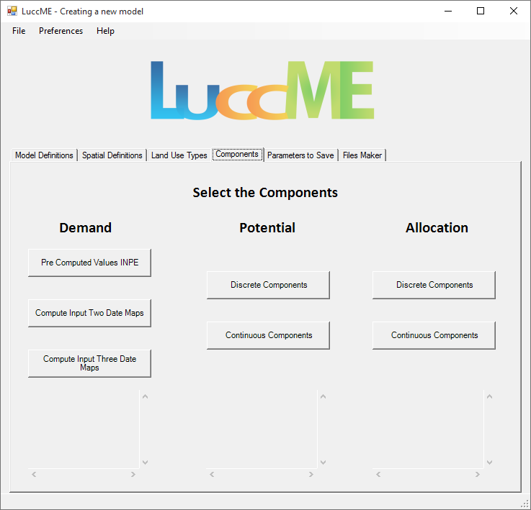

Figure 1: Components

**Demand Component**

There are three components of demand available to the user; they work for both discrete component as continuous.

The details of the components can be found on LuccME guides.

**Pre Computed Values INPE**

To generate the demand table this component uses the time of simulation (start and end) and the Land Use Types.

Make sure you have set these parameters before you add your data.

To access the Pre Computed Values INPE component click the button of the same name, and the component window will appear:

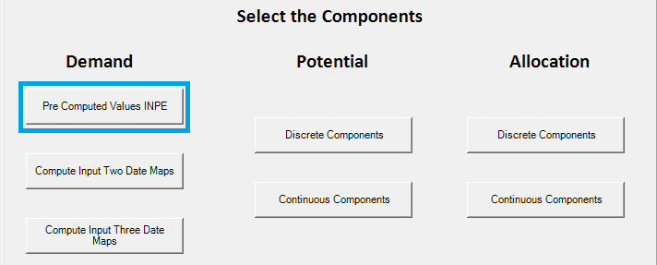

Figure 1: Pre Computed Values INPE Button

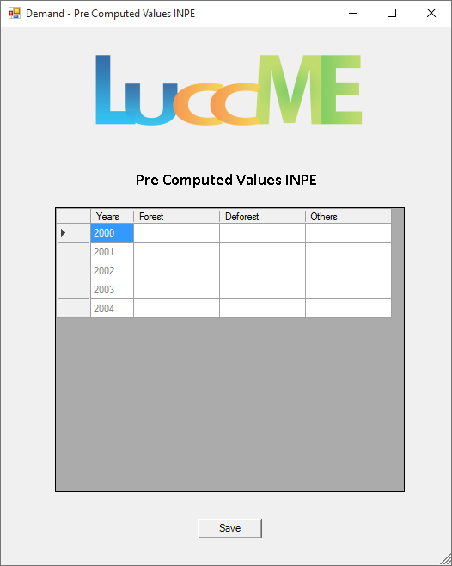

Figure 2: Pre Computed Values INPE

After add the data, a confirmation appears:

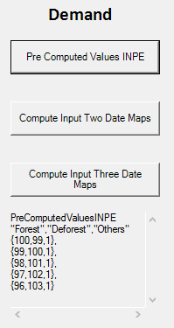

Figure 3: Pre Computed Values INPE Confirmation

**Compute Input Two Date Maps**

This component will ask for the year of the validation for simulation, and which columns of the database has the data for each land use type at this year.

To access the component click the Compute Input Two Date Maps button and the component window will appear:

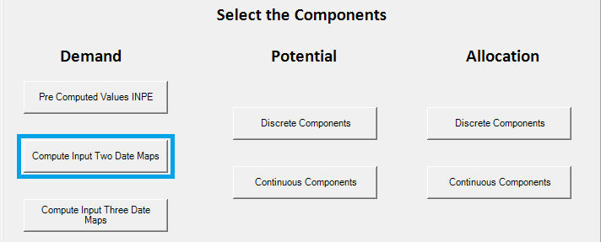

Figure 1: Compute Input Two Date Maps Button

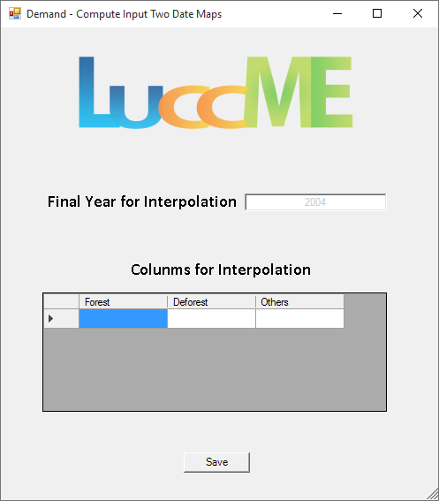

Figure 2: Compute Input Two Date Maps Window

After save the data the confirmation will appear:

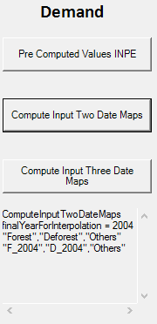

Figure 3: Compute Input Two Date Maps Confirmation

**Compute Input Three Date Maps**

This component will ask for two validation years for the simulation, and which columns of the database has the data for each land use type at each time.

To access the component click the Compute Input Two Date Maps button and the component window will appear:

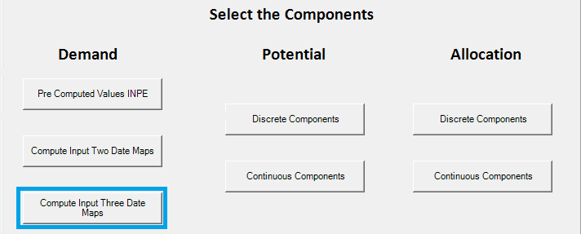

Figure 1: Compute Input Three Date Maps Button

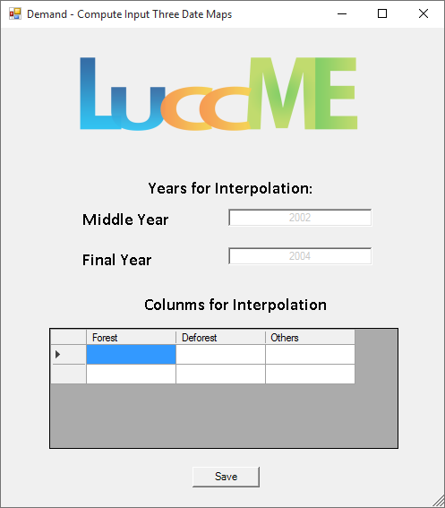

Figure 2: Compute Input Three Date Maps Window

After save the data a confirmation will appear:

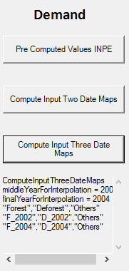

Figure 3: Compute Input Three Date Maps Confirmation

**Potential Component**

The Potential components are divide in Discrete and Continuous. The user must choose the component that best fit the models need.

The details of the components can be found on LuccME guides.

**Potential – Discrete Components**

To access the potential discrete components the user must click the Discrete Components button below Potential:

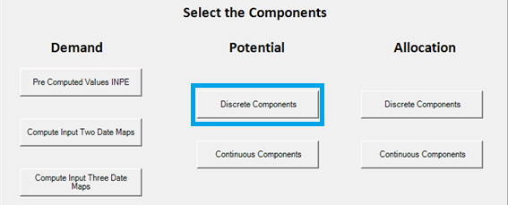

Figure 1: Potential – Discrete Components

A widow will open with the components:

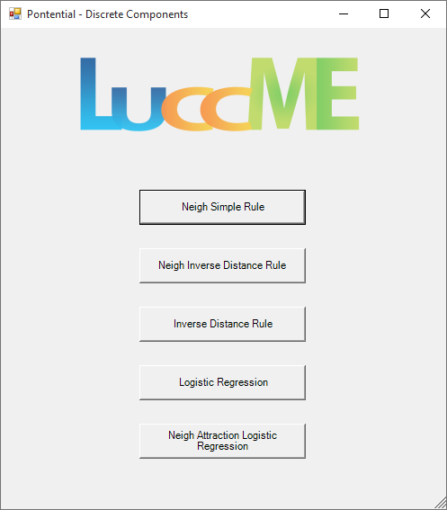

Figure 2: Potential – Discrete Components Window

**Neigh Simple Rule**

This component has no configuration parameter to access it just click on the button Simple Neigh Rule.

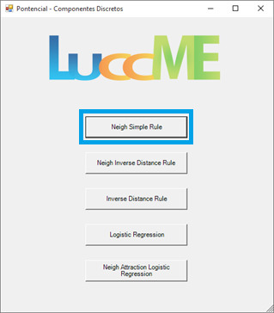

Figure 1: Neigh Simple Rule Button

After selecting, the confirmation will appear:

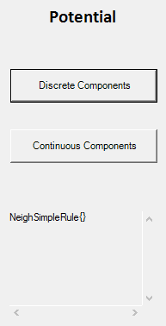

Figure 3: Neigh Simple Rule Confirmation

**Neigh Inverse Distance Rule**

This component uses the Land Use Types to input the data.

To select it just click on Neigh Inverse Distance Rule Button.

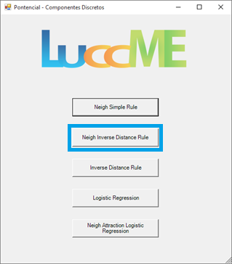

Figure 1: Neigh Inverse Distance Rule Button

After that, the component window will appear:

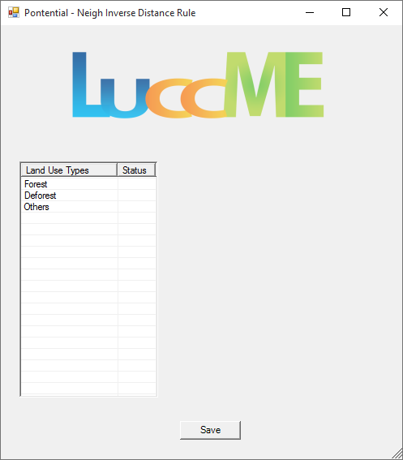

Figura 2: Neigh Inverse Distance Rule Window

To enter the component data you must select the Land Use Type, which you want to enter the data, the window will change to the data input mode:

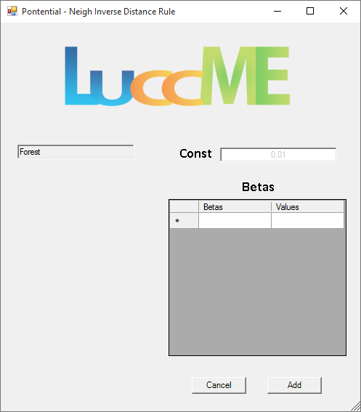

Figure 3: Neigh Inverse Distance Rule Window - Editing

After enter the values of each land use the status will be modified on the main window of the component.

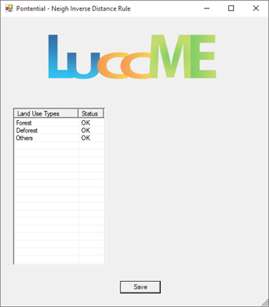

Figura 4: Modified Status

After save the data a confirmation will appear:

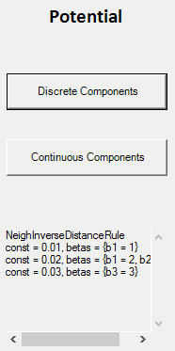

Figure 5: Potential – Neigh Inverse Distance Rule Confirmation

**Inverse Distance Rule**

This component uses the Land Use Types to input the data.

To select it just click on Inverse Distance Rule Button.

Figure 1: Inverse Distance Rule Button

After that, the component window will appear:

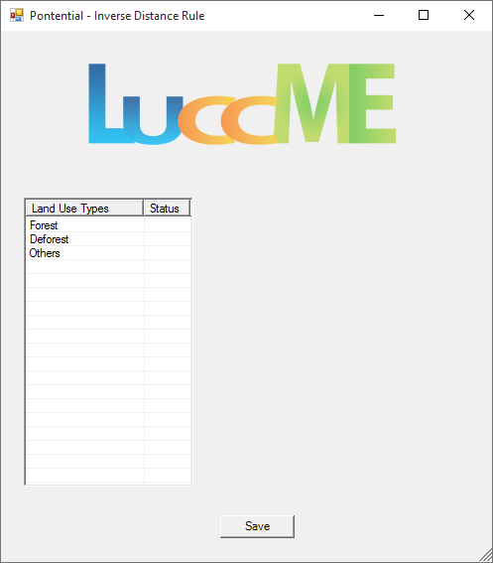

Figure 2: Inverse Distance Rule Window

To enter the component data you must select the Land Use Type, which you want to enter the data, the window will change to the data input mode:

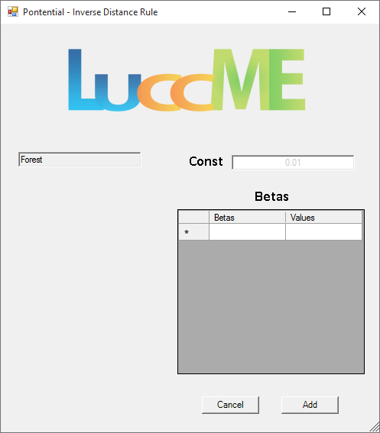

Figure 3: Inverse Distance Rule Window - Editing

After enter the values of each land use the status will be modified on the main window of the component.

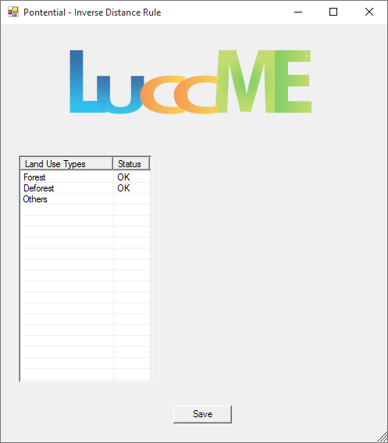

Figure 4: Inverse Distance Rule Window- Modified Status

After save the data a confirmation will appear:

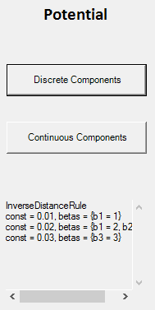

Figura 9: Potential – Inverse Distance Rule Confirmation

**Logistic Regression**

This component uses the Land Use Types to input the data.

To select it just click on Logistic Regression.

Figure 1: Logistic Regression Button

After that, the component window will appear:

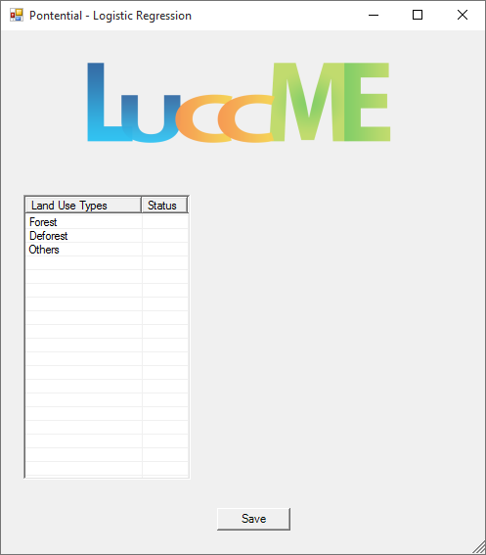

Figure 2: Logistic Regression Window

To enter the component data you must select the Land Use Type, which you want to enter the data, the window will change to the data input mode:

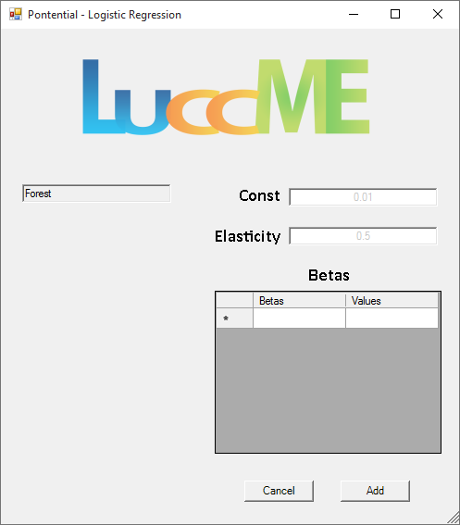

Figure 3: Logistic Regression Window - Editing

After enter the values of each land use the status will be modified on the main window of the component.

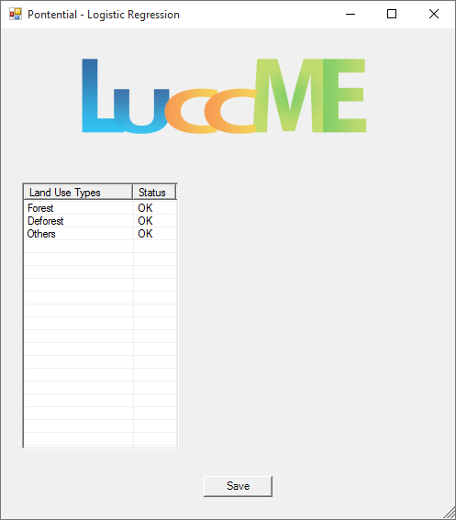

Figure 4: Logistic Regression Window – Modified Status

After save the data a confirmation will appear:

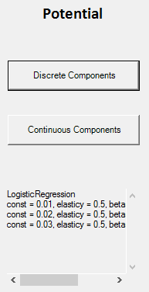

Figure 5: Potential – Logistic Regression Confirmation

**Neigh Attraction Logistic Regression**

This component uses the Land Use Types to input the data.

To select it just click on Neigh Attraction Logistic Regression.

Figure 1: Neigh Attraction Logistic Regression Button

After that, the component window will appear:

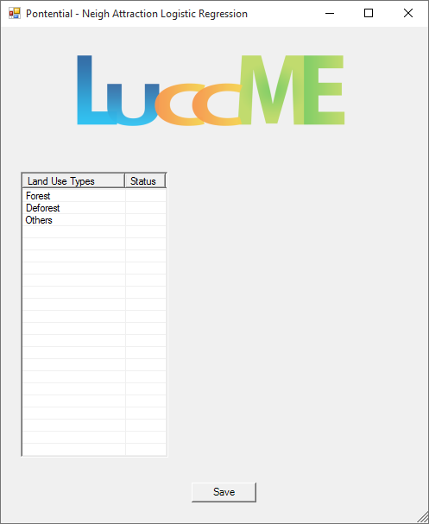

Figure 2: Neigh Attraction Logistic Regression Window

To enter the component data you must select the Land Use Type, which you want to enter the data, the window will change to the data input mode:

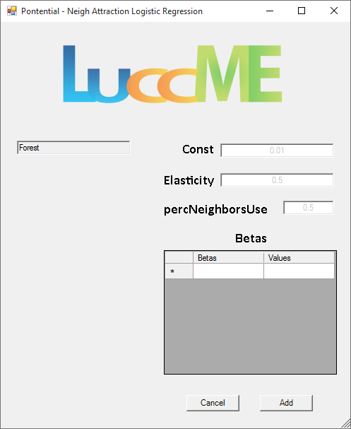

Figure 3: Neigh Attraction Logistic Regression Window - Editing

After enter the values of each land use the status will be modified on the main window of the component.

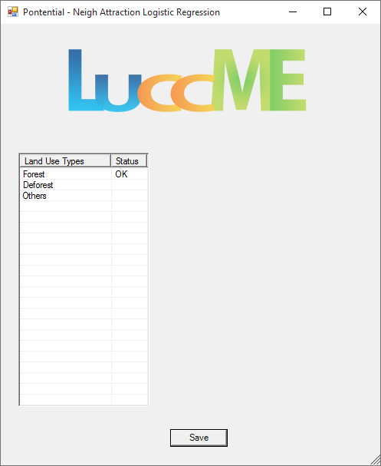

Figure 4: Neigh Attraction Logistic Regression Window – Modified Status

After save the data a confirmation will appear:

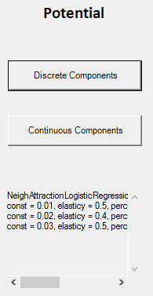

Figure 5: Potential – Neigh Attraction Logistic Regression Confirmation

**Potential – Continuous Components**

To access the potential continuous components the user must click on the Continuous Components button below Potential:

Figure 1: Potential – Continuous Component Button

A window with the list of the components will appear:

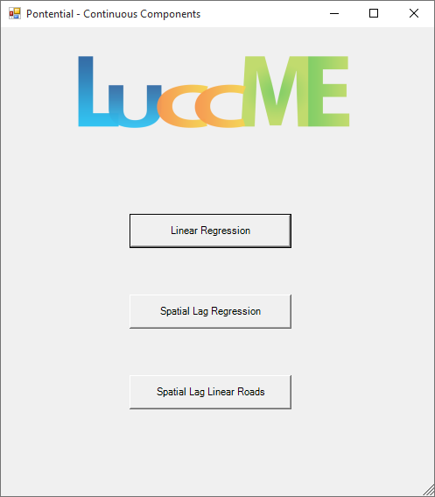

Figure 2: Potential – Continuous Components Window

**Linear Regression**

This component uses the Land Use Types to input the data.

To select it just click on Linear Regression.

Figure 1: Linear Regression Button

After that, the component window will appear:

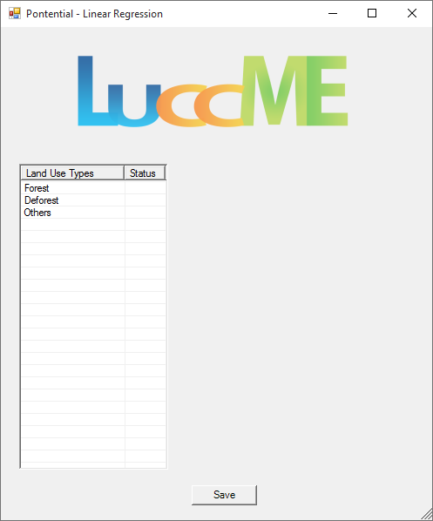

Figure 2: Linear Regression Window

To enter the component data you must select the Land Use Type, which you want to enter the data, the window will change to the data input mode:

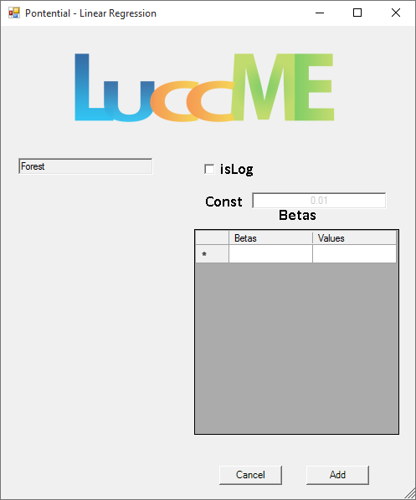

Figure 3: Linear Regression Window - Editing

After enter the values of each land use the status will be modified on the main window of the component.

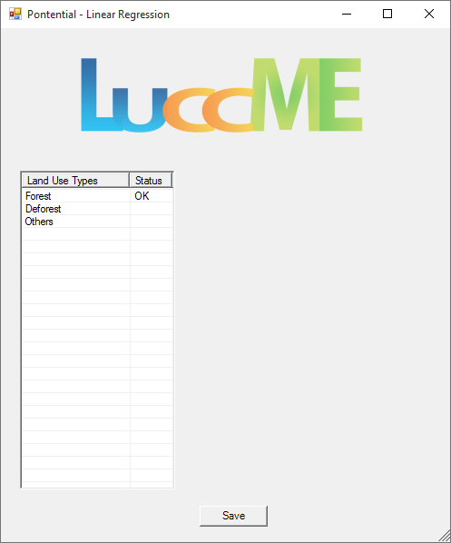

Figure 4: Linear Regression Window – Modified Status

After save the data a confirmation will appear:

Figure 5: Potential – Linear Regression Confirmation

**Spatial Lag Regression**

This component uses the Land Use Types to input the data.

To select it just click on Spatial Lag Regression.

Figure 1: Spatial Lag Regression Button

After that, the component window will appear:

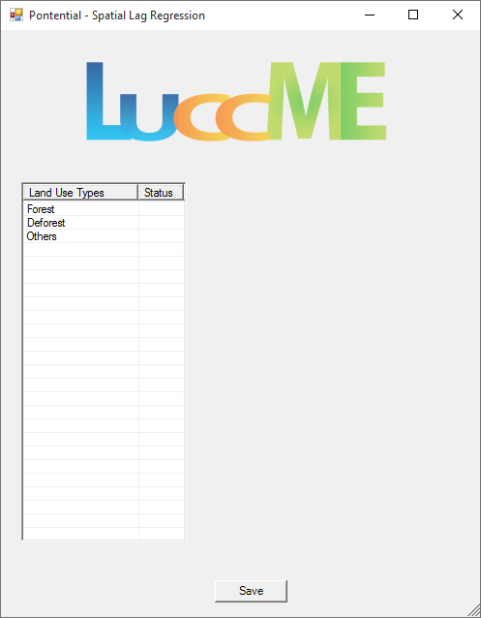

Figure 2: Spatial Lag Regression Window

To enter the component data you must select the Land Use Type, which you want to enter the data, the window will change to the data input mode:

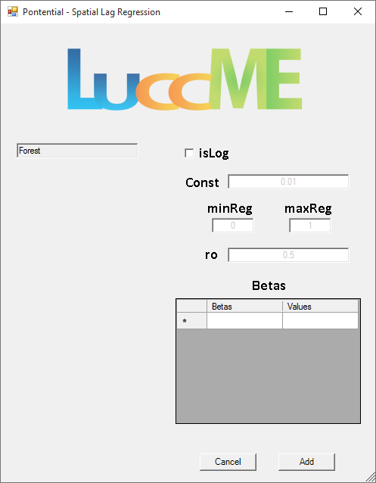

Figure 3: Linear Regression Window - Editing

After enter the values of each land use the status will be modified on the main window of the component.

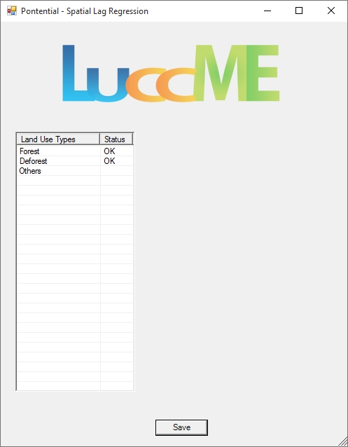

Figure 4: Spatial Lag Regression Window – Modified Status

After save the data a confirmation will appear:

Figure 5: Potential – Spatial Lag Regression Confirmation

**Spatial Lag Linear Roads**

This component uses the Land Use Types to input the data.

To select it just click on Spatial Lag Linear Roads.

Figure 1: Spatial Lag Linear Roads Button

After that, the component window will appear:

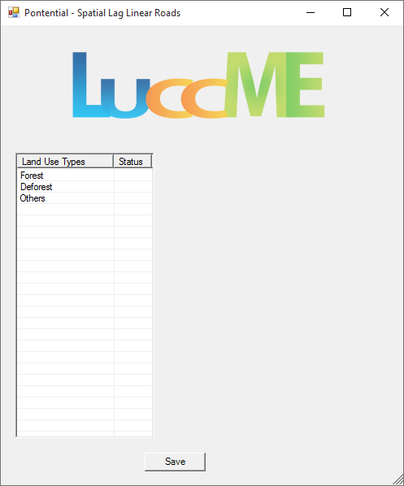

Figure 2: Spatial Lag Linear Roads Window

To enter the component data you must select the Land Use Type, which you want to enter the data, the window will change to the data input mode:

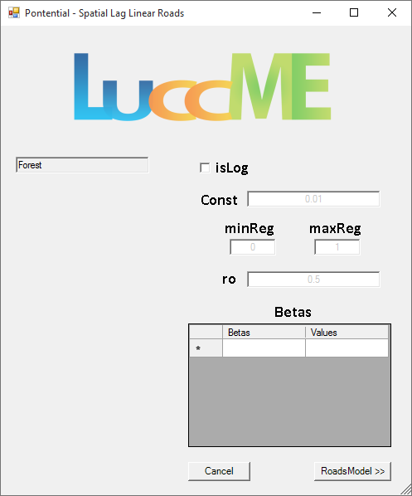

Figure 3: Spatial Lag Linear Roads Window – Editing

Clicking on Roads Model button the window will expand, making possible to enter the data for the road model of the selected Lan Use Type:

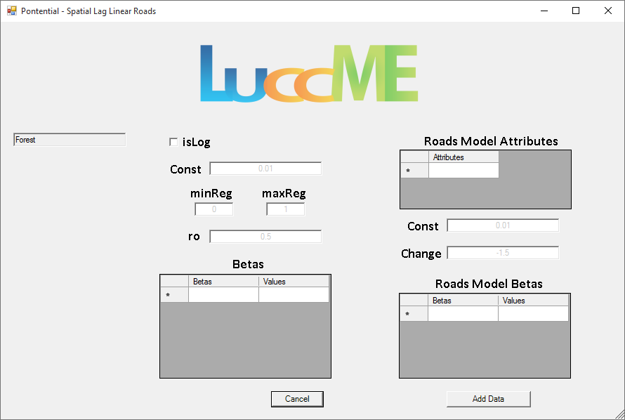

Figure 4: Spatial Lag Linear Road – Editing – Road Model

After enter the values of each land use the status will be modified on the main window of the component.

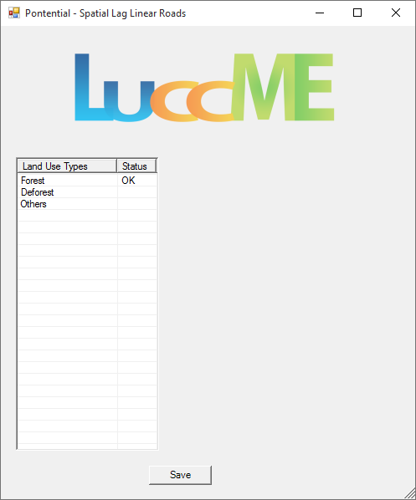

Figure 5: Spatial Lag Linear Roads Window – Modified Status

After save the data a confirmation will appear:

Figure 6: Potential – Spatial Lag Linear Roads Confirmation

**Allocation Components**

The Allocation components are divide in Discrete and Continuous. The user must choose the component that best fit the models need.

The details of the components can be found on LuccME guides.

**Allocation – Discrete Components**

To access the allocation discrete components the user must click the Discrete Components button below Allocation:

Figure 1: Allocation – Discrete Components Button

After that, a widow will open with the components:

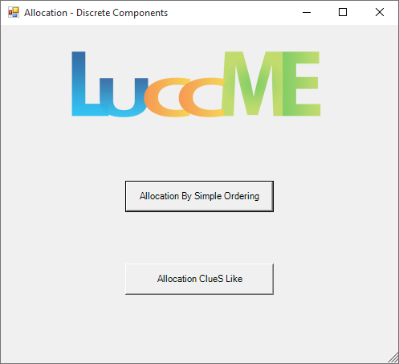

Figure 2: Allocation – Discrete Components Window

**Allocation By Simple Ordering**

This component has just one configuration parameter, to select it click on Allocation By Simple Ordering Button.

Figure 1: Allocation By Simple Ordering Button

After that, the component window will appear:

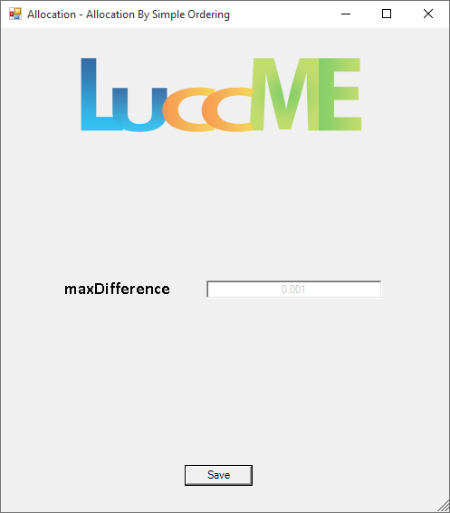

Figure 2: Allocation By Simple Ordering Window

After save the desired value, the confirmation will appear:

Figure 3: Allocation By Simple Ordering Confirmation

**Allocation ClueS Like**

This component has three configuration parameters and a transition matrix size of the number of land use types x number of land use types *(e.g.* *Uses - F, D, O = matrix 3x3)*. This matrix must be populate only with 0 or 1.

To access it just click on Allocation ClueS Like Button.

Figure 1: Allocation ClueS Like Button

After that, the component widow will open:

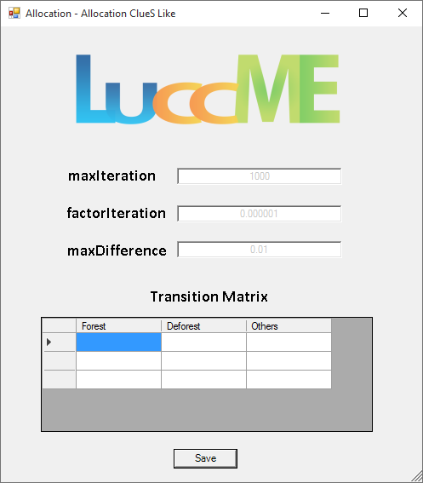

Figure 2: Allocation ClueS Like Window

After save the data, a confirmation will appear:

Figure 3: Allocation ClueS Like Confirmation

**Allocation – Continuous Components**

To access the allocation continuous components the user must click the Continuous Components button below Allocation:

Figure 1: Allocation – Continuous Components Button

After that, a widow will open with the components:

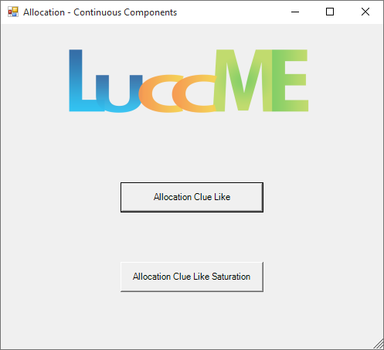

Figure 2: Allocation – Continuous Components Window

**Allocation Clue Like**

This component uses the Land Use Types to input the data.

To select it just click on Allocation Clue Like Button.

Figure 1: Allocation Clue Like Button

After that, the component widow will open:

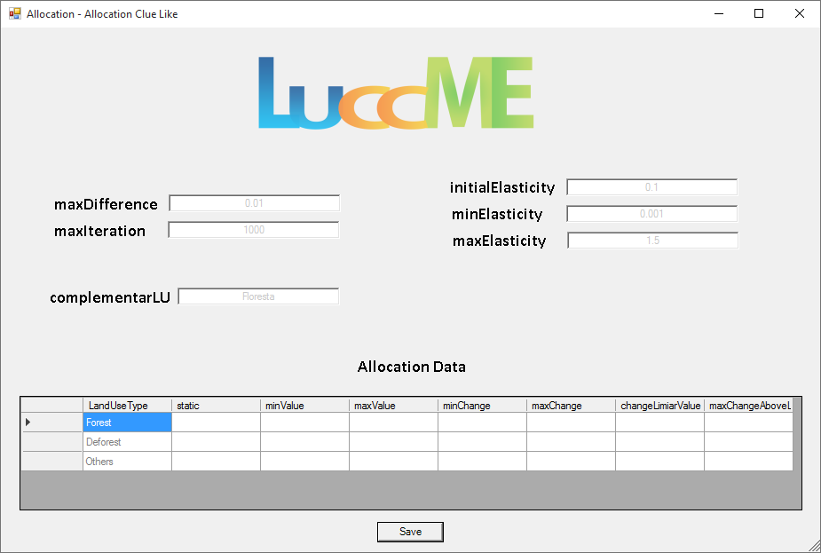

Figure 2: Allocation Clue Like Window

After save the data, a confirmation will appear:

Figure 3: Allocation Clue Like Confirmation

**Allocation Clue Like Saturation**

This component uses the Land Use Types to input the data.

To select it just click on Allocation Clue Like Saturation Button.

Figure 1: Allocation Clue Like Saturation Button

After that, the component widow will open:

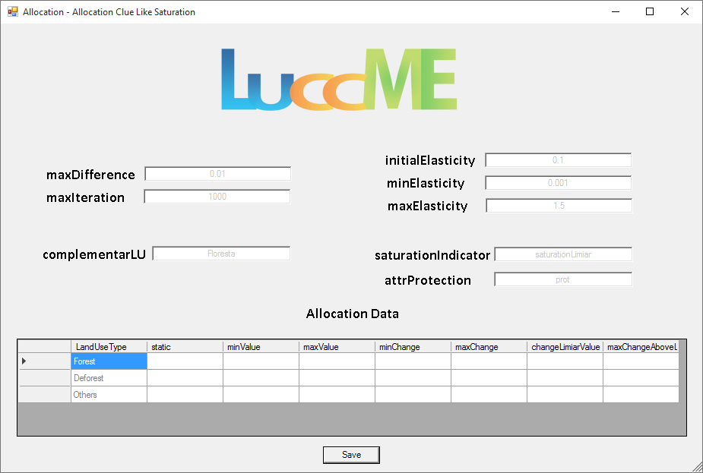

Figure 2: Allocation Clue Like Saturation Window

After save the data, a confirmation will appear:

Figure 3: Allocation Clue Like Saturation Confirmation

**Parameters to Save**

This section handles with the model outputs.

Here is defined the output theme name, who will be added an underline and the executed year that is desired to be saved *(e.g. Output Theme Name = output, Start Time = 1999, Final Time = 2000; the save themes will be: output_1999 and output_2000, in case of these years was selected)*; the years to be save and the land use types, that will be saved in three columns *(e.g. Land Use = Forest; Forest_out, Forest_pot and Forest_change).*

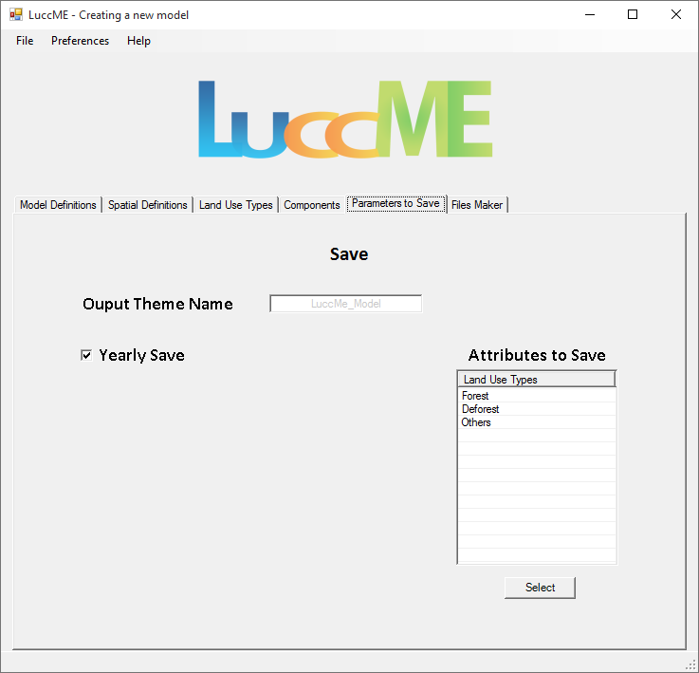

Figure 1: Parameters to Save

You have two options to select the years to be saved:

1. Check the option Yearly Save.

Figure 2: Yearly Save

1. Uncheck Yearly Save and select the specific years.

Change years to save

Figure 2: Years to Save

To do multiple selection of the years to be saved, just press **Ctrl** key and click on the desires years.

After click on **Select** button, a confirmation will appear:

Change to capture

Figure 3: Years to Save Confirmation

To undo the years selection, just click on Select button without select any year.

The process to choose the Land Use Types, or Attributes, to be saved happens the same way.

O processo de escolha dos Tipos de Uso da Terra, ou Atributos, a serem salvos se dá da mesma forma.

To do multiple selection just press **Ctrl** key and click on the desires Attributes.

After that, click on Select button and a confirmation will appear:

Change attributes

Figure 4: Attributes to Save Confirmation

**Files Maker**

This section handles with the files generation *(.lua)*.

Two files will be saved: one with the model name and *_main.lua*, having on it the configuration information of the model; a second one with the model name and *_submodel.lua,* having on it the selected components and its data.

Be sure to fulfill all the necessary data to make the files.

In order to make the files click on Make Files Button:

After a success file generate a message will show:

translate

Figure 1: Files successfully recorded

The Run Model Button will be visible after the files recorded, enabling to the user to execute the model that was saved.

**Opening a LuccME Modeling**

The models generates on this tool can be imported on it:

1. Through the Open Model button:

Figure 1: Open Model Button

1. Via the Main Menu:

Figure 2: Main Menu - File > Open

The Main file will be resquested:

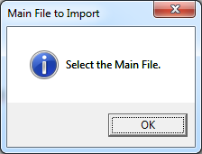

Figure 3: Main File to Import

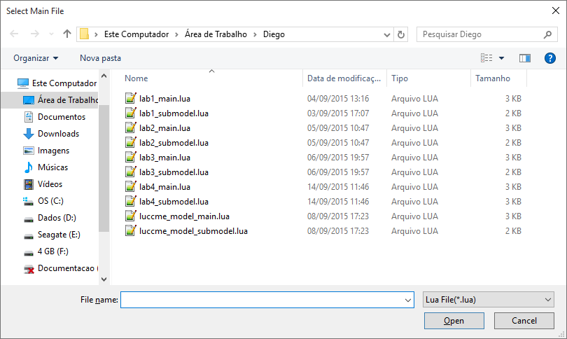

Figure 4: File Select Window (main)

If a main file is selected a confirmation will show and the submodel will be requested.

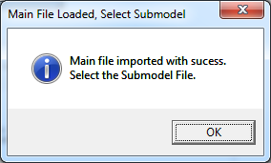

Figure 5: Main confirmation, Submodel requested

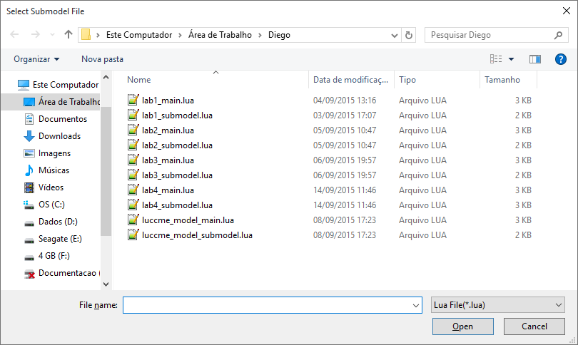

Figure 6: File Select Window (submodel)

After import the files the editing window will appear:

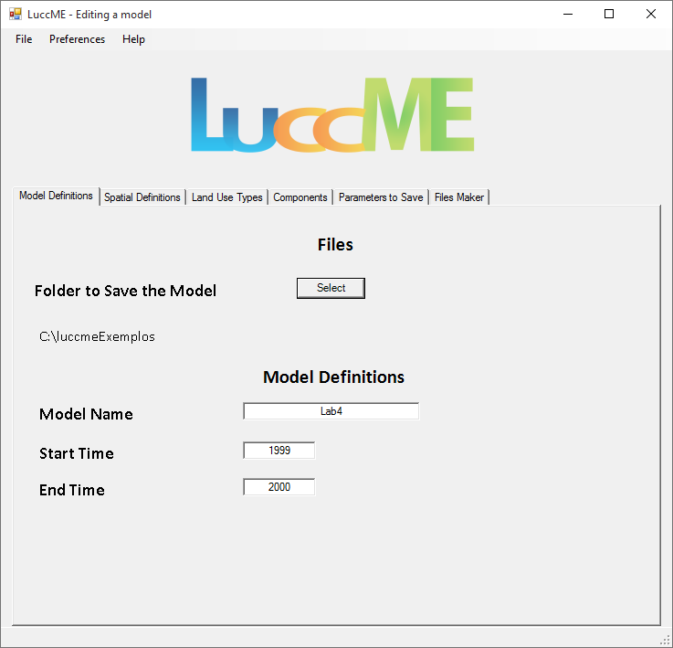

Figure 7: Editing Model Window

**Alterando o Idioma**

Para altera o idioma clique em **Language** no menu **Preferences**:

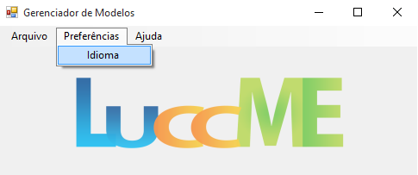

Figura 1: Menu Alterando Idioma

Depois de clicar em **Language**, selecione o idioma desejado e clique no botão **Select**:

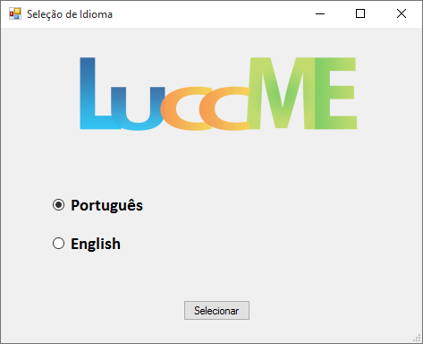

Figure 2: Janela Seleção de Idioma