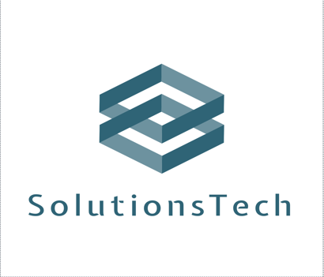

Company Name: SolutionsTech

Introduction

SolutionsTech strives to support and optimize companies' performance in the storage, extraction, and analysis of data through the provision of sophisticated and top-notch software, which elevates efficiency and productivity.

Culture of the company

SolutionsTech aims to excel in the technology industry by enhancing people's lives through technology and simplicity. Achieving these objectives requires being customer-ready, committed, innovation-driven, integrity-focused, and satisfied with a healthy work environment. As a leading customised system solution and information management software provider, customer satisfaction is our priority.

The immediate objective is to extend our consumer base over the initial few years using digital marketing techniques including focused advertising and product promotion. In the long run (5 years), we aim to attain a customer network 50% larger by engaging in diverse product innovations.

We are committed to providing regular software updates that meet the needs of the market and incorporate the latest technological advancements. Our aim is to remain flexible to current trends and in sync with market demand.

Structure of the Company

Our team of highly qualified developers, designers, and accessibility experts will work towards delivering the finest product to our customers.

With our marketing strategy in place and our team prepared, there is a significant demand in the software development industry. After examining the current state of this sector, given the rise in cyber threats, there is a great need for high-quality software with a robust structure, as we have observed a considerable increase in data production in recent years. Acknowledging this it is evident that businesses require efficient solutions for gathering, retaining, manipulating, and examining data. Therefore, the demand for companies offering services in the development and management of data systems remains high in a rapidly expanding field that advances due to technology.

Our product will provide advanced and user-friendly data analysis, robust data visualization capabilities, tailored support and training, and regular updates to stay abreast of technological advancements.

Customers can select their ideal fit with varying levels of functionality and support via monthly or annual subscriptions. We will also introduce permanent licensing for those who desire complete software control.

We shall offer specialised consultancy facilities to aid clients in implementing and optimising their platform, tailoring it to their precise requirements. To extend our product's outreach, we will employ focused internet marketing campaigns encompassing paid advertising, content marketing, active social media presence, and referral schemes to incentivise customers to introduce new clients and receive discounts or benefits in return.