A day in the life of a developer.
Vocabulary
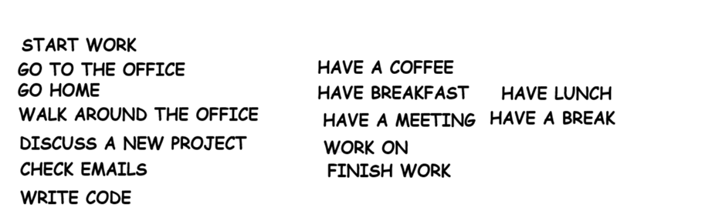
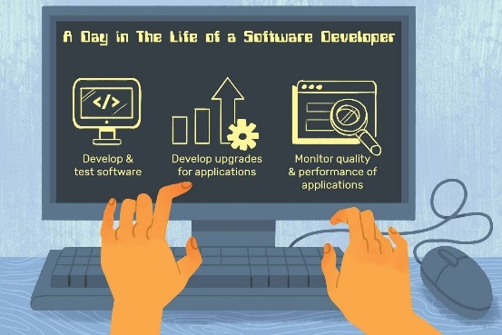
My name is Carlos. I am a software developer. I usually work from home but I sometimes go to my office. I work for a tech company in Buenos Aires. Every day, I start my work at nine o'clock. I have a coffee and I check my emails. At ten o'clock, I write code for two hours. At twelve o'clock, I have a meeting with my team. We discuss new projects. At one o'clock, I have lunch in the office cafeteria. I eat a sandwich and I drink water. After lunch, I continue working on my computer. At four o'clock, I have a short break. I walk around the office and I talk with my colleagues. My colleague Maria is also a developer. She works with me on projects. We are friends. At five thirty, I finish my work and I go home. I do not work on weekends. My office is modern and comfortable.
Fill in the blanks, use the correct form of the verb in brackets.
- Carlos _____________ (be) a software developer.
- He ____________ (work) for a tech company in Buenos Aires.
- Every day, he ______________ (start) work at nine o'clock.
- At twelve o'clock, he _________________ (have) a meeting with his team.
- Maria _________________ (be) his colleague. She ___________________ (work) with him on projects.
- Carlos ____________________ (not work) on weekends.
- After lunch, he _________________________ (continue) working on his computer.
Read the text and write T (True) or F (False).
- Carlos works for a company in Buenos Aires. ___
- He starts work at eight o'clock. ___
- He has lunch at twelve o'clock. ___
- He eats a sandwich for lunch. ___
- Maria is his manager. ___
- Carlos works on Saturdays. ___
- His office is modern and comfortable. ___
Answer the questions about the text.
- Does he check his emails in the morning?
- Does Carlos have a break at four o'clock?
- Does Maria work in a different office?
- What does he do at ten o'clock?
- Who does he have a meeting with at twelve o'clock?
- Where does he have lunch?
- What time does he finish work?
- Who is Maria?

