Load Testing Report: SignalQA API
Prepared 3 August 2026
Overview
Today we carried out a load test of the SignalQA API to understand how it behaves when many requests arrive at the same time. The goal was to find out how much traffic the service can comfortably handle, where it begins to slow down, and whether the rate limiting added earlier holds up under pressure.
We used Locust, an open source load testing tool. Locust simulates a swarm of users that call the API repeatedly, and it reports live figures such as requests per second, response times, and the number of failures. It also draws charts over time, which makes it easy to see how the service reacts as the load grows.
How the test was set up
- Tool: Locust 2.46.3, driven from its dashboard at http://localhost:8089.
- Target: the running web app at http://localhost:8000.
- Method: a small locustfile describes one simulated user and the calls it makes. The calls were split into two groups so each could be stressed on its own: a light group of quick endpoints, and a heavy group containing the /analyze endpoint that runs the models.
- We ran the light group first, then the heavy group, raising the number of users in stages.
Light endpoints
The light group covers the endpoints that do very little work: reading and saving the scoring weights, and rendering a report. We ramped up to 20 users, then to 100 users.
The results were excellent. Across 10,634 requests there were zero failures, the median response time stayed at about 4 milliseconds, and the service handled roughly 39 requests per second. Most telling of all, when we increased the load fivefold from 20 to 100 users, the response times did not get worse. That flat line is the sign of a service with plenty of room to spare.
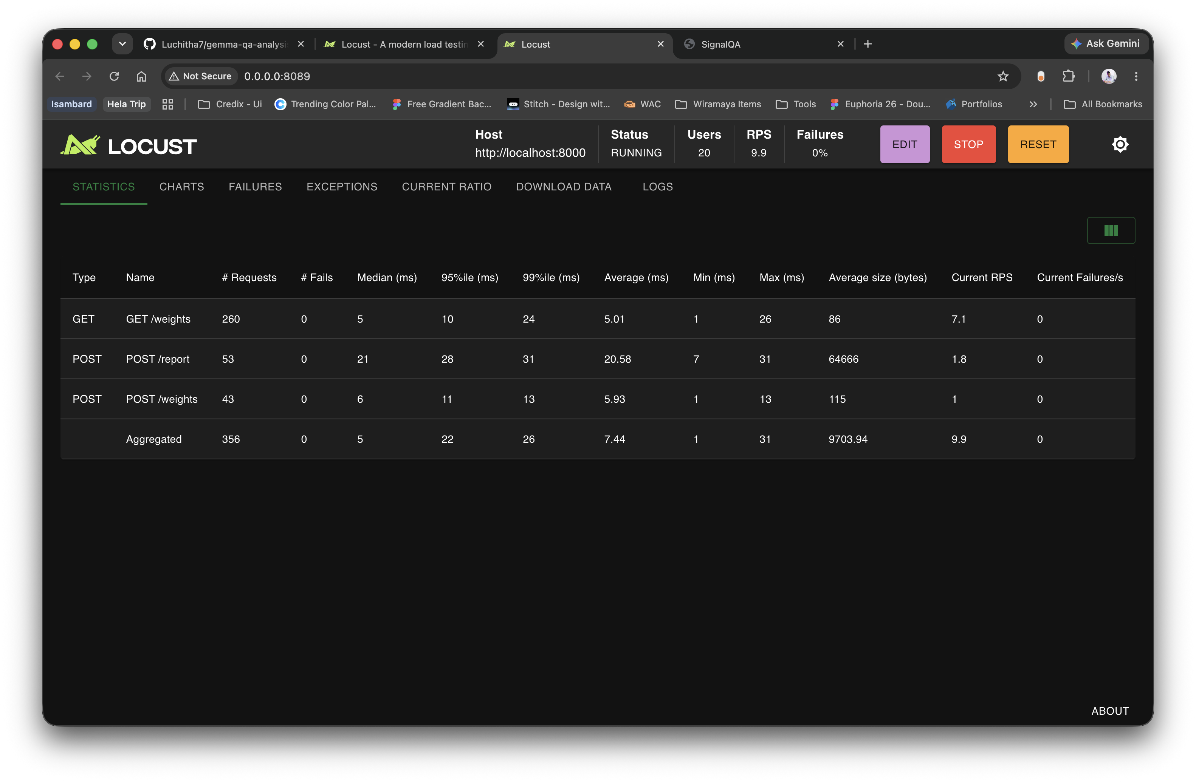
Light endpoints at 20 users: 356 requests, no failures, around 5 ms per request.
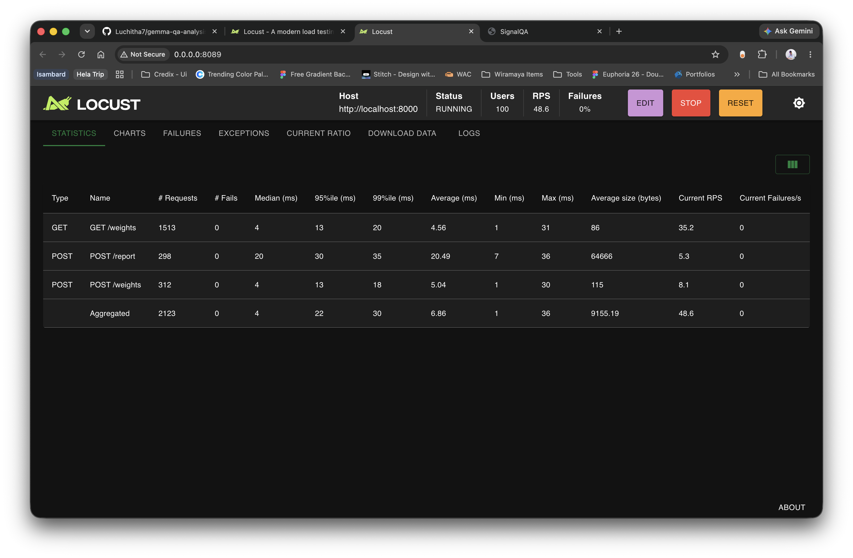
Light endpoints at 100 users: 2,123 requests, still no failures, response times unchanged.
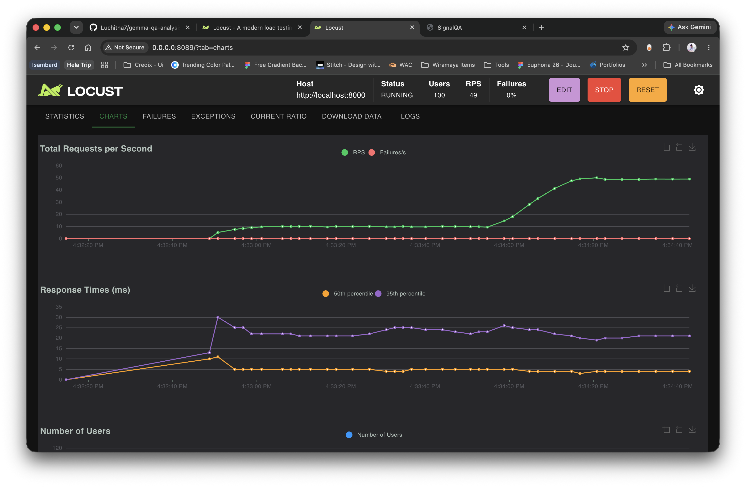
Requests per second climb to about 50 while response times stay flat and failures remain at zero.
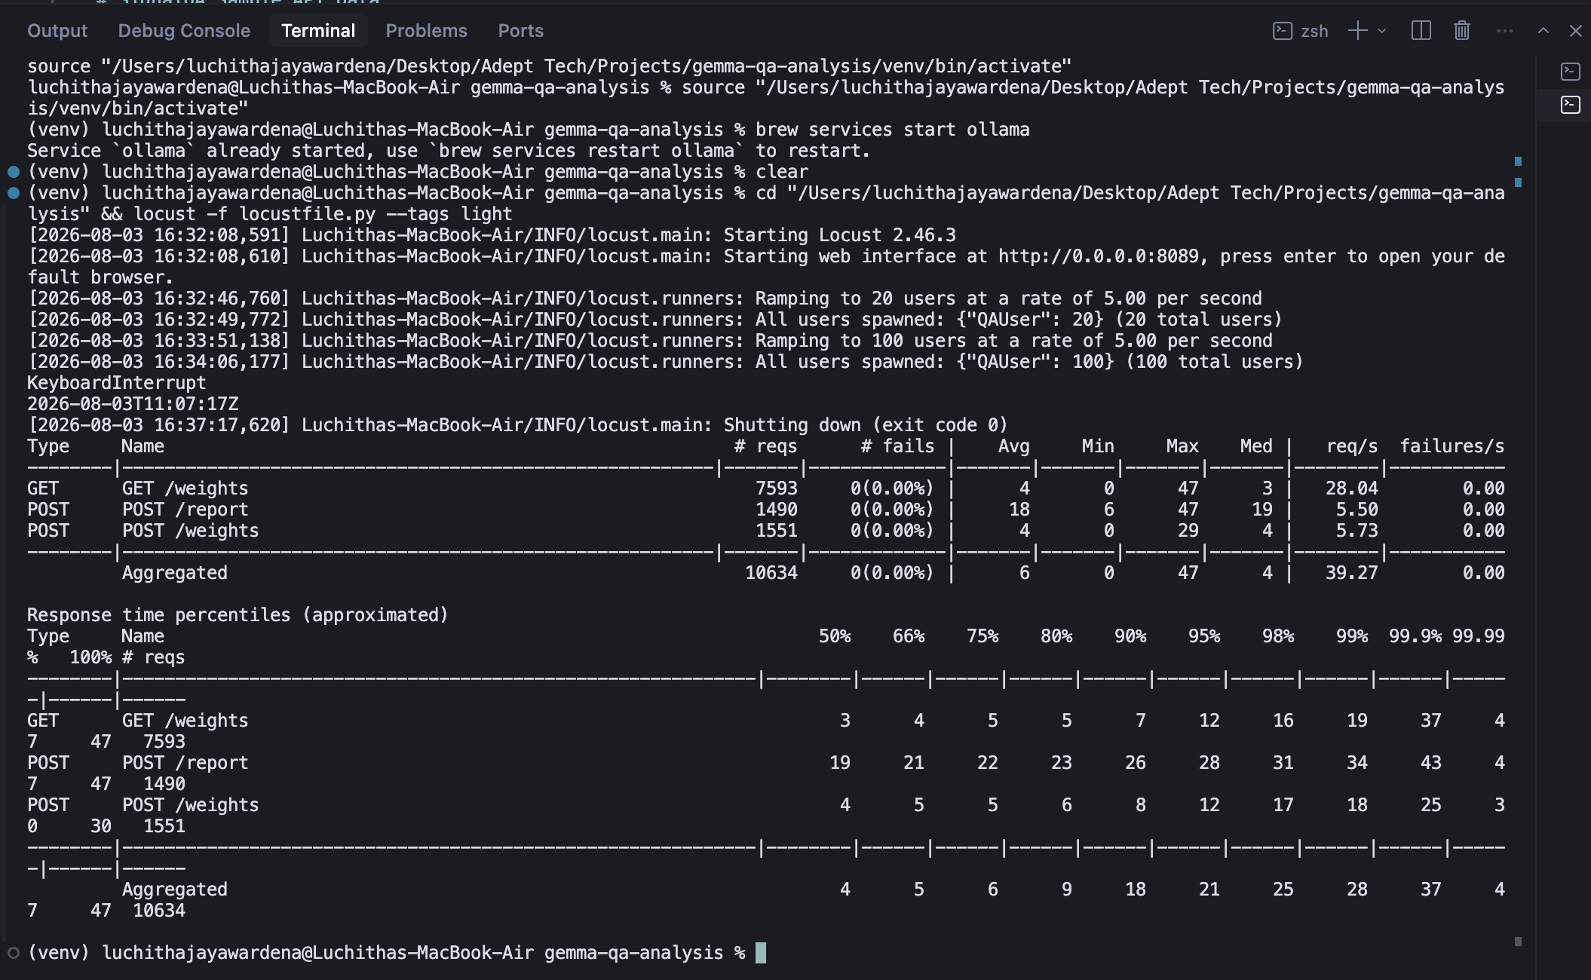
Final summary of the light run: 10,634 requests, zero failures, median around 4 ms.
Heavy endpoint (/analyze)
The heavy group is the /analyze endpoint, which runs the full scoring pipeline: the Gemma language model, the RoBERTa sentiment model, and the retrieval checks. A single call already takes several seconds, so this is where load has a real effect. We ramped to 5 users, and later to 50.
With 5 users, each analysis took around 17 to 18 seconds. As we pushed to 50 users, the median rose to about 23 seconds, the slowest requests reached roughly 60 to 100 seconds, and throughput settled at about 0.19 requests per second. Even under this pressure there were no failures. The requests simply queued and waited their turn.
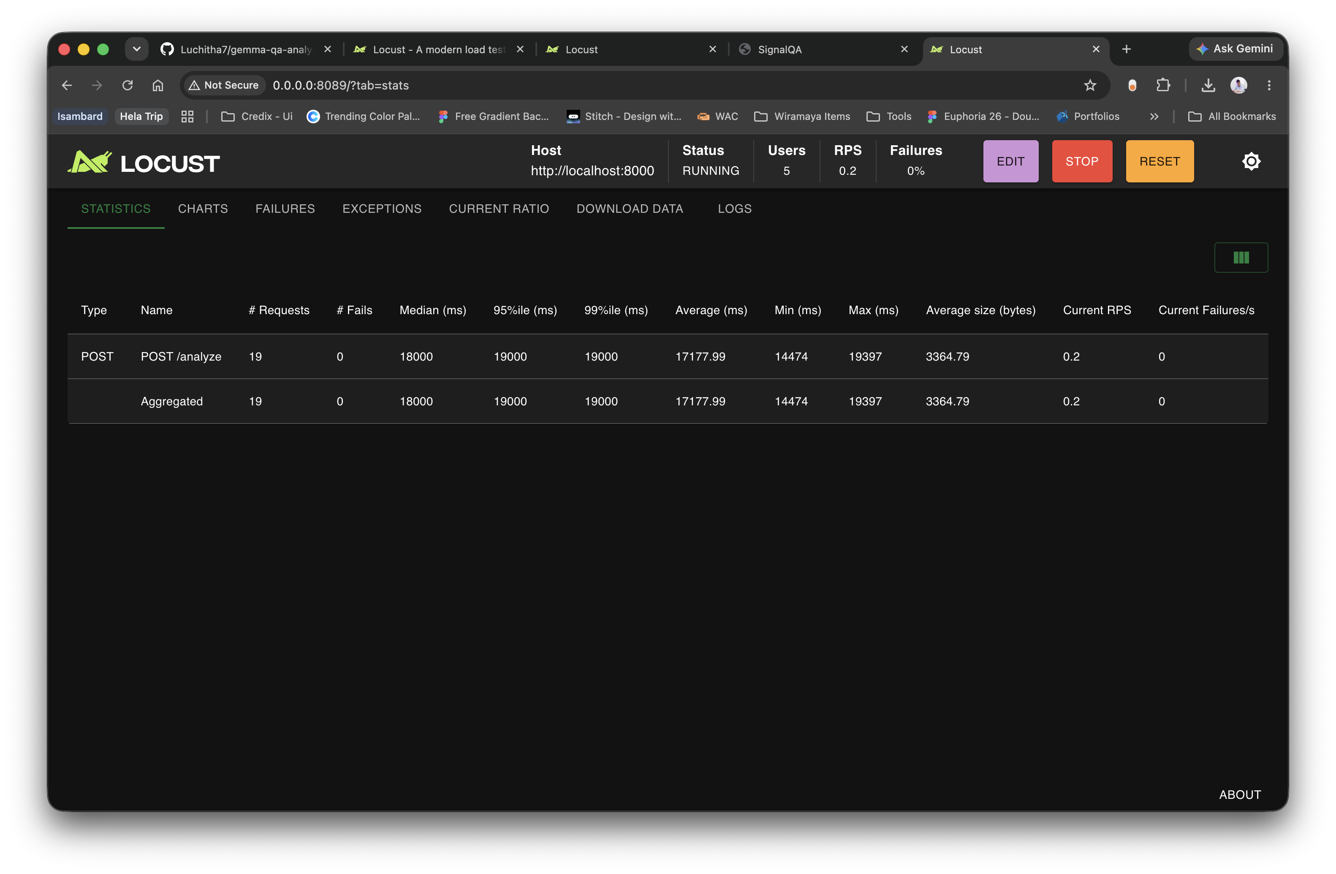
Heavy endpoint at 5 users: about 17 seconds per analysis, no failures.
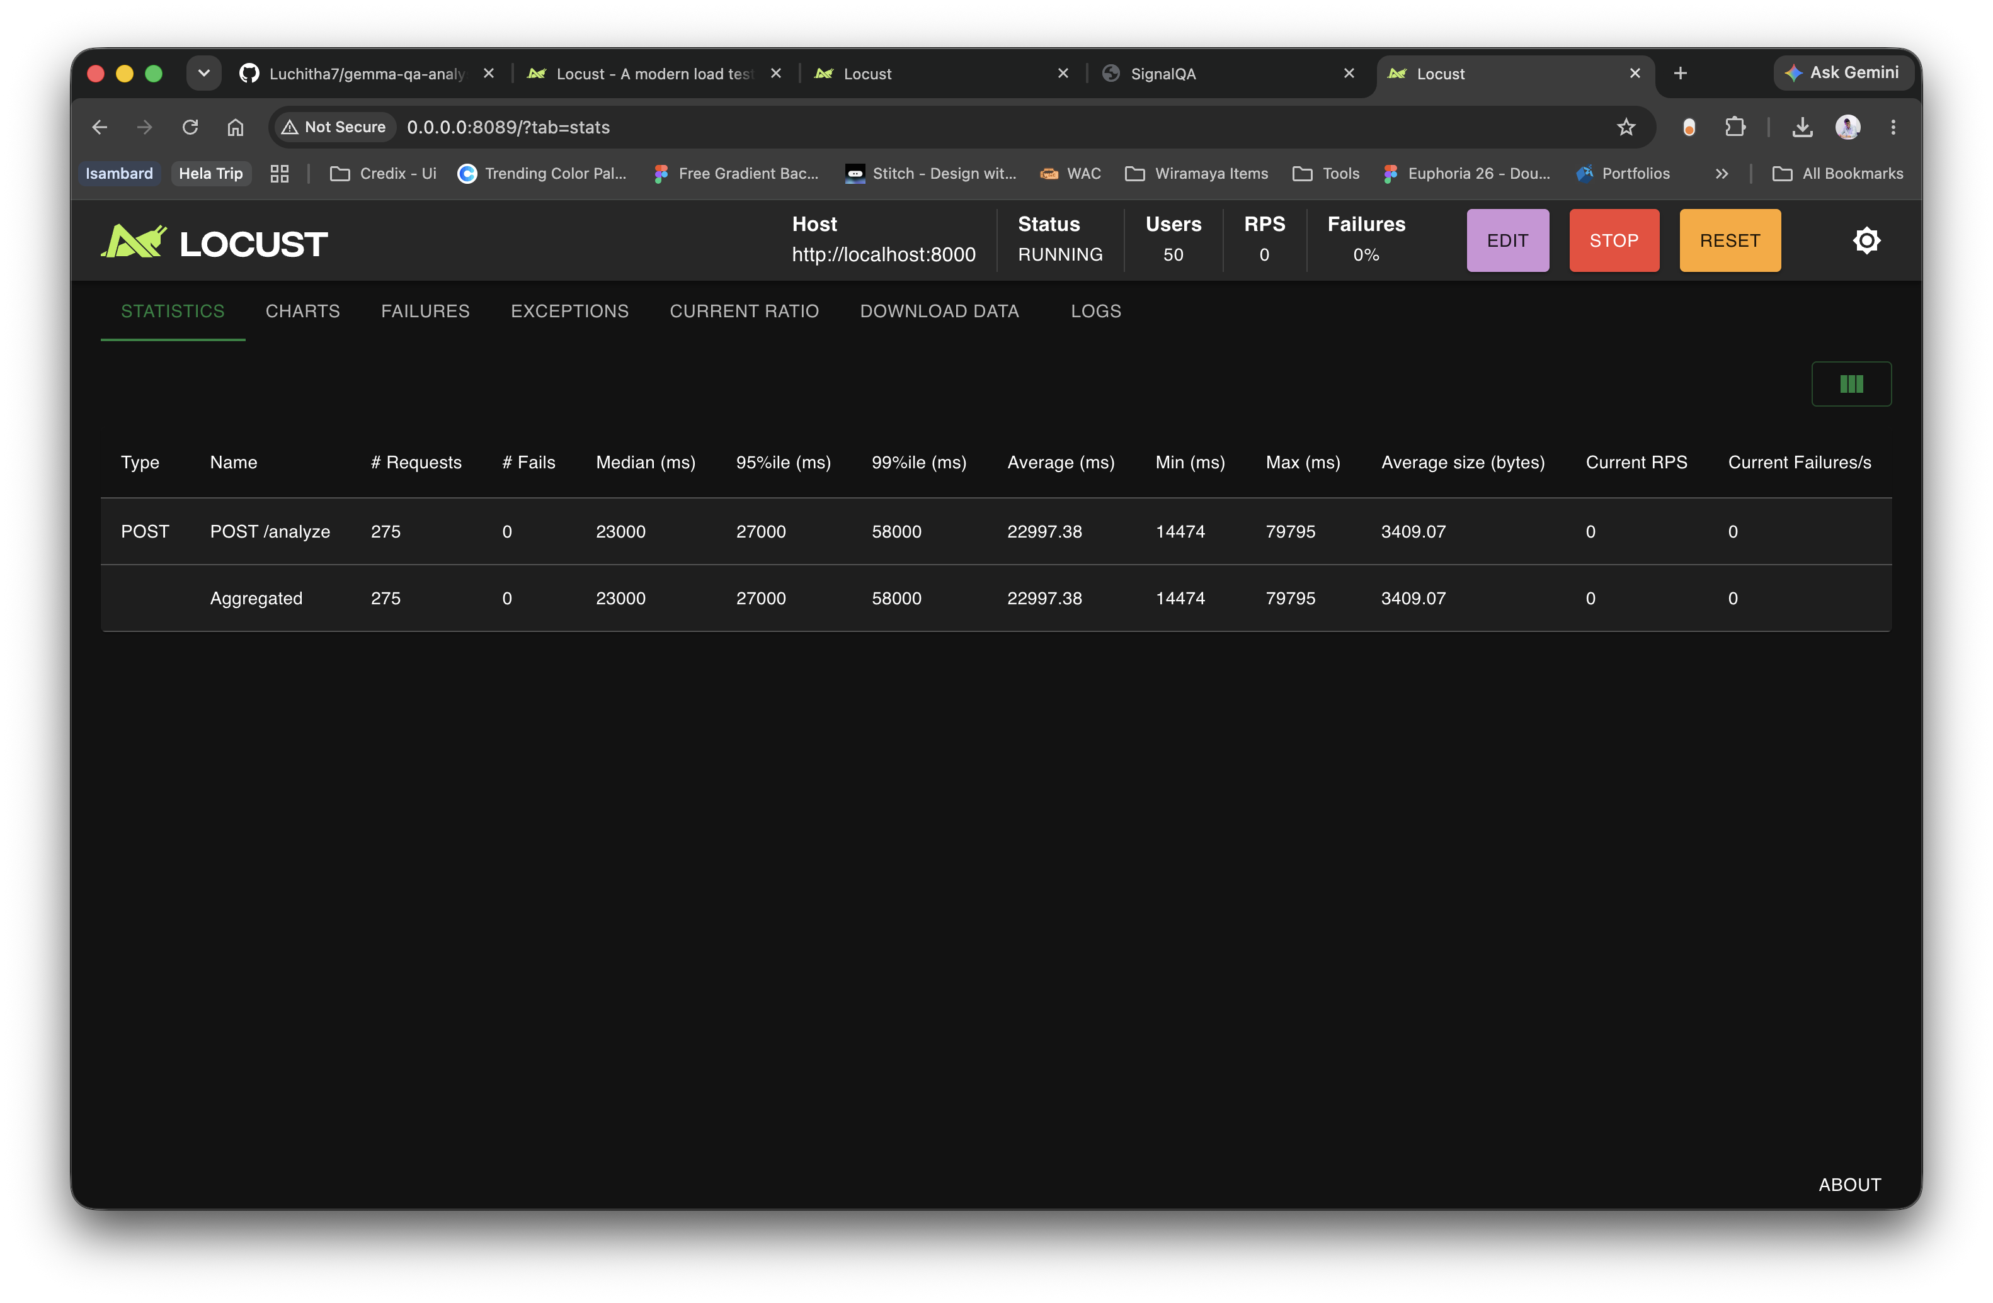
Heavy endpoint at 50 users: median around 23 seconds, slowest approaching 100 seconds, still no failures.
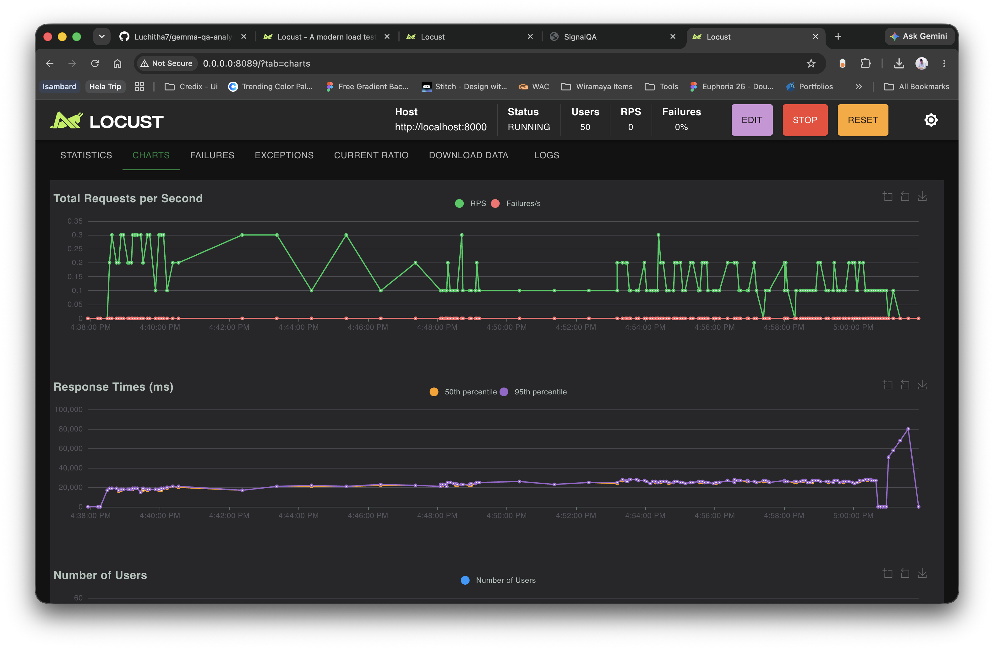
Throughput stays near 0.2 requests per second no matter how many users are added, while response times sit around 20 to 25 seconds.
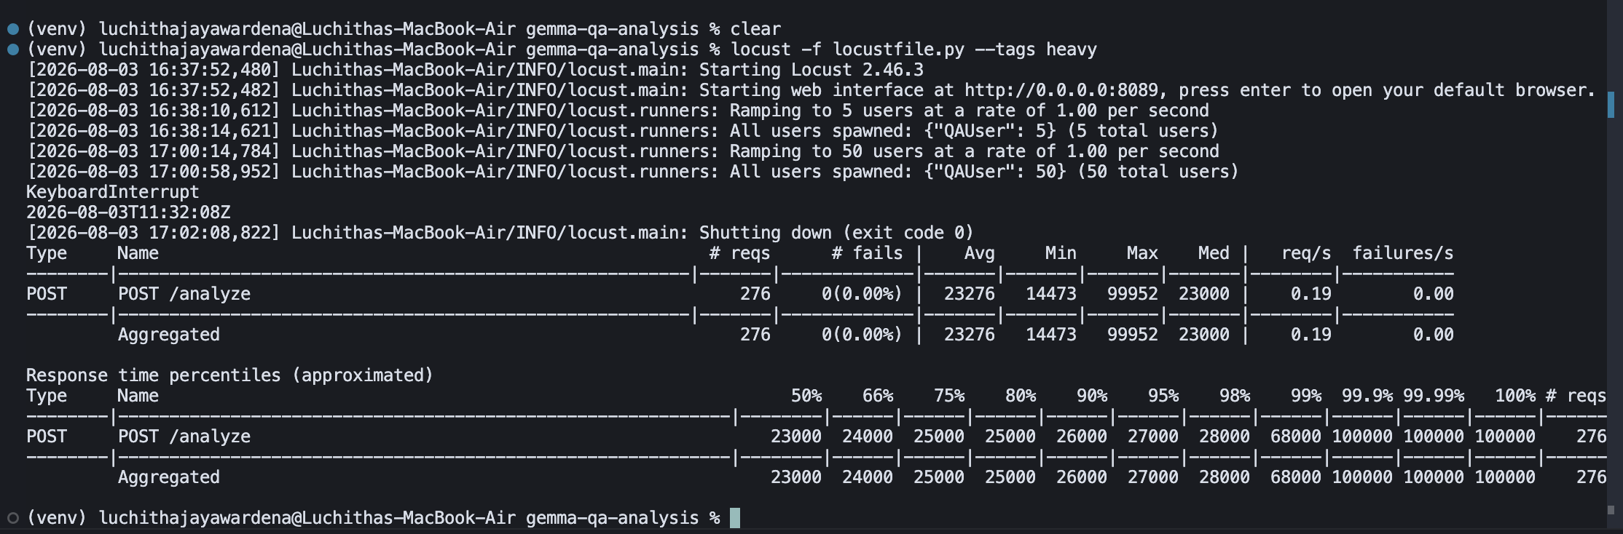
Final summary of the heavy run: 276 analyses, zero failures, median 23 seconds.
What the results mean
The two groups tell very different stories. The light endpoints scale effortlessly. They handle heavy concurrent traffic with low response times and no failures, and they clearly have a great deal of headroom left.
The /analyze endpoint is limited by computation, not by the web layer. A single analysis takes several seconds because it runs three models, and the server processes these essentially one at a time. When many users arrive together, their requests line up in a queue, which is why response times climb to tens of seconds while throughput stays near 0.2 requests per second no matter how many users we add.
One reassuring point across every test was that nothing failed. Under overload the service slowed down and made callers wait, rather than crashing or returning errors. That is the safe way for a system to behave when it is pushed beyond its comfort zone.
These figures also support the rate limit set earlier. Because the machine can realistically complete only a handful of analyses per minute, the limit of ten analyses per minute for /analyze is well matched to the true capacity, and it prevents callers from piling into a queue that cannot drain.
Recommendations
- Keep the light endpoints as they are. They are comfortably production ready at this scale.
- To handle real call centre volume on /analyze, scale it out rather than tuning the code: run several instances or workers, or place a background job queue in front so requests are accepted and processed as capacity allows.
- Consider faster hardware, such as a GPU host for the language model, if higher throughput per instance is needed later.
- Keep rate limiting in place. It protects the model pipeline from being overwhelmed and keeps response times predictable.

