**TEAM BUILDING**Línea horizontal

**Instructions:**

Execute a function called get_weather, which accepts the name of a city as its sole argument. For example: get_weather('Base Marambio').

The output of the function consists of providing a data frame with the forecast for the next 7 days.

**May the winds guide you towards the answer you seek.**

**Good luck!**

**Need some help?** Clearly, we need an action plan!



Here you have a Free Weather API: [Free Open-Source Weather API | Open-Meteo.com](https://open-meteo.com/)

You can provide the Latitude and Longitude of any city to the request, and the API will return the corresponding weather information.

Latitude and Longitude can be found in Wikipedia:

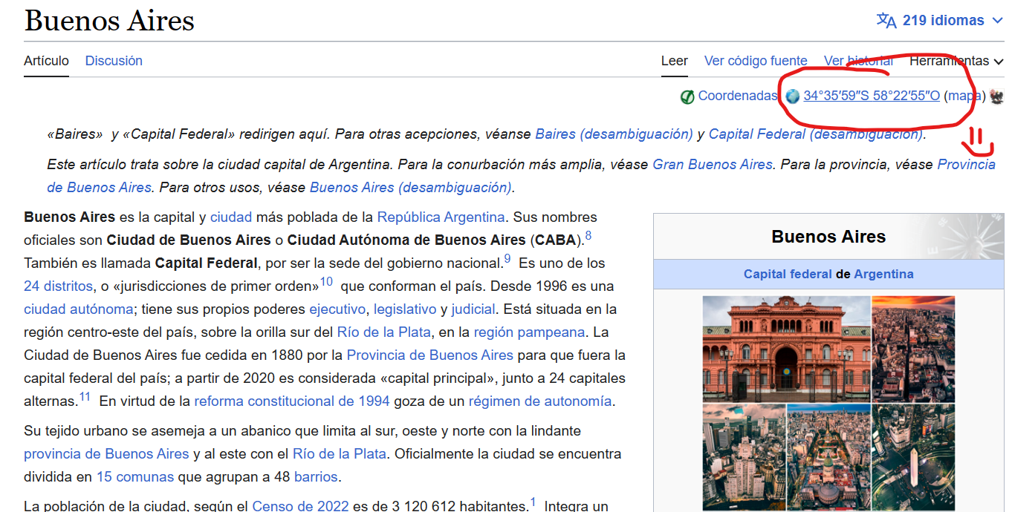

**Still lost?**



Did you wonder what type of request we are making?

Is it a GET?

Is it a POST?

Create functions with a narrow purpose and chain them together. Remember what is said in ETL:

**A journey of a thousand miles begins with a single step :?**

You are welcome: [wikipedia · PyPI](https://pypi.org/project/wikipedia/)

The following screenshot is a reasonable output from the desired API:

