Client Name: __________________ | Date of Birth: ____________ | Medicaid Number: _____________
Parents/Guardian: __________________ | Address: _________________________________
Author: _________________ | Intervention Settings: _______________

Type of Assessment:
X Initial Assessment | Reassessment
CLIENT is a 5-year-old male referred by his parents due to concerns related to Autism Spectrum Disorder, including difficulties with social engagement, emotional regulation, transitions, and functional communication within structured environments. CLIENT is verbal and is able to label familiar items and respond to simple questions; however, he requires frequent prompting to follow directions, remain engaged in tasks, and communicate his needs appropriately during moments of frustration. CLIENT currently attends an ESE classroom placement and requires structured supports to access instruction and participate meaningfully in daily routines.
CLIENT engages in behaviors such as task avoidance, difficulty transitioning between activities, limited peer interaction, and tantrum behaviors when frustrated or when expectations change. He often prefers solitary play and requires adult guidance to participate in group activities. During non-preferred tasks or transitions, CLIENT may disengage, become emotionally dysregulated, or require redirection to remain safe and on task. These behaviors interfere with his ability to function independently and consistently within the classroom and community settings.
When CLIENT experiences difficulty communicating or understanding expectations, he may exhibit frustration-related behaviors including crying, refusal, or emotional outbursts. He demonstrates rigidity with routines and benefits from predictability, visual supports, and adult prompting. Changes in routine or unexpected demands may result in decreased compliance and increased need for behavioral support.
Applied Behavior Analysis (ABA) services are medically necessary to reduce maladaptive behaviors, increase functional communication, improve emotional regulation, and build independence across daily routines. Consistent intervention will support CLIENT’s ability to participate appropriately at home, in school, and emerging community settings.

Self-Help Skills
CLIENT demonstrates independence with several self-care routines, including toileting, feeding, and basic hygiene tasks. However, he may require prompting to complete routines efficiently and appropriately, particularly during transitions or non-preferred tasks. CLIENT benefits from visual prompts and adult guidance to increase independence and compliance within self-help routines. Ongoing ABA services will focus on increasing task completion, tolerance of demands, and generalization of skills across settings.

Daily Living Skills
CLIENT can follow simple one-step directions but often requires verbal and visual prompts to maintain focus and complete tasks. He demonstrates difficulty sustaining attention during adult-directed activities and may engage in avoidance behaviors when tasks are challenging or non-preferred. Structured routines, visual schedules, and consistent reinforcement are necessary to support his participation and independence in daily living skills.

Safety Concerns
CLIENT requires supervision due to limited frustration tolerance and difficulties regulating emotions during transitions or demands. During moments of dysregulation, he may have difficulty following adult directives promptly, which can impact safety within structured environments. ABA intervention will focus on increasing coping skills, compliance with redirection, and emotional regulation strategies to ensure safe participation across settings.

Communication
CLIENT is verbal and capable of labeling items and responding to basic questions. However, he does not consistently use language functionally to request help, express needs, or communicate discomfort without prompting. When communication breaks down, CLIENT may become frustrated or disengaged. Functional Communication Training (FCT) will be implemented to increase spontaneous, appropriate communication, improve requesting skills, and support reciprocal interactions with adults and peers.

Self-Stimulatory Behavior
CLIENT may engage in repetitive or self-regulating behaviors during periods of excitement, frustration, or overstimulation. These behaviors appear to serve a regulatory function and may interfere with attention and task engagement in structured settings. Intervention will focus on teaching alternative coping strategies, improving tolerance to demands, and increasing engagement during instructional activities.

Medical Necessity
Behavior analysis services are medically necessary for CLIENT due to ongoing deficits in functional communication, emotional regulation, task engagement, and independence. CLIENT’s behaviors interfere with participation in age-appropriate educational and daily routines and require consistent behavioral intervention. Without continued ABA services, CLIENT is at risk for limited progress, increased frustration-related behaviors, and reduced independence. ABA therapy will provide structured, data-driven interventions to promote meaningful improvements in behavior, communication, and functional skills.

Strengths
CLIENT demonstrates emerging communication abilities and responds positively to structured routines and positive reinforcement. He can identify familiar letters, numbers, colors, and shapes and benefits from visual schedules and predictable expectations. When appropriately supported, CLIENT is capable of engaging in learning activities and completing tasks successfully.

Weaknesses
CLIENT exhibits difficulty with transitions, emotional regulation, peer interaction, and sustained attention during adult-directed tasks. He requires frequent prompting to communicate his needs effectively and to remain engaged during structured activities. Intervention will continue to prioritize increasing independence, improving functional communication, enhancing social engagement, and reducing frustration-related behaviors.

Medical Condition and Medications
CLIENT’s overall health is reported to be stable. No current medications were reported.

Maladaptive Behaviors
Behavior | Topographic Definition | Baseline
Elopement | Any instance of CLIENT moving away from adult more than 5 ft while outside or inside without permission. | 8x per session
Property destruction | Property destruction is defined as any instance in which CLIENT intentionally damages, breaks, or attempts to damage objects, materials, or the physical environment. This includes, but is not limited to:  - Throwing objects with enough force that they could break or cause damage.  - Tearing or ripping paper, books, or assignments in frustration. | 5x per session
Social Isolation | CLIENT engages in solitary behavior for more than 5 consecutive minutes without attempting to initiate or respond to social engagement. | 11x per session
Task refusal | CLIENT engages in behaviors such as ignoring instructions, walking away, placing her head down, or remaining silent for more than 10 seconds after a task demand is presented, resulting in incomplete or delayed task completion. Temper Tantrums: Any instance of CLIENT screaming, crying, kicking the floor, and stomping feet for one minute up to 5 minutes. | 22x per session
Tantrum | A tantrum is defined as a cluster of behaviors that may include crying, screaming. The episode is considered a tantrum when one or more of these behaviors occur for 30 seconds or longer and interfere with ongoing activities or task demands. | 3x per session
Aggression | Aggression is defined as any instance in which CLIENT engages in physical contact or attempts to make physical contact with another person that may cause harm or injury. Hitting (using an open or closed hand) | 4x per session
Target Behavior: Tantrum
Long-Term Objective (LTO) Reduce weekly incidents of Tantrum 90%-100 of baseline for at least 3 consecutive months.
Short-Term Objective #1 | Reduce weekly incidents of Tantrum by 10% of baseline for at least 1 month. Expected mastery Feb 2026

Short-Term Objective #2 | Reduce weekly incidents of Tantrum by 20% of baseline for at least 1 month.

Short-Term Objective #3 | Reduce weekly incidents of Tantrum by 30% of baseline for at least 1 month.

Short-Term Objective #4 | Reduce weekly incidents of Tantrum by 40% of baseline for at least 1 month.

Short-Term Objective #5 | Reduce weekly incidents of Tantrum by 50% of baseline for at least 1 month.

Short-Term Objective #6 | Reduce weekly incidents of Tantrum by 60% of baseline for at least 1 month.

Short-Term Objective #7 | Reduce weekly incidents of Tantrum by 70% of baseline for at least 1 month.

Short-Term Objective #8 | Reduce weekly incidents of Tantrum by 80% of baseline for at least 1 month.

Short-Term Objective #9 | Reduce weekly incidents of Tantrum by 90% of baseline for at least 1 month.

{%behavior_tantrum_graph}
{%sto_tantrum_graph}
Target Behavior: Property destruction
Long-Term Objective (LTO) Reduce weekly incidents of Property Destruction 90%-100 of baseline for at least 3 consecutive months.
Short-Term Objective #1 | Reduce weekly incidents of Property destruction by 10% of baseline for at least 1 month. Expected mastery Feb 2026

Short-Term Objective #2 | Reduce weekly incidents of Property destruction by 20% of baseline for at least 1 month.

Short-Term Objective #3 | Reduce weekly incidents of Property destruction by 30% of baseline for at least 1 month.

Short-Term Objective #4 | Reduce weekly incidents of Property destruction by 40% of baseline for at least 1 month.

Short-Term Objective #5 | Reduce weekly incidents of Property destruction by 50% of baseline for at least 1 month.

Short-Term Objective #6 | Reduce weekly incidents of Property destruction by 60% of baseline for at least 1 month.

Short-Term Objective #7 | Reduce weekly incidents of Property destruction by 70% of baseline for at least 1 month.

Short-Term Objective #8 | Reduce weekly incidents of Property destruction by 80% of baseline for at least 1 month.

Short-Term Objective #9 | Reduce weekly incidents of Property destruction by 90% of baseline for at least 1 month.

{%behavior_property_destruction_graph}
{%sto_property_destruction_graph}
Target Behavior: Task refusal
Long-Term Objective (LTO) Reduce weekly incidents of Task refusal 90%-100 of baseline for at least 3 consecutive months.
Short-Term Objective #1 | Reduce weekly incidents of Task refusal by 10% of baseline for at least 1 month. Expected mastery Feb 2026

Short-Term Objective #2 | Reduce weekly incidents of Task refusal by 20% of baseline for at least 1 month.

Short-Term Objective #3 | Reduce weekly incidents of Task refusal by 30% of baseline for at least 1 month.

Short-Term Objective #4 | Reduce weekly incidents of Task refusal by 40% of baseline for at least 1 month.

Short-Term Objective #5 | Reduce weekly incidents of Task refusal by 50% of baseline for at least 1 month.

Short-Term Objective #6 | Reduce weekly incidents of Task refusal by 60% of baseline for at least 1 month.

Short-Term Objective #7 | Reduce weekly incidents of Task refusal by 70% of baseline for at least 1 month.

Short-Term Objective #8 | Reduce weekly incidents of Task refusal by 80% of baseline for at least 1 month.

Short-Term Objective #9 | Reduce weekly incidents of Task refusal by 90% of baseline for at least 1 month.

{%behavior_task_refusal_graph}
{%sto_task_refusal_graph}
Target Behavior: Elopement
Long-Term Objective (LTO) Reduce weekly incidents of Elopement 90%-100 of baseline for at least 3 consecutive months.
Short-Term Objective #1 | Reduce weekly incidents of Elopement by 10% of baseline for at least 1 month. Expected mastery Feb 2026

Short-Term Objective #2 | Reduce weekly incidents of Elopement by 20% of baseline for at least 1 month.

Short-Term Objective #3 | Reduce weekly incidents of Elopement by 30% of baseline for at least 1 month.

Short-Term Objective #4 | Reduce weekly incidents of Elopement by 40% of baseline for at least 1 month.

Short-Term Objective #5 | Reduce weekly incidents of Elopement by 50% of baseline for at least 1 month.

Short-Term Objective #6 | Reduce weekly incidents of Elopement by 60% of baseline for at least 1 month.

Short-Term Objective #7 | Reduce weekly incidents of Elopement by 70% of baseline for at least 1 month.

Short-Term Objective #8 | Reduce weekly incidents of Elopement by 80% of baseline for at least 1 month.

Short-Term Objective #9 | Reduce weekly incidents of Elopement by 90% of baseline for at least 1 month.

{%behavior_elopement_graph}
{%sto_elopement_graph}

Target Behavior: Aggression
Long-Term Objective (LTO) Reduce weekly incidents of Aggression 90%-100 of baseline for at least 3 consecutive months.
Short-Term Objective #1 | Reduce weekly incidents of Aggression by 10% of baseline for at least 1 month. Expected mastery Feb 2026

Short-Term Objective #2 | Reduce weekly incidents of Aggression by 20% of baseline for at least 1 month.

Short-Term Objective #3 | Reduce weekly incidents of Aggression by 30% of baseline for at least 1 month.

Short-Term Objective #4 | Reduce weekly incidents of Aggression by 40% of baseline for at least 1 month.

Short-Term Objective #5 | Reduce weekly incidents of Aggression by 50% of baseline for at least 1 month.

Short-Term Objective #6 | Reduce weekly incidents of Aggression by 60% of baseline for at least 1 month.

Short-Term Objective #7 | Reduce weekly incidents of Aggression by 70% of baseline for at least 1 month.

Short-Term Objective #8 | Reduce weekly incidents of Aggression by 80% of baseline for at least 1 month.

Short-Term Objective #9 | Reduce weekly incidents of Aggression by 90% of baseline for at least 1 month.

{%behavior_aggression_graph}
{%sto_aggression_graph}
Target Behavior: Social Isolation
Long-Term Objective (LTO) Reduce weekly incidents of Social Isolation 90%-100 of baseline for at least 3 consecutive months.
Short-Term Objective #1 | Reduce weekly incidents of Social Isolation by 10% of baseline for at least 1 month. Expected mastery Feb 2026

Short-Term Objective #2 | Reduce weekly incidents of Social Isolation by 20% of baseline for at least 1 month.

Short-Term Objective #3 | Reduce weekly incidents of Social Isolation by 30% of baseline for at least 1 month.

Short-Term Objective #4 | Reduce weekly incidents of Social Isolation by 40% of baseline for at least 1 month.

Short-Term Objective #5 | Reduce weekly incidents of Social Isolation by 50% of baseline for at least 1 month.

Short-Term Objective #6 | Reduce weekly incidents of Social Isolation by 60% of baseline for at least 1 month.

Short-Term Objective #7 | Reduce weekly incidents of Social Isolation by 70% of baseline for at least 1 month.

Short-Term Objective #8 | Reduce weekly incidents of Social Isolation by 80% of baseline for at least 1 month.

Short-Term Objective #9 | Reduce weekly incidents of Social Isolation by 90% of baseline for at least 1 month.

{%behavior_social_isolation_graph}
{%sto_social_isolation_graph}
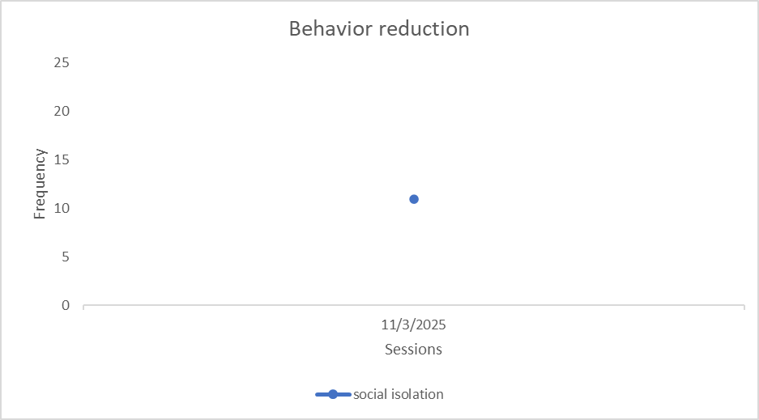
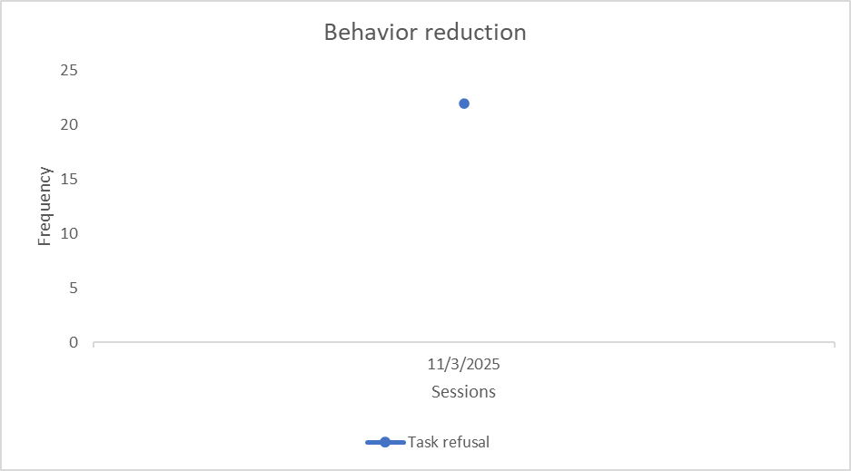

Reinforcement:
Stimulus Preference Assessment
Results based on FAI and Stimulus Preference Assessments (Paired Stimulus/forced choice) identified the following preferred items:
Social: High- fives, “Good job, CLIENT!”, social praise
Tangibles: coloring books, tablets, computers Edibles: cookies, and skittles.
Activities: watching cartoons, playing with electronics
Hypothesis-Based Interventions

The following hypothesis-based interventions and instructional practices will be initiated to address the different patterns of behavior/response classes. These strategies have been selected because they are directly linked to the functions of CLIENT ’s behavior and they are the least intrusive and most effective options available that will work within the environments in which he participates.
Access to Tangibles/ Activities
Behaviors: Disruption, Task Refusal, Physical Aggression, Temper Tantrums, Property Destruction
Preventive Strategies  (antecedent-based) | Replacement Skills  (related to function) | Management Strategies  (consequence-based)
Clarify what and quantity of items CLIENT can have from list of preferred items.  Clarify how long CLIENT can have access to the list of preferred items or activities.  Remove highly preferred items/distracting items from CLIENT ’s sight when he is expected to engage in a non-preferred activity. | -Functional Communication Mands and Expressive language. Receptive language (tact training) in order to request tangibles or activities, using the word or proximity word or gesture.  - Waiting for tangibles.  - Playing skills (sharing with others).  -Following instructions. -Discrimination Training - Intraverbal skills. | Positive Behaviors:  If CLIENT waits for desired items/activities, praise and give the access to tangible/activities once the designed time has passed.  If CLIENT asks for tangibles using the word or proximity word, gesture without using maladaptive behav-  iors, then praise and honor request giving the desired item/activity, if available.  If CLIENT requests and item he cannot have, suggest an alternative.
When CLIENT is in a new environment, let him know what items he may or may not have.  Remind CLIENT to ask for permission before taking items. |  | Maladaptive behaviors:  If CLIENT displayed maladaptive behaviors, do not allow him to access the item, once he is calm for 15 seconds; redirect him to use the appropriate request for tangibles/activities.  If CLIENT refuses to terminate use of item or activity, provide a verbal warning letting know that the item/activity will be taken and put away.

Escape
Behaviors: Disruption, Distraction,
Physical Aggression, Task Refusal, Social Isolation, Property Destruction,
Preventive Strategies (antecedent-based) |  | Replacement Skills  (related to function) | Management Strategies (consequence-based)
- Simplify, shorten, or clar-  ify tasks, activities, or demands.  - Embed preferred items or  activities such as toys, edibles in unpleasant or difficult tasks.  - Remind CLIENT of more  enjoyable activities that will occur following completion of the task/demand using “if-then” statements.  - Begin demands with tasks  that are relatively easy to complete to create behavioral momentum.  - Clearly differentiate choices from directives.  - Avoid presenting demands  in the presence of a noisy environment.  - Remind CLIENT when he  is allowed to say "no" and |  | - Teach CLIENT to say  "no" to a task, activity, or demand by (e.g., shaking head, “not now”, “No, thanks”), using the words or proximity words, gesture.  - Teach CLIENT to request  a break by saying “Break” and/or proximity word, gesture).  - Teach CLIENT to ask for  assistance by saying “help” (using the word or proximity word, gesture).  - Following Instructions.  - Time on tasks.  - Playing skills (sharing with others/take turns) | Positive Behaviors:  If CLIENT says "no" and the task, activity, or demand is not required (e.g., playing a game), respect decision.  If CLIENT asks for a break, allow to exit the activity for (5) minutes while resting in the sofa or walking (not very reinforcing activity). If CLIENT asks for assistance, provide appropriate help.  If CLIENT demonstrates following instructions skills/ Compliance skills at the expected % of trials according to objective described below (Goals of target for Replacement section), praise him immediately and allow him to take a break, if needed.  If CLIENT remains on task, praise and remind him that he will be able to take a break after a certain period of time (FI) according to the objective he is working at the moment. See objectives in the section: Goals of targets for Replacement.  Maladaptive behaviors:  -If CLIENT engages in Disruptive behaviors or Social Isolation do not allow him to leave the demand until he completes at least part of the task.
•  • | to request breaks or assistance.  CLIENT’s working materials and environment should periodically change to avoid escape based behaviors by satiation.  Teach CLIENT to develop a plan for completing activities, allowing brief breaks and ordering tasks to make them more manageable. |  | -Withhold access to enjoyable activities until the task, activity, or demand has been completed.  -If CLIENT engages in physical/verbal aggression, disruptive behavior that escalate to other behaviors, redirect to complete at least part of the activity or to request a break.
Attention
Behaviors: Disruption, Distraction, Task Refusal, Temper Tantrums,
Property Destruction
Preventive Strategies  (antecedent-based) | Replacement Skills  (related to function) | Management Strategies  (consequence-based)
Give CLIENT Non-Contingent  (NCR) high-quality attention periodically (every 15 minutes) throughout the day while he is engaged in any meaningful activity.  Remind CLIENT to use good manners if he wants to gain someone’s attention.  Use CLIENT ’s communication  repertoire for sustained attention.  Show CLIENT using visual cues when attention is available and when it is not.  Remind CLIENT to use appropriate words to request what he wants and to express his feelings. | -Functional Communication Mands and Expressive language, Receptive language (tact training) in order to request properly attention, using the word or proximity word, gesture.  Following instructions  Compliance Training  Coordinated games with younger peers  Verbalize Feelings appropriately  Follow rules and norms for social communication. | Positive Behaviors:  If CLIENT demonstrated the correct behavior, follow the steps below:  - Provide immediate attention if possible when CLIENT requests attention appropriately  - If unable to provide attention, let CLIENT know when you will be available  - Reward lengthy periods of independent activity with special, attention-rich activities.  Maladaptive Behaviors  - Planned Ignored, not giving any attention (don’t look at him, say name, acknowledge in any manner) • Once CLIENT stops the behavior  redirect to request attention • Record data.  If CLIENT engages in any other maladaptive behaviors to request attention, implement the steps below:
- Planned ignore and continue your activities not giving direct attention to what he is telling or doing.
- Once CLIENT stops the behavior, redirect to request attention appropriately.
- Record data
Sensory
Behaviors: Stereotypical Behavior.
Preventive Strategies  (antecedent-based) | Replacement Skills  (related to function) | Management Strategies  (consequence-based)
Provide opportunities for CLIENT to play soccer or other desired activity in the backyard.  Remind CLIENT of more enjoyable activities that will occur following completion of the task/demand using “if-then” statements (Premack Principle).  -Begin demands with tasks that are relatively easy to complete to create behavioral momentum.  - Clearly, differentiate choices from directives by (explain how).  - Avoid presenting demands during moments when CLIENT is tired, hungry, sick, or have been previously completing non-preferred activities/tasks.  -DRO will be used to reinforce every instance when CLIENT remains sharing with others without displaying disruption, stereotypical, or Off-task behavior. | - Teach CLIENT to com-  municate discomfort by saying “I do not like it”, “It hurts” or “I feel bad”.  - Request for Break. • Request Attention. | If CLIENT demonstrated the correct behavior, follow the steps below:  • Encourage to use appropriate activities that provide stimulation.  If CLIENT engages in Stereotypical Behavior, redirect to other activity.

A functional behavioral reassessment was conducted by Analyst on 5/12/2025 to obtain information regarding the probable contexts and functions of client’s behavior. The following processes and tools were utilized:
Assessment tools | Date
Functional Assessment Interview | 5/12/2025
Verbal report of client’s caregiver on maladaptive and replacement behaviors. | 5/12/2025
Vineland-3 | 5/12/2025
BASC-3 | 5/12/2025
Reinforcement Survey | 5/12/2025

QABF Results
⚠ MANUAL STEP REQUIRED: Insert QABF results chart here. Generate from your QABF scoring tool and paste as an image.

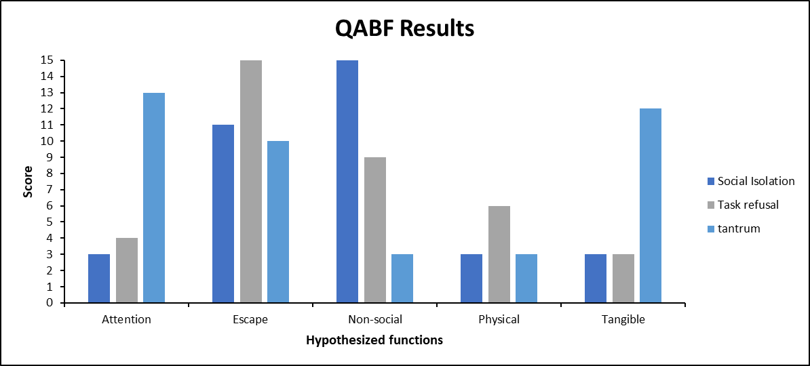

BASC-3
⚠ MANUAL STEP REQUIRED: Insert BASC-3 T-score profile here. Export from Pearson Q-global and paste as an image

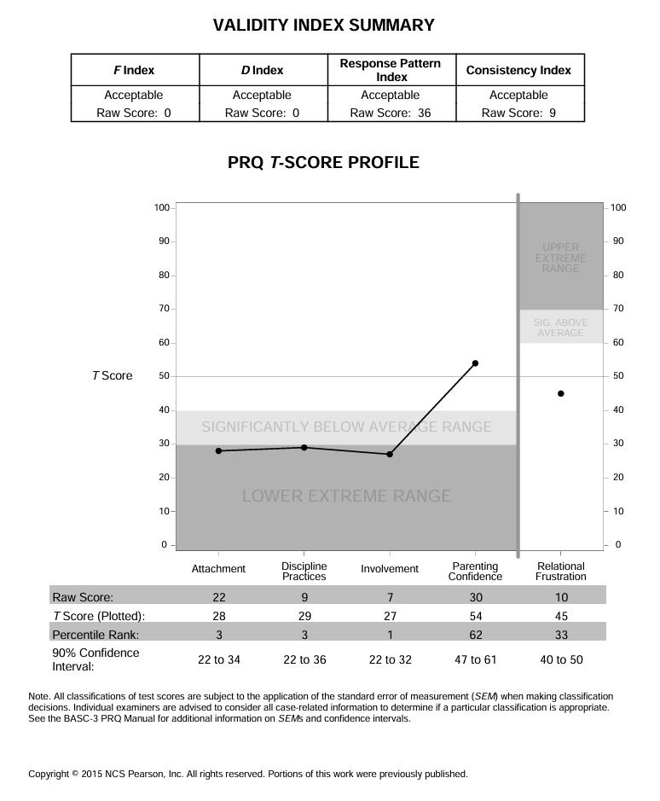

Vineland-3
⚠ MANUAL STEP REQUIRED: Insert Vineland-3 score chart here. Export from Pearson Q-global and paste as an image.
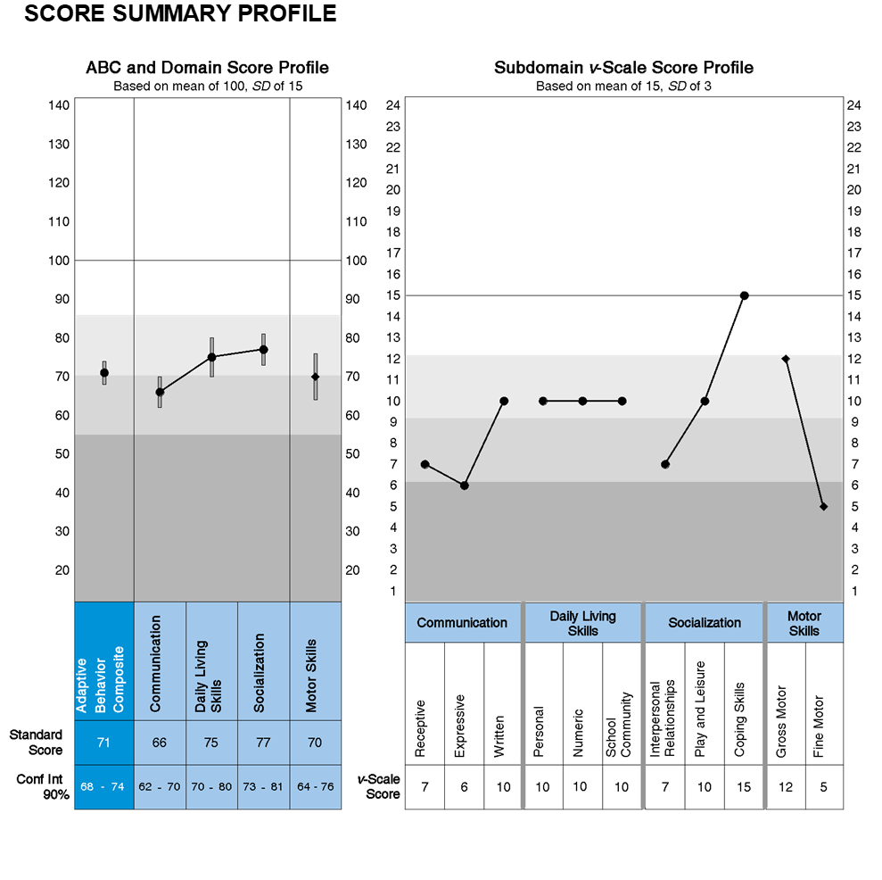

Interventions

• Differential Reinforcement of Alternative Behavior (DRA)
When CLIENT presents behavior, present an alternative behavior that serves similar purpose/function of unwanted behavior. Example, working on an art project, choosing a similar clothing item, etc.

• Differential Reinforcement of Incompatible Behaviors (DRI)
When CLIENT engages in maladaptive behavior, engage him in an activity incompatible to maladaptive (cannot happen at same time. Ex: sitting vs standing, holding pillow vs pulling hair, etc). Praise CLIENT when engaged in incompatible behavior.

• Differential Reinforcement of other Behavior (DRO)
Present the reinforcer when the unwanted behavior is not present. Example, give CLIENT the phone when behaving appropriately, praise the child when behaving as expected, etc.

• Stop-Redirect-Reinforce (SRR)
When CLIENT presents maladaptive behavior, adult will communicate to him to stop the behavior, will redirect CLIENT to a different activity/behavior, and reinforce CLIENT’s engagement in new behavior.

• Premack Principle
When CLIENT does not want to engage in a behavior/activity, use a behavior that he is highly motivated to do. CLIENT will do the preferred behavior only after completing the behavior/task requested. Example: Going outside only after finishing homework.

• Planned Ignoring
CLIENT will be informed that behavior will be ignored, and to notify adult once he is ready/able to calm down and communicate what upsets him. CLIENT ’s behavior will be intentionally ignored by not making eye contact. Visual supervision will still be provided from an indirect angle. Once CLIENT calmed down, adult will approach him, reinforcing behavior of communicating concern.

• Environment Manipulation
CLIENT ’s current environment will be manipulated/changed in order to deescalate behavior by introducing/removing items/place/people to CLIENT’s environment.

• Verbal/Descriptive Praise
CLIENT will be provided with verbal and descriptive praise to reinforce wanted behavior. Praise should be detailed and specific to CLIENT s wanted behavior.

• Behavioral Plan
A plan will be developed along with caregivers to include CLIENT ’s daily tasks, including responsibilities, chores, schoolwork, extra-curricular events, sports, and luxury activities. CLIENT will get a reinforcer on days he completes all tasks. If CLIENT completes all week, a bigger reinforcer should be given. These reinforcers should be based on family’s ability and CLIENT ’s preference. At beginning of treatment, daily tasks should be 4-5, and escalate from there after as he meets goals.

• Role modeling
Model for CLIENT the behavior/task expected of him. Make sure to verbally describe the steps to complete task/behavior. Reinforce when CLIENT completes partially or fully until mastery is achieved.

• Chaining
Forward, Backward, or All-Task Chaining. A step-by-step guide will be developed to fully complete a task.
Forward Chaining: CLIENT will do first step independently; remaining steps will be completed with direct assistance. Once first step is mastered, CLIENT will do step 1 and 2 independently, and remaining steps will be done with direct assistance. Then so on, until mastery of whole task is achieved. Backward chaining: CLIENT will complete last step independently; previous steps will be completed with direct assistance. Once last step is mastered, he will complete last and previous to last steps independently, and remaining steps will be completed with assistance. Then so on, until he has fully mastered completion of task. All-Task-chaining. CLIENT will complete all steps independently based on list. Each step on each of the chaining methods will be reinforced.

• Prompting
CLIENT will be given a prompt, 1-2 step task. This prompt should be specific and reinforced upon completion.

• Extinction
Reinforcement to maladaptive behavior is removed to decrease frequency of problem behavior.
• Escape Training
Training to provide CLIENT with options when needing to disengage/stop from an activity.

• Non-Contingent Reinforcement
This technique is used focusing on the antecedent. Reinforcement will be given to CLIENT unconditionally to satisfy the function/need/purpose of the maladaptive behavior before it appears.

• Incidental Teaching
Capture situations of daily living to redirect and follow program procedures in order to teach CLIENT appropriate ways of obtaining reinforcement during all-natural opportunities throughout the day.

• Errorless Teaching
CLIENT will be prompted to make the correct response immediately, ensuring a correct response each time. The prompt is then slowly faded in order to promote accuracy with the least amount of errors and frustration.

Skills/Replacement Behaviors

• Appropriate Attention Seeking (A.A.S)
Time contingent attention will be instructed to provide attention to CLIENT every 10 minutes that he is at home. At the end of each 10-minute interval, caregiver should approach CLIENT and provide attention by engaging in a short conversation. Let CLIENT know when attention will be available and unavailable by for example, explaining when caregiver is going to be in a phone call and how attention will be available immediately after that. Provide alternative activities or toys, musical instruments, rolling cars, legos, and puzzles when attention will be withdrawn. Provide immediate attention (Reinforcer) if possible when CLIENT requests attention appropriately.
If unable to provide attention, let him know when caregiver will be available. Reward lengthy periods of independent activity with special, attention-rich activities such as playing a game together (Reinforcers). If CLIENT engages in maladaptive behavior, redirect (Redirection) him to requesting attention with words or gestures. Withhold or minimize maladaptive behavior by minimizing conversation and looking away (Planned Ignoring), Environmental Manipulation, Stop-Redirect-Reinforce, or redirecting any possible harmful behavior. If necessary, remove yourself or CLIENT to another room to prevent interaction and escalation (Redirection).

• Escape from Demands
Simplify, shorten, or clarify tasks, activities, or demands. Embed preferred items or activities such as games, edibles in unpleasant or difficult tasks. Remind CLIENT of more enjoyable activities that will occur following completion of the task/demand using “if-then” statements. Begin demands with tasks that are relatively easy to complete to create behavioral momentum. Clearly differentiate choices from directives. Avoid presenting demands in the presence of a noisy environment. Remind CLIENT when he is allowed to say no and to request breaks or assistance. CLIENT ’s working materials and environment should periodically change to avoid escape based behaviors by satiation. Teach him to develop a plan for completing activities, allowing brief breaks and ordering tasks to make them more manageable. If CLIENT says no and the task/activity/demand is not required (e.g., playing a game), respect his decision. If CLIENT asks for a break, allow him to exit the activity for (5) minutes while resting in a comfortable place or singing a song (not very reinforcing activity). If CLIENT asks for assistance, provide appropriate help. If he demonstrates following instructions skills at the expected % of trials according to objective described (Skills/Replacement Behavior), praise him immediately and allow him to take a break, if needed. If CLIENT remains on task, praise him and remind him that a break will happen after a certain period of time (Following Instructions) according to the objective he is working at the moment. See objectives in the section: Skills/Replace-
ment Behavior. If CLIENT engages in task refusal, do not allow him to leave the demand (Escape Training) until at least part of the task has been completed. Withhold access to enjoyable activities until the task, activity, or demand has been completed. If he engages in risky behavior, redirect (Redirection) him to complete at least part of the activity or to request a break.

• Task Completion
Completion of task will be instructed to CLIENT. Level of details will be provided based on developmental age of CLIENT . Before starting activity, work with him in collecting all necessary items to complete task. Break task in episodes/steps/ranges to facilitate completion. Extend episodes/steps/ranges as he masters task. Provide breaks if needed depending on child’s needs/functioning. Remind him to request attention/items/breaks with appropriate behavior. Provide immediate Reinforcer (verbal or tangible) when he completes steps of task (even if partially). Reward full completion of task with special, attention-rich activities such as playing a game together (Reinforcers). If CLIENT engages in maladaptive behavior, redirect (Redirection) him to requesting attention with words or gestures. Withhold or minimize maladaptive behavior by minimizing conversation and looking away (Planned Ignoring), Environmental Manipulation, StopRedirect-Reinforce, or redirecting any possible harmful behavior. If necessary, remove yourself or client to another room to prevent interaction and escalation (Redirection).

• Following Instructions
CLIENT will be instructed to follow a specific direction (1 or more steps, depending on his developmental stage/functioning level). Level of details will be provided based on developmental age and/or functioning level of CLIENT . When giving direction, break task in episodes/steps/ranges to facilitate completion. Extend episodes/steps/ranges as CLIENT masters task. Provide breaks if needed depending on child’s needs/functioning. Remind him to request attention/items/breaks with appropriate behavior. Provide immediate Reinforcer (verbal or tangible) if possible when he completes steps of task (even if partially). Reward full completion of task with special, attention-rich activities such as playing a game together (Reinforcers). If CLIENT engages in maladaptive behavior, redirect (Redirection) him to requesting attention with words or gestures. Withhold or minimize maladaptive behavior by minimizing conversation and looking away (Planned Ignoring), Environmental Manipulation, Stop-Redirect-Reinforce, or redirecting any possible harmful behavior. If necessary, remove yourself or client to another room to prevent interaction and escalation (Redirection).

• Accepting “no” Response
CLIENT will be told “no” when presenting a maladaptive behavior. Make sure to get to eye-level and provide explanation/reasoning for the denial. Use language appropriate to his developmental age/functioning level. Provide CLIENT of a time/situation when request could be positive (going to a particular place, doing a specific activity), or provide reasoning if request is always going to be a “no” (playing with fire, etc). Redirect him to another activity. Provide immediate Reinforcer (verbal or tangible) if possible when he accepts a “no” for response. Reward acceptance, attention-rich activities such as playing a game together (Reinforcers). If CLIENT engages in maladaptive behavior, redirect (Redirection) him to requesting attention with words or gestures. Withhold or minimize maladaptive behavior by minimizing conversation and looking away (Planned Ignoring), Environmental Manipulation, Stop-Redirect-Reinforce, or redirecting any possible harmful behavior. If necessary, remove yourself or client to another room to prevent interaction and escalation (Redirection).

• Positive Access To Tangibles (P.A.T.)
Anticipate transitions and tell CLIENT what it is going to happen next, giving him time to reorganize. Use a timer to indicate the end of an activity and the beginning of the new task. When possible, only start activities when the is time to complete them. Let CLIENT know when the activities will be available again (e.g., on a picture schedule). Encourage him to engage in another activity while waiting. Remind him of positive upcoming activities, using “if-then” statements. Remove highly preferred items that he cannot have from sight or reach– or keep them out of the house altogether . Remind CLIENT to ask for permission before taking items. If he waits for desired items/activities: Praise and give the access to the tangible once the designed time has passed. If he asks for tangibles (mands, tacts, echoics) using words instead of tantrums, repetitive, or aggressive behaviors then praise and honor request giving him the desired item/activity, if available. If CLIENT engages in tantrums to have access to tangibles, do not allow access to the item (Planned Ignoring), once he is calm for three seconds; redirect to use the appropriate request for tangible (DRA). If he refuses to terminate use of item or activity, provide a verbal warning letting him know that the item/activity will be taken and put away. If CLIENT engages in maladaptive behaviors do not give access to the tangible and wait until he is calm, and redirect him to ask for what is needed, using only words. If he engages in risky behavior and redirect to ask for what he wants by only using words.

• Accepting Non-Preferred Activities/Tangibles/Events (ATE)
Simplify, shorten, or clarify tasks, activities, or demands. Embed preferred items or activities such as games, edibles in unpleasant or difficult tasks. Remind CLIENT of more enjoyable activities that will occur following completion of the task/demand using “if-then” statements. Begin demands with tasks that are relatively easy to complete to create behavioral momentum. Clearly differentiate choices from directives. Avoid presenting demands in the presence of a noisy environment. Remind CLIENT when he is allowed to say no and to request breaks or assistance. CLIENT ’s working materials and environment should periodically change to avoid escape based behaviors by satiation. Teach CLIENT to develop a plan for completing activities, allowing brief breaks and ordering tasks to make them more manageable. If CLIENT says no and the task/activity/demand is not required (e.g., playing a game), respect his decision. If he asks for a break, allow him to exit the activity for (5) minutes while resting in a comfortable place or singing a song (not very reinforcing activity). If CLIENT asks for assistance, provide appropriate help. If he demonstrates following instructions skills at the expected % of trials according to objective described (Skills/Replacement Behavior), praise him immediately and allow him to take a break, if needed. If CLIENT remains on
task, praise him and remind him that a break will happen after a certain period of time (SRR) according to the objective he is working at the moment. See objectives in the section: Skills/Replacement Behavior. If CLIENT engages in tantrums, task refusal, do not allow him to leave the demand (Escape Training) until at least part of the task has been completed. Withhold access to enjoyable activities until the task, activity, or demand has been completed. If CLIENT engages in risky behavior, redirect (Redirection) him to complete at least part of the activity or to request a break.

• Increased Time on Task
Step 1: Begin by selecting very brief periods of waiting (1-2 seconds) for specific, preferred, but not highly preferred, items or activities.
Step 2: Provide the direction to ‘wait’ once without indicating to CLIENT what the period of waiting will be, say “not now, you can have (or do it) later”.
Step 3: If CLIENT waits for the selected period of time and participates in ongoing activities without exhibiting problem behavior, provide praise and the item or activity he was waiting for, and go on to other activities, when this has occurred 34 consecutive times, go to step 5.
Step 4: If CLIENT exhibits safety-concern behavior, do not talk with him or permit him to access any preferred items or activities. Remain with CLIENT until he has not exhibited these behaviors for 1-5 minutes. If these behaviors are intense, protective equipment may become necessary. If these behaviors continue to occur other behavioral procedures may be necessary. Then, return to step 2 with the same waiting period and the same item or activity.
Step 5: Then, gradually intersperse longer and longer periods of waiting, and waiting for more highly preferred items or activities, and return to step 2.

How to Increase Effectiveness
Delivery of the release cue and reinforcement should only be given if CLIENT continues to engage in the appropriate behavior for the amount of time specified in the delay cue. Ensure that reinforcement is delivered when specified. Do not increase the requirements for reinforcement during a given opportunity. Gradually increase the requirements to stay in the task (e.g., “three more problems”). Increasing in short increments will be more effective. Use specific cues, such as, “Read 2 more minutes” instead of general such as “Almost done”. This intervention can be used with verbal cues, visual cues, or a combination of cues.

Function-Specific Antecedent Strategies

Escape-Maintained Behavior:
a. Stimulus Fading (Demand Fading): Gradually increase task demands to build tolerance.
b. Choice Making Opportunities: Provide choices between tasks, materials, or order of completion to increase cooperation.
c. Time-Based Escape (Noncontingent Escape): Provide scheduled breaks independent of behavior to reduce escape motivation.
d. Task Modification: Adjust task difficulty, length, or format to match the client’s skill level.
e. Environmental/Activity Adjustment: Relocate or modify the setting to reduce aversive stimuli when appropriate.

Attention-Maintained Behavior:
a. Noncontingent Reinforcement (NCR) – Attention: Provide attention on a fixed-time schedule to reduce motivation for attention-seeking behavior.
b. Planned Attention Delivery: Increase frequency of attention for appropriate behaviors.
c. Discriminative Stimulus Training: Teach when attention is available vs. unavailable (e.g., “wait” signals, visual cues).
d. Transfer of Stimulus Control: Gradually shift from contrived to natural sources of attention (peers, teachers, caregivers).

Tangible-Maintained Behavior:
a. Noncontingent Access to Tangibles (NCR): Provide access to preferred items on a time-based schedule.
b. Choice and Preference Assessment: Frequently assess and rotate preferred items to maintain motivation.
c. Structured Access: Clearly define when and how tangibles can be accessed (e.g., visual schedules, token systems).
d. Transition Supports: Provide warnings and visual timers before removal of preferred items.

Automatically Reinforced Behavior:
a. Competing Stimuli (NCR): Provide access to stimuli that compete with the sensory function of the behavior.
b. Environmental Enrichment: Increase availability of sensory-appropriate activities throughout the session.
c. Response Effort Manipulation: Make maladaptive behavior more effortful and appropriate alternatives easier.
d. Scheduled Sensory Opportunities: Embed sensory breaks into the routine to reduce deprivation.

TREATMENT MODEL TO BE PROVIDED AND RECOMMENDATIONS
Based on the CLIENT ’s need and the maladaptive behaviors that he is currently presenting, the treatment modality that will be provided is Comprehensive ABA Treatment, due to need to provide him an early intensive behavioral intervention we the overarching goal is to close the gap between the CLIENT’s level of functioning and that of typically developing peers. Discrete Trial Training (DTT) or Natural Environment Teaching (NET) will be use as treatment tactics.
Progress will be monitored regularly through supervision, evaluation of data collection with RBT and caregiver. Training on data collection will be provided to caregiver to ensure data is collected accurately. If CLIENT is not making consistent progress, modifications to this plan will be considered.
It is strongly recommended that behavior analysis services be approved to assist CLIENT with the reduction of maladaptive behaviors as well as to increase some alternative appropriate behaviors that allow him to enjoy a peaceful family environment, developing meaningful relationships and participating with age peers and family members in group’s activities and outings as well to encourage placement in a least restrictive environment at school. Additionally, these skills should promote the behavior necessary for him to improve overall functioning skills.

Skills/Replacement Behaviors
Target Behavior | 6-Month Target Level (Short-Term Objective) | Baseline Data | Current Level | Mastery Criteria (Long-Term Goal)
Off-task, Elopement, Task Refusal | CLIENT will request a break using a preferred mode of communication (vocal, PECS) in 10% of opportunities per week for 4 consecutive weeks. Expected mastery: January 2026 | 0% of opportunities | NEW | CLIENT will request a break vocally or via PECS in 80% of opportunities per week for 4 consecutive weeks. Expected mastery: December 2026
Social Inappropriate Behavior, Elopement, Task Refusal | CLIENT will request help using a preferred mode of communication in 10% of opportunities per week for 4 consecutive weeks. Expected mastery: January 2026 | 0% of opportunities | NEW | CLIENT will request help vocally or via PECS in 80% of opportunities per week for 4 consecutive weeks. Expected mastery: November 2026
Social Inappropriate Behavior, Task Refusal | CLIENT will request attention verbally ( “excuse me,” stating name) in 10% of opportunities per week for 4 consecutive weeks. Expected mastery: January 2026 | 0% of opportunities | NEW | CLIENT will request attention verbally ( “excuse me,” stating name) in 80% of opportunities per week for 4 consecutive weeks. Expected mastery: August 2026
Task Refusal | CLIENT will follow 1-step directions within 5 seconds in 10% of opportunities per week for 4 consecutive weeks. Expected mastery: January 2026 | 0% of opportunities | NEW | CLIENT will follow multi-step directions in 80% of opportunities per week for 4 consecutive weeks. Expected mastery: July 2026
Task Refusal | CLIENT will accept “no” and/or an alternative in 10% of opportunities per week for 4 consecutive weeks. Expected mastery: January 2026 | 0% of opportunities | NEW | CLIENT will accept “no” and/or an alternative in 80% of opportunities per week for 4 consecutive weeks. Expected mastery: November 2026
Elopement | CLIENT will tolerate delays/wait for up to 5 seconds in 10% of opportunities per week for 4 consecutive weeks. Expected mastery: January 2026 | 0% of opportunities | NEW | CLIENT will tolerate delays/wait for a designated duration in 80% of opportunities per week for 4 consecutive weeks. Expected mastery: December 2026
Tantrum, Distraction, Task Refusal | CLIENT will transition from preferred to non-preferred activities in 10% of opportunities per week for 4 consecutive weeks. Expected mastery: January 2026 | 0% of opportunities | NEW | CLIENT will transition between activities independently in 80% of opportunities per week for 4 consecutive weeks. Expected mastery: December 2026
Tantrum, Distraction, Task Refusal | CLIENT will increase time on task in 10% of opportunities per week for 4 consecutive weeks. Expected mastery: January 2026 | 0% of opportunities | NEW | CLIENT will maintain time on task in 80% of opportunities per week for 4 consecutive weeks. Expected mastery: December 2026
Tantrum, Distraction, Task Refusal | CLIENT will respond to greetings in 10% of opportunities per week for 4 consecutive weeks. Expected mastery: January 2026 | 0% of opportunities | NEW | CLIENT will respond to greetings in 80% of opportunities per week for 4 consecutive weeks. Expected mastery: April 2026
Tantrum, Distraction, Task Refusal | CLIENT will engage in parallel play in 10% of opportunities per week for 4 consecutive weeks. Expected mastery: January 2026 | 0% of opportunities | NEW | CLIENT will engage in parallel play in 80% of opportunities per week for 4 consecutive weeks. Expected mastery: April 2026

{%replacement_behaviors_graph}
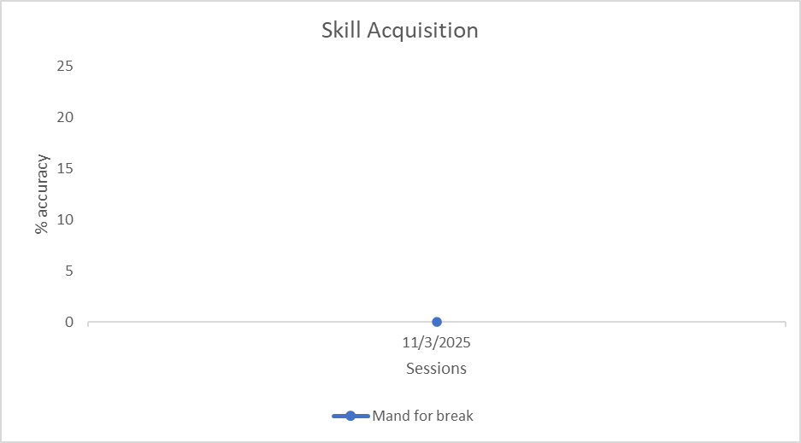
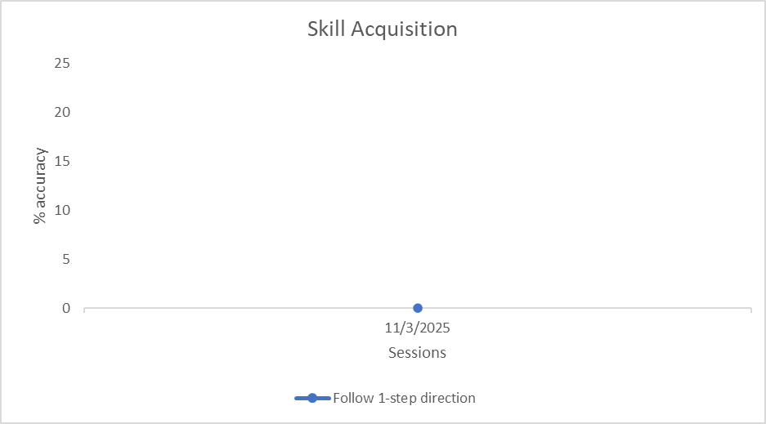
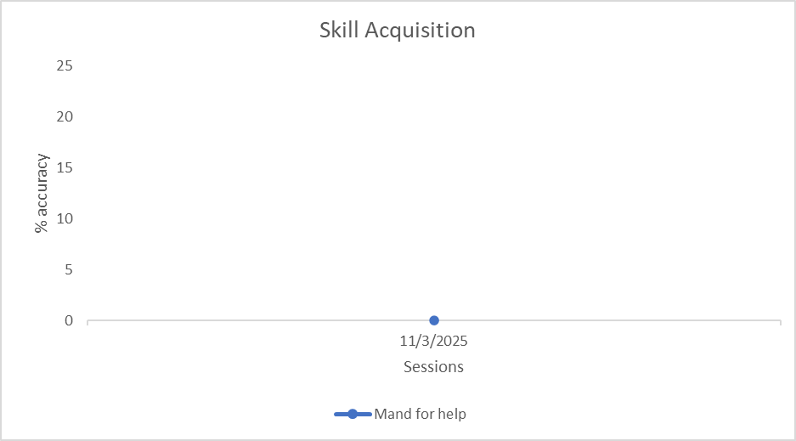

Caregiver Training Goals

  - Data Collection: (This program will cover all the maladaptive behavior in this assessment.)
  - Interventions/Environmental manipulations (This program will cover all the proposed interventions in this assessment.) Caregiver will continue working on being be able to implement the following intervention upon occurrence of maladaptive behaviors. Intervention monitored: Premack Principle
During parent training, each week the analyst will observe and determine the percent of occurrence in which the caregiver implemented the intervention for every time the maladaptive behaviors occur. Caregiver’s progress will be graphed monthly.
STO1 Caregiver will independently demonstrate Premack Principle procedure, 20% of opportunities, for two months. Expected mastery January 2026
STO 2 Caregiver will independently demonstrate Premack Principle procedure, 40% of opportunities, for two months.
STO3 Caregiver will independently demonstrate Premack Principle procedure, 60% of opportunities, for two months.
STO 4 Caregiver will independently demonstrate Premack Principle procedure, 80% of opportunities, for two months
LTO Caregiver will independently Caregiver will independently demonstrate Premack Principle procedure near 100% of opportunities, for two months. Expected mastery January 2027

{%caregiver_premack_graph}

Use of Reinforcement. Caregiver will continue working on being be able to provide continuous reinforcement upon the occurrence of CLIENT engaging in an appropriate replacement program.

During the parent training, each week the analyst will observe and determine the percent of occurrence in which the caregiver demonstrate the use of reinforcement. Caregiver’s progress will be graphed monthly.

STO 1 Caregiver will demonstrate the use of reinforcement (contingent to replacement behavior) ,20 % of opportunities for two months. Expected mastery January 2026
STO 2 Caregiver will demonstrate the use of reinforcement (contingent to replacement behavior),40 % of opportunities for two months.
STO 3 Caregiver will demonstrate the use of reinforcement (contingent to replacement behavior), 60 % of opportunities for two months.
STO 4 Caregiver will demonstrate the use of reinforcement (contingent to replacement behavior) ,80 % of opportunities for two months.
LTO Caregiver will demonstrate the use of reinforcement (contingent to replacement behavior), near 100 % of opportunities, for two months. Expected mastery December 2026

{%caregiver_reinforcement_graph}

Professional Conduct and Scope of Practice
- Describe the BACB’s RBT supervision requirements and the role of RBTs in the service-delivery system.
- Respond appropriately to feedback and maintain or improve performance accordingly.
- Communicate with stakeholders (e.g., family, caregivers, other professionals) as authorized.
- Maintain professional boundaries (e.g., avoid dual relationships, conflicts of interest, social media contacts). Maintain client dignity.
- LEAD ANALYST will work with CLIENT 4 hours a week, in the she following primary content areas: Measurement, Assessment, Skill Acquisition, Behavior Reduction, Documentation and Reporting, and Professional Conduct and Scope of Practice.
- LEAD ANALYST will supervise the RBT 5% to 15% of the RBT’s hours depending of the necessity.
- LEAD ANALYST (lead Analyst) will work 2 hours a week on Caregivers Training and RBT supervision.
- LEAD ANALYST will supervise the RBT at least 5% of the RBT’s hours depending of the necessity.
- Practitioner responsible for the implementation of BA services including: the completion and review of behavior assessments, reassessments, behavior plans, and behavior plan reviews.
Florida Medicaid. Behavior analysis services coverage policy, AHCA October 2017. Coverage information, page 3: “4.2.2 Behavior Analysis Up to 40 hours per week, per recipient, consisting of services identified on the recipient’s behavior plan in order to reduce maladaptive behaviors and to restore the recipient to his or her best possible functional level. Services include: – Implementing behavior analysis interventions, and monitoring and assessing the recipient’s progress towards goals in the behavior plan – Behavior analysis interventions, for example, discrete trial teaching, task analysis training, differential reinforcement, non-contingent reinforcement, conducting task analyses of complex responses, and teaching using chaining, prompting, fading, shaping, response cost, and extinction – Training the recipient’s family, caregiver(s), and other involved persons on the implementation of the behavior plan and intervention strategies (the recipient must be present when clinically appropriate).”
Flexibility in the schedule is needed to determine which days and times are best for CLIENT to work on programs, always following the schedule previously agreed with CLIENT ’s caregiver, and making accommodation according to their preferences/needs.

RBT Schedule:
RBT will work with CLIENT tentatively Monday - Saturday by 4 or 6 hours daily, and when caregiver requests some Sundays, too.
Flexibility in the schedule is needed to determine which days and times are best for CLIENT to work on programs, always following the schedule previously agreed with CLIENT’s caregiver, and making accommodation according to their preferences/needs.
Monday  5 hours during the session | Tuesday  5 hours during the session | Wednesday 5 hours during the session | Thursday  5 hours during the session | Friday  5 hours during the session
RBT implements replacement goals and verbal behavior goals | RBT implements replacement goals and verbal behavior goals | RBT implements replacement goals and verbal behavior goals | RBT implements replacement goals and verbal behavior goals | RBT implements replacement goals and verbal behavior goals
RBT provides data collection of behaviors during all hours RBT will generalize behaviors to other settings such as parks, mall, etc.

- The Behavior plan will be reviewed with family members/staff and include explanations and demonstrations of procedures to be employed.
- Family members will initially observe Lead Analyst training with RBT in Behavior Plan implementation and will be asked to participate in data collection, prompting of replacement behaviors, and response strategies.
- Competency check will be completed once a month with the family members.
- Lead Analyst will train and monitor Behavior Assistant 2-3 days a week and record performance on the behavior plan.
- Lead Analyst will train parents on effectively implementing Behavior Plan.
- Training will consist of explanation and demonstration of procedures to be employed, as well as direct observation and feedback.
- Competency check will be completed once a month once with the RBT.
- If problems are evident during observations, retraining will occur as necessary (i.e., review, explanation, and demonstration of procedures).
- Train parents on basic principles of behavior management.

Recommendations

It is strongly recommended that behavior analysis services be approved to assist CLIENT with the reduction of maladaptive behaviors as well as to increase some alternative appropriate behaviors that allow CLIENT to enjoy a peaceful family environment, developing meaningful relationships and participating with age peers and family members in group’s activities and outings as well to encourage placement in a least restrictive environment at school. Additionally, these skills should promote the behavior necessary for CLIENT to improve overall functioning skills. Due to the high intensity and frequencies or CLIENT ’s maladaptive behaviors, a tiered model will be required in order to be able see the most improvement and decrease therapy frequency in the future. CLIENT is minimally verbal and will need to be taught basic gestures, such as pointing, in order to communicate. The requested hours are necessary due to the amount of time it will take to teach CLIENT basic gestures to communicate.

Coordination of Care

The behavior analyst/assistant will share the behavior plan and behavior plan updates with medical specialists and/or ordering physician per caregiver’s request annually. Collaboration will be at caregiver’s request in the form of phone calls, email and/or even face-to-face meetings if requested.

Generalization and Maintenance

Procedures will be implemented at home, and in the community using different trainers (caregiver, registered behavior therapist, behavioral analyst, and/or behavior assistant) to promote generalization. As soon as caregiver can, caregiver should start to implement the programs. Incidental teaching will be used to further generalization. After mastery, these procedures will be incorporated into CLIENT ’s daily routine and the schedules of reinforcement will be thinned to promote maintenance of behavior. Least to most prompting is going to be used for all training. Prompting will be faded to least restrictive form.

Program Change Criteria
If no progress has been demonstrated over a period of three months, the program will be analyzed to determine the reason, and modifications, adjustments, or training will occur to achieve progress.

Discharge Criteria
Services will be terminated when all behaviors targeted for reduction are at an average of less than 1 incidents per week, for 6 consecutive months; all short-term objectives for replacement behaviors and other skill acquisition programs are met, and caregiver meets, at least, 95% criteria of competency implementing interventions and programs included in this BASP. Competency will be assessed to determine meeting criteria before termination.

Transition Plan
Transition plan will be used as a step-down process. As CLIENT is close to reach LTO, analyst will evaluate and determine if a step-down service (psychotherapy and/or any other less intrusive/intense services) is appropriate. Plan will be developed with caregiver and coordinate linkage.
Phase | Action Steps (Linked to Goals) | Criteria for Progression | Time Frame | BCBA Supervision (97155) | RBT Direct (97153)
Phase 1: Skill Acquisition & Stabilization | 1. Reduce maladaptive behaviors (e.g., aggression, elopement, non-compliance, tantrums) through implementation of the Behavior Intervention Plan (BIP).  2. Increase functional communication (FCT) to request needs (e.g., “help,” “break,” “more”) with minimal prompting.  3. Teach replacement behaviors (e.g., waiting, following one-step directions, transitioning appropriately).  4. Introduce caregiver/staff training on prompting, reinforcement, and behavior strategies. | 1. Maladaptive behaviors reduced to < 3 occurrences/hour across settings.  2. ≥ 80% independence across communication and replacement behavior targets for 3 consecutive weeks.  3. Caregiver demonstrates basic implementation of strategies with BCBA support. | 6 consecutive months | 5 hrs/week | 30 hrs/week
Phase 2: Generalization Across Settings | 1. Maintain behavior reduction across school, home, and community environments.  2. Increase independence in transitions, group participation, and task completion.  3. Expand communication to include spontaneous manding and responding to social interactions.  4. Continue caregiver training with focus on consistency and generalization. | 1. Maladaptive behaviors reduced to < 2 occurrences/hour across environments.  2. ≥ 80% independence maintained across all targets.  3. Demonstrates generalization with at least 2 different people/settings. | 6 consecutive months | 4 hrs/week | 25 hrs/week
Phase 3: Independence & Self-Management | 1. Increase independent use of coping strategies (e.g., requesting breaks, self-regulation strategies).  2. Improve social skills (e.g., initiating interactions, respecting boundaries, turn-taking).  3. Teach self-monitoring/self-management strategies.  4. Fade prompts and reinforcement to more natural schedules. | 1. Maladaptive behaviors reduced to < 1 occurrence/hour.  2. ≥ 90% independence across adaptive, communication, and social goals.  3. Demonstrates independent initiation of skills in unstructured settings. | 6 consecutive months | 2 hrs/week | 15 hrs/week
Phase 4: Maintenance, Caregiver Mastery & Discharge | 1. Maintain skills across all environments without reliance on direct ABA support.  2. Caregiver/staff independently implement behavior strategies with high fidelity.  3. Prepare for transition to reduced services or discharge (home/school/community plan in place). | 1. Maladaptive behaviors reduced to ≤ 0.5 occurrences/hour.  2. ≥ 90% independence across all domains.  3. Caregiver demonstrates ≥ 90% fidelity with intervention strategies.  4. Skills maintained for minimum of 4–8 weeks without intensive support.

Services Recommendations

CPT | Description of Service | # of units | Location | Person  Providing  Service
97155 | Behavior Analysis- Lead Analyst | 412 units | Home and community | Lead Analyst
97156 | Behavior Analysis- Lead Analyst | 208 units | Home and community | Lead Analyst
97153 | Behavior Analysis- Technician/Behavioral Assistant | 3120 units | Home and community | Technician

Crisis Plan
Please check risk factors as applicable at time of interview/assessment.
☐ Assaultive Behavior X Social Isolation
☐ Self-Injurious Behavior | ☐ | Sexually offending behavior
☐ Fire setting | ☐ | Current substance abuse
X Impulsive Behavior | ☐ | Psychotic Symptoms
☐ Self-mutilation/cutting | ☐ | Caring for ill family recipient
☐ Current family violence  ☐ Prior psychiatric inpatient admission  ☐ other _____________________________  Suicidality | ☐ | Coping with significant loss
☒Not present ☐Ideation ☐Plan ☐Means Homicidality: |  | ☐Prior attempt (last 12 months)
☒Not present ☐Ideation ☐Plan ☐Means |  | ☐Prior attempt (last 12 months)
Caregiver was instructed to call 911 if CLIENT ’s behavior becomes life threatening in any situation. Also, to call significant person within the family if they recognize something they think is not manageable with their resource.
If CLIENT becomes aggressive or engages in Stereotypical behavior, block the responses by holding CLIENT ’s arms for no more than 15 seconds and move him away from other people. When no physical aggression or Stereotypical behavior has been exhibited for at least 1 minute, tell him to relax, ask for a break, tangibles, or attention.
Caregiver Plan for Prevention of Crisis:
- Caregiver needs to have a clear understanding of the goals and objectives detailed in the behavior plan.
- Caregiver needs to have a clear understanding of CLIENT’s target maladaptive behavior, the precursors to the target behavior, triggers which cause escalation.
- Caregivers should have with them contact details of people that can be involved in the de-escalation process. Names and Phone Numbers clearly available, preferably written down physically and digitally (cell phone). Emergency information cards with the crisis plan and important information about your child can be posted in your home for caregivers, therapists, and first responders.
- Understanding of communication techniques which prevent a miscommunication and project calm toward the person in crisis.
- Understanding of the phases of escalation and have an ability to follow through on steps to prevent escalation during appropriate moments (when triggers are unpreventable for example).
- Understand the signs leading up to behavior that is harmful or dangerous to CLIENT or others.
- Caregivers (parents, siblings, family members) should be taught crisis management techniques by the Analyst and have an understanding of basic crisis management.

Print Parent/Guardian Name: ___________________
Parent/Guardian Signature ______________________ Date:

Lead Analyst Name: ________________________

Behavior Analyst Signature: _____________________ Date:

