Group: Iker, Lucía, Samuel, Adrián
Development Environment
Bank System
Final Project

1.- Introduction & System description 2
2.- Requirement specification 2
2.1. Functional requirements 2
2.2. Non-functional requirements 3
2.3. System Requirements 3
3.- USE CASE DIAGRAM
4.- CLASS DIAGRAM
5.- SCREEN / UI DESIGN
6.- EXPECTED MILESTONE SCHEDULE

1.- Introduction & System description
This project focuses on the development of a Digital Banking System, designed to securely and efficiently manage the essential operations of a modern bank. The system allows users to perform actions such as checking account balances, managing multiple accounts, making transfers, reviewing transaction history, and updating personal information. All functionalities are presented through a clear, structured, and user-friendly interface.

2.- Requirement specification

2.1. Functional requirements
The system must provide the following functional capabilities:
- User Authentication
  - The system must allow users to log in using a valid username and password.
- Account Management
  - Users must be able to view all their bank accounts.
  - The system must display account details such as balance, account number, and account type.
  - Users must be able to update personal information (email, phone number, address).
- Balance Inquiry
  - Users must be able to check the current balance of any of their accounts.
  - The system must retrieve and display real-time account information.
- Transaction Management
  - Users must be able to view a list of recent transactions.
- Money Transfers
  - Users must be able to transfer money between their own accounts.
  - Users must be able to transfer money to external accounts.
  - The system must validate available balance before completing a transfer.
- Security & Session Control
  - The system must automatically log out inactive users after a defined period.
  - The system must encrypt sensitive data such as passwords and account numbers.

2.2. Non-functional requirements

- The interface must be intuitive and easy to navigate.
- All sensitive data must be encrypted.
- Significant changes must be recorded for the system.
- The systems must be able to handle multiple clients at the same time

2.3. System Requirements

- The balance is updated in real time.
- There are different types of users.
- Employe has special permission.

REQUERIMENTS
SYSTEM | FUNCTIONAL | NON-FUNCTIONAL
- Update balance in real time | - Sign up | - Hashing password
- Different types of users | - Login | - Significant changes must be recorded (day and hour)
- The admin have special permissions | - Customers can view their recent transactions | - Must be able to handle multiple clients at the same time
 | - If a customer enters the wrong password 3 times in a row ,the account must be marked as blocked
 | - The admin can lock, unlock accounts
 | - Customers can deposit / withdraw money
 | - Users can apply for a loan, which will be approved or denied by the employee
 | - Users can make a transfer

3.- Use case diagram

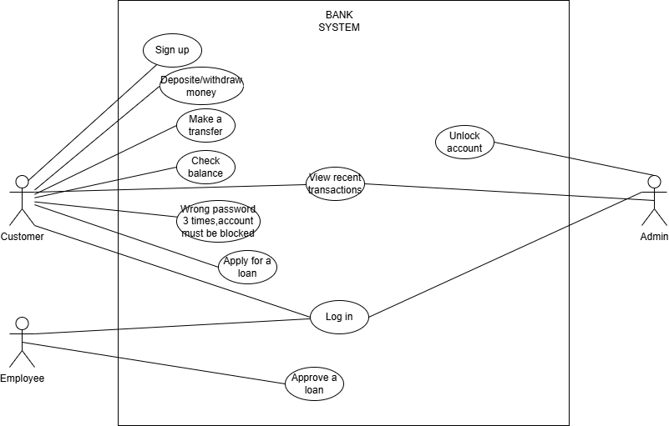

4.- Class diagram

5.- Screen / UI Design
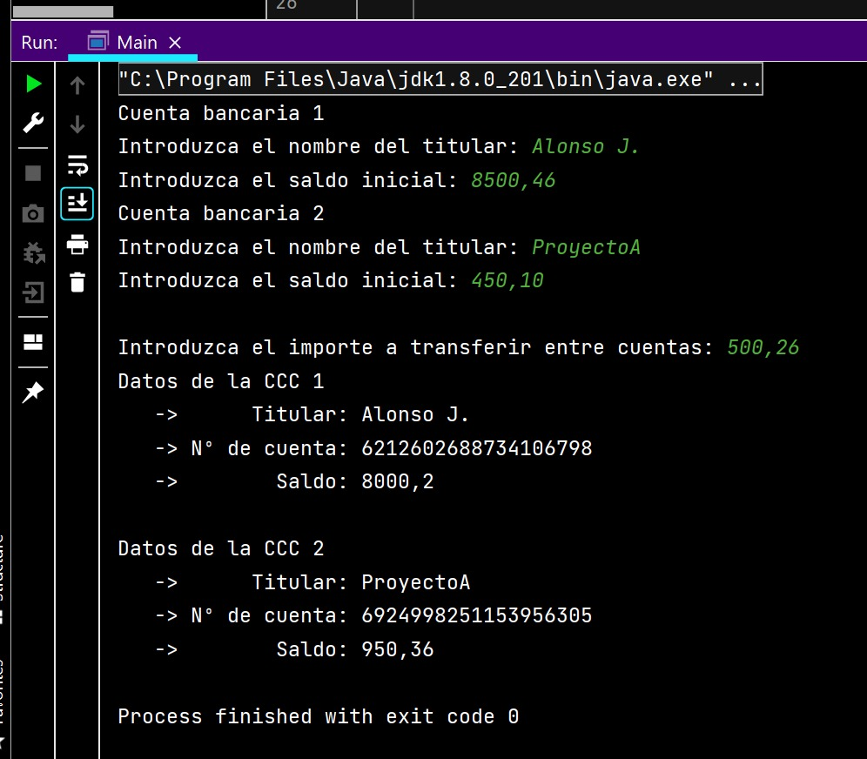

6.- Expected Milestone Schedule

