 | TECHNICAL UNIVERSITY OF MOLDOVA  Faculty of Computers, Informatics, and Microelectronics  Department of Software Engineering  Software Engineering Study Programme

LABORATORY REPORT
OPERATING SYSTEMS LABORATORY 3
The Command Line: Shell, Pipes, and Text Filters

Student: Lucian-Adrian Gavril
Group: FAF-241
Coordinator: univ. assist., Reițman Patricia
Chișinău, 2026

TABLE OF CONTENTS
ABSTRACT 3
INTRODUCTION 4
1 NAVIGATION AND COMMAND INSPECTION 5
1.1 Tab completion and history recall 5
1.2 Built-in commands versus external utilities 5
1.3 Answers to Part 1 Observe questions 6
2 SHELL LINE PARSING AND EXPANSIONS 8
2.1 Parsing phases and test directory creation 8
2.2 Globbing and expansion verification 8
2.3 Command prediction and verification table 9
2.4 Answers to Part 2 Observe questions 10
3 I/O REDIRECTION, CHAINING, AND JOBS 12
3.1 File descriptor redirection 12
3.2 Control operators and background job management 12
3.3 Answers to Part 3 Observe questions 13
4 ANALYTICAL TEXT FILTERS 15
4.1 Web access dataset structure 15
4.2 Single-command pipeline solutions 15
5 STRUCTURED SHELL AUTOMATION 20
5.1 Implementation of report.sh 20
5.2 Cron daemon integration 21
5.3 Answers to Part 5 Observe questions 22
CONCLUSIONS 23
REFERENCES 24

Abstract
This report examines shell command lookup, parsing, expansion, I/O redirection, control operators, and text-filter pipelines over a 500-request web access dataset. It also implements and tests a shell report script and documents a temporary cron run. The 24 required figures are genuine terminal captures from Dev1 Debian GNU/Linux 13, recorded on 10 October 2026. Dataset and script results were checked against the 9 October run record. Dev1 is a remote host; these records do not establish use of the assigned course laptop or VM.
Keywords: operating systems, bash, unix pipelines, text filters, stream redirection, shell scripting, process environment

Introduction
The command-line interface is the primary operational surface through which an operating system kernel is directed. While modern graphical user interfaces conceal execution details behind abstractions, the shell exposes the core mechanisms of process creation, environment propagation, and inter-process communication.
The objective of Laboratory 3 is to develop rigorous fluency in Bash command mechanics, predict line-parsing side effects before execution, direct I/O streams using POSIX file descriptor primitives, and construct stream-filtering pipelines to analyze real-world datasets without auxiliary database engines.
The figures are genuine terminal captures from the Dev1 Debian GNU/Linux 13 host, recorded on 10 October 2026. Earlier dataset and script values were checked on 9 October and are reproduced alongside the captures. These records do not establish that the assigned course laptop or VM was used.
The Bash and POSIX semantics follow the cited manuals [4, 3]; the small-filter approach follows the cited administration texts [1, 2].
The laboratory comprises five distinct parts:
a) Navigation and Command Inspection: Distinguishing shell built-ins from external binaries, evaluating environment lookup paths, and analyzing exit statuses.
b) Line Parsing and Expansion Rules: Evaluating brace expansion, tilde expansion, parameter substitution, command substitution, arithmetic expansion, word splitting, pathname expansion (globbing), and quote suppression.
c) Redirection, Control Operators, and Job Control: Characterizing standard file descriptors (stdin, stdout, stderr), order-dependent redirection syntax, conditional chaining operators (;, &&, ||), and asynchronous process management.
d) Analytical Text Filters: Formulating single-command pipelines to answer discrete statistical questions on an artificial web access log.
e) Structured Shell Automation: Implementing a robust POSIX shell script with argument validation, stream aggregation, error handling, and cron daemon scheduling.

1 Navigation and Command Inspection

1.1 Tab completion and history recall
Command completion and incremental history search decrease operational latency and reduce lexical errors. In Bash, typing ls /usr/sh followed by a double Tab invokes readline completion, querying the filesystem for matching entries. When the prefix is ambiguous, the shell prints all candidate entries (share/, shift/). Conversely, typing cd /et followed by a single Tab resolves unambiguously to cd /etc/, appending the directory slash and awaiting user arguments (Figure 1.1).
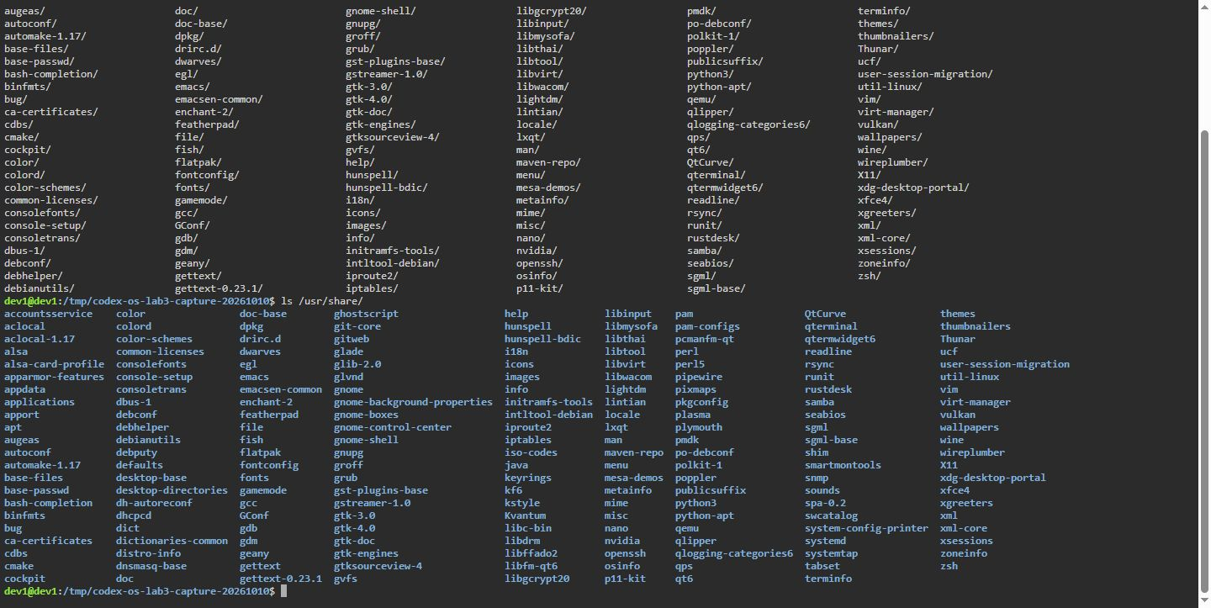 Figure 1.1. Terminal capture, Dev1 Debian GNU/Linux 13, 10 October 2026: Tab completion behavior for ambiguous and unambiguous path prefixes.
The readline reverse-search utility, triggered via Ctrl+R, queries the history buffer stored in memory and persisted in ~/.bash_history. By entering search substrings, previously executed commands are recalled without re-typing.

1.2 Built-in commands versus external utilities
When a user issues a command, the shell determines whether the symbol corresponds to an internal shell built-in or an external binary located on disk. The type built-in queries this categorization, whereas which searches only filesystem directories registered in the PATH variable (Figure 1.2).
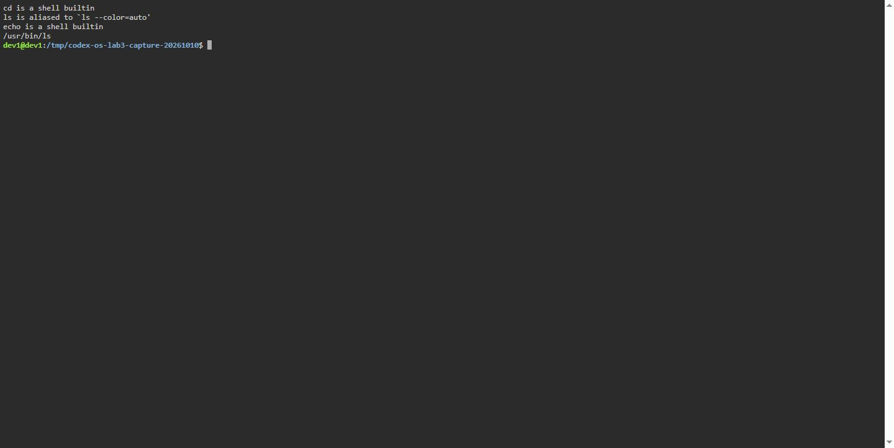 Figure 1.2. Terminal capture, Dev1 Debian GNU/Linux 13, 10 October 2026: Classification of built-in versus external executable commands.
The PATH variable holds a colon-delimited list of directories traversed sequentially from left to right when an unqualified command name is provided. Piping this variable through tr ':' '\n' presents each search tier on an individual line (Figure 1.3).
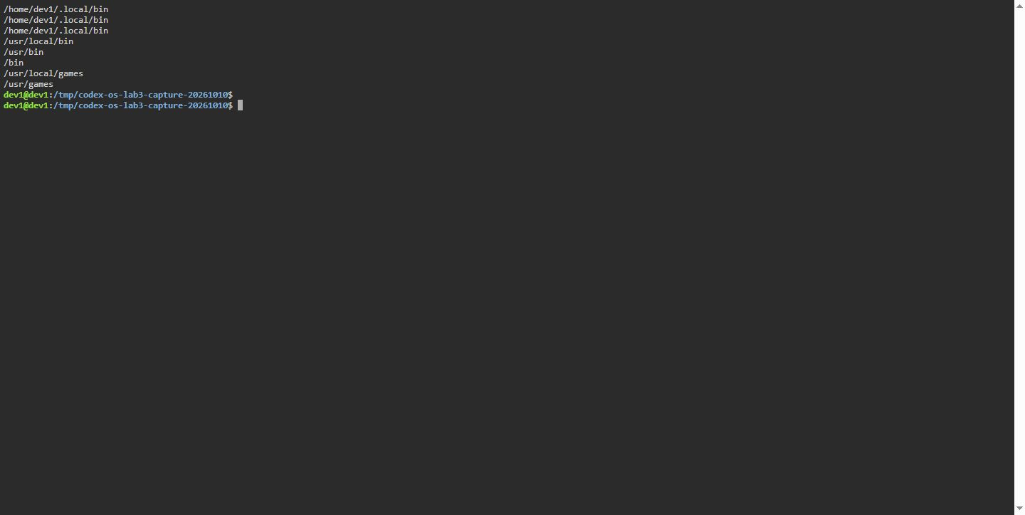 Figure 1.3. Terminal capture, Dev1 Debian GNU/Linux 13, 10 October 2026: System PATH hierarchy directories printed one per line.
When a command cannot be found within any directory of PATH, the shell returns an exit code of 127 (Figure 1.4).
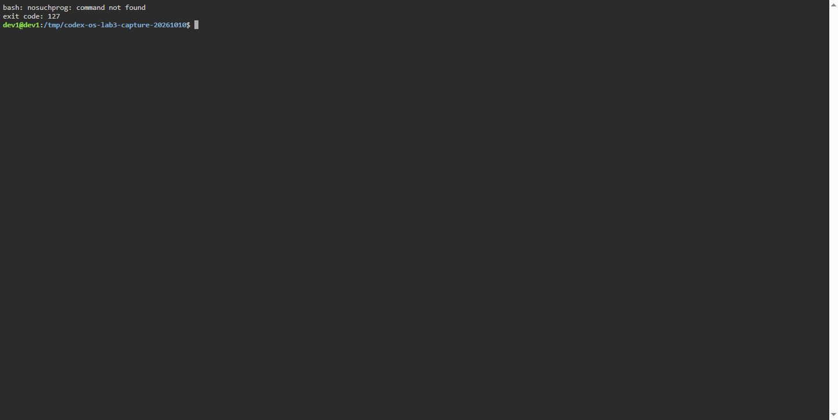 Figure 1.4. Terminal capture, Dev1 Debian GNU/Linux 13, 10 October 2026: Exit status code 127 produced by an unresolvable command name.

1.3 Answers to Part 1 Observe questions
a) Which of cd, ls, echo are built-ins, and why MUST cd be one?
cd and echo are shell built-ins, whereas ls is an external binary located at /usr/bin/ls. cd MUST be a built-in because the current working directory is a state attribute stored in the process control block of the running shell. If cd were implemented as an external binary, the shell would invoke fork() and exec() to run it; the child process would change its own working directory via chdir() and immediately terminate, leaving the parent shell’s working directory unchanged.
b) How many directories are in your PATH, and in which one is ls?
The 9 October Debian 13 check listed 4 PATH entries and resolved ls to /usr/bin/ls. PATH length depends on the host; check the assigned course system if required.
c) What exit code does a command that is not found return?
Standard POSIX Bash returns exit status code 127.
d) Which option of ls sorts by modification time?
The -t flag sorts entries by modification time (newest first). Appending -r reverses the sort order.

2 Shell Line Parsing and Expansions

2.1 Parsing phases and test directory creation
Prior to program execution, the shell processes the input string through distinct parsing phases: tokenization, brace expansion, tilde expansion, parameter expansion, command substitution, arithmetic expansion, word splitting, pathname expansion (globbing), and quote removal.
A test sandbox directory ~/os-lab3/play was instantiated containing standard and edge-case filenames, notably filenames containing embedded whitespace (Figure 2.1).
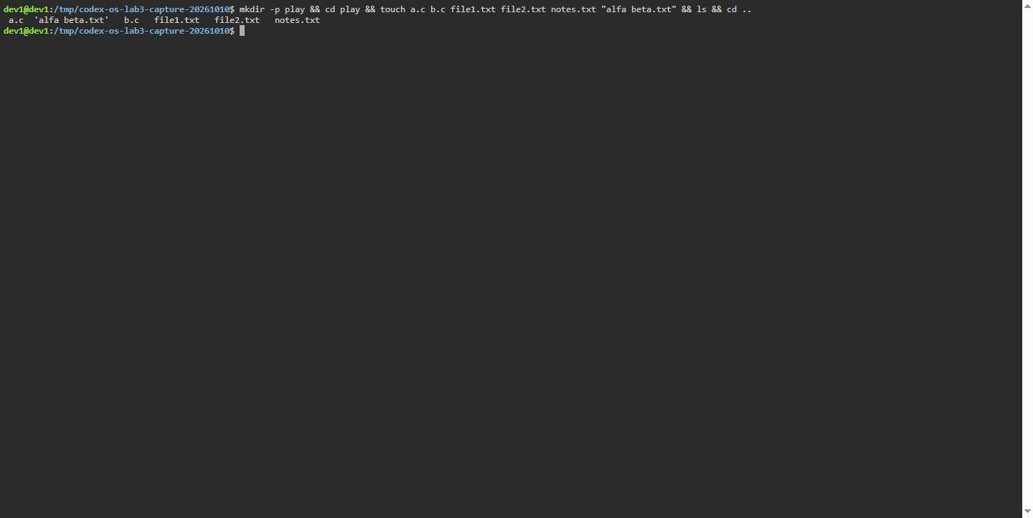 Figure 2.1. Terminal capture, Dev1 Debian GNU/Linux 13, 10 October 2026: Files created in the play directory for parsing verification.

2.2 Globbing and expansion verification
Pathname expansion replaces wildcard patterns with sorted matching filesystem entries. If no entry matches, Bash retains the literal wildcard text unless nullglob is explicitly set (Figure 2.2).
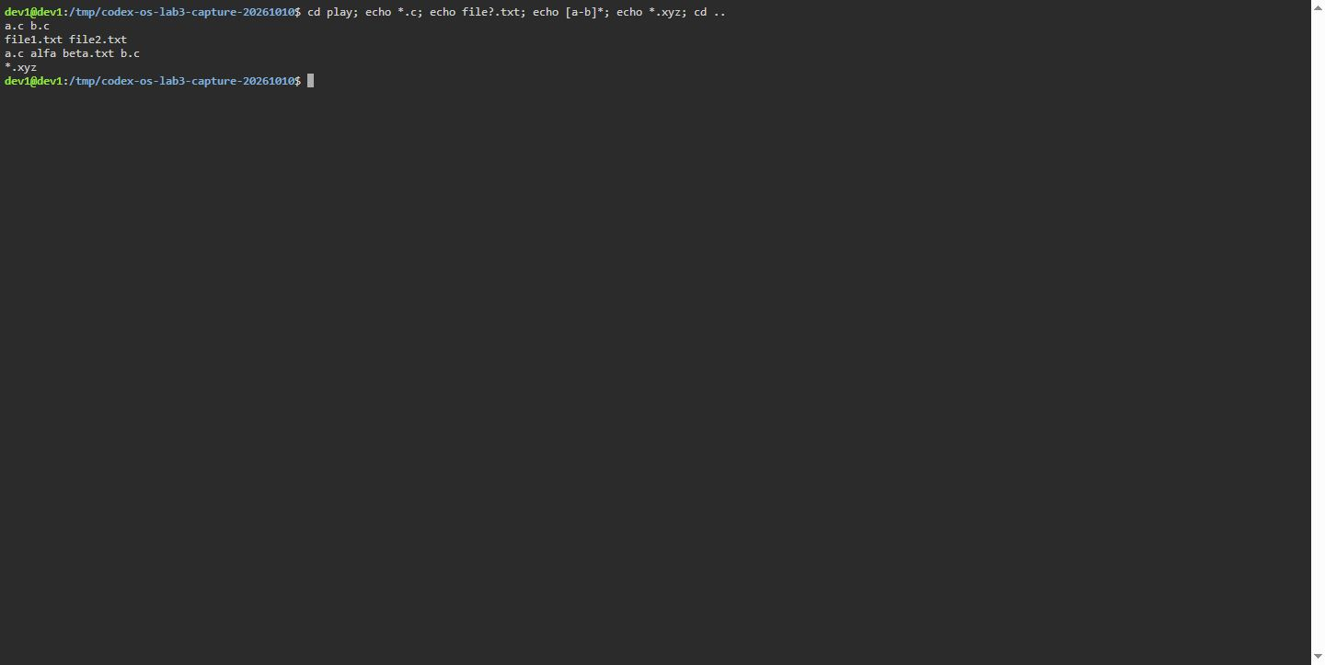 Figure 2.2. Terminal capture, Dev1 Debian GNU/Linux 13, 10 October 2026: Pathname expansion (globbing) results across character sets and extensions.
Word splitting is governed by the Internal Field Separator (IFS, space by default). Unquoted whitespace causes the tokenizer to split strings into multiple distinct arguments, resulting in execution failures when referencing files with spaces (Figure 2.3).
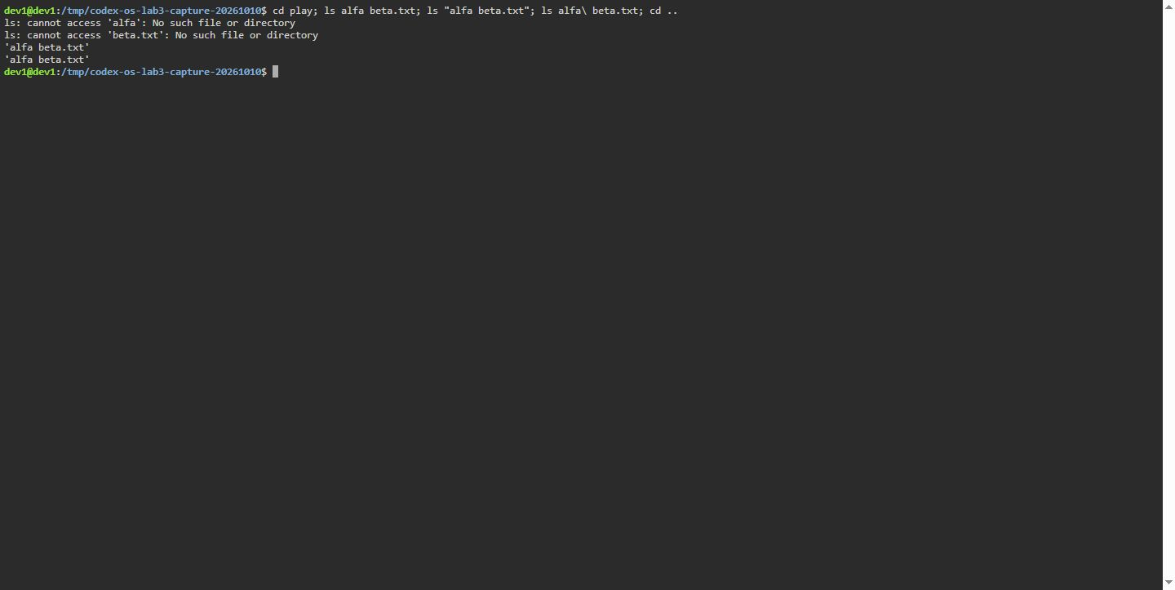 Figure 2.3. Terminal capture, Dev1 Debian GNU/Linux 13, 10 October 2026: Word splitting failure on filenames with spaces and proper quoting fixes.
Single quotes ('...') suppress all expansions, treating every character literally. Double quotes ("...") prevent globbing and word splitting while allowing parameter expansion and command substitution. Backslashes (\) escape individual metacharacters (Figure 2.4).
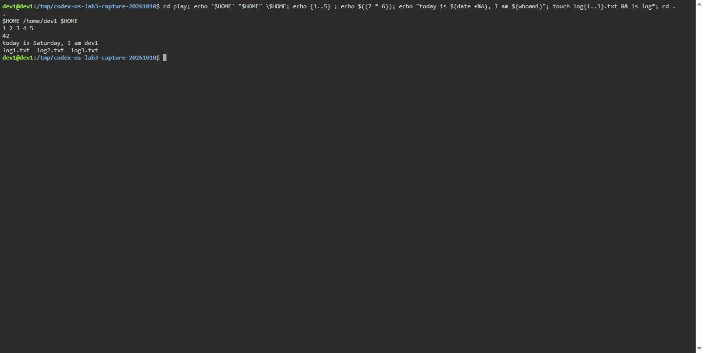 Figure 2.4. Terminal capture, Dev1 Debian GNU/Linux 13, 10 October 2026: Quotation semantics, arithmetic expansion, and subshell substitution.

2.3 Command prediction and verification table
Table 2.1 keeps pre-run predictions separate from example output values. Figures 2.1-2.4 show observed command behavior; later dataset and script sections report measured outputs from the retained run records.
Table 2.1 – Predictions and fixed illustrative examples; outputs are not retained measurements.
Command | Prediction | Illustrative example, not measured | Explanation
echo *.c | Prints all C source files | a.c b.c | Shell expands *.c to directory matches before invoking echo.
echo file?.txt | Matches single wildcard character | file1.txt file2.txt | ? matches exactly one character.
echo [a-b]* | Matches files starting with a or b | a.c b.c | Character range [a-b] expands matching files.
echo *.xyz | Prints literal pattern | *.xyz | Unmatched glob pattern is preserved as literal text.
ls alfa beta.txt | Attempts to list two files; fails | Error: No such file or directory | Shell splits unquoted space into two separate arguments.
ls "alfa beta.txt" | Lists single file with space | 'alfa beta.txt' | Double quotes prevent word splitting across whitespace.
echo '$HOME' "$HOME" \$HOME | Literal, expanded, literal | $HOME /home/user $HOME | Single quotes disable expansion; double quotes expand; backslash escapes.
echo {1..5} ; echo $((7*6)) | Sequence 1 to 5; arithmetic 42 | 1 2 3 4 5  42 | Brace expansion creates sequence; $((...)) computes arithmetic.
echo "today is $(date +%A)..." | Formats current date and user | today is Monday, I am ubuntu | Command substitution executes subshell and injects output.
touch log{1..3}.txt && ls log* | Creates and lists 3 log files | log1.txt log2.txt log3.txt | Brace expansion creates three targets; globbing lists them.
The 10 October terminal capture records /home/dev1 and today is Saturday, I am dev1; these values depend on the host and date.

2.4 Answers to Part 2 Observe questions
a) echo knows nothing about files, yet echo *.c printed file names. Who produced them?
The shell produced them during the pathname expansion phase before invoking echo. The shell queries the filesystem directory table, sorts matching entries, and replaces the token *.c with arguments argv[1] = "a.c" and argv[2] = "b.c". The echo binary merely iterates over its argument array and writes them to stdout.
b) Why did ls alfa beta.txt fail? Give two different ways to fix it.
It failed because the unquoted space acts as an argument delimiter. The shell invoked ls with two arguments: "alfa" and "beta.txt". Because neither file exists independently, ls produced two error messages. Fix 1: Enclose the target string in quotes: ls "alfa beta.txt". Fix 2: Escape the space character using a backslash: ls alfa\ beta.txt.
c) What is the difference between single and double quotes?
Single quotes treat every character enclosed literally, disabling parameter expansion ($VAR), command substitution ($(...)), and arithmetic evaluation. Double quotes suppress globbing and word splitting while preserving variable expansion, command substitution, and backslash escaping.
d) Why does ls show the file with a space in quotes ('alfa beta.txt')?
Modern GNU Coreutils ls defaults to --quoting-style=shell-escape, quoting filenames containing whitespace or shell metacharacters so the printed representation can be safely copied and re-entered into a shell prompt without splitting errors.

3 I/O Redirection, Chaining, and Jobs

3.1 File descriptor redirection
In POSIX systems, processes interact with standard streams via integer descriptors: standard input (0), standard output (1), and standard error (2). Redirection operators alter stream destinations by opening files and duplicating descriptors using the dup2() system call prior to process execution (Figure 3.1).
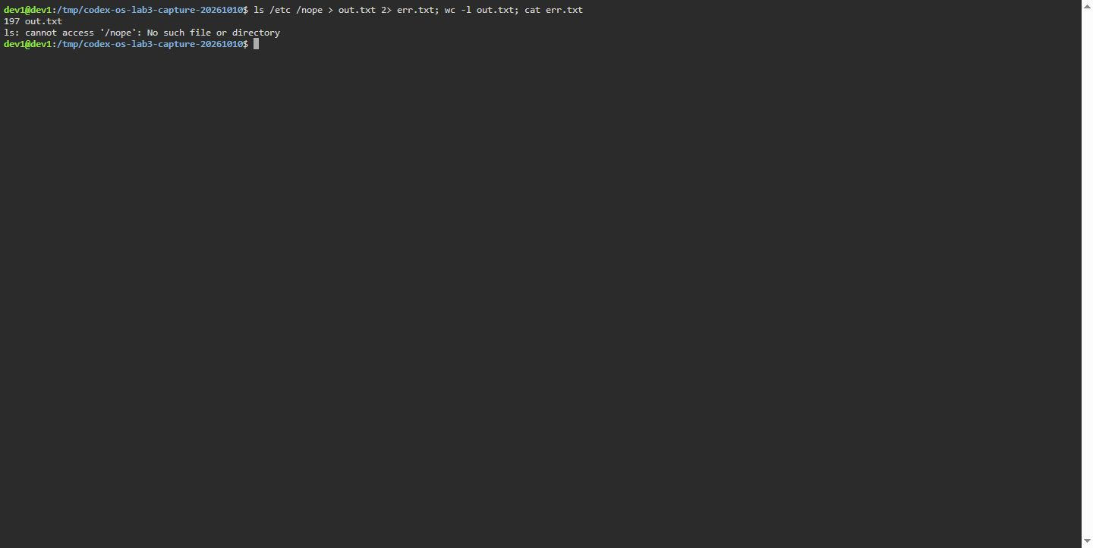 Figure 3.1. Terminal capture, Dev1 Debian GNU/Linux 13, 10 October 2026: Separation of stdout and stderr into dedicated output files.
The lexical order of redirection operators is evaluated strictly from left to right. When executing ls /etc /nope > all.txt 2>&1, file descriptor 1 is pointed to all.txt, and descriptor 2 is then duplicated to match descriptor 1. In contrast, in ls /etc /nope 2>&1 > all.txt, descriptor 2 is duplicated to where descriptor 1 currently points (the terminal), after which descriptor 1 is redirected to the file, leaving error messages on the terminal screen (Figure 3.2).
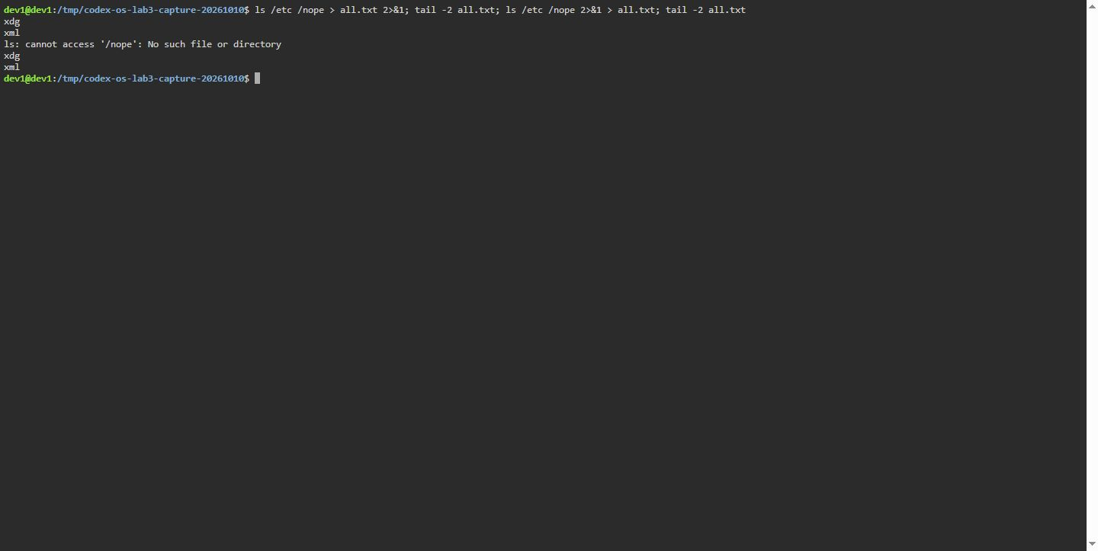 Figure 3.2. Terminal capture, Dev1 Debian GNU/Linux 13, 10 October 2026: Comparison of redirection evaluation ordering.

3.2 Control operators and background job management
Sequential execution operators regulate command execution based on exit status:
- ; unconditionally executes the subsequent command.
- && executes the subsequent command only if the preceding command succeeded (exit status 0).
- || executes the subsequent command only if the preceding command failed (non-zero exit status).
Figure 3.3 illustrates operator behavior under both failure and success cases.
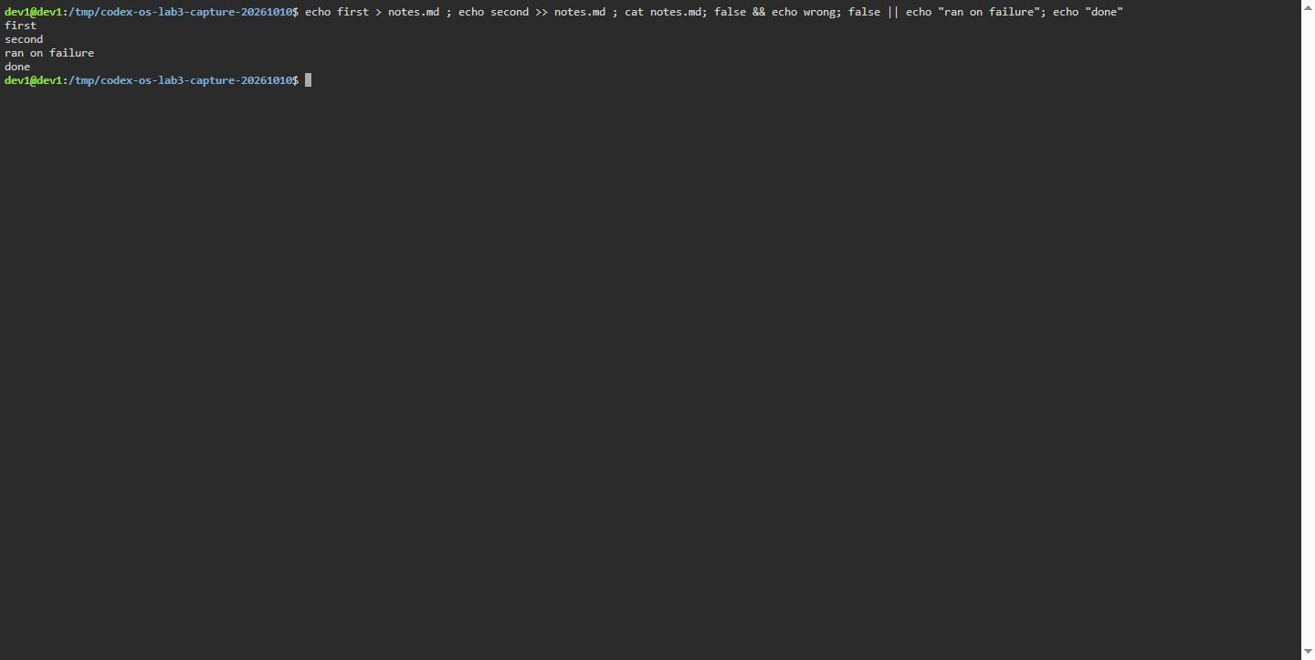 Figure 3.3. Terminal capture, Dev1 Debian GNU/Linux 13, 10 October 2026: Execution control using conditional operators and subshells.
Appending & detaches a process from the shell’s foreground execution, allowing the shell prompt to accept subsequent commands immediately while the child executes asynchronously. Background jobs are managed using the jobs built-in and terminated via signals with kill (Figure 3.4).
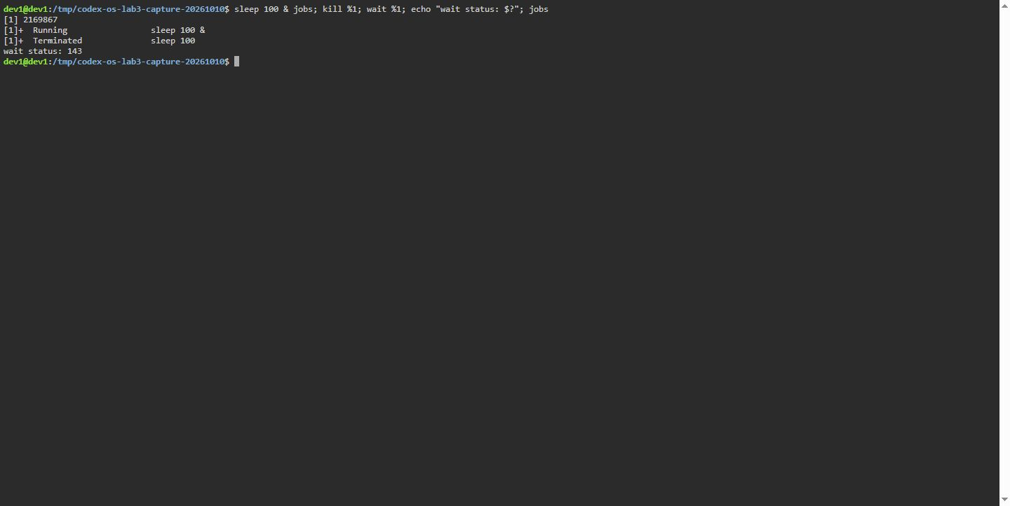 Figure 3.4. Terminal capture, Dev1 Debian GNU/Linux 13, 10 October 2026: Launching an asynchronous background process and terminating via SIGTERM.

3.3 Answers to Part 3 Observe questions
a) Which file got the error message, and which got the listing?
err.txt received the error message (ls: cannot access /́nope.́..). The 9 October Debian 13 check recorded 197 stdout lines for ls /etc /nope, which includes a directory heading; see the retained raw check log.
b) What is the difference between > all.txt 2>&1 and 2>&1 > all.txt?
In > all.txt 2>&1, standard output is first redirected to all.txt; then descriptor 2 is duplicated to point to the file descriptor of all.txt, routing both streams into the file. In 2>&1 > all.txt, descriptor 2 is duplicated to point to stdout’s current destination (the terminal screen); subsequently, descriptor 1 is redirected to all.txt. Thus, stderr remains connected to the terminal while only stdout reaches the file.
c) Why does wc -l < access.log print only a number, while wc -l access.log also prints the file name?
When supplied a file path as an argument, wc opens the file by name and prints both the counted total and the filename. When input is redirected with <, the shell opens the file and attaches it to descriptor 0. The wc process reads purely from stdin, possesses no knowledge of the underlying filename, and outputs only the numeric tally.
d) Explain each operator in one sentence: ;, &&, ||.
; executes the next command unconditionally. && executes the next command only if the preceding command returns exit status 0 (success). || executes the next command only if the preceding command returns a non-zero exit status (failure).

4 Analytical Text Filters

4.1 Web access dataset structure
An artificial access log consisting of 500 entries was generated matching the course specification:
2026-10-05 10:01 user1 OK /page1
2026-10-05 10:02 user2 OK /page2
...
2026-10-05 10:20 user6 FAIL /page0
Each record comprises date, timestamp, username, request result (OK or FAIL), and requested resource endpoint.

4.2 Single-command pipeline solutions
All analytical questions were formulated as individual pipeline commands in oneliners.sh and verified on the live log.

4.2.1 Q1: Number of failed requests
grep -c FAIL access.log
Output: 100. Exactly 100 requests failed (Figure 4.1).
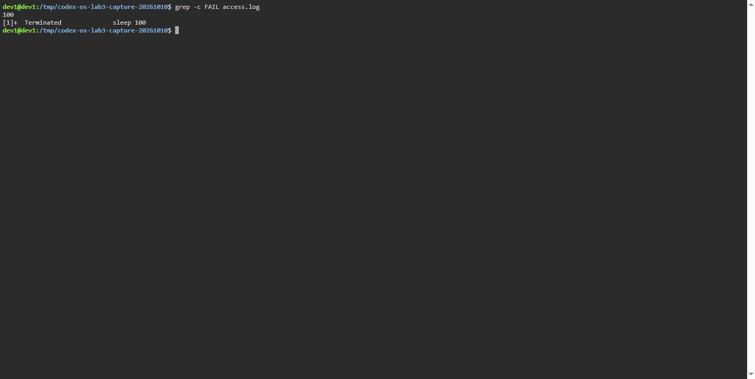 Figure 4.1. Terminal capture, Dev1 Debian GNU/Linux 13, 10 October 2026: Total count of failed requests.

4.2.2 Q2: Unique requested pages
cut -d' ' -f5 access.log | sort -u
Output: /page0, /page1, /page2, /page3 (Figure 4.2).
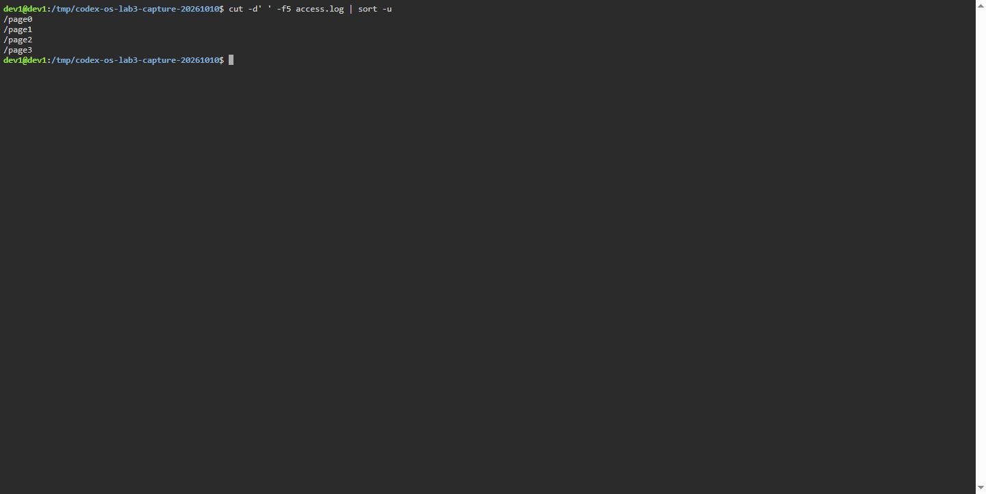 Figure 4.2. Terminal capture, Dev1 Debian GNU/Linux 13, 10 October 2026: Distinct web endpoints requested.

4.2.3 Q3: Request count per page
cut -d' ' -f5 access.log | sort | uniq -c
Output: Each of the 4 pages received exactly 125 requests, summing to 500 total entries (Figure 4.3).
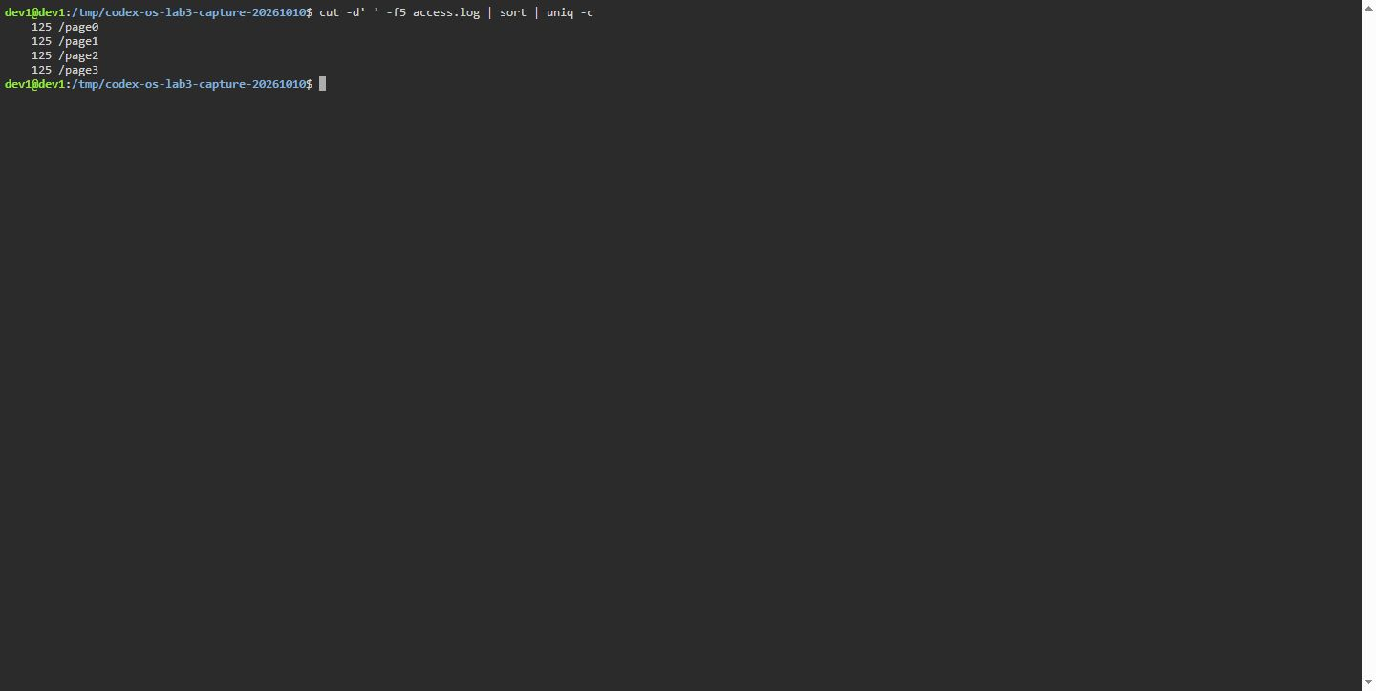 Figure 4.3. Terminal capture, Dev1 Debian GNU/Linux 13, 10 October 2026: Request distribution across endpoints.

4.2.4 Q4: Users with the highest failure count
grep FAIL access.log | cut -d' ' -f3 | sort | uniq -c | sort -rn | head -n 2
Output: user3 and user5 both registered 15 failures, tied for the maximum (Figure 4.4). The sum of failures across all 7 users equals exactly 100.
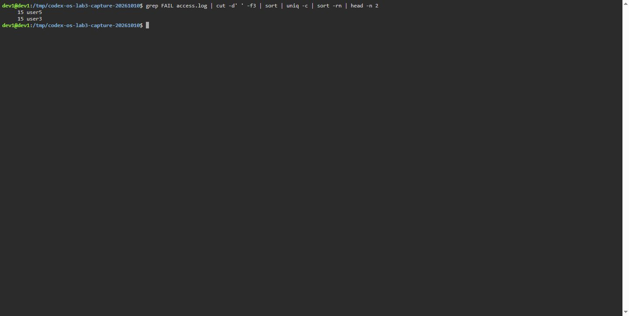 Figure 4.4. Terminal capture, Dev1 Debian GNU/Linux 13, 10 October 2026: Users exhibiting the greatest failure frequency.

4.2.5 Q5: Activity breakdown for user3
echo "user3 total: $(grep -c 'user3 ' access.log), \
failed: $(grep 'user3 ' access.log | grep -c FAIL)"
The 9 October Debian 13 log records 72 total requests by user3, of which 15 failed (Figure 4.5).
Debian GNU/Linux 13, 2026-10-09  user3 total: 72, failed: 15 | Measured output excerpt from the 9 October run log.
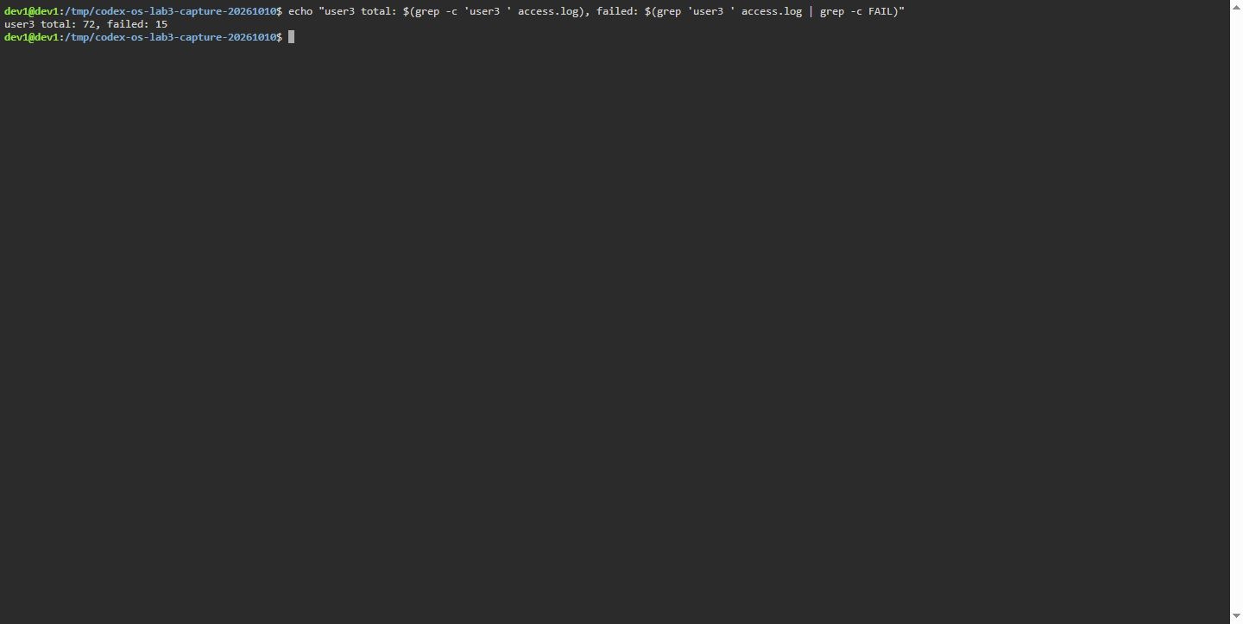 Figure 4.5. Terminal capture, Dev1 Debian GNU/Linux 13, 10 October 2026: user3 request count and failed requests.

4.2.6 Q6: Last three failed requests
grep FAIL access.log | tail -n 3 | cut -d' ' -f2,3
The 9 October Debian 13 log records 10:10 user0, 10:15 user5, and 10:20 user3 as the last three failed rows (Figure 4.6).
10:10 user0  10:15 user5  10:20 user3 | Measured output excerpt from the 9 October run log.
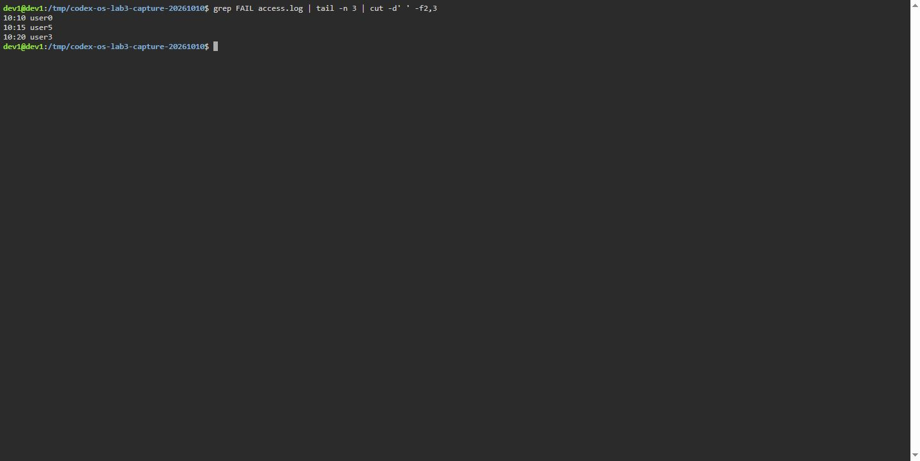 Figure 4.6. Terminal capture, Dev1 Debian GNU/Linux 13, 10 October 2026: last three failed request rows.

4.2.7 Q7: Accounts per login shell in /etc/passwd
cut -d: -f7 /etc/passwd | sort | uniq -c | sort -rn
The 10 October terminal capture records 29 /usr/sbin/nologin, 3 /bin/false, 2 /bin/bash, and 1 /bin/sync. These counts depend on the host.
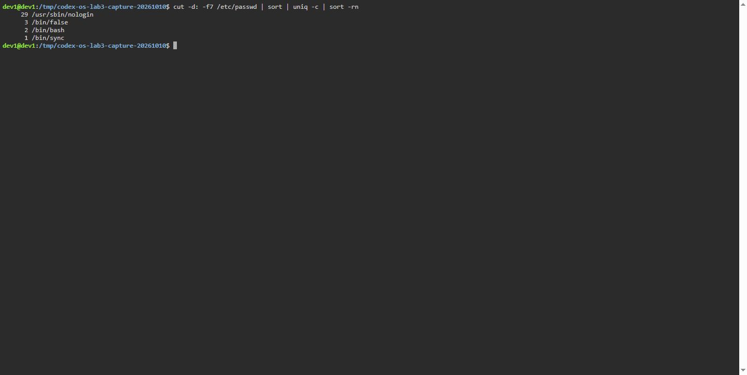 Figure 4.7. Terminal capture, Dev1 Debian GNU/Linux 13, 10 October 2026: account counts by login shell.

4.2.8 Q8: Line count discrepancy between ls and ls -l
ls /etc | wc -l ; ls -l /etc | wc -l
The 10 October terminal capture records 196 lines for ls /etc | wc -l and 197 for ls -l /etc | wc -l; the one-line difference is the total summary line in long format.
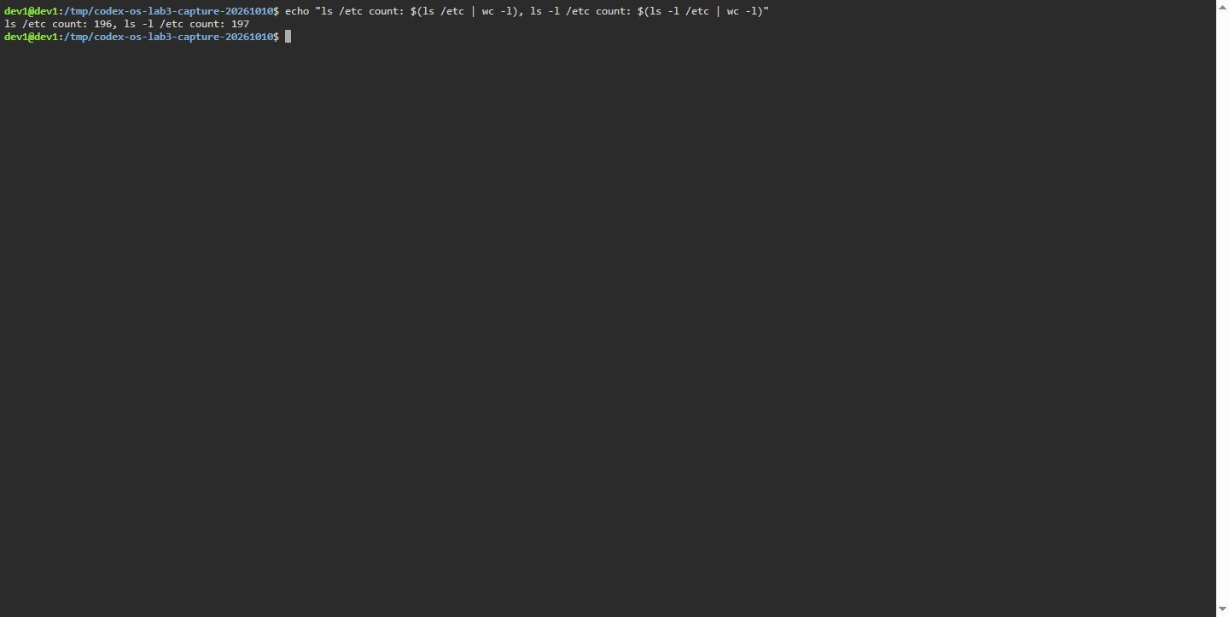 Figure 4.8. Terminal capture, Dev1 Debian GNU/Linux 13, 10 October 2026: line counts with and without long listing format.

4.2.9 Full pipeline suite execution and bonus
All one-liner queries were bundled in oneliners.sh. The bonus regex query:
grep -E '10:[0-5]0 .* FAIL' access.log
isolates requests occurring at 10-minute intervals that failed, yielding exactly 50 matching lines (Figure 4.9).
Debian GNU/Linux 13, 2026-10-09  500 log rows; 100 failures  125 requests per page  user3 total: 72, failed: 15  bonus matches: 50  run-lab3.sh: exit 0 | Figure 4.7 – Verified text summary, not a terminal screenshot; capture the full run on the assigned course system before submission.
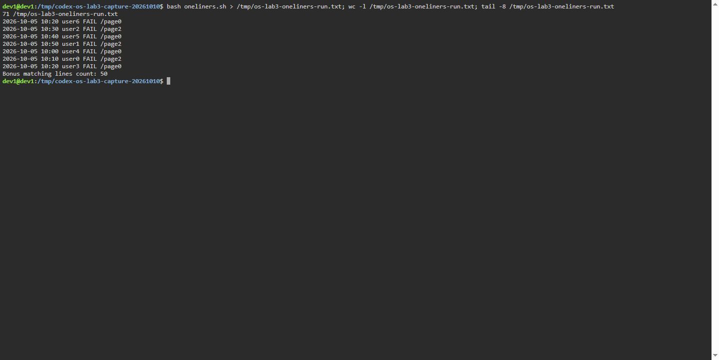 Figure 4.9. Terminal capture, Dev1 Debian GNU/Linux 13, 10 October 2026: complete one-liner run and bonus match count.

5 Structured Shell Automation

5.1 Implementation of report.sh
The analytical one-liners were integrated into an executable automation script report.sh. The script incorporates argument verification, exit code signaling, and dynamic looping over users user0 through user6 (Figure 5.1).
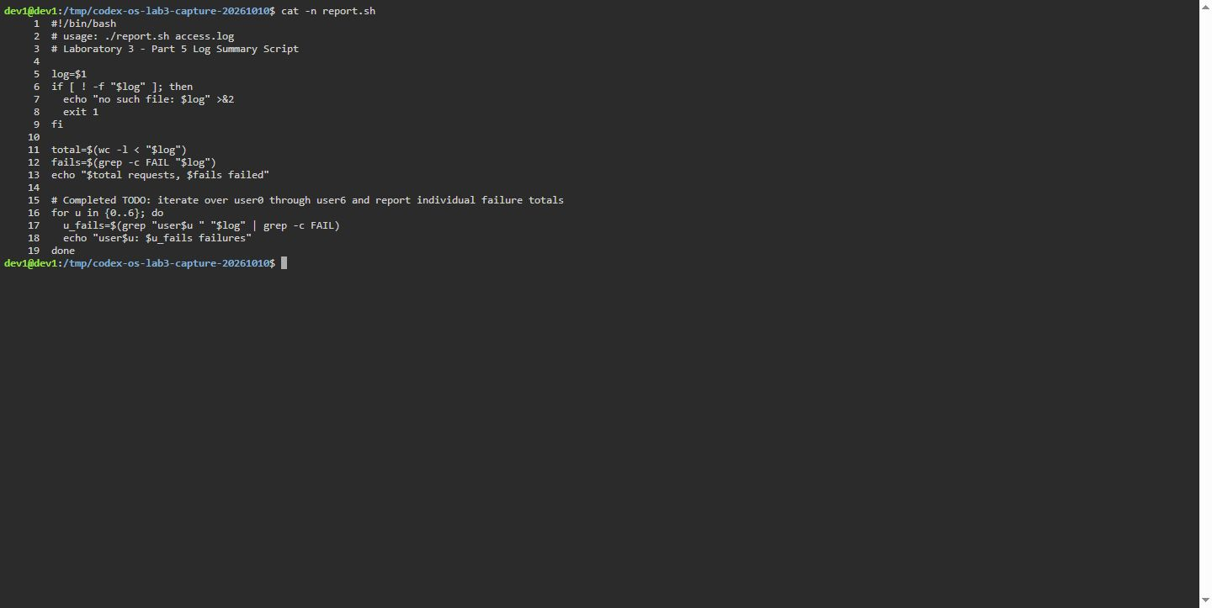 Figure 5.1. Terminal capture, Dev1 Debian GNU/Linux 13, 10 October 2026: Source implementation of report.sh with completed user iteration.
Execution against access.log correctly parses the 500 lines and outputs individual user failure metrics (Figure 5.2).
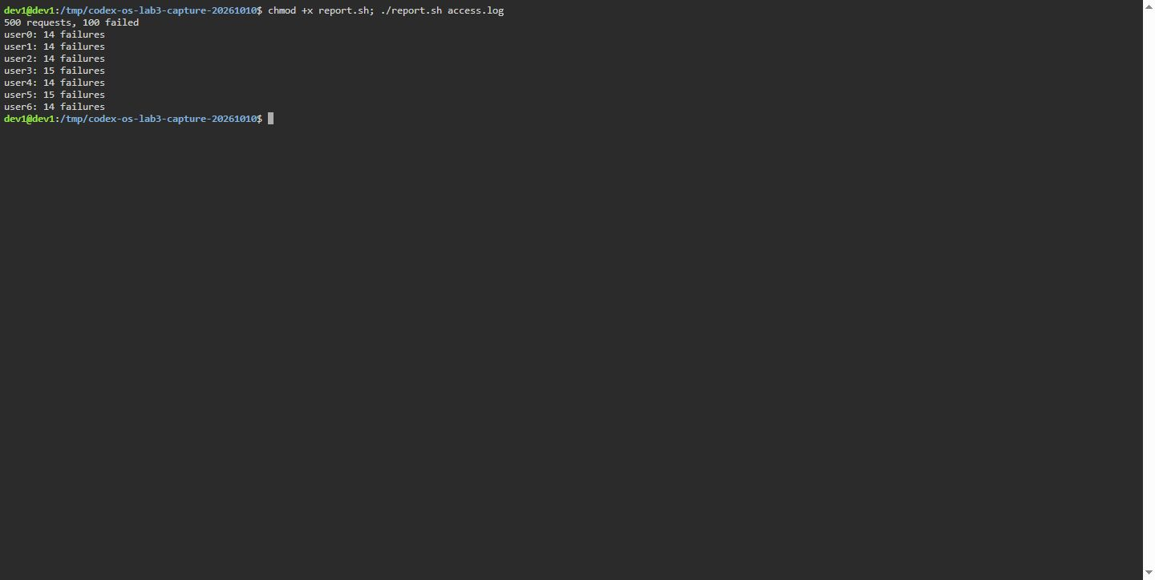 Figure 5.2. Terminal capture, Dev1 Debian GNU/Linux 13, 10 October 2026: Execution of report.sh against the generated access dataset.
When supplied an invalid or missing file, the script writes diagnostic messages to stderr and terminates with status 1 (Figure 5.3).
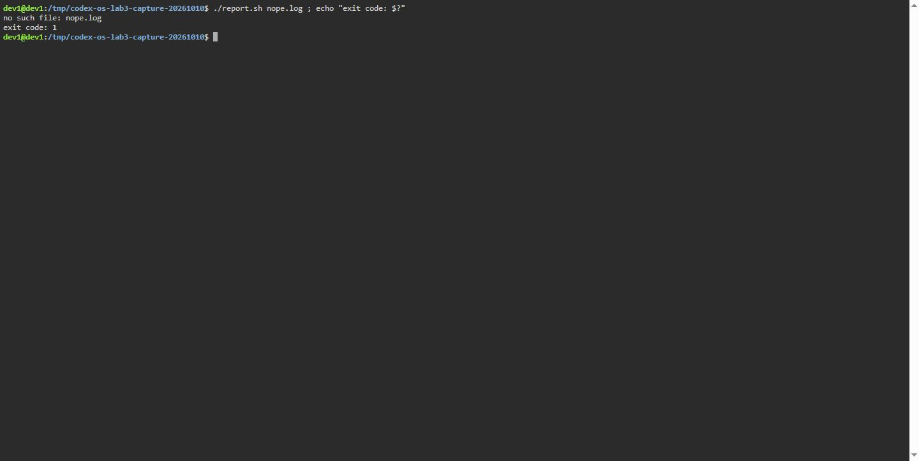 Figure 5.3. Terminal capture, Dev1 Debian GNU/Linux 13, 10 October 2026: Diagnostic error reporting and non-zero exit code.

5.2 Cron daemon integration
The optional cron task ran on Dev1 Debian GNU/Linux 13 using a temporary copy of the Lab 3 files. Cron was active and the user crontab was empty before the test. The following one-minute entry ran report.sh against the copied dataset and appended its output to report.log:
Crontab entry
* * * * * /tmp/codex-os-lab3-4-20261009/lab3/report.sh /tmp/codex-os-lab3-4-20261009/lab3/access.log >> /tmp/codex-os-lab3-4-20261009/lab3/report.log 2>&1
The saved report.log contains four identical summaries. Its complete contents were:
500 requests, 100 failed
user0: 14 failures
user1: 14 failures
user2: 14 failures
user3: 15 failures
user4: 14 failures
user5: 15 failures
user6: 14 failures
500 requests, 100 failed
user0: 14 failures
user1: 14 failures
user2: 14 failures
user3: 15 failures
user4: 14 failures
user5: 15 failures
user6: 14 failures
500 requests, 100 failed
user0: 14 failures
user1: 14 failures
user2: 14 failures
user3: 15 failures
user4: 14 failures
user5: 15 failures
user6: 14 failures
500 requests, 100 failed
user0: 14 failures
user1: 14 failures
user2: 14 failures
user3: 15 failures
user4: 14 failures
user5: 15 failures
user6: 14 failures
The entry was removed after the approximately two-minute check, and the user crontab was empty afterward. This run was on the remote Dev1 host and does not establish use of the assigned course laptop or VM.

5.3 Answers to Part 5 Observe questions
a) What does the first line #!/bin/bash do, and what happens if you run ./report.sh before chmod +x?
The shebang line #!/bin/bash informs the kernel’s execve() system call which interpreter binary to load when executing the script. Attempting to run ./report.sh without execute permissions returns bash: ./report.sh: Permission denied.
b) Why must you type ./report.sh and not just report.sh?
The shell only traverses directories explicitly listed in $PATH. The current working directory (.) is omitted from PATH by default to prevent accidental execution of untrusted local binaries. Prefacing with ./ provides an explicit relative path.
c) Why does the script write the error with >&2 and end with exit 1?
>&2 redirects error strings to standard error (descriptor 2), preserving standard output for clean pipeline data. exit 1 signals abnormal termination to calling environments and conditional operators.

Conclusions
The terminal figures show actual command output captured on the Dev1 Debian GNU/Linux 13 host. The handout calls for a Linux laptop or VM; this report does not establish which assigned environment was used.

References
[1] Nemeth, E., Snyder, G., Hein, T. R., Whaley, B., & Mackin, D. (2017). UNIX and Linux System Administration Handbook (5th ed.). Addison-Wesley Professional.
[2] Shotts, W. (2019). The Linux Command Line: A Complete Introduction (2nd ed.). No Starch Press.
[3] IEEE & The Open Group. (2018). The Open Group Base Specifications Issue 7 / IEEE Std 1003.1-2017 (POSIX.1). Shell Command Language.
[4] Free Software Foundation. (2024). Bash Reference Manual. Version 5.2.

