Ministerul Educaţiei și Cercetării al Republicii Moldova Universitatea Tehnică a Moldovei
Facultatea Calculatoare, Informatică și Microelectronică

Laboratory work 1:
Study and Empirical Analysis of Algorithms
for Determining
Fibonacci N-th Term

Elaborated:
st. gr. FAF-211 Lupan Lucian

Verified:
asist. univ. Fiștic Cristofor

Chişinău – 2024

Contents
ALGORITHM ANALYSIS 3
Tasks: 3
Theoretical Notes: 3
Introduction: 4
Comparison Metric: 4
Input Format: 4
IMPLEMENTATION 5
Recursive Algorithm: 5
Recursion with Cache Algorithm: 6
Iterative Algorithm: 8
Binet Formula Algorithm: 9
Matrix Power Algorithm: 10
Pisato Period Algorithm: 12
CONCLUSION 14

ALGORITHM ANALYSIS
Study and analyze different algorithms for determining Fibonacci n-th term.

Tasks:
- Implement at least 3 algorithms for determining the n-th Fibonacci number;
- Decide properties of input format that will be used for algorithm analysis;
- Decide the comparison metric for the algorithms;
- Analyse empirically the algorithms;
- Present the results of the obtained data;
- Deduce conclusions of the laboratory.

Theoretical Notes:
An alternative to mathematical analysis of complexity is empirical analysis.
This may be useful for obtaining preliminary information on the complexity class of an algorithm; comparing the efficiency of two (or more) algorithms for solving the same problems; comparing the efficiency of several implementations of the same algorithm; obtaining information on the efficiency of implementing an algorithm on a particular computer.
In the empirical analysis of an algorithm, the following steps are usually followed:
- The purpose of the analysis is established.
- Choose the efficiency metric to be used (number of executions of an operation (s) or time execution of all or part of the algorithm.
- The properties of the input data with which the analysis is performed are established (data size or specific properties).
- The algorithm is implemented in a programming language.
- Generating multiple sets of input data.
- Run the program for each input data set.
- The obtained data are analysed.
The choice of the efficiency measure depends on the purpose of the analysis. If, for example, the aim is to obtain information on the complexity class or to check the accuracy of a theoretical estimate then it is appropriate to use the number of operations performed. But if the goal is to assess the behavior of the implementation of an algorithm, then execution time is appropriate.
After the execution of the program with the test data, the results are recorded and, for the purpose of the analysis, either synthetic quantities (mean, standard deviation, etc.) are calculated or a graph with appropriate pairs of points (i.e. problem size, efficiency measure) is plotted.

Introduction:
The Fibonacci sequence is the series of numbers where each number is the sum of the two preceding numbers. For example: 0, 1, 1, 2, 3, 5, 8, 13, 21, 34, 55, 89, 144, 233, 377, 610, … Mathematically we can describe this as: xn = xn-1 + xn-2.
Many sources claim this sequence was first discovered or "invented" by Leonardo Fibonacci. The Italian mathematician, who was born around A.D. 1170, was initially known as Leonardo of Pisa. In the 19th century, historians came up with the nickname Fibonacci (roughly meaning "son of the Bonacci clan") to distinguish the mathematician from another famous Leonardo of Pisa.
There are others who say he did not. Keith Devlin, the author of Finding Fibonacci: The Quest to Rediscover the Forgotten Mathematical Genius Who Changed the World, says there are ancient Sanskrit texts that use the Hindu-Arabic numeral system - predating Leonardo of Pisa by centuries.
But, in 1202 Leonardo of Pisa published a mathematical text, Liber Abaci. It was a “cookbook” written for tradespeople on how to do calculations. The text laid out the Hindu-Arabic arithmetic useful for tracking profits, losses, remaining loan balances, etc, introducing the Fibonacci sequence to the Western world.
Traditionally, the sequence was determined just by adding two predecessors to obtain a new number, however, with the evolution of computer science and algorithmics, several distinct methods for determination have been uncovered.
As mentioned previously, the performance of an algorithm can be analyzed mathematically (derived through mathematical reasoning) or empirically (based on experimental observations).
Within this laboratory, we will be analyzing 6 algorithms empirically.

Comparison Metric:
The comparison metric for this laboratory work will be considered the time of execution of each algorithm T(n).

Input Format:
As input, each algorithm will receive two series of numbers that will contain the order of the Fibonacci terms being looked up. The first series will have a more limited scope, (np.unique(np.linspace(5, n, 17, dtype=int))); n = 40, to accommodate the recursive method, while the second and third algorithms will have a bigger scope to be able to compare the other algorithms between themselves, but still limited due to recursion limit(np.unique(np.linspace(5, n, 17, dtype=int))); n = 2000. The 4-6th algorithms compute much higher terms - (np.unique(np.linspace(5, n, 17, dtype=int))); n = 10000/20000.

IMPLEMENTATION
All six algorithms are implemented in Python and analyzed empirically based on the time required for their completion, using the matplotlib and time libraries. The error margin is estimated to be ~2.5 seconds.

Recursive Algorithm:
Algorithm Description:
The recursive algorithm is one of the most inefficient algorithms for determining Fibonacci numbers, as it has a time complexity of O(2^n), making numbers >40 taking minutes/hours to compute. This algorithm’s weakness is that it never uses the memory for storage, meaning it doesn’t store the number that have already been computed, and therefore it has to compute them again through recursion. In figure 1, we can notice the problem with this algorithm.
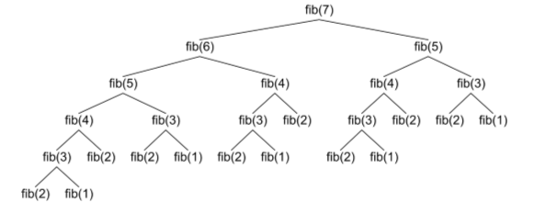
Figure 1. Fibonacci recursion

Implementation:
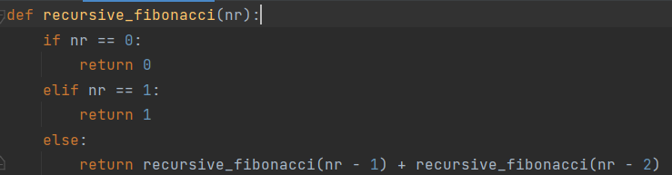
Figure 2. Fibonacci recursion code

Results:
After running the algorithm in Python, the time it took to obtain the terms above 40 was very high (too high for Intel Pentium), as can be observed in the table below.
N | 5 | 7 | 9 | 11 | 13 | 15 | 18 | 20 | 22 | 24 | 26 | 29 | 31 | 33 | 35 | 37 | 40
Milliseconds | ~0 | ~0 | ~0 | ~0 | ~0 | 0.998 | 1 | 3 | 10.99 | 28.86 | 78 | 576 | 984 | 2663 | 7206 | 27520 | 74868

Below, in Figure 4, we can see the time it took to compute the nth term through the use of a graph. There’s a sudden spike at n=40, doubling the time taken for each of the terms.
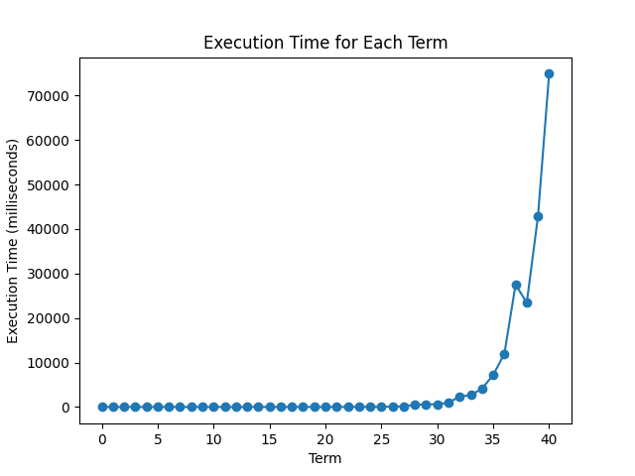
Figure 3. Fibonacci recursion time execution
In Figure 3, we can notice that this algorithm is incredibly slow, having a time complexity of O(2^n), making it so that terms above 40 take incredibly long to compute. This is because we’re continuously recursing through already computed elements, having to compute them again, thus wasting operational time.

Recursion (Dynamic programming) Algorithm:
Algorithm Description:
This method generally functions the same as the recursive method, however we add a “cache”, that stores the values of the already computed Fibonacci numbers, thus decreasing the runtime and making finding numbers that are higher than 40 less demanding.

Implementation:
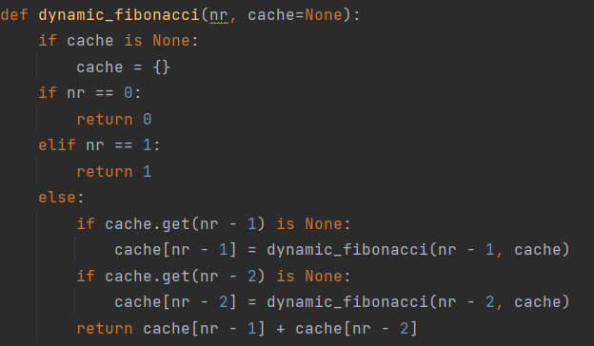
Figure 4. Dynamic programming code
Results:
After the execution, we can notice a massive decrease in the time required to compute each of the numbers.
N | 5 | 129 | 254 | 379 | 503 | 628 | 753 | 877 | 1002 | 1127 | 1251 | 1376 | 1501 | 1625 | 1750 | 1875 | 2000
Milliseconds | 0.03 | 0.25 | 2.19 | 0.74 | 1.60 | 1.96 | 1.69 | 1.99 | 2.29 | 1.81 | 1.93 | 2.22 | 2.59 | 3.26 | 3.83 | 3.02 | 3.42

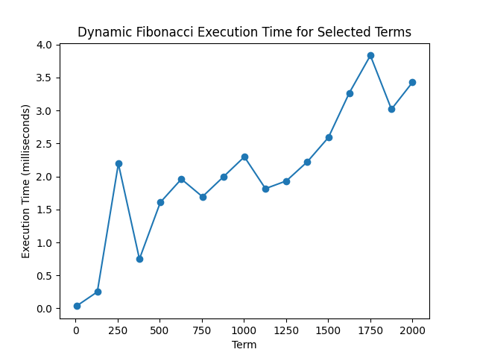
Figure 5. Dynamic programming graph

With the optimized recursive algorithm, we can notice the graph in Figure 5 showing far less time for higher Fibonacci terms, having a time complexity of just O(n). This algorithm is still relatively slow however, and because it uses recursion, we encounter the max recursion limit error, which makes it so that we have trouble computing terms past 2000, even through the use of system functions which increase recursion limit, as we still encounter the stack overflow.

Iterative Algorithm:
The Iterative algorithm is much like the dynamic programming approach, storing the values of the already computed terms; however it doesn’t utilize recursion, but a single for loop to determine the Fibonacci terms.

Implementation:
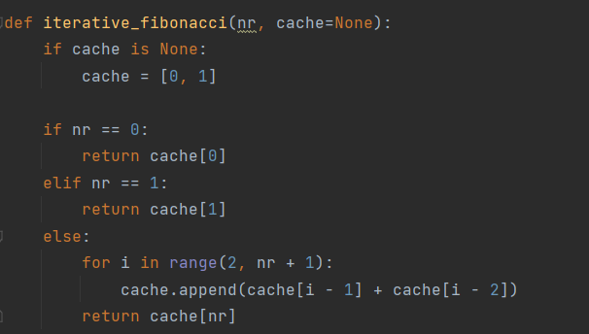
Figure 6. Iteration method code
Below, we can see the results displayed in a table:
Results:
N | 5 | 129 | 254 | 379 | 503 | 628 | 753 | 877 | 1002 | 1127 | 1251 | 1376 | 1501 | 1625 | 1750 | 1875 | 2000
Milliseconds | 0.01 | 0.03 | 0.05 | 0.07 | 0.09 | 0.12 | 0.16 | 0.24 | 0.22 | 0.24 | 0.27 | 0.31 | 0.31 | 0.36 | 0.38 | 0.45 | 0.61

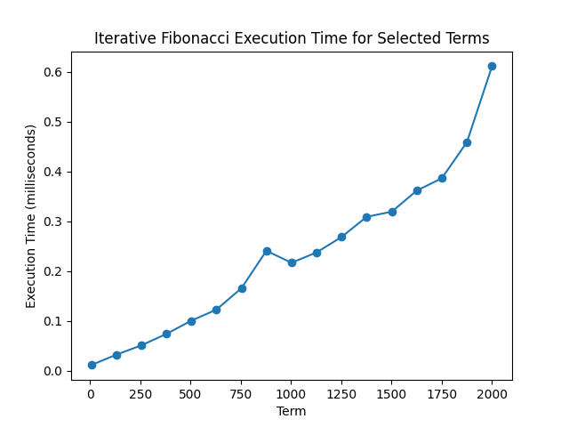
Figure 7. Iteration method graph

As we can notice in Figure 7, the runtime of the iterative algorithm is better than the dynamic programming approach, having a time complexity of O(n). This is due to not having to prioritize other checks when going through the recursion, saving time by focusing on computing the terms efficiently.

Binet Formula Algorithm:
Algorithm Description:
The Binet Algorithm is a very performant algorithm that directly computes the nth term of the Fibonacci sequence by utilizing the golden ration formula. However, this is done at the expense of accuracy. Because square root has to be computed (and since it’s not an integer, it has rounding errors), and the division doesn’t return an int, we have to deal with rounding errors, and when comparing with actual Fibonacci terms, it’s pretty clear to see that the error is quite significant.
Implementation:
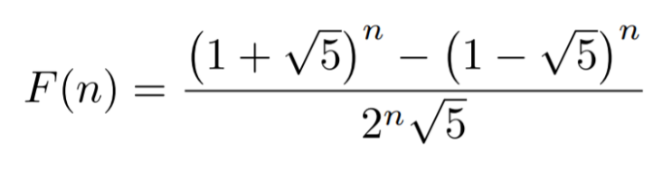
Figure 8. Binet formula
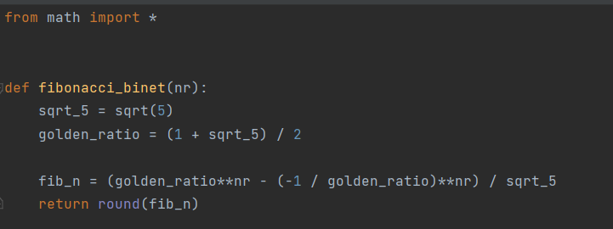
Figure 9. Binet formula code

Results:
N | 5 | 1254 | 2504 | 3754 | 5003 | 6253 | 7503 | 8752 | 10002 | 11252 | 12501 | 13751 | 15001 | 16250 | 17500 | 18750 | 20000
Milliseconds | 4.41 | 2.91 | 4.08 | 3.24 | 4.73 | 14.97 | 18.17 | 6.66 | 7.72 | 9.54 | 14.37 | 10.42 | 15.44 | 20.73 | 11.66 | 15.73 | 15.46

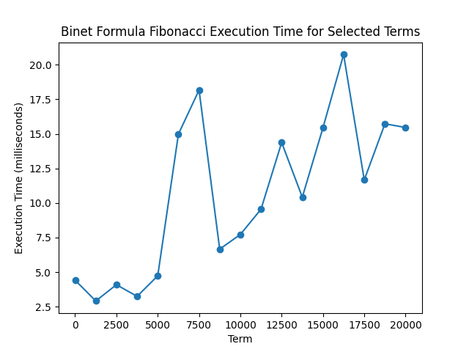
Figure 10. Binet formula graph

In figure 10, we can see the graph describing Binet formula’s performance. Due to its time complexity of only O(1), I expected much better performance, but the time increase might be due to rounding of decimals. Additionally, the graph doesn’t show the increasing errors, that spike at around the 70th term, making this an unreliable algorithm for accurately determining the values of the Fibonacci sequence.

Matrix Power Algorithm:
Algorithm Description:

The matrix power method is an iterative numerical algorithm used to find the dominant eigenvalue and corresponding eigenvector of a square matrix. It involves repeatedly multiplying a starting vector by the matrix and normalizing the result until convergence, providing an approximation of the dominant eigenpair. The time complexity of this algorithm is only O(log(n)).
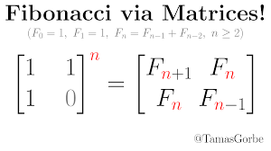
Figure 11. Matrix power formula

Implementation
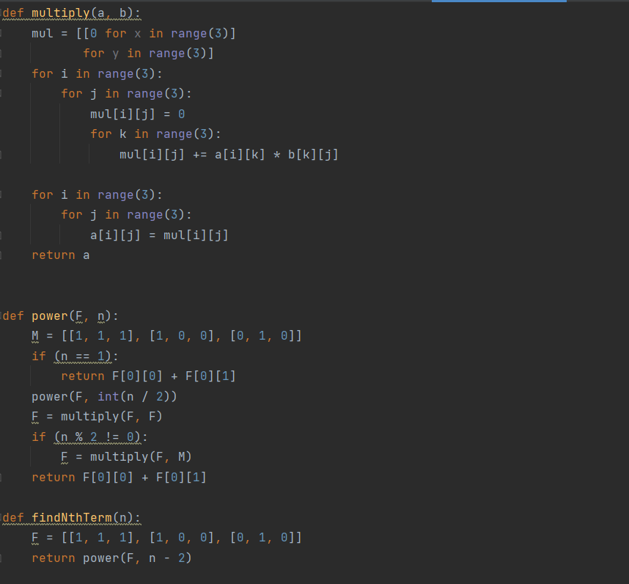
Figure 12. Matrix power code
Results:
N | 5 | 629 | 1254 | 1879 | 2503 | 3128 | 3753 | 4377 | 5002 | 5627 | 6251 | 6876 | 7501 | 8125 | 8750 | 9375 | 10000
Milliseconds | 0.05 | 1.08 | 0.52 | 0.32 | 0.48 | 0.49 | 0.54 | 0.58 | 0.69 | 0.98 | 0.77 | 0.87 | 1.06 | 1.12 | 1.14 | 1.28 | 1.43

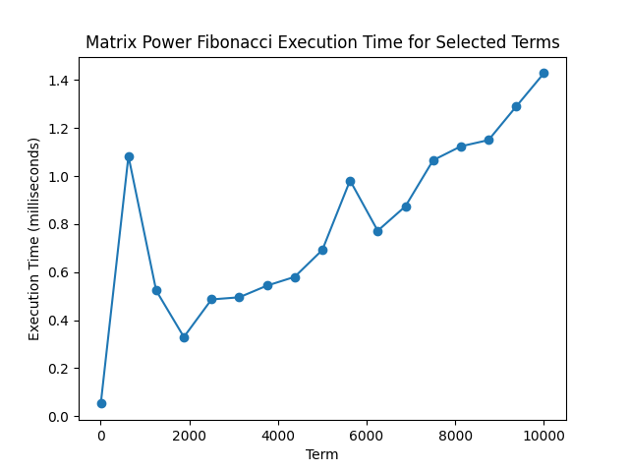
Figure 13. Matrix power graph

In figure 13, we can notice that the matrix power method is very fast. Completing the 10000th term took only 1.43 ms, which is very fast and efficient, boasting an incredible O(log n) time complexity, beating basically every algorithm we’ve used beforehand.

Pisano Period Algorithm:
Algorithm Description:
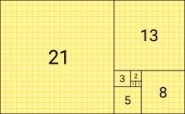
Figure 14. Pisano Period
The Pisano Period, also known as the Fibonacci Period, is the periodic sequence of remainders when the Fibonacci numbers are divided by a positive integer m. The period length is determined by m and is related to the modular arithmetic properties of Fibonacci numbers.
Implementation:
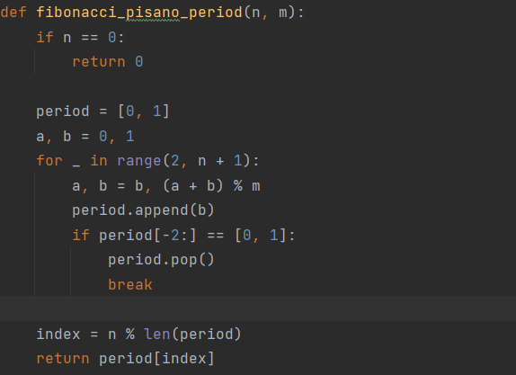
Figure 15. Pisano Period code

Results:
N | 5 | 629 | 1254 | 1879 | 2503 | 3128 | 3753 | 4377 | 5002 | 5627 | 6251 | 6876 | 7501 | 8125 | 8750 | 9375 | 10000
Milliseconds | 0.005 | 0.07 | 0.15 | 0.19 | 0.25 | 0.32 | 0.40 | 0.64 | 0.52 | 0.58 | 0.65 | 0.73 | 0.77 | 0.95 | 0.91 | 0.97 | 1.04

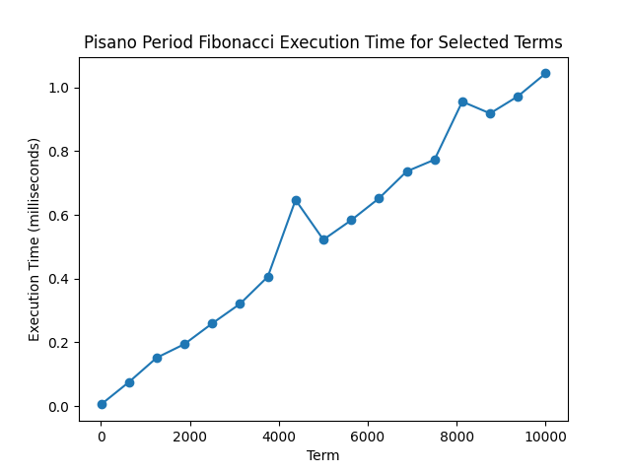
Figure 15. Pisano Period graph

In Figure 16, we have the Pisano Period graph. The results are good, especially when compared to the Binet formula and the recursion approach. After computing ten thousand terms, we’re still only at 1 ms/term, which is really good. Having a time complexity of O(m^2), where m = modulo (in our case, m = 10), this algorithm is really fast.

CONCLUSION

After finishing this laboratory work, I learnt about 6 different ways to compute the Fibonacci sequence. The first one – the recursive approach – although it’s the slowest, it’s good enough to find the lower terms (up to 40) of the Fibonacci sequence relatively quickly. After 40, however, this method becomes increasingly inefficient. The second one – the dynamic programming approach, is much better, but we’re still limited by the maximum recursion limit, which is predefined by the system, and changing it to a higher number leads to a stack overflow error. The third one, the iterative approach, combines simplicity with efficiency. For a couple of lines of code, we can efficiently obtain the higher numbers of the Fibonacci sequence very quickly (~0.6 ms for the 10000th term).
The Binet formula is the 4th method used to obtain the Fibonacci sequence values. Although it’s relatively fast, having a complexity of O(1) on paper, my own results proved that the time required to compute a term took far longer than expected. This is probably due to constant rounding the decimals and multiple computations which lead to slower runtime and computation of terms. The 5th method was the Matrix Power algorithm. It was the 2nd fastest algorithm, falling short only to the Pisano period. It overall provided very good results, as expected of a O(log n) algorithm. It could be used to compute very high terms, without a significant increase in computational time. The last algorithm was also the fastest – the Pisano period. Making use of the Fibonacci sequence properties, it has a great time complexity – O(m^2), ‘m’ being the modulo, leading to only a ~1ms/term computed.
The most important lesson I learnt from this laboratory work is that different approaches to a problem can solve it far more efficiently. Additionally, algorithms that are at first inefficient, can be optimized through the use of dynamic programming, optimizing the total amount of recursions by storing values in a cache. The big O notation is a great indication of how fast an algorithm could run, but it doesn’t determine everything. Applying an algorithm might require other modules, which might make them take far longer than predicted – as noticed in the Binet formula, due to the high amount of computations.

