**Fitness Hero**



**Lucian-Gabriel Juratu, 2021**

**Programming for Mobile Devices, IE2**

**Submission date: 16/05/2021**

**Supervisor: Liviu Octavian Mafteiu-Scai**

Content

1. Abstract 3

2. Goal and users 3

3. Introduction 4

4. State of art 4

4.1. Level Up Life 4

4.2 Calorie Counter – MyFitnessPal 5

4.3. Simple Workout Log 7

5. Original contribution of the author 8

6. Functionality 8

7. Running the app 8

8. App’s structure 9

9. Conclusions and Future work 10

10. References 10

# 1. Abstract

This report describes the Fitness Hero mobile application. It includes a model overview of the proposed application and details about the features, target users and objectives, similar applications, author’s contribution, development plan and references.

# 2. Goal and users

Fitness Hero is an Android application designed to help people who want to start working out but cannot find the motivation to do so. The application allows an easy planning of workouts and meals and rewards the user by leveling up his character whenever an objective is complete. The user can keep track of his progress like he would do in an RPG game, making the process of working out more fun.

# 3. Introduction

One of the hardest things when someone starts working out is keeping track of everything he has to do and of the progress he is making. This application allows the user to easily plan his workouts and diet during the week and shows him what he has to do in a given day. It also helps the user to keep all of his information in one place, such as weight, height, body measurements, how many calories he needs in a day and so on.

This application also aims to keep the user motivated by combining basic fitness tracking with RPG features. The user can level up by sticking to his plans and can use his progress to fight enemies in turn-based combat. The user can also learn combat skills by reaching real-life goals, such as doing 20 consecutive pushups, or finish quests that are designed to make him stronger.

# 4. State of art

## 4.1. Level Up Life

Level Up Life is an application which allows the user to track his daily achievements while progressing in an RPG-style online platform. The user earns XP through real life challenges ranging from simple to life changing. As the user earns XP, he will level up and unlock increasingly difficult achievements which provide new experiences and challenges.

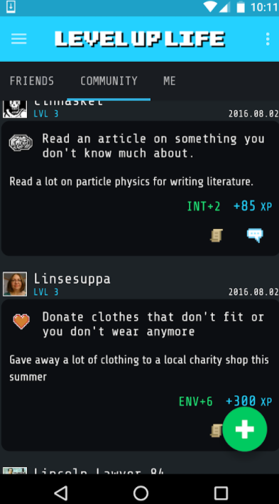

## 4.2 Calorie Counter – MyFitnessPal

An application designed to help the user to lose weight, tone up, get healthy, change his habits or start a new diet. The application allows the user to track his meals and keep a diary in which he logs what he eats. The user can also choose a goal, like losing weight, gaining weight or maintaining it.

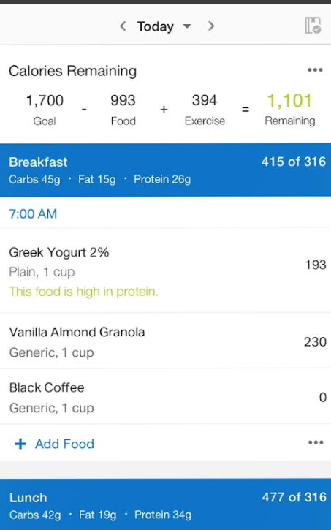

## 4.3. Simple Workout Log

This application is a simple tool to log and track the workouts. It requires minimal user input and it replaces the paper workout journals. The user can create his own routine and keep track of his past workouts.

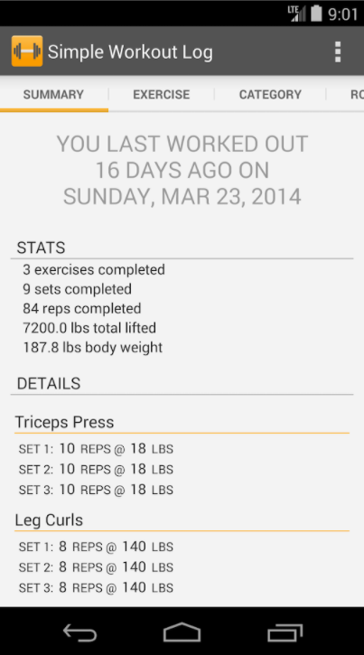

# 5. Original contribution of the author

The application provides all the tools someone needs in order to organize his workouts and to keep track of his progress. The application does not require an internet connection and all the features are simple to use. Fitness Hero allows the user to keep track of his progress by playing a RPG game. The user creates a character and progresses in the game by working out and eating healthy. Then, he can complete quests, buy items and equipment or fight enemies in turn-based combat.

# 6. Functionality

The functionality considering the previously described features can be seen in the following Use Case Diagram.

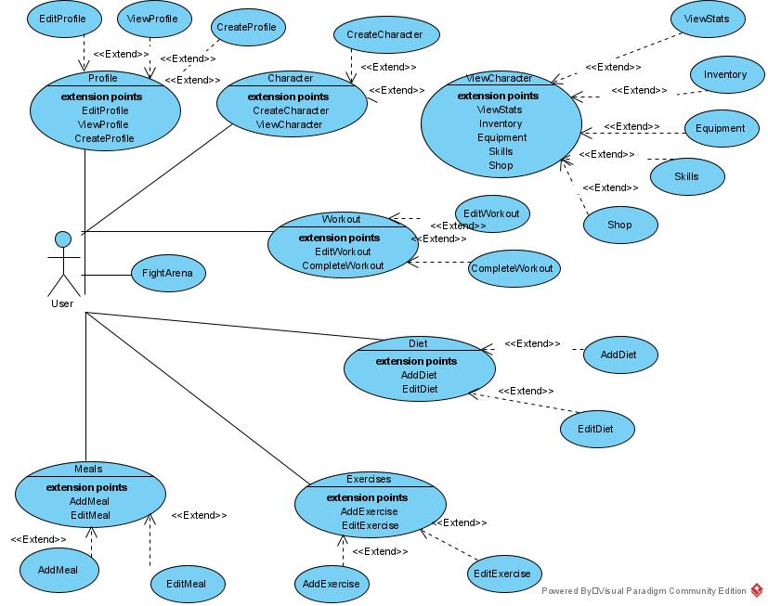

# 7. Running the app

The user creates a local profile, so he does not have to register and sign in and he does not need an internet connection in order to use the application. He can keep all his stats, such as weight, height and body measurements and easily update them by using buttons to increase or decrease the values. The user can add his own exercises and use them to design his workouts. He can also create his own meals, provide the number of calories and use them to design his diet. The exercises and meals are saved in order to be easily added in other plans. The user can manage his exercises and meals using the settings. The application will calculate the total calories and tell the user how many calories he needs to eat daily. The user is also notified if he has a workout planned for that day. The RPG part is directly linked to fitness goals rather than life goals. The user has to workout and stick to his diet. Whenever he does that he marks the objective as complete for that day, gaining experience. He can also train for specific goals in order to learn and upgrade skills. He can also finish quests which provide gold. Gold can be used to buy equipment and items. To make progress tracking more fun, he can fight in turn-based combat in the arena. As the user sticks to his plan and progresses he will be able to fight stronger enemies.

# 8. App’s structure

WorkoutCreate Class- the onBackPressed method is overridden to take the user to the WorkoutSettings class using an Intent object. An ArrayAdapter object is used to update the list of exercises. The cancel button takes the user to the WorkoutSettings class using an Intent object. The finish button is used to save the workout. It uses a SharedPreferences object to retrieve the value of "workday", which was previously set based on the day the user has chosen for his workout, and save it in the "day" variable. Then, the value of the "day" variable is checked, a Gson object is created and used to convert the list of exercises to a String called "set". Then, based on the value of "day", a SharedPreferences Editor is used to save the string in the specific day. The value of "set" is checked to see if it is empty or not. If it is empty, then a boolean is set to false, else it is set to true. The user is redirected to the WorkoutSettings class using an Intent object. The add break button creates an AlertDialog which asks for input. The input is validated using regex, so it is not empty and it is a number. Then, the break is added to the adapter. The add exercises button executes the addItems function onClick. The function creates an AlertDialog with 2 input fields: an EditText for the number of reps and an AutoCompleteTextView for the exercises. The list of exercises is retrieved from SharedPreferences. If it is not empty, then an ArrayAdapter is used for the autocomplete. If the fields are not empty and the reps input is a number, then it checks if the list of exercises contains the exercise provided by the user. If it does not, then it is added to the list, a Gson object is used to convert the list to a String and a SharedPreferences Editor is used to update the list. The exercise and the reps are added to the adapter.

# 9. Conclusions and Future work

Fitness Hero combines all the tools needed by someone in order to live an active lifestyle in one application. Unlike other fitness tracking applications, these tools are easy to use and do not require an Internet connection. Other applications combine life goals with a RPG game, but this application is designed only for fitness goals. In order to improve the application in the future, the character will include an avatar which can be created and a full guide for creating workouts and diets will be added.

# 10. References

**[1] Level Up Life -** [**https://lvluplife.com/**](https://lvluplife.com/)

**[2] Calorie Counter – MyFitnessPal - https://www.myfitnesspal.com/mobile/android**

**[3] Simple Workout Log -https://www.simpleworkoutlog.com/**

**[4] Gson library**