Embedding a file in metadata pathing;

First, use notepad to make a file, but add to it a colon to path to another file.

This secondary file will not be accessable except through the metadata, so explorer and -ls or `dir` won’t access it.

Command: notepad file1.txt:hiddenfile.txt

(then you can fill the file with whatever secret info is meant to be hidden)

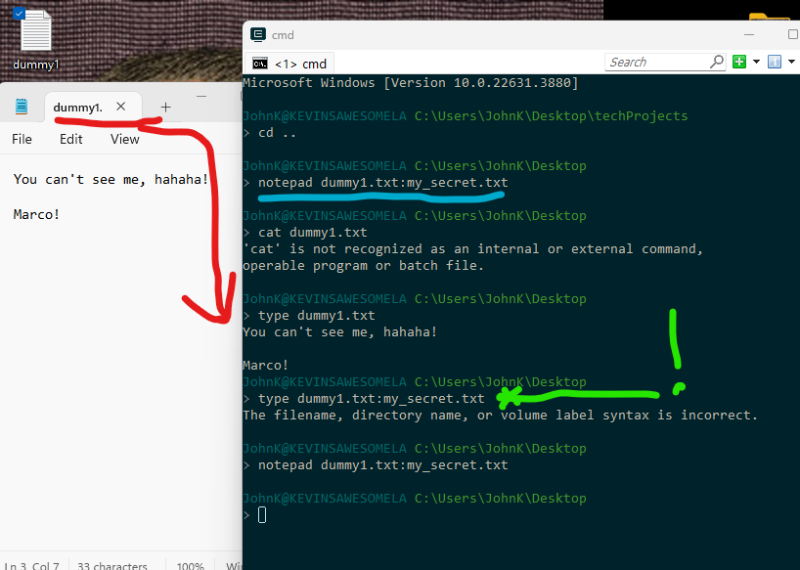

Cat and Type will not work on the meta-data pathing from CLI, so forget that approach.

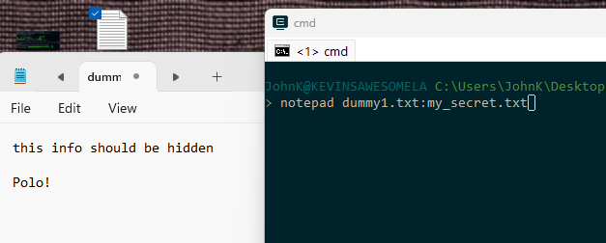

Actually opening the file with the metadata pathing will open up the notepad with hidden info. The screenshot has 2 tabs, the my_secret.txt tab is hidden because the window is small. Also, there is only one file in the directory, the desktop, so just browsing where the dummy file is, you have no way of seeing in the GUI that there’s a secret file too.