Banner grabbing with netcat:

After connecting to netcat, you will get a service banner to whatever it tries to connect to

The syntax is command: nc ip.address port#

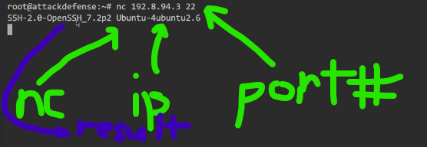

The option –script=banner within nmap will give the same info underneath the port output. This is useful for mass-scanning. The instructors are dumb if they tell you that connecting with netcat is a “good” way for grabbing a banner. Nmap exists for fingerprinting. Netcat is only incidentally capable of giving banner info, and should not be your go-to option.

