Run an nmap scan, finding tcp port 22 running SSH 2.0.

Not too sure that version 2.0 really matters here though…

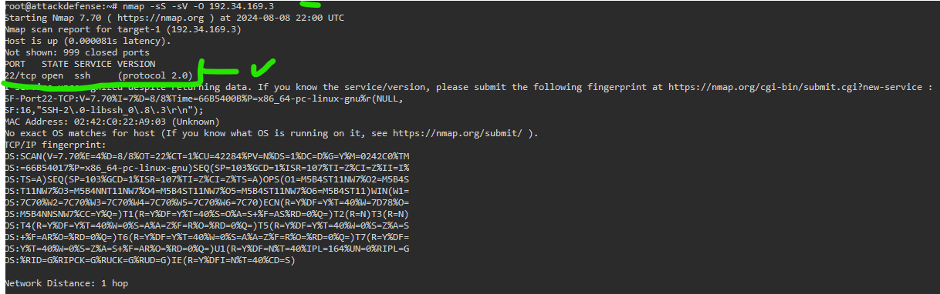

Let’s take a look at a scanner in regards to ssh and authentication bypass



Read info and properly manage params

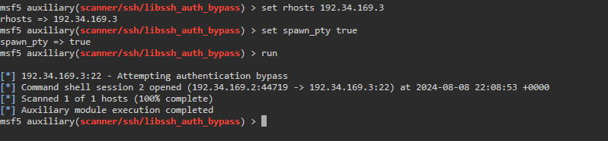

Above output isn’t too clear, but let me explain.

It should open a session, as mentioned in the second blue star.

So, let’s check on the sessions active in msfconsole

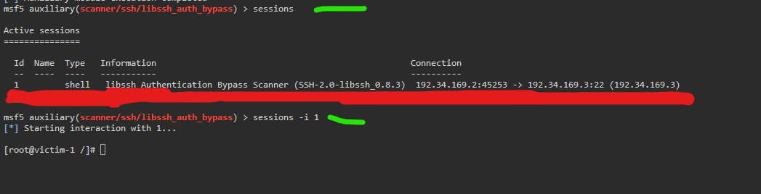

I accidentally made a second session, thus the red bar, sorry about the screencap flaw.

The point is, we got a session we can interact with now by using

Command; sessions -i 1

Oh, look, we’re root.

