Tshark overview and common commands

View the current version of tshark

Command : tshark -v

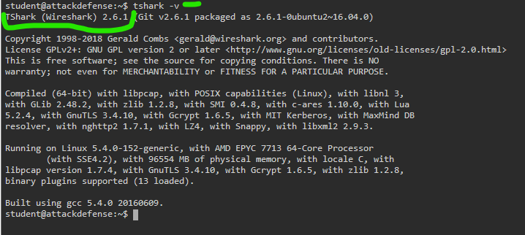

Command : tshark -D

Display available interfaces

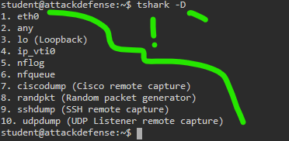

Read first 100 packets from a target pcap file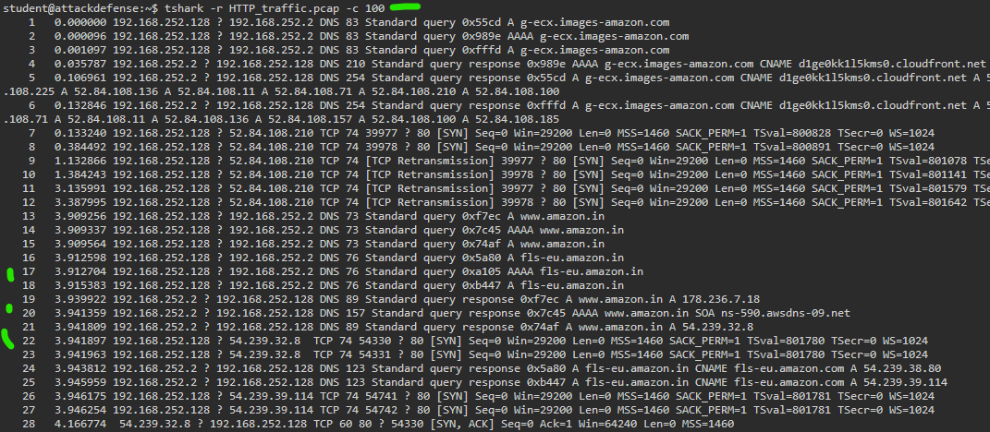

Filter pcap with -Y for a target string

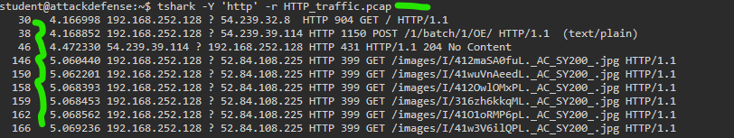

Find pcaps with a certain source and certain destination ip address:

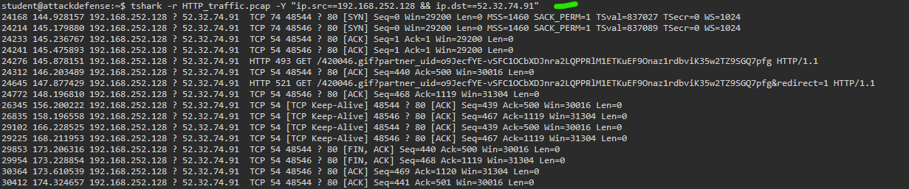

Find all http packets containing the string password



