

Assessment Cover Page
Student Full Name: Luciana Pereira Hamaji
Student Number: 2026408
Module Title: Stats for Data Analytics
Assessment Title: CA1
Lecturer/Supervisor: Taufique Ahmed
Assessment Due Date: 01/11/2026
Date of Submission: 01/11/2026

Use of AI Tools
I acknowledge the use of ChatGPT (OpenAI) to support the development of this assessment, including explanations of statistical concepts, guidance on Python coding and data visualisation, assistance with interpreting statistical results, and reviewing academic English.
ChatGPT was also used to support the organisation and presentation of the Jupyter Notebook and written report. The dataset was analysed using Python, and the calculations, visualisations and outputs were reviewed as part of the assessment.
Declaration
By submitting this assessment, I confirm that I have read the CCT policy on academic misconduct and understand the implications of submitting work that is not my own or does not appropriately reference material taken from a third party or other source.
I declare it to be my own work and that all material from third parties has been appropriately referenced.
I further confirm that this work has not previously been submitted for assessment by myself or someone else in CCT College Dublin or any other higher education institution.

Contents
1. Introduction 3
2. Dataset Description and Data Quality 3
3. Descriptive Statistics 4
4. Binomial Distribution 6
5. Poisson Distribution 7
6. Normal Distribution 9
7. Comparison of Distributions 10
8. Conclusion 10
9. References 11

- Introduction
Bike-sharing services have emerged as an alternative to address several challenges associated with urban transportation. In addition to providing an affordable means of transport, they offer a cleaner, more sustainable and healthier option for commuting. They may also help reduce traffic congestion and dependence on private cars, while easing pressure on public transport systems.
However, bicycle usage can be influenced by several factors, including weather conditions (Heinen et al., 2010) and the time of day, particularly during morning and evening commuting hours.
This report analyses the Bike Sharing Dataset using descriptive statistics and three probability distributions: Binomial, Poisson and Normal. The aim is to identify patterns in bicycle rental demand, examine the characteristics of the selected variables and evaluate how well these statistical distributions represent the observed data.

- Dataset Description and Data Quality
The Bike Sharing Dataset was obtained from the UCI Machine Learning Repository and contains 17,379 hourly observations of bicycle rentals from the Capital Bikeshare system in Washington, D.C., covering 2011 and 2012.
The dataset includes 17 variables, combining categorical and numerical data. The main variable analysed is cnt, which represents the total number of hourly bike rentals. Other variables include workingday, hr (hour), season, temp (temperature), hum (humidity) and windspeed.
The meteorological variables are already normalised in the original dataset: temperature is divided by 41, humidity by 100 and wind speed by 67, according to the UCI documentation.
Data quality was assessed using Python to check for missing values and duplicate records. No missing values or fully duplicated rows were identified. Therefore, no removal or imputation was necessary, and the dataset was considered suitable for the statistical analysis.

- Descriptive Statistics
Descriptive statistics were used to summarise the central tendency, variability and distribution shape of the selected numerical variables (Illowsky and Dean, 2018). The results showed that hourly bike rentals had a mean of 189.46 and a median of 142, with a standard deviation of 181.39, indicating considerable variability in rental demand. Furthermore, a skewness value of 1.28 indicates a positively skewed distribution, suggesting that many hours experience relatively low rental demand, while some hours record significantly higher numbers of rentals.

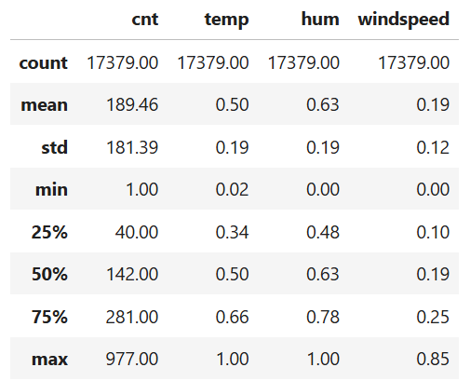

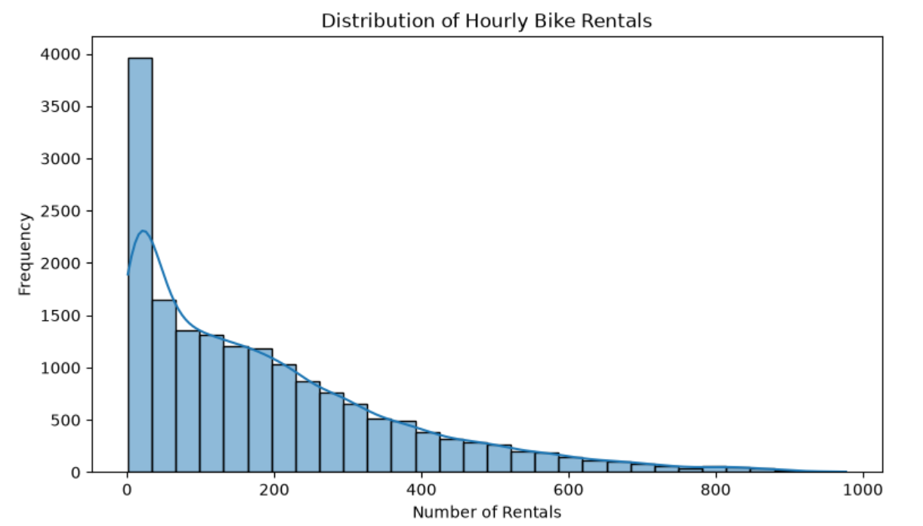

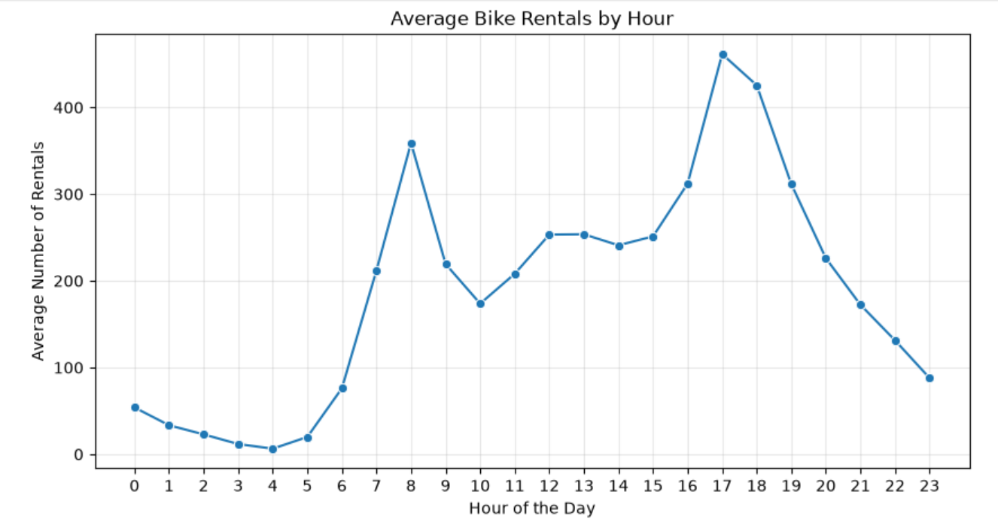
The graph showing average bike rentals by hour revealed that 4 a.m. had the lowest demand. The first peak occurred at 8 a.m., followed by a second peak at 5 p.m., when rental demand was highest.

This variation in hourly rental demand may be associated with commuting patterns, as previous research has identified the time of day as an important factor influencing bike-sharing usage (Bean, Pojani and Corcoran, 2021).
The boxplot showing bike rental distribution by season indicated that summer had the highest rental demand, while winter had the lowest. However, these patterns do not establish a causal relationship, and the historical nature of the dataset limits the applicability of the findings to current bike-sharing behaviour.
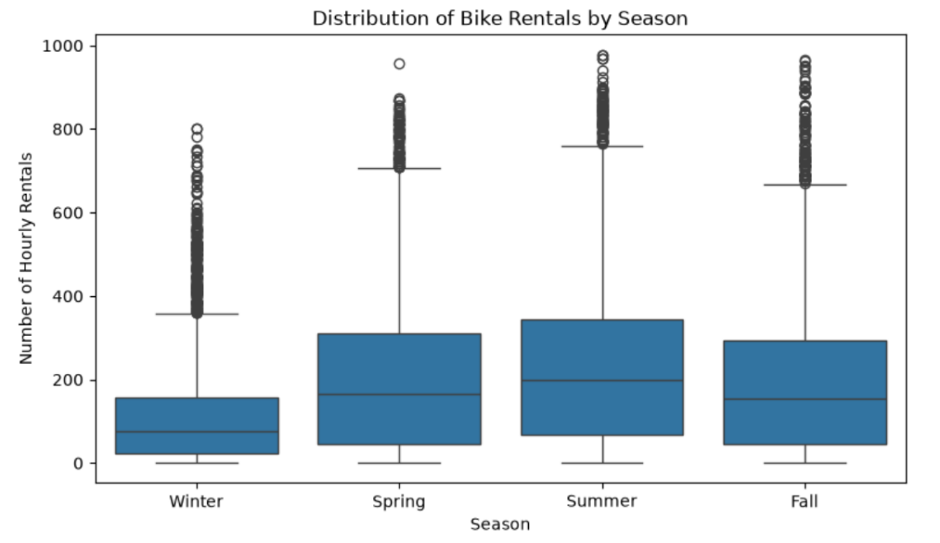

- Binomial Distribution
The Binomial distribution was applied to the workingday variable, which has two possible outcomes: working day (1) and non-working day (0). This variable was selected because it represents a binary outcome, making it suitable for a Binomial model.
The probability of a working day was estimated at approximately 0.684. Considering a sample of 10 observations, the probability of obtaining exactly seven working days was approximately 0.265.
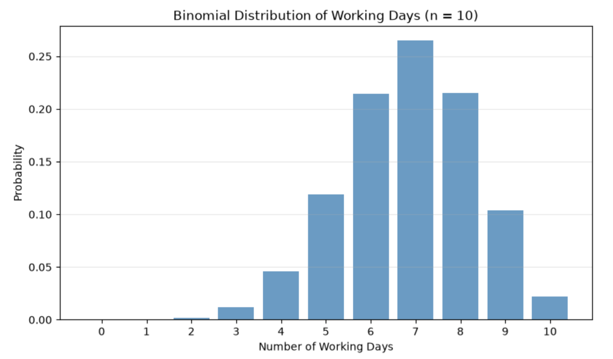

The visualisation showed how the probability is distributed across different numbers of working days. When the sample size increased to 100, the Binomial distribution became more symmetric and could be approximated by a Normal distribution, as both np and n(1−p) were sufficiently large.

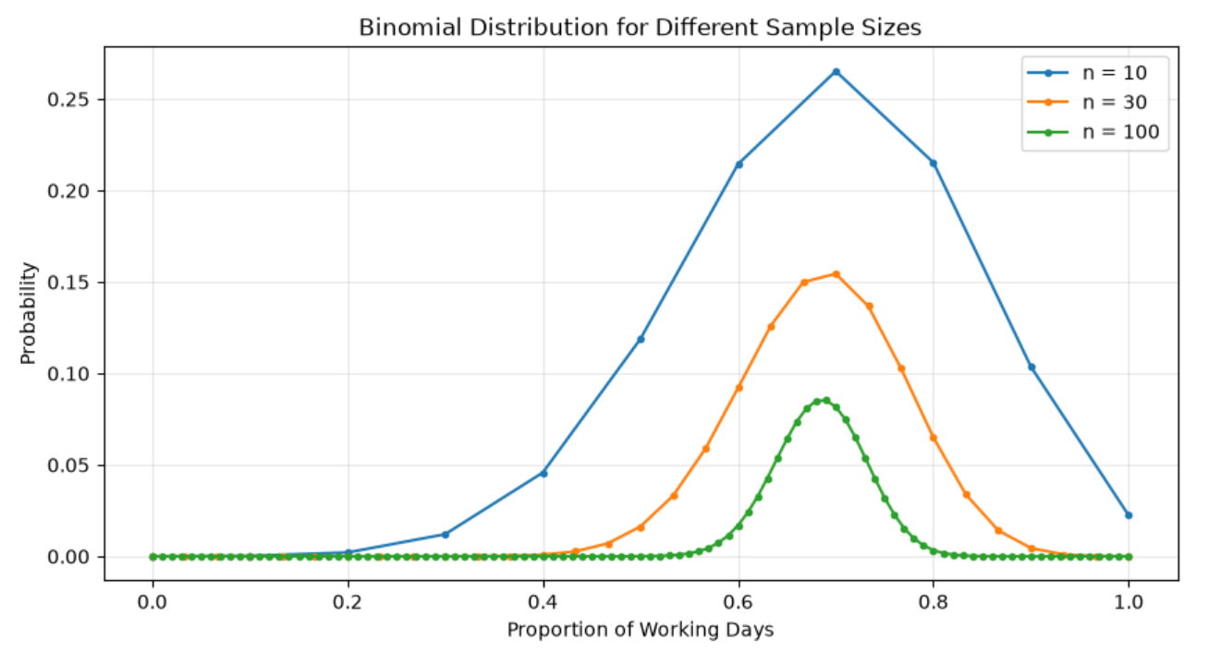

However, the model assumes independent trials and a constant probability of success. These assumptions may not fully reflect the dataset, as working days follow a calendar pattern and hourly observations from the same day are not independent.

- Poisson Distribution
The Poisson distribution was applied to hourly bike rental counts (cnt), as it is commonly used to model the number of events occurring within a fixed time interval, assuming a constant average rate and appropriate independence conditions (Pennsylvania State University, n.d.).
Initially, the overall dataset showed a mean of 189.46 rentals and a variance of 32,901.46, resulting in a variance-to-mean ratio of 173.66. This indicates substantial overdispersion, suggesting that a simple Poisson model does not adequately represent the overall rental counts.
To reduce variation associated with different times of day, the analysis focused on rentals recorded at 4 a.m. Across 697 observations, the mean was 6.35 and the variance was 17.17, giving a variance-to-mean ratio of 2.70.
Using λ = 6.35, the theoretical probability of exactly six rentals was 15.9%, compared with an observed proportion of 10.9%.
The graph showed that the observed data had more frequent low rental counts and a longer right tail than the theoretical Poisson distribution. Although restricting the analysis to 4 a.m. reduced overdispersion, the model still underestimated the variability in rental demand.

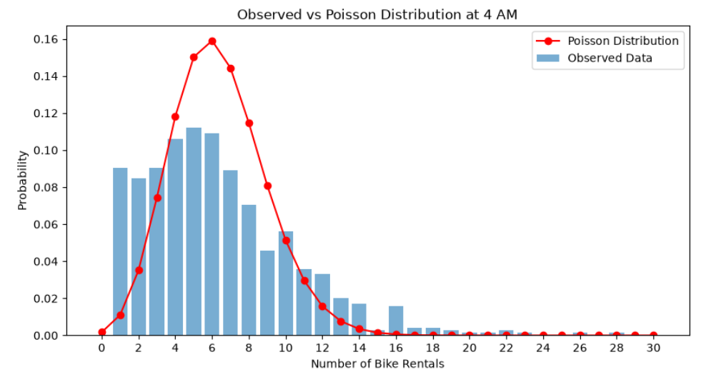

As λ increases, the theoretical Poisson distribution becomes more symmetric and approaches a Normal distribution. However, this theoretical approximation does not eliminate the overdispersion observed in the dataset.

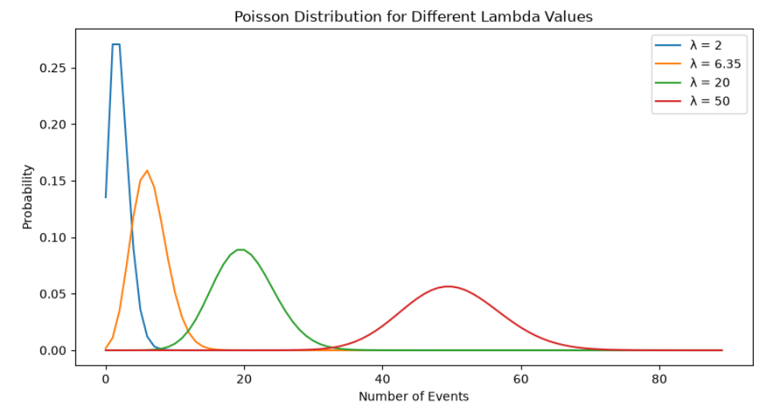

- Normal Distribution
The Normal distribution was applied to the temp variable, which represents normalised temperature. This variable was selected because it is continuous and can be used to investigate how closely the observed data follow a Normal distribution.
The analysis showed a mean of approximately 0.497 and a standard deviation of 0.193. The skewness value was approximately −0.006, indicating that the temperature distribution was nearly symmetric.
The histogram showed that the observed temperatures were concentrated around the centre, with a shape resembling a Normal distribution. However, some differences were observed between the empirical distribution and the theoretical Normal curve, particularly towards the tails.
These findings suggest that normalised temperature can be approximately represented by a Normal distribution, although the fit is not perfect. Furthermore, temperature values in this dataset are bounded, while a theoretical Normal distribution extends infinitely in both directions.

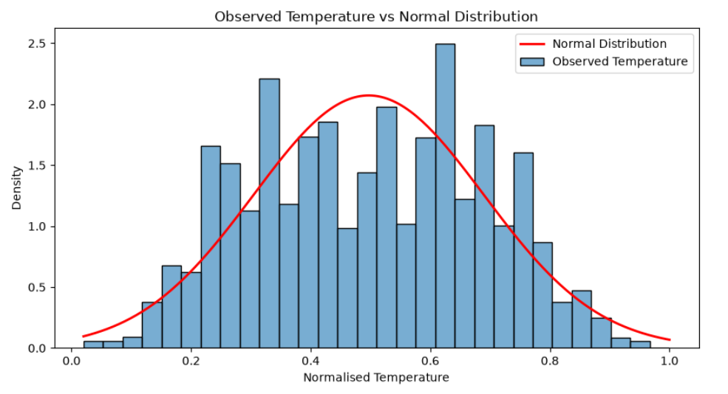

- Comparison of Distributions
The three statistical distributions were applied to different types of variables in the Bike Sharing Dataset. The Binomial distribution was used for the binary variable workingday, the Poisson distribution for hourly bike rental counts (cnt), and the Normal distribution for the continuous variable temp.
Each distribution has different assumptions and limitations. The Binomial distribution assumes independent trials and a constant probability of success. The Poisson distribution assumes equal theoretical mean and variance, but the observed rental data showed substantial overdispersion. Although temperature was approximately symmetric, its observed distribution differed from the theoretical Normal curve.
The analysis also demonstrated that discrete distributions can be approximated by a Normal distribution under certain conditions. The Binomial distribution approaches a Normal distribution when the number of trials is sufficiently large and both np and n(1−p) are sufficiently high. Similarly, the Poisson distribution becomes more symmetric and approaches a Normal distribution as λ increases.
However, these theoretical approximations do not necessarily imply a good fit to the observed data. Therefore, selecting an appropriate statistical distribution requires considering the variable type, the assumptions of the model and the characteristics of the data.

- Conclusion
Although appropriate statistical distributions were selected for different types of variables in the dataset, the results did not always match the theoretical expectations. This may be partly explained by the considerable variation in bike rental demand across different hours of the day and seasons of the year.
The analysis showed that, even when a statistical distribution is theoretically suitable for a particular variable, it may not fully represent the observed data. These findings highlight the importance of examining data behaviour, understanding the limitations of statistical models and selecting appropriate methods for each type of variable.

- References
Bean, R., Pojani, D. and Corcoran, J. (2021) ‘How does weather affect bikeshare use? A comparative analysis of forty cities across climate zones’, Journal of Transport Geography, 95, 103155. Available at: https://doi.org/10.1016/j.jtrangeo.2021.103155

Fanaee-T, H. and Gama, J. (2013) Bike Sharing Dataset. UCI Machine Learning Repository. Available at: https://archive.ics.uci.edu/dataset/275/bike+sharing+dataset

Heinen, E., van Wee, B. and Maat, K. (2010) ‘Commuting by bicycle: An overview of the literature’, Transport Reviews, 30(1), pp. 59–96. Available at: https://doi.org/10.1080/01441640903187001

Illowsky, B. and Dean, S. (2018) Introductory Statistics. OpenStax. Available at: https://openstax.org/details/books/introductory-statistics

Pennsylvania State University (n.d.) The Poisson Distribution. STAT 414: Introduction to Probability Theory. Available at: https://online.stat.psu.edu/stat414/Lesson12

