Sumário

2.35 Notebook: Analyzing Student Data 2

# 2.35 Notebook: Analyzing Student Data

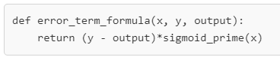

When you opened this task, the exercise body had only:

***def error_term_formula (y, output):***

***pass***

Don’t enter any more variables. Develop your function with only these two variables (y and output).

**Note that:**

* sigmoid = Y ^ = output
* and that x is (1 - output)

Try to develop the function again and see how it works.

If you have a problem with the next step, please show us the error so we can help you.

Hope this helps!