

A Student-to-Student System

[*learnluckycoin.com*](https://luckycoin.info/)

# Whitepaper

**V1.**

# Summary

Abstract

1. Introduction
   1. *The Story*
   2. *The Problem*
   3. *The Idea*
2. Method
   1. *Subject*
   2. *Explication*
   3. *Example*
   4. *Impact*
3. Problems
   1. *Weak Communities*
   2. *Poor Knowledge*
4. Roadmap
5. Allocation
6. Funds Usage
7. “LuckyLearning” Platform
8. Applicability
9. Team
10. Purpose

*The Luckycoin Team*

**Abstract.** *The aim of the project was to create an ecosystem for the younger generation - students and even adults who are concerned about their children's future. Peer-to-peer technology is part of the solution and will be achieved by creating a currency dedicated to young people who are aware and prepared for tomorrow's economy. The implementation of the currency will be done in The Binance Smart Chain Network, a secured blockchain contract that offers the possibility to execute commerce without the action of a financial institution or a third party.*

# Introduction

* 1. The Story

It is hard to tell when the story has begun. We are currently studying at one of the top Computer Science Highschools in Romania, Europe, passionate about technology and desiring to create something new, we started reading about this technology called the blockchain or "crypto" a long time ago. Of course, after a long period of research the idea was born and the story began.

* 1. The Problem

We know that cryptocurrencies already represent the future of the global commerce, however the implementation is still going too slow compared to people’s expectations. In consequence, the problem has to be solved from the beginning of the adult life.

* 1. The Idea

A coin created by students for students that offers the advantage to learn, commerce and transfer valuables at high hash rates.

# Method (SEXI)

(S- Subject, E-explication, X-example, I-impact)

* 1. Subject

By giving the opportunity to the young generation to learn and use the blockchain technology, the evolution process will maximize and grow substantially. Once you understand the timestamp servers and the logic behind the Proof-of-Work, you are able to use the currency.

* 1. Explication

‘A timestamp server works by taking a hash of a block of items to be timestamped and widely publishing the hash. The timestamp proves that the data must have existed at the time, obviously, in order to get into the hash. Each timestamp includes the previous timestamp in its hash, forming a chain, with each additional timestamp reinforcing the ones before it. For our timestamp network, we implement the proof-of-work by incrementing a nonce in the block until a value is found that gives the block's hash the required zero bits. Once the CPU effort has been expended to make it satisfy the proof-of-work, the block cannot be changed without redoing the work. As later blocks are chained after it, the work to change the block would include redoing all the blocks after it.’

The Satoshi Nakamoto description may be a little bit harsh, but describes the peer-to-peer system, including the timestamped servers and the proof-of-work.

* 1. Example

The longest chain generated by the hash blocks will be confirmed as the real address and the secured one. If the blockchain stops, it will start again generating blocks from zero. The other blocks(orphans) exist outside the main chain. The genesis block starts generating the main chain.

Main chain

Genesis block

Orphan blocks

* 1. Impact

Using A Student-to-Student System based currency, trust and communication between students all over the world is encouraged and built. Being created by students, the currency is made to fulfill student needs and interests, while always taking suggestions and trying to improve to meet the community’s priorities. The main idea and concept of the coin is that students can have a passive income to help them have a start up in life or in a business. Also, people that want to motivate teens involve in finance and modern technology can invest and grow the liquidity of the token and therefore encourage more people to join the project.

# Problems we solve

* 1. Weak communities

When teens want to enter the crypto world, it looks scary and complicated.They see people with experience that seem to speak a foreign language and will always be a step ahead of them because of their experience and education. That is why a lot of them are discouraged and feel like it is impossible to win in a race where they are inferior. But with Luckycoin, the “race” did not start in the past, and they have an opportunity to start from scratch next to other beginners with the same interests.

* 1. Poor knowledge

There is no doubt that cryptocurrencies are still an abstract concept for a lot of people, and it is hard to understand how it works. That is the reason why it is not an industry that grows extremely fast, and you need time to put in to get results. Encouraging young people to get involved in such a project since their first financially independent years, the crypto community gains investors that are in no rush, and are willing to believe in a technology of the future.



# Roadmap



First lessons

START 27.12.2022(IPO)



Community learning

# 

Web 2.0

Development

luckycoin.info

First Platform Deployed

People start learning



Start Mobile Development

Learning Platform

Android Users

Web 2.0

Development

learnluckycoin.com

Second Web Deploy

2024

People that learn will receive the 6% back by learning and staking

Redeployment

6% Tax

2% Tax ready for staking

4% Tax is returning to the learners

2024

Start Web 3.0 Development

# Allocation

|  |  |  |
| --- | --- | --- |
| % | Amount (LUCK) | Participant |
| 80% | 200,000,000,000 | IPO |
| 20% | 50,000,000,000 | Founding Team and Investors |

1. **Funds Usage**

The percentage allocated for the founding team will be used in the following way:

(Please note that we do not want that new investors to destroy the liquidity by selling uncontrolled)

20% of 250.000.000.000 represents 50.000.000.000

|  |  |
| --- | --- |
| **Amount (LUCK)** | **Participant** |
| 5.000.000.000 | Independent Investors |
| 15.000.000.000 | Partners of our project |
| 10.000.000.000 | Marketing |
| 10.000.000.000 | “LuckyLearning” Platform |
| 10.000.000.000 | Emergency Credit |

## “LuckyLearning” Platform

The structure of the platform is the following:

* Every person will create a personal account;
* The platform will contain information about the cryptocurrencies, liquidity, smart chains all you need to know before entering the crypto world;
* At the end of every chapter a test will check your knowledge, with questions from the documentation, the user will be rewarded with LUCK(Luckycoin), equivalent with the amount of knowledge they have;
* Experience can be achieved by trading the free coins received after completing the tests(with a real time advisor and even personal meetings with the crew);
* The platform will include an Openai, that will answer you in real time any question about the crypto world or the Luckycoin Project, creating an API with playful and educational prompts;

## Applicability

The purpose of our team is to educate the young generation and start creating an environment for teenagers and adults to understand the benefits behind this cryptocurrency.

## Team

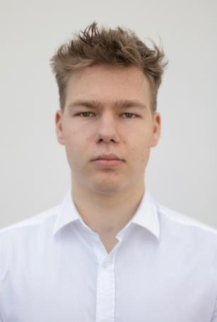Meet Luckycoin Team and Investors

## Max Pokker

* *Manager human resources Luckycoin Team*
* Graphic designer
* Student at *Politecnico di Milano*

## Pop Samuel

* *IT assistant Luckycoin Team*
* IT Student at West University of Timisoara
* Database , S.O Engineer

## Nicoara Andrei

* *Marketing Agent Luckycoin Team*
* IT Assistant Luckycoin Team
* IT Student at *University Babeç Bolyai, Cluj, Romania, Europe*

## Alex Lolea

* + 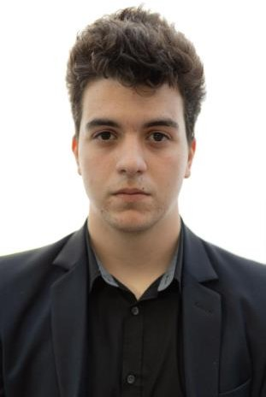*IT Expert Luckycoin Team*
  + IT Student at DELFT, Netherlands
  + *Specialized in Computer Science and Engineering*

## Minda Lucian – Founder of Luckycoin (A Student-to- Student System)

Experienced in trading, fascinated about the blockchain technology, created the first project in Europe, Romania, targeting students and learning the basics of the blockchain technology, participated in Erasmus Project Eur’Aquatic, Internships at Endava, passionate of the world finance system, ambitious. The evolution of finance is coming.

In the begging of human history people used

to trade animals, coins(made of copper, silver, gold). Now we are using bills.

The future represents digital coins like(Bitcoin, BNB, Ethereum, Luckycoin…). We call this “The digitalization of World Currency”.

We need to learn more and teach others about the criptocurrencies benefits.

## Mottoes

*“Words become flesh”*

*“We are going to change people vision about crypto world. We are young, we know what teenagers understand and like!”*

## Conclusion

*“Trust is the key to success!”*

Luckycoin represents the future of trust in a decentralized world. Luckycoin offers a transparent, secure, and efficient solution to establish trust in various student communities.

Join us on this revolutionary journey as we redefine trust for the digital age. Together, we can unlock new opportunities and build a trustworthy and reliable global ecosystem.