Introduction
The Philippines is regarded as one of the most disaster-prone areas in the world. Being included in the 2018 World Risk Report and ranked third most at risk and most susceptible to natural disasters among the 171 countries included. The Philippines experiences almost all forms of disasters and an average of 20 typhoons yearly.

For this reason, provision of temporary shelters to affected communities is of invaluable importance. As of July 2019, the Department of Public Works and Highways (DPWH) has built 82 evacuation centers in 52 provinces, while 55 more are ongoing, according to Philippine Senate President Ralph Recto. Meanwhile, the local government of Marikina City in 2018 set up modular tents in public schools to accommodate affected families during the monsoon. This improved the living conditions of evacuees throughout their stay in evacuation centers and set an example for other local government units to follow.

In 2018, the Department of Interior and Local Government (DILG) provided the guidelines for selecting shelter construction sites. According to Memorandum Circular No. 122, these sites must be established in safe and stable areas away from hazard zones. These sites must also be accessible by vehicular transportation all year round, withstand wind speeds of 300 kilometers per hour, and moderate seismic activity of at least 8.0 magnitude on the Richter Scale, and must be strategically located near basic goods, services, and healthcare facilities. Several papers have also emphasized the importance of shelter location in optimizing evacuation times.

In relation, various shelter location-allocation models are already present in literature. A model by Sherali et al. in 1991 [23] sought to minimize the total time spent in seeking shelters. Their objective function was written in terms of steady-state flow rate and free-flow travel time, the decision variable being the steady-state flow rate for each path from communities to shelters. As well, Mollah et al. [16] added a facility location model to address the relief distribution in flood scenarios. Their objective function is written in terms of the total cost of transporting population and relief kits and also the penalty cost for victims that were not evacuated, the objective function is subject to time and capacity constraints.

Existing General Location Allocation Model (GEN)
Saadatseresht et al. [20], Zhao et al. [26], and Xu et al. [25] developed multiobjective models to solve the shelter location-allocation problem; objectives such as minimizing the total distance travelled by evacuees and total cost of constructing the shelters.

Particularly in the study of Xu et al. [25], one of the objective groups aimed to minimize the toal evacuation distance and the total shelter area, presented as:
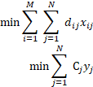
subject to
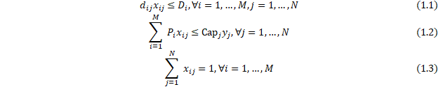
where
- number of communities
- number of candidate shelter sites
- distance of th community to th candidate shelter
- population of th community
- maximum distance that can be traveled by th community
- cost of constructing and/or maintaining a shelter on th site
- total capacity of th candidate site to be used to construct a shelter
- binary variable where 1 indicates that the th community is allocated to th shelter
- binary variable where 1 indicates that the th site is selected as a shelter.
Since the model is multi-objective, it is solved using a Pareto-based optimization method called the Modified Particle Swarm Optimization (MPSO) proposed by Zhao et al. in 2015 [26]. Particle Swarm Optimization is a nature-inspired algorithm that relies on function evaluations to determine the best solutions. In MPSO, Particle Swarm Optimization is combined with Simulated Annealing and is modified for multiobjective setup. This method yields several solutions called Pareto solutions instead of a single best solution. For their case study, 85 Pareto solutions were obtained.
In the latter part of this paper, we will refer to this model as the General SingleLevel Model (GEN) and we will use this as a reference model for our modifications along with the hierarchical model that we will introduce later. However, for simplicity, instead of solving GEN model using multiobjective optimization techniques, we will instead assign weights such that to each objective and minimize their weighted sum. Thus the final form of GEN model is
subject to
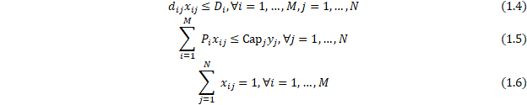
Existing Hierarchical Location-Allocation Model (HIER)
On the other hand, Chen et al. [4], Li et al. [15], and Widener and Horner [24] considered hierarchical shelters in their studies. Hierarchical shelters take into account different levels of shelters according to length of stay and level of service to address the time-varying needs of evacuees during different phases of evacuation. In hierarchical models, evacuees are allowed to transfer shelters. Transferability between shelters implies the merging of evacuees into less number of shelters for easier distribution of relief goods and monitoring of evacuees.
Widener and Horner [24] and Li et al. [15] placed the points of demand to the closest open facility of desired level in each evacuation phase. In particular, Li et al. [15] constructed a two-stage model which they refer to as Emergency Shelter Location Model (ESLM) and Victim Allocation Model (VAM). ESLM minimizes the construction cost of shelters and is formulated as
subject to
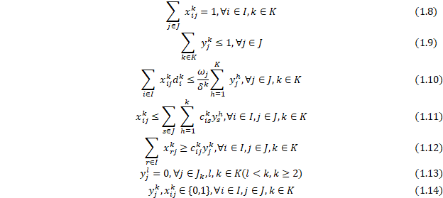
where
set of community indices
- set of shelter indices
set of hierarchical levels
if otherwise
- area of candidate shelter
required area per one victim who needs level shelter service
- construction cost per unit area to build level shelter
- number of victims from residential community during phase
- variable indicating 1 if site is located to build level shelter; 0 otherwise
- variable indicating 1 if site is allocated to shelter during phase otherwise
Meanwhile, the Victim Allocation Model (VAM) minimizes the total travel distance for each evacuation phase and is formulated as
subject to
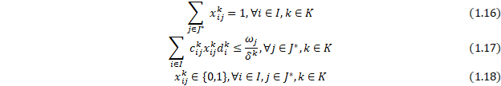
where
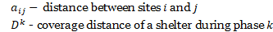
Since these models are constructed and solved as two-stage models, we simply assign weights such that to each objective, minimize their weighted sum, and combine distinct constraints to construct our reference hierarchical model HIER.
subject to
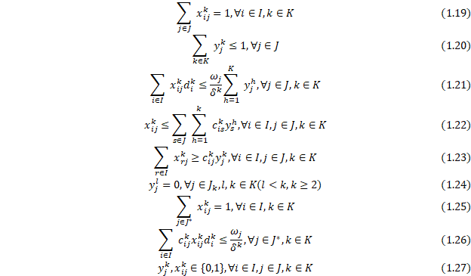
In particular, this study aims to formulate models that consider distance between shelters in the transfer of evacuees, allocation of evacuees to shelters with and without transfer to a higher-level shelter, and proximity of evacuees to a workplace. We will also provide proof for the existence of solutions of the proposed models, to solve for the optimal solution of the models using an optimization algorithm, and to apply the models on a case study in the municipality of Calumpit in Bulacan.
Binary Genetic Algorithm
Since the shelter location-allocation problem includes many binary variables, we intend to use a nondeterministic method called the binary genetic algorithm as described in [10] for our case study. Genetic algorithms are nature-inspired optimization algorithms introduced by John Holland in 1960 based on the mechanics of natural selection and evolution [21]. Unlike traditional algorithms that start at a single point, GA starts by generating a population of points that will undergo selection, crossover, and mutation to decide the best solutions that will carry over their attributes to the next generation. The algorithm ends when a stopping criterion, e.g. number of generations, is met. Figure 1.1 shows the flow chart of a binary genetic algorithm that is applied to our models.
The chromosome. A point in GA is called a chromosome. A chromosome is a row vector that consists of genes, where each gene corresponds to a variable in the model. Genes consist of bits, or 0 s and 1 s , and every combination of bits correspond to a unique continuous value. The processes of converting continuous values to binary and vice versa are called encoding and decoding, respectively. However, since we are dealing with binary variables in our case study, we do not have to do these steps, so we will not include them in the discussion. Figure 1.2 is an example of a chromosome for a model with 5 variables where each gene has 2 bits. Since the variables in our models are binary, there will be one bit in a gene and the number of bits in a chromosome would be the same as the number of variables in the model.
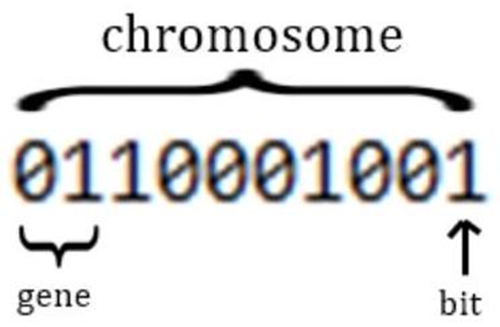
Selection. GA starts by generating chromosomes with bits each. Each of these chromosomes are evaluated by their objective function values. The best chromosomes are then selected and reproduced for the next generation using a userdefined selection rate is used to compute for given by
chromosomes are selected to be included in the crossover and mutation processes as well as in the next generation of GA. The standard selection rate is so that the best genes for mating are included, while giving less chance for bad performers to contribute their traits to the next generation of chromosomes.
For our case study, rank weighting is used to select the chromosomes for mating. The chromosomes are first ranked according to their function values. Chromosomes with the best function values are given the highest rank and hence the highest chances of mating. Let be the rank of a chromosome. Then its probability is computed by
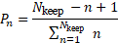
The cumulative probability of each chromosome is also computed
To select a pair of parents, a random number between 0 and 1 is generated, for instance . The first chromosome whose cumulative probability exceeds is selected for mating.
Mating. Similar to its biological meaning, mating in GA is the reproduction of one or more offsprings from selected parents. For our case study, mating is done through single-point crossover. In single-point crossover, a crossover point is randomly selected between the first and last bits of a chromosome. Then the bits of each parent from that crossover point onwards are exchanged to produce two new offsprings.
Mutation. Mutation is a way for GA to explore the domain. It keeps GA from converging too early by introducing traits that have not been generated by the previous population. To do this, mutation rate is defined at the start of the algorithm and is used to decide the number of mutations to be done. The number of mutations nmut is computed using
Except for the WORK model, the mutation rate for our case study decreases and follows a harmonic sequence. Among the whole population nmut bits are randomly selected to be mutated, except the elite solution or solution with the best value. Elite solutions do not mutate because we do not want to change a perfectly good solution. Mutation is done simply by changing 1 to 0 on the selected bits and vice versa
Methodology
This study aims to modify the existing models in literature. In particular, four models are presented, taking into account the transferability between shelters, sequence of transfer, and distance of shelters to major workplaces. In these models, we aim to minimize the total travel distance of evacuees and construction and maintenance cost of shelters in a single objective function.
Bilevel Non-sequential Transfer (BNST) Model
In this model, the evacuees may evacuate to any level of shelter during the initial phase of evacuation. Each community is assigned to exactly one shelter, which may be level 1 or level 2, but not both. After a couple of days, the remaining occupants of a level 1 shelter must transfer to a level 2 shelter while the remaining occupants of a level 2 shelter may or may not transfer to another level 2 shelter. Some evacuees may opt to return to their homes or move out of shelters to stay with their relatives upon recovery, reducing the number of occupants in the shelters. Therefore, merging the remaining occupants into a smaller number of shelters eases relief distribution and management.
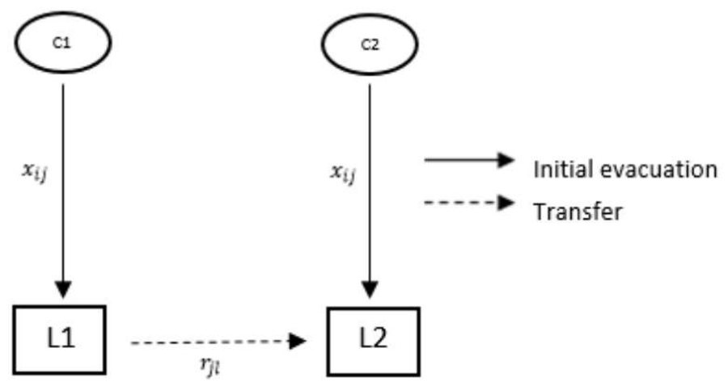
The proposed model is
subject to
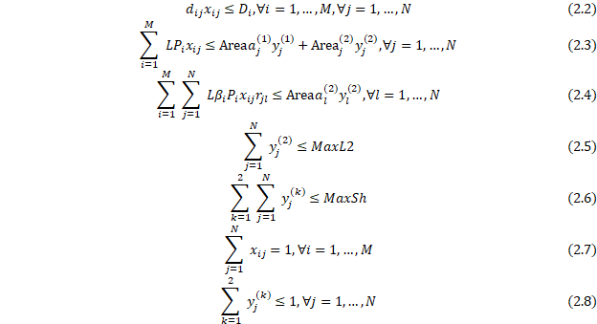
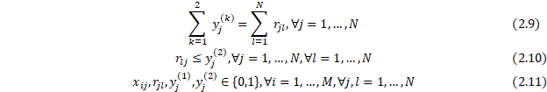
The first term of objective (2.1) minimizes the total travel distance of evacuees moving from communities to shelters and transferring to higher-level shelters. The second term minimizes the construction and maintenance cost of shelters. Constraint (2.2) represents the distance constraint which ensures that a community is allocated to a nearby shelter. Constraints (2.3) and (2.4) are the capacity constraints. Constraints (2.5) and (2.6) limit the number of Level 1 and Level 2 shelters to be constructed. Constraint (2.7) ensures that a community will be allocated to exactly one shelter. Constraint (2.8) ensures no co-location of shelters. That is, at most one level of shelter may be constructed on each site. Constraint (2.9) relates the variables and . If site is selected as a shelter, then its occupants must be transferred to another shelter, possibly to itself; otherwise no transfer must happen. Constraint (2.10) determines the level of the shelter. If occupants of at least one shelter transfers to shelter , then is a level 2 shelter. Equivalently, this constraint ensures that a occupants of a lower level shelter must transfer to a higher level shelter, but not vice versa. Lastly, constraint (2.11) defines the binary variables of the problem. This model has a total of variables and constraints.
Bilevel Sequential Transfer (BST) Model
This model is similar to model 1 , however only level 1 shelters are available for initial evacuation. That is, each community must be initially allocated to a level 1 shelter, then afterwards they are transferred to level 2 shelters. This may be useful if level 2 shelters need more time to be set up for more advanced facilities and medical services such as medical operations. Figure 2.2 illustrates this model. The model is
subject to
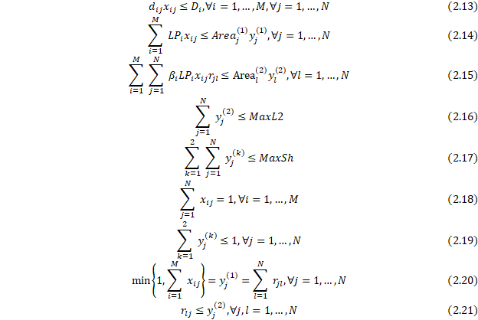
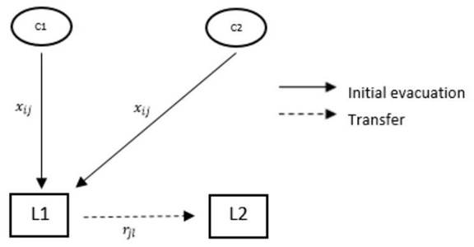
Figure 2.2: Transfer flow of evacuees between shelters according to the BST model
The objective of this model is the same with the first model. The difference is in the constraints. Constraints (2.13), (2.14), and (2.15) are the distance, level 1 capacity, and level 2 capacity constraints, respectively. Constraints (2.16) and (2.17) limit the number of Level 1 and Level 2 shelters to be constructed. Constraint (2.18) ensures that a community will be allocated to exactly one shelter. Constraint (2.19) ensures no co-location of shelters. Constraint (2.20) relates the variables and and distinguishes this model from the first model. If at least one community is assigned to shelter , then is a level 1 shelter and its occupants must be transferred to another shelter. Constraint (2.21) determines the level 2 shelters. If occupants of at least one shelter are transferred to shelter , then is a level 2 shelter. Consequently, occupants of lower level shelters must transfer to higher level shelters. Lastly, constraint (2.22) defines the binary variables of the problem. This model has a total of variables and constraints.
Bilevel No-Transfer (BNT) Model
In this model, two levels of shelters are constructed. However, all communities stay in their assigned shelters throughout the recovery phase and do not transfer at all. This model may be useful when deciding, for instance, whether to build two level 1 shelters or one level 2 shelter. This provides some flexibility for shelter capacities which are otherwise not incorporated in existing models that do not require transferability.
Figure 2.3 illustrates this model. The model is
subject to
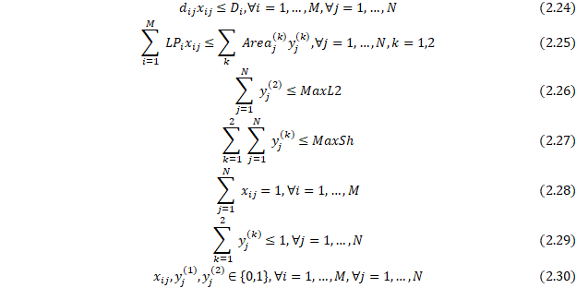
The first term of objective (2.23) minimizes the total travel distance while the second term minimizes the construction/maintenance cost of shelters. Constraints (2.24) and (2.25) are the distance and capacity constraints. Constraints (2.26) and (2.27) limit the number of Level 1 and Level 2 shelters to be constructed. Constraint (2.28) ensures that each community is assigned to exactly one shelter. Constraint (2.29) ensures that at most one level of shelter can be constructed at each site. Constraint (2.30) again defines the binary variables of the problem. This model has a total of variables and constraints.
Single-level with Workplace Distance Inclusion
Hierarchical shelters are not incorporated in this model for simplicity. Instead of the usual distance minimization objective, this model aims to minimize as well the distance of communities to companies where majority of the residents work. This now allows some communities to be allocated to a farther shelter but closer to their work and other communities are given the chance to be allocated to nearer shelters. This may address the problem of being indiscriminately assigned to a farther shelter. Figure 2.4 illustrates this model. The model is
subject to
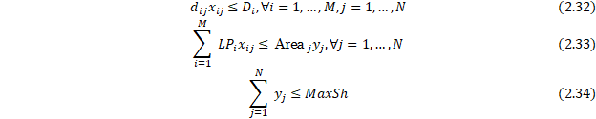
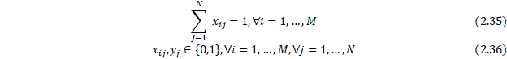
The first term of objective (2.31) minimizes the sum of the distances of communities to shelters and workplaces while the second term minimizes the construction and/or maintenance costs. Constraints (2.32) and (2.33) are the distance and capacity constraints. Constraint (2.34) limits the number of shelters to be constructed. Constraint (2.35) ensures that each community is assigned to exactly one shelter. Constraint (2.36) defines the binary variables of the problem. This model has a total of variables and constraints.
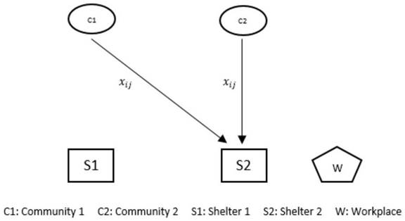
Figure 2.4: Transfer flow of evacuees between shelters according to the WORK model
Proof of Existence of Solution
This section provides sufficient conditions for the existence of a feasible solution for each model. In particular, the conditions in the number and capacities of shelters as well as in the distance between communities and shelters. Afterwards, the study will prove the existence of solutions for BNST and BST models. For BNT and WORK models, the study will instead provide simpler conditions for the existence of solutions of the existing single-level model and prove that the solution of the existing model is also a solution of the BNT and WORK models.
Bilevel Non-sequential Transfer (BNST) Model
Proposition. Let
finite number of communities,
finite number of candidate shelters,
be the set of communities, with population denoted by Pop ,
be the set of shelters, with level 1 and level 2 capacities denoted by and , respectively, ,
- portion of community that will transfer to a level 2 shelter,
- maximum distance that can be traveled by community .
Suppose there is no limit to the number of level 1 and level 2 shelters to be constructed, and the following conditions are satisfied:
1. ,
2. for each ,
3. , and
4. .
Then a solution exists for the Bilevel Non-sequential Transfer Model.
This proposition provides sufficient conditions for the existence of a feasible solution for the BNST model. Firstly, there must be more candidate shelters than there are communities. Secondly, the level 2 capacity of shelters must naturally be larger than their level 1 capacity. The third condition ensures that any community will fit inside any shelter. The last condition on the distance constraint requires that all the candidate shelters must be within reach of any community.
Proof. For each , assign community to shelter , that is,
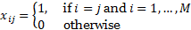
This is possible because . Let each of these shelters be level 2 shelters, i.e.,
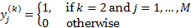
Also, none of the occupants of the shelters will transfer, that is,
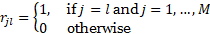
Claim: is a feasible point of the model.
Constraint (2.2): Distance constraint. This constraint is already assumed.
Constraint (2.3): Level 1 capacity. For . For each
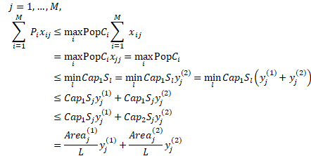
Constraint (2.4): Level 2 capacity. Since for 0 for . For ,
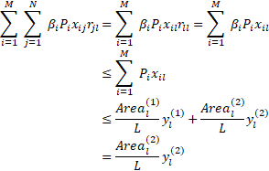
Constraints (2.5) and (2.6): Maximum number of shelters that can be constructed. By the assumption that there is no limit to the number of shelters to be constructed, these constraints are therefore satisfied.
Constraint (2.7): Each community is allocated to exactly one shelter. For each ,
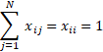
Constraint (2.8): No co-location of shelters. For each ,
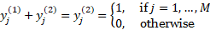
Constraint (2.9). For each ,
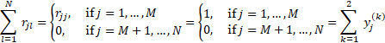
Constraint (2.10). For each ,
Finally, we assumed that there are a finite number of communities and candidate shelters, thus the feasible set is also finite. Moreover, the objective function is bounded below by zero due to nonnegativity constraints and the nonnegativity of distance and construction cost values. Since is feasible on a finite set, this proves the claim on the existence of a solution.
Bilevel Sequential Transfer (BST) Model
Proposition. Let
finite number of communities,
finite number of candidate shelters,
be the set of communities, with population denoted by Pop ,
be the set of shelters, with level 1 and level 2 capacities denoted by and , respectively, ,
- portion of community that will transfer to a level 2 shelter,
- maximum distance that can be traveled by community .
Suppose there is no limit to the number of level 1 and level 2 shelters to be constructed, and the following conditions are satisfied:
1. ,
2. for each ,
3. ,
4. , and
5. .
Then a solution exists for the Bilevel Sequential Transfer Model.
The proposition provides stricter sufficient conditions for the existence of solution for the BST model. That is, the number of candidate shelters must not be less than twice the number of communities, and the capacity of any level 2 shelter must be larger than that of any level 1 shelter.
Proof. For each , assign community to shelter , that is,

Moreover, occupants of shelter must transfer to shelter for , i.e.,
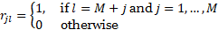
This is possible because . Let be level 1 shelters and be level 2 shelters, i.e.,
Claim: is a feasible point of the model.
Constraint (2.13): Distance constraint. This constraint is already assumed.
Constraint (2.14): Level 1 capacity. For . For each
,
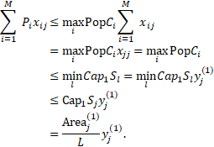
Constraint (2.15): Level 2 capacity. For ,
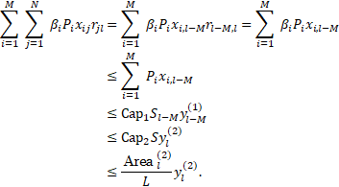
For . Thus .
Constraints (2.16) and (2.17): Maximum number of shelters that can be constructed. By the assumption that there is no limit to the number of shelters to be constructed, these constraints are therefore satisfied.
Constraint (2.18): Each community is allocated to exactly one shelter. For each ,

Constraint (2.19): No co-location of shelters. For each ,
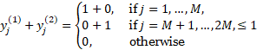
Constraint (2.20). For each ,
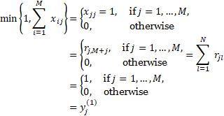
Constraint (2.21). For each ,
This proves the claim.
General Single-level (GEN) Model
For the two remaining models, we will instead provide sufficient conditions for the existing general model GEN and afterwards we will prove that the solution of this model is also a feasible point of BNT and WORK models.
Proposition. Let
finite number of communities,
finite number of candidate shelters,
be the set of communities, with population denoted by Pop ,
be the set of shelters, with capacities denoted by ,
- maximum distance that can be traveled by community .
Suppose there is no limit to the number of shelters to be constructed, and the following conditions are satisfied:
1. ,
2. , and
3. .
Then a solution exists for the General Single-level Model.
This proposition only simplifies the conditions needed for the solution of the GEN model to exist, and its proof is similar with the proof for the BNST model.
Proof. For each , assign community to shelter , that is,

This is possible because . Moreover, select sites as shelters, that is,
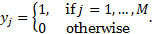
Claim: is a feasible point of the model.
Constraint (1.4): Distance constraint. This constraint is already assumed.
Constraint (1.5): Capacity constraint. For . For each ,
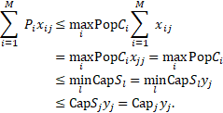
Constraint (1.6): Each community is allocated to exactly one shelter. For each ,

This proves the claim.
WORK and GEN models only differ in the objective function but still have the same constraints. Thus a solution for the GEN model is also a solution for the WORK model. Meanwhile, BNT and GEN models differ in the capacity constraints, but a solution satifying the capacity constraint of the GEN model also satisfies that of the BNT model. We prove this in the next proposition.
Proposition. Suppose the conditions for the existence of solution for GEN model are true. Let be a solution of the GEN model. Let
That is, we decide to construct only level 1 shelters. Then is a feasible point of the BNT model.
Proof.
Constraint (2.24): Distance constraint and Constraint (2.24): Each community is allocated to exactly one shelter. These constraints are the same as in the GEN model and thus are already satisfied.
Constraints (2.26) and (2.27): Maximum number of shelters that can be constructed. By the assumption that there is no limit to the number of shelters to be constructed, these constraints are therefore satisfied.
Constraint (2.29): No co-location of shelters. For each ,
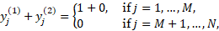
Constraint (2.25): Capacity constraint. Note that
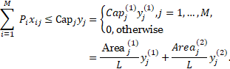
This proves the claim.
It is important to note that in all these propositions, we made the natural assumption that the number of communities and candidate shelters must be finite so that we can work on a finite feasible set. If the feasible region for the problem is unbounded, the existence of a feasible point will not suffice to prove the existence of an optimal solution, and an optimal solution may not exist.
Results and Discussion
To evaluate the performance of the models, the researchers utilized simulated data based on the municipality of Calumpit, Philippines, involving shelters and communities.
Although the data does not meet the conditions specified in the theoretical propositions—primarily due to the number of shelters being fewer than the number of communities—it nonetheless yielded feasible solutions across all models. In the BST model, 8 shelters were activated, with 13 communities assigned to shelters based on affected population sizes ranging from 0 to 115 individuals. Assuming an area requirement of 1 square meter per person, the total shelter capacity was calculated accordingly. Among the shelters, 2 were upgraded to level 2, while the rest remained at level 1. In the BNST model, 11 shelters were opened, with all but one upgraded to level 2, resulting in a more evenly distributed community-to-shelter allocation. The BNT model activated 15 shelters, with 2 upgraded to level 2 and a similarly balanced distribution, with no shelter serving more than 4 communities. In contrast, the Work model opened only 7 shelters and exhibited a more uneven allocation, including one shelter that served 10 communities. All models adhered to a maximum allowable distance of 11 kilometers between communities and their assigned shelters.
The distance between each community and shelter was calculated using the road segments connecting the two calculated using the haversine distance calculation, providing an accurate distance estimate. The researchers set the weights for all models to be equal at 0.5 for both values, to provide equal priority for cost and distance. The parameters for the binary genetic algorithm are presented in Table 4.x.
Parameter | HIER | GEN | BNST | BST | BNT | WORK
Max. generations | 500 | 500 | 500 | 500 | 500 | 500
Num. of solutions | 100 | 100 | 100 | 100 | 100 | 100
Mutation rate | 0.2 | 0.2 | 0.2 | 0.2 | 0.2 | 0.2
Mutation iterations | 2 | 2 | 2 | 2 | 2 | 2
Max. shelters | 33 | 33 | 33 | 33 | 33 | 33
Max. level 2 shelters | 33 | 33 | 33 | 33 | 33 | 33
Area per individual (m²) | 1 | 1 | 1 | 1 | 1 | 1
Table 4.x: Parameters for binary genetic algorithm used in the test problem
The solutions of the models were then compared according to the following criteria:
1. Total travel distance
2. Total construction cost of shelters
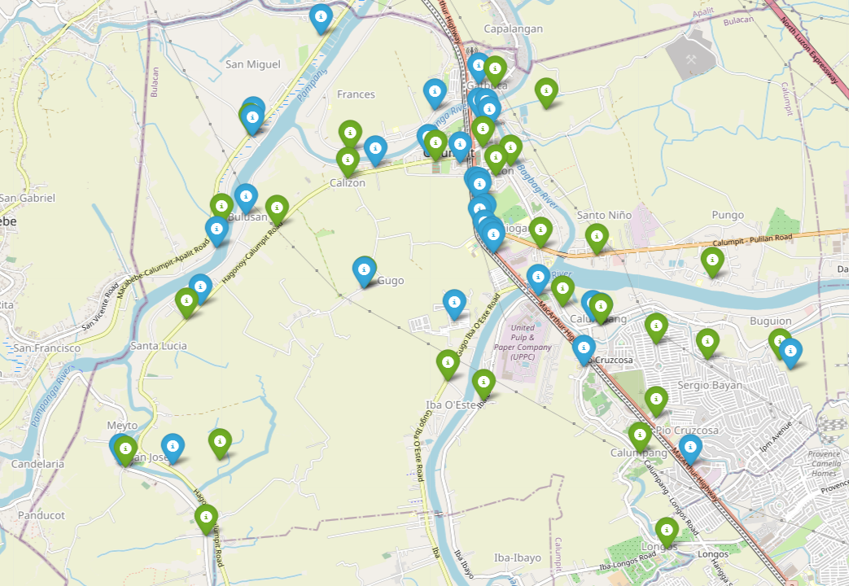
Figure 4.x: Problem illustration with X communities, Y shelters, and 16 workplaces.
The algorithms were demonstrated in Python. Table 4.x shows the best shelter location allocation configuration across 500 runs for the BNT model. Figure 4.x also presents the most optimal location-allocation plot solution for the BNT model. The solutions for each model were improving as more runs were added and are consistently obtaining better objective function values.
Community | Shelter Assigned
Balite | Palimbang Empty Lot
Balungao | Palimbang Empty Lot
Buguion | Mun. Covered Court
Bulusan | Barangay Hall Bulusan
Calizon | BMLTC Multi-Purpose Bldg and EC
Calumpang | BMLTC Multi-Purpose Bldg and EC
Caniogan | San Miguel Meysulao High School
Corazon | Calumpit Sports Complex
Frances | San Marcos Elem. Sch.
Gatbuca | San Miguel Meysulao High School
Gugo | Mun. Covered Court
Iba Este | F. Mendoza Memorial Elem Sch.
Iba O'Este | NV9 Multi-Purpose
Longos | Calumpit Sports Complex
Meysulao | BMLTC Multi-Purpose Bldg and EC
Meyto | F. Mendoza Memorial Elem Sch.
Palimbang | Caniogan Empty Lot 2
Panducot | Caniogan Empty Lot 2
Pio Cruzcosa | NV9 Multi-Purpose
Poblacion | F. Mendoza Memorial Elem Sch.
Pungo | San Miguel Meysulao High School
San Jose | Caniogan Empty Lot 2
San Marcos | Corazon Empty Lot 2
San Miguel | Calumpit Sports Complex
Santa Lucia | Barangay Hall Bulusan
Santo Niño | F. Mendoza Memorial Elem Sch.
Sapang Bayan | Corazon Empty Lot 2
Sergio Bayan | Palimbang Empty Lot
Sucol | F. Mendoza Memorial Elem Sch.
Table 4.x: The optimal shelter location allocation for the BNT model across 500 runs.
The four proposed models were implemented in a case study focused on the municipality of Calumpit, Bulacan, and were solved using the binary genetic algorithm described in earlier sections. Constraint handling was managed using the penalty function method.
Study Area. Calumpit, located in the province of Bulacan, is widely recognized as the most flood-prone municipality in the province and possibly in the entire Philippines. Based on the 2020 Census, the municipality had a total population of 118,471 distributed across 29 barangays.
Candidate Shelters. A total of twenty-two (22) existing structures—including covered courts, barangay halls, designated evacuation centers, and schools—were identified within Calumpit as potential shelters. In addition, several vacant lots were considered as backup options in the event that the designated shelters lacked sufficient capacity. In the simulation, level 2 shelter capacities were assumed to be double that of their level 1 counterparts.
Communities. All 29 barangays of Calumpit were treated as individual communities. It was assumed that 5% of the population in each barangay would evacuate to shelters, based on official data provided to the researchers indicating that roughly 5% of residents sought refuge during a typhoon in 2022. Figure 5.x presents a map of Calumpit, sourced from OpenStreetMap, showing green markers for communities and blue markers for shelters. A comprehensive list of community and shelter names is provided in the Appendix.
Evacuation Distance. Distances between communities and shelters were calculated based on road network paths, using the haversine formula to determine the length of each road segment. To simplify the model, a generously large maximum travel distance was assigned, assuming that any community would be willing to evacuate to any shelter within the municipality of Calumpit.
Workplace Consideration. In the WORK model, evacuation routes were influenced by the proximity to major workplaces. A total of 16 significant workplaces within Calumpit were identified and included in the model. Multiple workplaces located in the same vicinity were grouped together as a single workplace to streamline the model formulation.
The problem setup includes 29 communities and 33 potential shelters, with a total population of 118,471. It is assumed that a maximum of 5% of each community's population would evacuate, based on prior evacuation data. Shelter capacity was modeled such that level 2 shelters have twice the capacity of level 1 shelters. Since all shelters and communities are located within the boundaries of Calumpit, an arbitrarily large maximum allowable distance was defined, making distance constraints non-restrictive. As a result, feasible solutions were found for all models under these assumptions.
Conclusion
In the BNST model, the most feasible solution emerged after 372 generations, with a runtime of approximately 10 minutes. The solution continued to improve across subsequent generations, ultimately reaching its optimal state at the 1177th generation. Initially, the model allocated 17 level 1 shelters, accommodating around 60% of the affected population. Over time, the solution evolved to prioritize capacity optimization by reducing the total number of shelters to 11, with 10 of them upgraded to level 2. This configuration allows for more efficient deployment of emergency services and support for evacuees with advanced needs.
The BST model, which operates under stricter constraints, achieved feasibility after 388 generations, with a runtime of 11 minutes. Among the ten GA runs, the first produced the best solution, which stabilized at the 4909th generation. The final result included 8 shelters, initially with 6 at level 1. Two previously unutilized shelters were later upgraded to level 2 to meet capacity demands.
For the BNT model, characterized by the fewest constraints and designed with a focus on shelter capacity and facility upgrades, the best solution was reached more efficiently. It became feasible after just 3 minutes of runtime at the 4335th generation. The final configuration included 15 shelters: 13 at level 1 and 2 upgraded to level 2.
The WORK model, being the most streamlined of the four, achieved feasibility in just 126 generations with a runtime of 2 minutes. The most optimal solution was found during the fifth run and finalized at the 7521st generation.
It is important to note that the best solutions identified in each model are not guaranteed to be completely optimal due to the complexity of the problem and the stochastic nature of the Genetic Algorithm. Each run may yield slightly different solutions. However, feasible results tend to emerge after several thousand generations, and continued iterations generally lead to progressively more refined and near-optimal outcomes.

