WhiteFlood

UI System Design

STATUS  Proposed |  | OWNER  Bima Chakti |  | LAST UPDATED  August 10, 2026

Authors | Bima Chakti
Reviewers | Bima Chakti / Codex
Related docs | docs/WHITEFLOOD_UI_REDESIGN.md; implementation_plan.md
Scope | Desktop UI shell and page contracts for the approved WhiteFlood feature plan.

1. Abstract
Dokumen ini menetapkan shell dan enam halaman kerja WhiteFlood untuk foto produk furnitur: Workspace, Hapus Background, Upscale, Vectorize Image, Remove Watermark Image, dan Remove Watermark Video. CustomTkinter/Tkinter, preview besar, worker thread, dan callback after() tetap menjadi batas implementasi.
Desain ini tidak menambahkan editor node SVG, tracking watermark, auto-detect, cloud upload, atau framework UI baru. Engine berat tetap dimuat lazy dan tidak berjalan bersamaan. Board visual yang dibuat generator adalah referensi komposisi, bukan bukti runtime.

2. Goals and Non-Goals
Goal | Non-goal
Make active tool and next action obvious. | No web rewrite or framework replacement.
Keep preview dominant and status persistent. | No native SVG node editor.
Expose safe local processing and file boundaries. | No cloud upload or auto-detect.
Gate each feature with evidence before rollout. | No tracking in the first release.

3. Background and Problem Statement
Source aktif sudah memiliki dark theme, sidebar ramping, preview Before/After, dan pemisahan Remove Background serta Upscale. Masalah utama yang perlu diselesaikan sebelum fitur baru masuk adalah ownership halaman: area file dan action berubah arti sesuai alat, sehingga state kosong, proses, berhasil, dan error belum punya tempat yang konsisten.
Usulan mempertahankan shell lokal dan memindahkan perbedaan workflow ke inspector kontekstual. Rail memilih satu alat, stage menampilkan media, dan status strip selalu menjelaskan fase serta aksi berikutnya. Invarian utamanya: file input tidak diubah, output tidak menimpa file lama diam-diam, dan kontrol berat terkunci saat worker berjalan.

4. Proposed Architecture

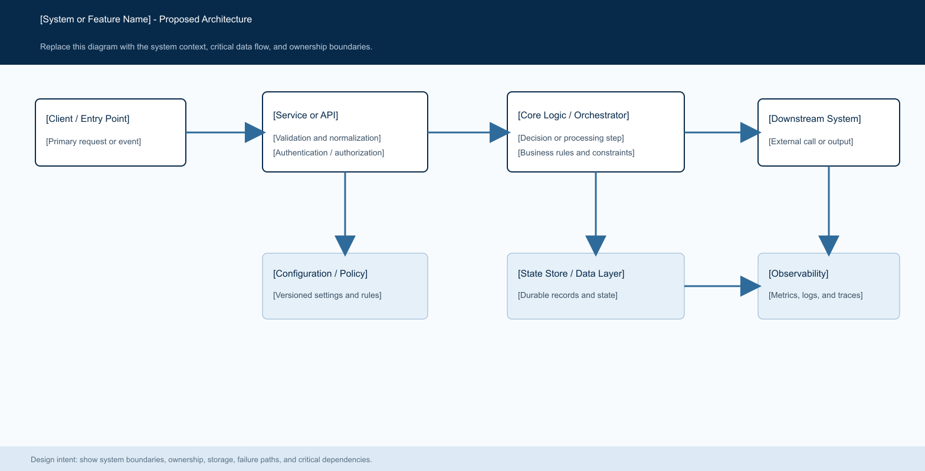
Figure 1. WhiteFlood workbench: ToolRail -> ToolInspector -> MediaStage -> StatusStrip -> Output.

Core components

Component | Responsibility | Primary storage | Failure behavior
ToolRail | Selects exactly one active page. | Tk variables | Keeps the current page and shows a warning if busy.
ToolInspector | Owns controls for the selected workflow. | Page-local state | Disables unsafe controls during processing.
MediaStage | Shows image, frame, mask, split preview, and empty state. | PIL/ImageTk cache | Retains the original on error.
Feature services | Vectorize, LaMa inpaint, media validation, and video streaming. | Temporary files and model sessions | Raises actionable error and cleans temporary output.
StatusStrip | Shows phase, progress, cancel, warnings, and next action. | Tk StringVar/ProgressBar | Falls back to text when percentage is unavailable.

5. Request Lifecycle
- User memilih alat lalu membuka gambar atau video yang sesuai dengan workflow aktif.
- UI memvalidasi ekstensi, path, ukuran, dan mode media sebelum worker dimulai.
- Inspector memuat preset, mask, metadata media, model, atau binary lokal hanya saat dibutuhkan.
- Worker menjalankan engine lokal dan mengirim status melalui callback after() tanpa memblokir UI.
- Output sementara ditulis dengan nama collision-safe dan input asli tetap read-only.
- Cancel menghentikan worker/subprocess yang relevan, membersihkan temporary output, lalu mengembalikan kontrol.
- UI menampilkan hasil, ukuran atau metadata yang benar-benar diprobe, warning, dan tombol simpan yang sesuai.

6. API and Data Contracts

Primary data contract

Field | Type | Required | Description
active_tool | enum | Yes | workspace, remove_bg, upscale, vectorize, watermark.
source_path | Path | Yes | Existing user-selected input; never overwritten.
preset | enum | For vector | Logo, Illustration, Line Art, or Detailed.
source_mask | PIL L | For mask | Mask at original pixel dimensions; empty masks are rejected.
cancel_event | threading.Event | Yes | Shared cancellation token read by worker and subprocess loops.
media_info | MediaInfo | Video | Width, height, fps, duration, frame count, audio, rotation.
output_path | Path | Yes | Collision-safe destination selected by the user.

Contract guarantees

- Kontrak UI dan service memvalidasi ukuran media, mask, preset, path output, dan status pembatalan sebelum proses.
- Satu operasi memiliki satu worker dan satu CancellationToken; tidak ada proses ganda dari tombol yang sama.
- Output mencatat input path, mode halaman, preset, ukuran, dan hasil probe yang tersedia untuk status pengguna.
- State UI adalah state sesi, bukan database atau sumber kebenaran file. File hasil yang sudah disimpan menjadi artefak user.
Kontrak internal dipublikasikan pada source feature modules dan diperbarui bersama setiap perubahan workflow.
[Link to interface or schema]Dokumen pendamping: docs/WHITEFLOOD_UI_REDESIGN.md.

7. Consistency, Idempotency, and Replay

Operasi baru bersifat single-run dan collision-safe. Retry hanya dimulai setelah temporary output dibersihkan. Untuk video, frame diproses streaming dan audio copy yang gagal boleh diulang sebagai video-only dengan warning yang terlihat. Mask tetap menjadi input yang sama untuk semua frame.
Scenario | Expected behavior | Reasoning
Duplicate save target | Ask for confirmation or choose a collision-safe name. | Prevents silent overwrite of user output.
Model or binary missing | Stop before processing and name the missing local resource. | A false success is worse than a clear setup error.
Cancel during media work | Stop worker/subprocess and remove only temporary output. | Input and already-saved output stay safe.
Settings change during worker | Keep the worker snapshot authoritative until it ends. | Prevents mid-process state drift.

8. Security and Privacy Considerations

- Aplikasi desktop lokal tidak mengirim gambar atau video ke API cloud. Akses file mengikuti dialog Windows.
- Log dan status tidak boleh memuat isi gambar, mask, atau payload media; hanya path dan metadata yang diperlukan.
- Model, FFmpeg, dan konfigurasi path berada di resource lokal atau bundle; tidak ada credential service.
- Default memproses lokal, tidak menimpa input, tidak auto-process tool lain, dan tidak mengaktifkan tracking.
- Temporary output dihapus saat cancel/error; output yang dipilih user tidak dihapus otomatis oleh aplikasi.

9. Operational Readiness
Signal | SLO or alert | Owner | Launch gate
Workflow completion | All required static contracts pass. | Bima / Codex | Required
UI responsiveness | No heavy work on Tk main thread in source review. | Bima / Codex | Required
Fallback and error rate | Missing resources and cancel paths are actionable. | Bima / Codex | Required
Packaging drift | Bundled model/binary path is explicit and checksummed. | Bima / Codex | Required
Output integrity | Dimensions, alpha, FPS, duration, orientation, and cleanup checks pass. | Bima / Codex | Required
Required

Alternatif berikut dipertimbangkan terhadap batas Windows lokal, dependency, privasi, dan risiko integrasi.

Alternative | Why it was considered | Why it was not selected
Rewrite UI in web React | More visual design tooling. | Would replace the approved native Windows stack and add packaging risk.
Keep one generic inspector | Smallest code diff. | Makes page ownership and feature-specific states unclear.
Add CairoSVG preview | Could render SVG in-app. | Adds native Windows dependency without being required for the MVP.
Use cloud inpainting | Could reduce local model setup. | Violates local-first privacy boundary without explicit approval.

11. Open Questions
- Apakah lebar rail dan pembagian inspector pada board visual sudah sesuai ukuran monitor kantor yang dipakai Bima?
- Apakah folder FFmpeg yang akan dibundel sudah tersedia dan checksum/notice lisensinya sudah disepakati?
- Apakah halaman Workspace perlu menjadi halaman awal default atau aplikasi tetap membuka alat terakhir?
- [Open question 4: identify an ownership, access-control, or tooling decision.]

12. Decision and Next Steps
Rekomendasi: implementasikan shell dan inspector baru terlebih dahulu, lalu kunci regression test Remove Background/Upscale sebelum Vectorize dan Watermark masuk. Milestone pertama adalah UI state map dan screenshot source run. Setelah itu fitur dipasang bertahap: Vectorize, Watermark Image, lalu Watermark Video. Promosi lebih luas menunggu syntax, unit/static test, GUI smoke test, screenshot, dan verifikasi output yang relevan.
Milestone | Deliverable | Exit criteria
M1 | Shared shell and page state map | Existing Remove Background and Upscale behavior remains intact in static review.
M2 | Vectorize Image page and service | Valid SVG, invalid-input handling, collision safety, and tests pass.
M3 | Watermark Image page and mask service | Source-pixel mask mapping, alpha, dimensions, cancel, and cleanup checks pass.
M4 | Watermark Video page and streaming processor | FFprobe metadata, frame progress, audio fallback, orientation, and temp cleanup pass.

Use footnotes for definitions, assumptions, or terms that need precision without interrupting the main narrative.

