Objective
The SQL/MED (Management of External Data), extension to the SQL standard provides extensions to SQL that define foreign-data wrappers and data link types to allow SQL to manage external data. External data is data that is accessible to, but not managed by, an SQL-based DBMS.
The Objective of this task is - PDI (Pentaho Data Integration), a well known open source ETL tool can already be used as a data source from several applications (viz., Pentaho Reporting and many custom implemented applications) should be extended to use as a Foreign Data source from LucidDB using SQL/MED as communication interface. The Objective can be met by developing a SQL/MED interface based on Farrago SQL/MED, to connect to PDI and serve data into LucidDB being the foreign data source.

How to Implement a SQL/MED for PDI

PDI

PDI API

Farrago
SQL/MED

SQL/MED - PDI

LucidDB

PDI API
A Java API to Connect, Access and Execute the Transformations stored in PDI Repository

Farrago SQL/MED
Existing SQL/MED framework to implement the foreign data source plug-in to LucidDB

SQL/MED – PDI
LucidDB plug-in for SQL/MED access to PDI, which allows user to query PDI via SQL

Design Description
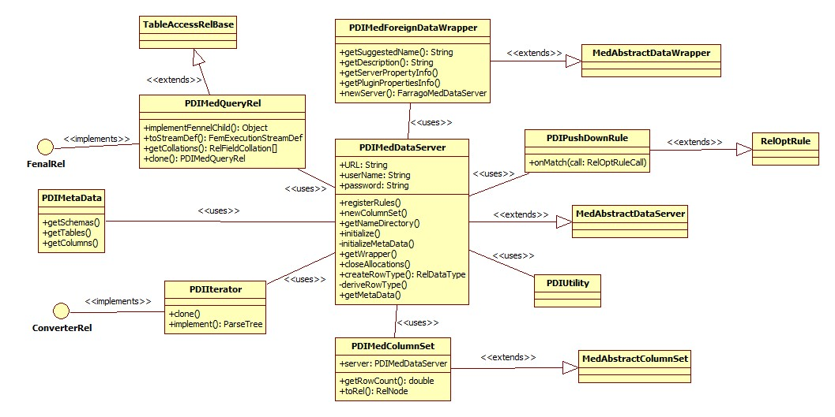Zoom In to view actual diagram
Class Name | Description
PDIMedForeignDataWrapper | An implementation to access the foreign data source ie., PDI.  The Class must provide a public default constructor in order to be loaded via the CREATE {FOREIGN|LOCAL} DATA WRAPPER statement from LucidDB.
PDIMedDataServer | A PDI instance accessed via PDIMedForeignDataWrapper.  This class is responsible for implementation of all the Data Access Calls to PDI and to give SQL/MED access to LucidDB
PDIMedColumnSet | Class to Access Foreign Tables (PDI transformation steps)
PDIMedQueryRel | Class to Adopt SQL to query data and metadata from PDI transformations
PDIMetaData | This class holds the metadata information of a PDI Transformation, this can be implemented by extending PDI API
PDIIterator | Class to hold the Record Set of the PDI Transformation, which is a replica of Resultset
PDIPushDownRule | Class to define the rule to push filters to PDI transformations to get the required records
PDIUtility | Utility class to have all PDI related API Class which will be used by PDIMedDataServer, Methods are not listed as of now as we are planning to include while implementation.
MedAbstractDataWrapper | Farrago SQL/MED base Wrapper class
MedAbstractDataServer | Farrago SQL/MED base Data Server Class
MedAbstractColumnSet | Farrago SQL/MED base Column Set Interface
RelOptRule | Farrago SQL/MED framework class
FenalRel | Farrago SQL/MED framework interface
ConverterRel | Farrago SQL/MED framework interface
TableAccessRelBase | Farrago SQL/MED framework class

