Activity 5%

You assigned to find the right design pattern and create it in the following class diagram :

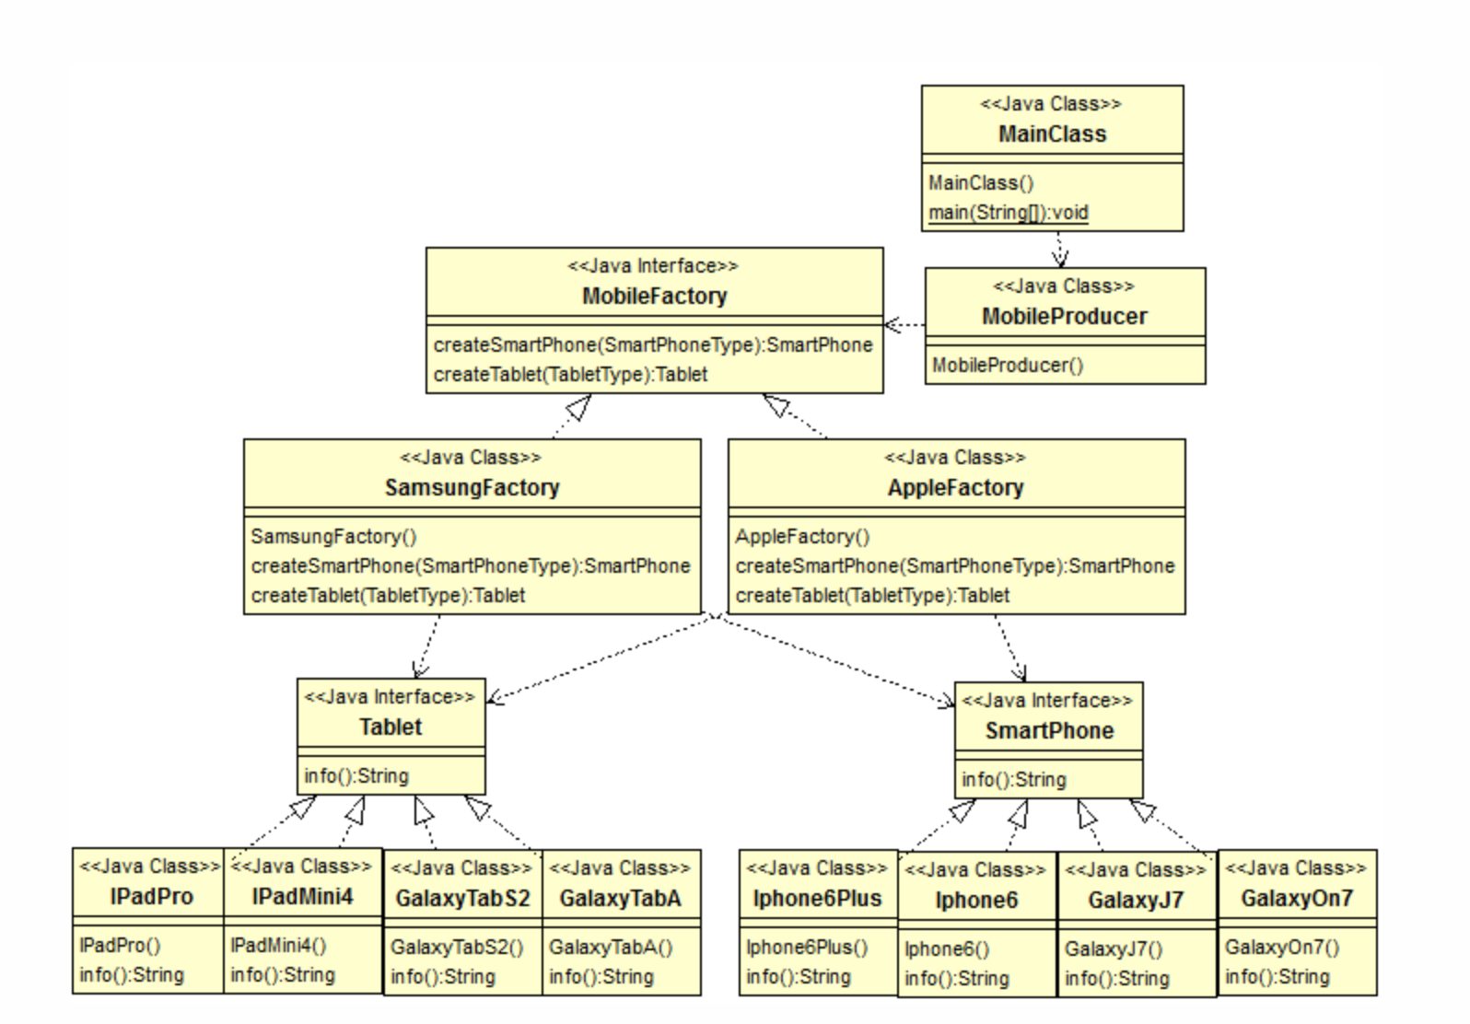

I use the Abstract Factory Pattern for this activity.

There is my source structure by using Abstract factory pattern. ( include output)

