Assignments 1 :

Question 1 : Implements completely priority queue with Heap.

# Question 2 : Write the java program to print all nodes of a perfect binary tree in a specific order

Variation 1: Print Top-Down

(1, 2, 3, 4, 7, 5, 6, 8, 15, 9, 14, 10, 13, 11, 12)

Variation 2: Print Bottom-Up

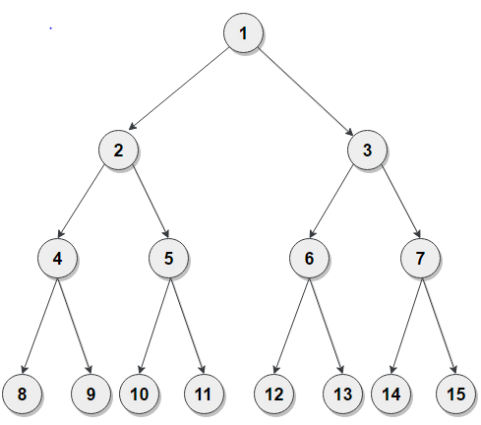

Question 3 :  Write a Java program to shuffle the elements in a linked list.

Question 4 : Write a Java program of swap two elements in an array list.

Question5: Write a Java program to print all the elements of a ArrayList using the position of the elements.

Question6:  Write a Java program to join two linked lists.

Question 7: Write a Java program to replace an element in a linked list.

Question 8: Write a Java program to retrieve and remove the last element of a tree set

Question 9: Write a Java program to count the number of elements in a priority queue.

Question 10: Write a Java program to replace the second element of a ArrayList with the specified element.

