ENTITY-RELATIONSHIP DIAGRAM AND USER INTERFACE DESIGN

The ERD below presents the database structure that was designed for this project. It is important to note that some parts of it might change with the module integration, in order to work with all the other modules of the projects using the same entities.

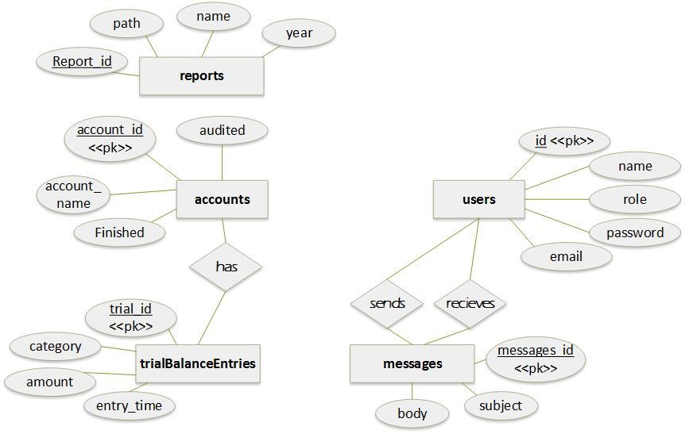

Figure 1: Entity-Relationship Diagram

The user interface was designed as a dashboard providing a summary of important information, which leads to different parts of the website. It is completed by a menu providing the same functions, for an easier navigation between the pages.

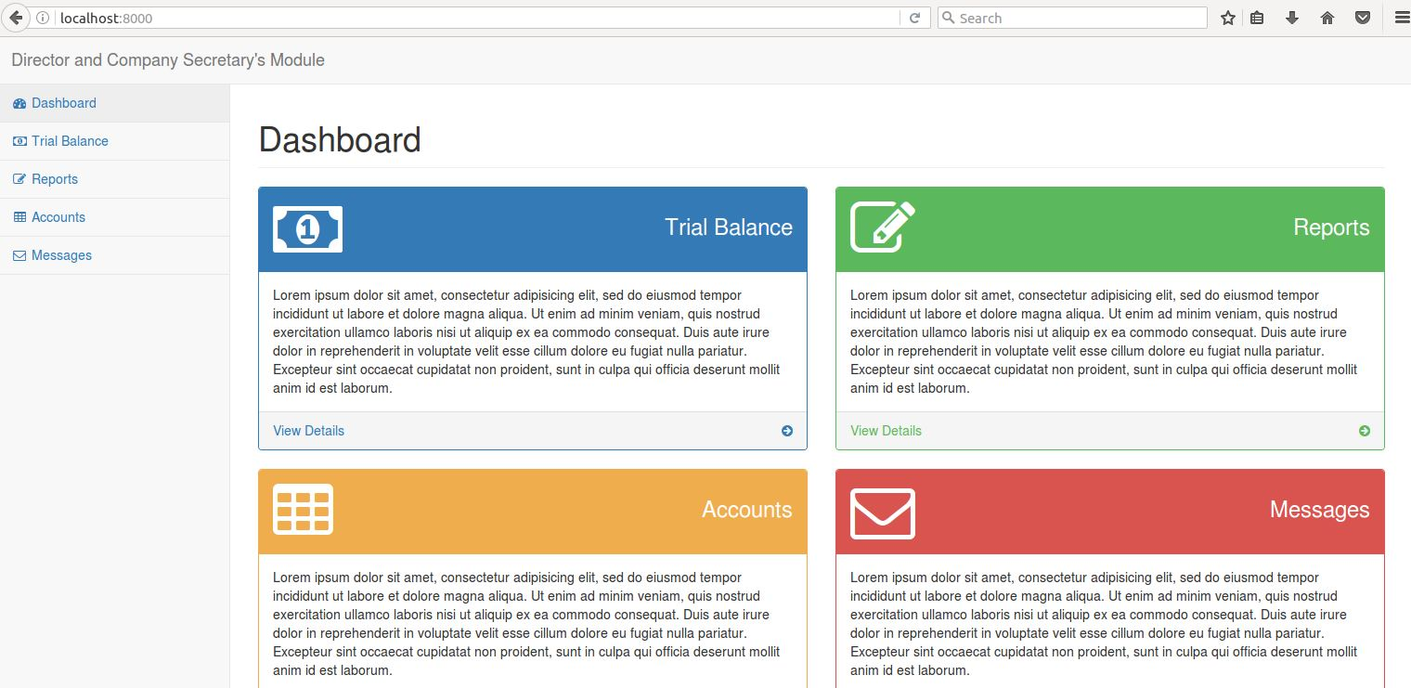

Each of these panels would contain a few important information. The “Trial Balance” could present the current total of credits and debits, the “Accounts” could present last modified account or total of finished and audited accounts, the “Report” could show basic information about the last report and “Messages” could show last received messages. Clicking on any of these panels would lead to the corresponding page:

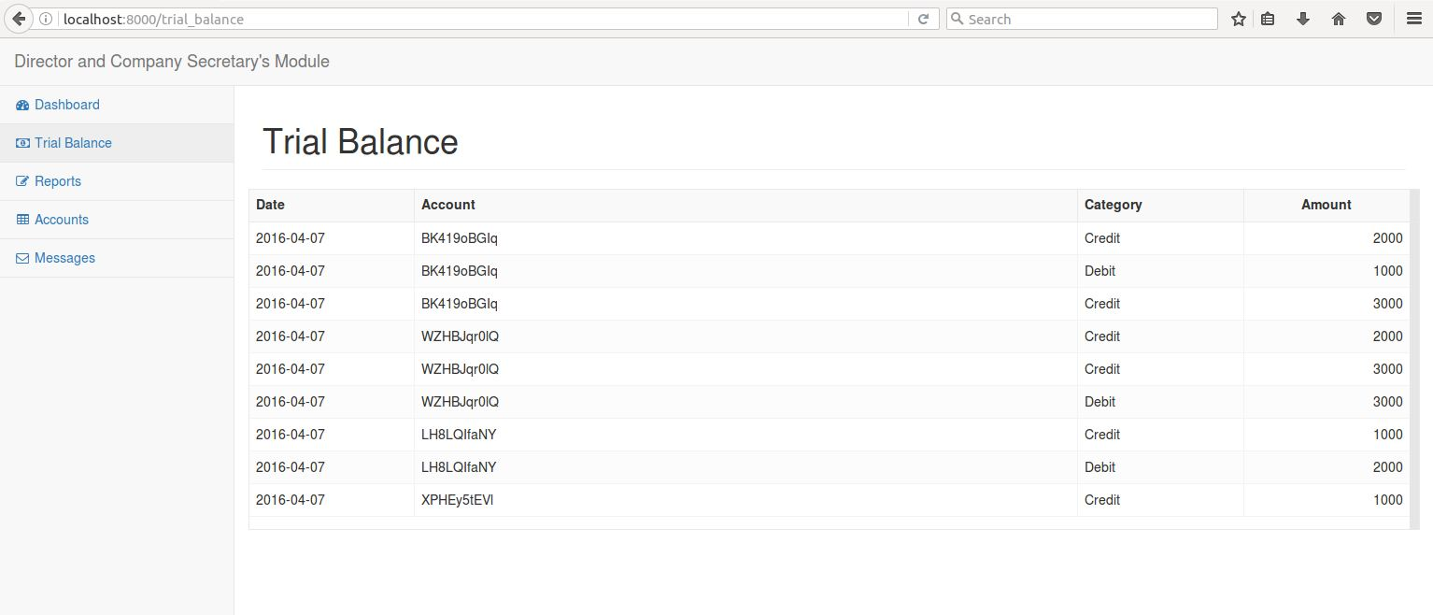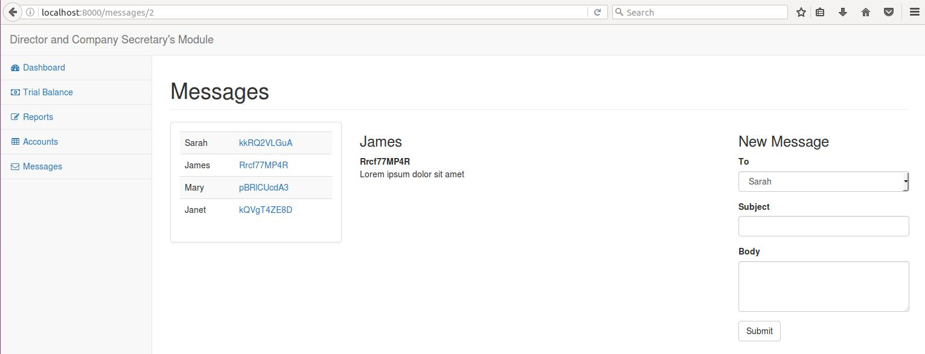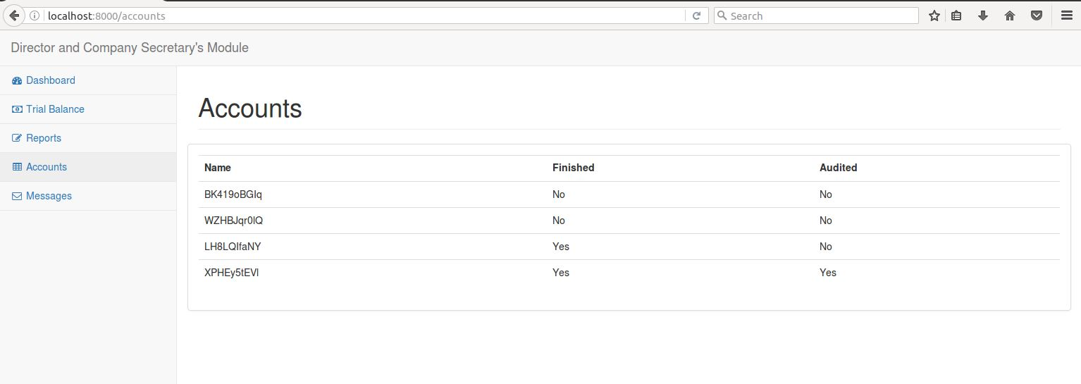

There is no current design for the « Reports » page, as the structure of the reports is not known.