­­­

Software Requirements Specification

For Module 10

Director and Company Secretary’s Module

Version 1.0

Prepared by:

NURFARAH AFIQAH BINTI AZLAN (173315)

SITI MADIHAH BINTI MOHD ALI (177373)

LUCIE HELENE STEINER (ES01077)

ALI RAFEA YOUSIF (176956)

University of Putra Malaysia

7th January 2017

Table of Contents

1. Introduction 2

1.1 Purpose 2

1.2 References 2

2. Overall Description 2

2.1 User Classes and Characteristics 2

2.2 Operating Environment 2

3. Functional Requirements 2

4. System Use Cases 3

4.1 View Reports (UC1) 3

4.2 Make Adjustments to Trial Balance (UC2) 3

4.3 See Accounts’ Information (UC3) 4

4.4 Communicate Among Workers (UC4) 4

5. Other Non-functional Requirements 5

5.1 Performance Requirements 5

5.2 Integrity Requirements 5

5.3 ReliabilityRequirements 5

5.4 Usability Requirements 5

6. Other Requirements 5

7. System Requirements Chart 5

# Introduction

## Purpose

This SRS describes the software functional and nonfunctional requirements for Module 10 release 1.0 of the Laravel Project. This document intended to be used by the members of the project team that will implement and verify the correct functioning of the system. This system will make view and ability of directors and company secretary easier. Unless otherwise noted, all requirements specified here is high priority and committed for release 1.0.

## References

Wiegers, Karl. Cafeteria Ordering System Vision and Scope Document,

www.processimpact.com/projects/COS/COS_vision_and_scope.doc

# Overall Description

## User Classes and Characteristics

### Director

#### Director of the company whom will be having all functions of requirements in this module.

### Secretary

Secretary of the company which have only few functions to this overall module.

### Accountant

### Auditor

### Clerk

## Operating Environment

The system shall operate with the following browser:

Internet Explorer versions 2011 and above also Google Chrome version 2011 and above.

# Functional Requirements

### Director can:

* view reports,
* make adjustments to trial balance,
* see accounts’ information,
* communicate with each other.

### Secretary can:

* view reports,
* see accounts’ information,
* communicate with each other.

# System Use Cases

This use case system consists of 4 use cases. The use cases are, view reports, make adjustments to trial balance, see account’s informations, and communicate with each other.

## View Reports (UC1)

1. **UC1**
2. **Objective** – The use case is to make sure the system shall be able to view and print audited directors’ report annually.
3. **Priority** – High.
4. **Source** – Accounts.
5. **Actors** – Director and Secretary.
6. **Flow of Events** 
   1. **Basic Flow**
      1. This use case begins when a user desires to view reports.
      2. The user clicks the buttons available of their desired option.
      3. The system will print out the reports to view.
      4. Flow of events normally executed in the use-case.
   2. **Alternative Flow(s)** – None.
   3. **Exception Flow(s)** – None.
7. **Includes** – None.
8. **Preconditions** – The Director/Secretary must be already logged in. This meant that the Director/Secretary ID need already to be valid.
9. **Post conditions** – None.
10. **Notes/Issues** – None.

## Make Adjustments to Trial Balance (UC2)

1. **UC2**
2. **Objective** – The use case is for intention of doing some changes, editing options to the credit and debit ledgers.
3. **Priority** – Very High.
4. **Source** – Accounts, Auditor.
5. **Actors** – Director and Secretary.
6. **Flow of Events** 
   1. **Basic Flow**
      1. This use case begins when a user desires to edits the trial balance.
      2. The user edits the fields.
      3. The user confirms the changes.
   2. **Alternative Flow(s)** – None.
   3. **Exception Flow(s)** – None.
7. **Includes** – None.
8. **Preconditions** – The Director/Secretary must be already logged in. This meant that the Director/Secretary ID need already to be valid.
9. **Post conditions** – The trial balance will be updated.
10. **Notes/Issues** – None.

## See Accounts’ Information (UC3)

1. **UC3**
2. **Objective** – The use case is for Director/Secretary when they want to know whether the account has finished or not and also whether the account has been audited or not.
3. **Priority** – High.
4. **Source** – Accounts, Accountant.
5. **Actors** – Director/Secretary.
6. **Flow of Events** 
   1. **Basic Flow**
      1. This use case begins when a Director/Secretary desires to see accounts’ information.
      2. A summary of all accounts and their current state is displayed.
   2. **Alternative Flow(s)** – None.
   3. **Exception Flow(s)** – None.
7. **Includes** – None.
8. **Preconditions** – The Director/Secretary must be already logged in. This meant that the Director/Secretary ID need already to be valid.
9. **Post conditions** – None.
10. **Notes/Issues** – None.

## Communicate Among Workers (UC4)

1. **UC4**
2. **Objective** – The use case is for Director/Secretary to communicate with clerk, accountant and auditors.
3. **Priority** – Low.
4. **Source** – Director/ Secretary.
5. **Actors** – Director/ Secretary and Clerk/Accountant/Auditor.
6. **Flow of Events** 
   1. **Basic Flow**
      1. This use case begins when a Director/ Secretary desires to communicate with other workers.
      2. The messages received are displayed.
      3. The user types the message in the provided area.
      4. The user clicks on submit.
   2. **Alternative Flow(s)** – None.
   3. **Exception Flow(s)** – None.
7. **Includes** – None.
8. **Preconditions** – None.
9. **Post conditions** – The message will be send to the intended receiver.
10. **Notes/Issues** – None.

# Other Non-functional Requirements

## Performance Requirements

The response time of the module should be very less time taken for every pages to load and also every buttons to perform to the request. Response time is the waiting time while the systems accesses, queries and retrieves the information of accounts, director and secretary.

## Integrity Requirements

All network transactions that involve financial information or personally identifiable information shall be encrypted.

## ReliabilityRequirements

The system shall be available 24 hours a day, 7 days a week. Not only that, the system shall provide up-to-date information about accounts availability information.

## Usability Requirements

The system shall provide user-friendly interface that should be easily navigable and understandable.

# Other Requirements

No other requirements have been identified.

# System Requirements Chart

|  |  |  |  |  |
| --- | --- | --- | --- | --- |
| **ID** | **UC1** | **UC2** | **UC3** | **UC4** |
| **Priority –**  Low (L) or High (H) | H | VH | H | L |
| **Type** – Functional (F) or Non-functional(NF) | F | F | F | F |
| **Source** | Accounts | Accounts, Auditor | Accounts, Accountant | Director/ Secretary |

References

Appendix A: Analysis Models

1. Use Case Diagram

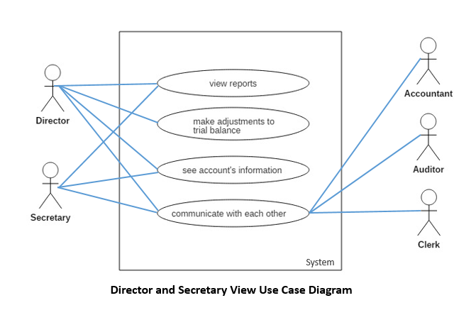

1. Activity Diagram

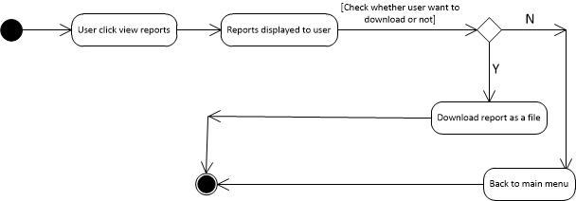

Figure 1 Use Case 1

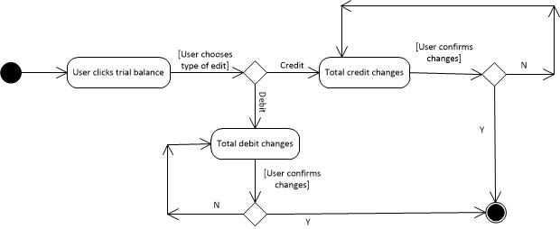

Figure 2 Use Case 2

G:\UC3.jpg

Figure 3 Use Case 3

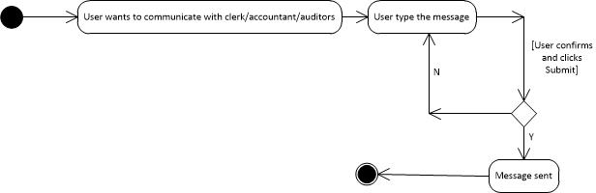

Figure 4 Use Case 4

1. **Traceability Matrix**

|  |  |  |  |  |
| --- | --- | --- | --- | --- |
| **ID** | **UC1** | **UC2** | **UC3** | **UC4** |
| **UC1** |  | / | / | N/A |
| **UC2** | / |  | / | N/A |
| **UC3** | / | / |  | N/A |
| **UC4** | N/A | N/A | N/A |  |

**Descriptions:**

The use case 1 shall match up with use case 2 and 3.

The use case 2 shall match up with use case 1 and 3.

The use case 3 shall match up with use case 1 and 2.

The use case 4 shall not match up with any use case.

**Keywords:**

UC1 : View Reports.

UC2 : Make Adjustments to Trial Balance.

UC3 : See Accounts’ Information.

UC4 : Communicate with Each Other.