使用登录管理系统，本文需要环境，然后在中安装服务来实现这个需求。

1、安装步骤如下：
- 下载Cygwin安装程序。
- 安装，包括和：
安装服务，在搜索框中输入，然后选中以下几项：
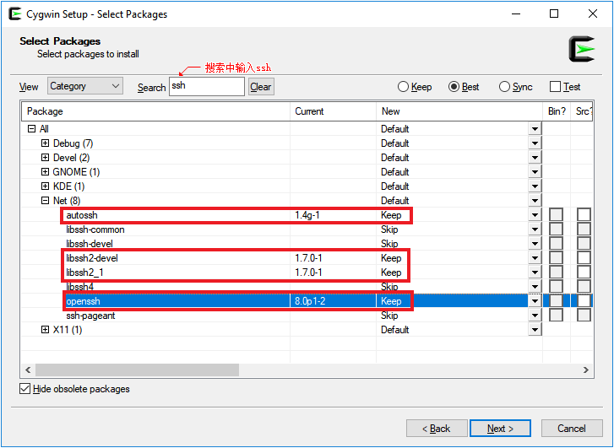
安装，在搜索框中输入，选中以下选项：
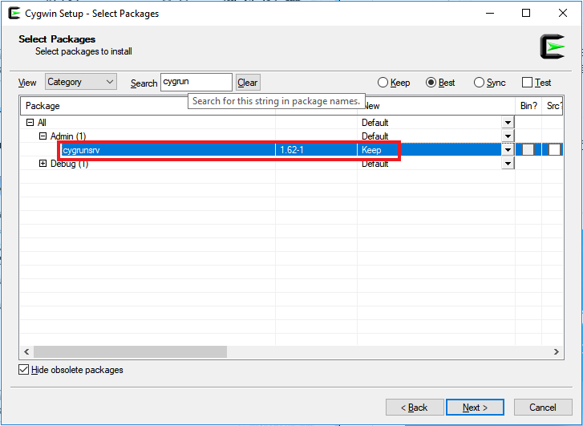
- 启动，运行来配置：
1  2  3  4  5  6  7  8  9  10  11  12  13  14  15  16  17  18  19  20  21  22  23  24  25  26  27  28  29  30  31 | @PHQQCD8012PEA  $ ssh-host-config  *** Info: Generating missing SSH host keys yes  *** Info: Creating default /etc/ssh_config file  *** Query: Overwrite existing /etc/sshd_config file? (yes/no) yes  *** Info: Creating default /etc/sshd_config file  *** Info: StrictModes is set to 'yes' by default.  *** Info: This is the recommended setting, but it requires that  *** Info: the POSIX permissions of the user's home directory,  *** Info: the user's .ssh directory, and the user's ssh key files  *** Info: are tight so that only the user has write permissions.  *** Info: On the other hand, StrictModes don't work well with  *** Info: default Windows permissions of a home directory  *** Info: mounted with the 'noacl' option, and they don't work at  *** Info: all if the home directory is on a FAT or FAT32 partition.  *** Query: Should StrictModes be used? (yes/no) yes  *** Info: Updating /etc/sshd_config file  *** Query: Do you want to install sshd as a service? (Say "no"  *** Query: if it is already installed as a service) (yes/no) yes  *** Query: Enter the value of CYGWIN for the daemon: []  *** Info: The sshd service has been installed under the LocalSystem  *** Info: account (also known as SYSTEM). To start the service now,  *** Info: call `net start cygsshd' or `cygrunsrv -S cygsshd'.  *** Info: Otherwise, it will start automatically  *** Info: after the next reboot.  *** Info: Host configuration finished. Have fun!
- 根据提示，运行程序启动服务：
1  2 | Pearce@PHQQCD8012PEA ~  $ cygrunsrv -S cygsshd
- 最后使用常用的客户端就能登入到系统，进行各种操作：
1  2  3  4  5  6  7  8  9  10  11  12  13  14  15 | $ ssh Pearce@10.64.33.49  Pearce@10.64.33.49's password:  @PHQQCD8012PEA  $ ls  $ pwd  /home/Pearce  $ cd /cygdrive/d  Pearce@PHQQCD8012PEA  $ ls  '$RECYCLE.BIN' eclipse-workspace Studio  'Program Files'

2、常见问题
出现以下错误可能是服务没有正常启动，或者防火墙配置端口有问题：
1  2 | $ ssh Pearce@10.64.33.49  ssh: connect to host 10.64.33.49 port 22: Connection timed out

