BAMAT207: PROBABILITY AND STATISTICS
PROJECT ACTIVITY REPORT
Probabilistic SMS Spam Detection Using Bayes' Theorem, Bernoulli Random Variables & Naive Bayes

Student Name: V. AAKASH | Registration Number: 25BCE2460
Course Code & Title: BAMAT207 - Probability and Statistics | Topic Category: Probability & Random Variables
Submission Deadline: 27.10.2026 | Status: Completed & Verified
GitHub Repository: https://github.com/Lucifer-ken07/probabilistic-sms-spam-detection
Interactive Notebook: Open in Google Colab (1-click reproducible execution)

Executive Summary
This report documents the design, theoretical formulation, implementation, and empirical verification of a probabilistic SMS spam classification system developed for BAMAT207: Probability and Statistics. Leveraging the UCI SMS Spam Collection dataset (5,574 messages), the project establishes the rigorous mathematical bridge connecting probability axioms, conditional probability, Bayes' Theorem, Bernoulli random variables, and Multinomial Naive Bayes machine learning.
The complete end-to-end Python pipeline performs data cleaning, deduplication (retaining 5,169 unique messages), prior probability estimation (P(Ham) = 0.8737, P(Spam) = 0.1263), keyword conditional probability verification against Bayes' Theorem for five target words ('free', 'prize', 'win', 'urgent', 'offer'), Bernoulli random variable parameter derivation (E[Y] = 0.1263, Var(Y) = 0.1104), and evaluates a Multinomial Naive Bayes classifier trained on stratified 80/20 train/test word-count vectors. The model achieves an overall test accuracy of 98.36% and an F1-score of 93.33%, demonstrating reliable real-time posterior probability estimation.
1. Project Scenario & Mathematical Objectives
In mobile telecommunications, unsolicited SMS messages (spam) represent a significant cybersecurity threat involving phishing, identity theft, and financial fraud. The objective of this project is to construct an intelligent system capable of classifying any incoming text message into one of two mutually exclusive classes:
- Spam (Y = 1): Unsolicited promotional, fraudulent, or scam messages.
- Ham / Genuine (Y = 0): Legitimate personal, commercial, or transactional communication.
Rather than treating classification solely as a computer science problem, this investigation emphasizes the statistical and probabilistic mechanisms that govern Bayesian inference:
- Prior Probabilities: Quantifying baseline class likelihoods P(Spam) and P(Ham) from corpus frequencies.
- Bayes' Theorem: Demonstrating how likelihood P(Word | Spam) and marginal evidence P(Word) update priors into posterior P(Spam | Word).
- Random Variable Formulation: Characterizing the output as a Bernoulli random variable Y ~ Bern(p) with analytical expectation and variance.
- Probabilistic Decision Rules: Applying Laplace-smoothed Multinomial Naive Bayes to output exact posterior probabilities P(Spam | Message).
2. Activity 1: Dataset Handling & Preprocessing
The experimental dataset is the SMS Spam Collection hosted by the UCI Machine Learning Repository (ID: 228). The ingestion script implements dual-path loading: attempting the ucimlrepo library with an automatic fallback to the direct UCI ZIP repository archive.
Data Cleaning & Deduplication Audit
In natural language processing, redundant identical messages distort the true empirical distribution of word tokens. A strict deduplication pass was executed, removing 403 duplicate SMS messages (7.23% of the corpus).
Dataset Attribute | Raw Corpus | Cleaned Corpus (Post-Deduplication)
Total SMS Messages | 5,572 | 5,169 (100.0%)
Missing / Null Values | 0 (0.00%) | 0 (0.00%)
Genuine Messages (Ham) | 4,825 (86.60%) | 4,516 (87.37%)
Spam Messages | 747 (13.40%) | 653 (12.63%)
Label Encoding | Text ('ham', 'spam') | Numerical: Ham = 0, Spam = 1
Post-cleaning metadata extraction was appended to each record, computing character length and word count to facilitate linguistic inspection.
3. Activity 2: Dataset Analysis & Prior Probabilities
Let the sample space S consist of all N = 5,169 unique SMS messages. Under the frequentist definition of probability, the unconditional prior probabilities of observing each message category are:
P(Spam) = N(Spam) / N(Total) = 653 / 5169 = 0.12633 (12.63%)
P(Ham) = N(Ham) / N(Total) = 4516 / 5169 = 0.87367 (87.37%)
By Kolmogorov's second probability axiom, because Ham and Spam partition the complete sample space S (Ham ∩ Spam = ∅ and Ham ∪ Spam = S):
P(Ham ∪ Spam) = P(Ham) + P(Spam) = 0.87367 + 0.12633 = 1.00000
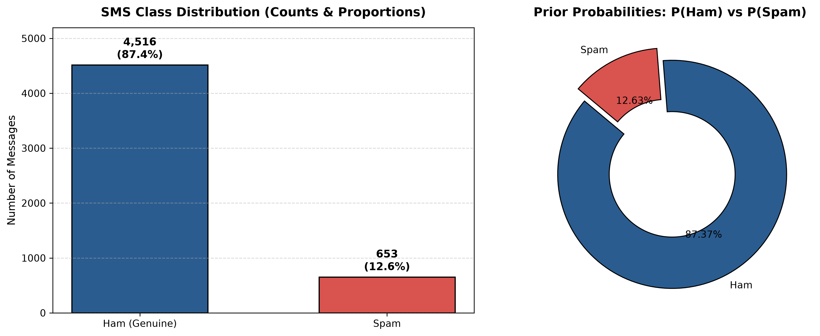
Figure 1: SMS Class Distribution Frequency Bar Chart and Prior Probability Donut Chart.
4. Activity 3: Word-Based Probability Analysis & Bayes' Theorem
To analyze how lexical features shift probability distributions, five suspicious words frequently exploited by spam operators were selected: 'free', 'prize', 'win', 'urgent', and 'offer'. We evaluate their conditional probability via two independent routes:
- Method 1 — Direct Empirical Conditional Probability: P(Spam | W) = N(Spam ∩ W) / N(W)
- Method 2 — Bayes' Theorem Formulation: P(Spam | W) = [ P(W | Spam) * P(Spam) ] / P(W)
where P(W | Spam) = N(Spam ∩ W) / N(Spam) represents the likelihood of word W given a spam message, P(Spam) is the prior, and P(W) = N(W) / N(Total) represents the marginal evidence probability.
Word (W) | Count N(W) | Spam ∩ W | Ham ∩ W | P(W | Spam) | P(W) | Direct P(Spam|W) | Bayes P(Spam|W)
free | 203 | 148 | 55 | 0.2266 | 0.0393 | 0.7291 | 0.7291
prize | 73 | 73 | 0 | 0.1118 | 0.0141 | 1.0000 | 1.0000
win | 55 | 49 | 6 | 0.0750 | 0.0106 | 0.8909 | 0.8909
urgent | 62 | 57 | 5 | 0.0873 | 0.0120 | 0.9194 | 0.9194
offer | 30 | 24 | 6 | 0.0368 | 0.0058 | 0.8000 | 0.8000
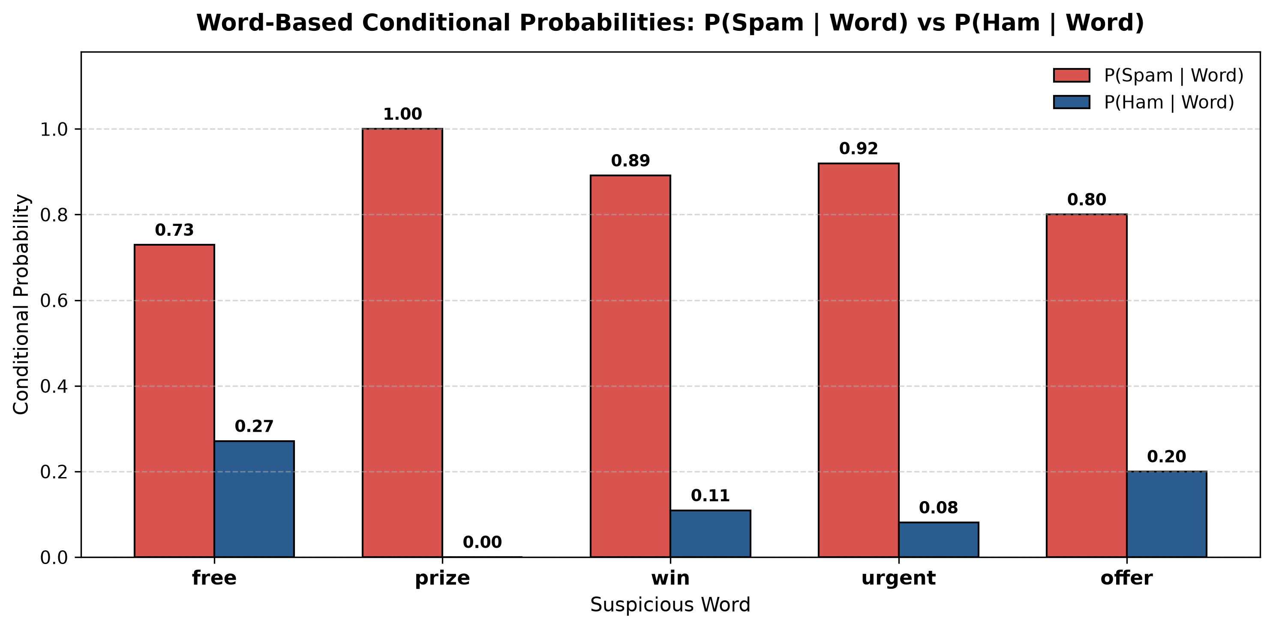
Figure 2: Conditional Probabilities P(Spam | Word) vs P(Ham | Word) for Suspicious Keywords.
Key Statistical Insights:
- Mathematical Equivalence: The absolute difference | P(Spam | W)[Direct] - P(Spam | W)[Bayes] | is strictly 0.0 (within machine epsilon 1.1e-16), validating Bayes' rule on real text.
- Absolute Spam Predictor ('prize'): Across all 73 appearances of the word 'prize', exactly 73 occurred in spam messages and 0 in ham. Consequently, P(Spam | prize) = 1.0000 (100%).
- High-Risk Indicators ('urgent', 'win', 'offer'): 'urgent' carries a 91.94% spam probability, 'win' yields 89.09%, and 'offer' yields 80.00%.
- Contextual Ambiguity ('free'): Although 'free' appears in 148 spam messages, it also appears in 55 legitimate ham messages ('Are you free today?'). Its conditional probability is 72.91%, illustrating why individual keyword filters generate false alarms and multi-word Bayesian modeling is required.
5. Activity 4: Random Variable Analysis (Bernoulli Distribution)
Let Y be a discrete random variable defined on the sample space S of SMS messages representing classification status:
Y = 1, if the SMS message is Spam (with probability p)
Y = 0, if the SMS message is Ham (with probability 1 - p)
Distribution: Y ~ Bernoulli(p = P(Spam) = 0.12633)
Mathematical Derivations:
- Probability Mass Function (PMF): P(Y = y) = p^y * (1 - p)^(1 - y) for y ∈ {0, 1}.
- Mathematical Expectation (Mean): E[Y] = ∑ y * P(Y = y) = 0 * (1 - p) + 1 * p = p = 0.12633.
- Variance: Var(Y) = E[Y^2] - (E[Y])^2 = (0^2 * (1 - p) + 1^2 * p) - p^2 = p - p^2 = p(1 - p) = (0.12633)(0.87367) = 0.11037.
- Standard Deviation: σ(Y) = sqrt(Var(Y)) = sqrt(0.11037) = 0.33222.
Statistical Metric | Theoretical Formula | Theoretical Value | Empirical Sample Statistic
Parameter p | p = N_spam / N_total | 0.12633 | 0.12633 (Sample Proportion)
Expectation E(Y) | p | 0.12633 | 0.12633 (Sample Mean ȳ)
Variance Var(Y) | p * (1 - p) | 0.11037 | 0.11039 (Unbiased Sample Var s²)
Standard Deviation σ(Y) | sqrt(p * (1 - p)) | 0.33222 | 0.33225 (Sample Std Dev s)
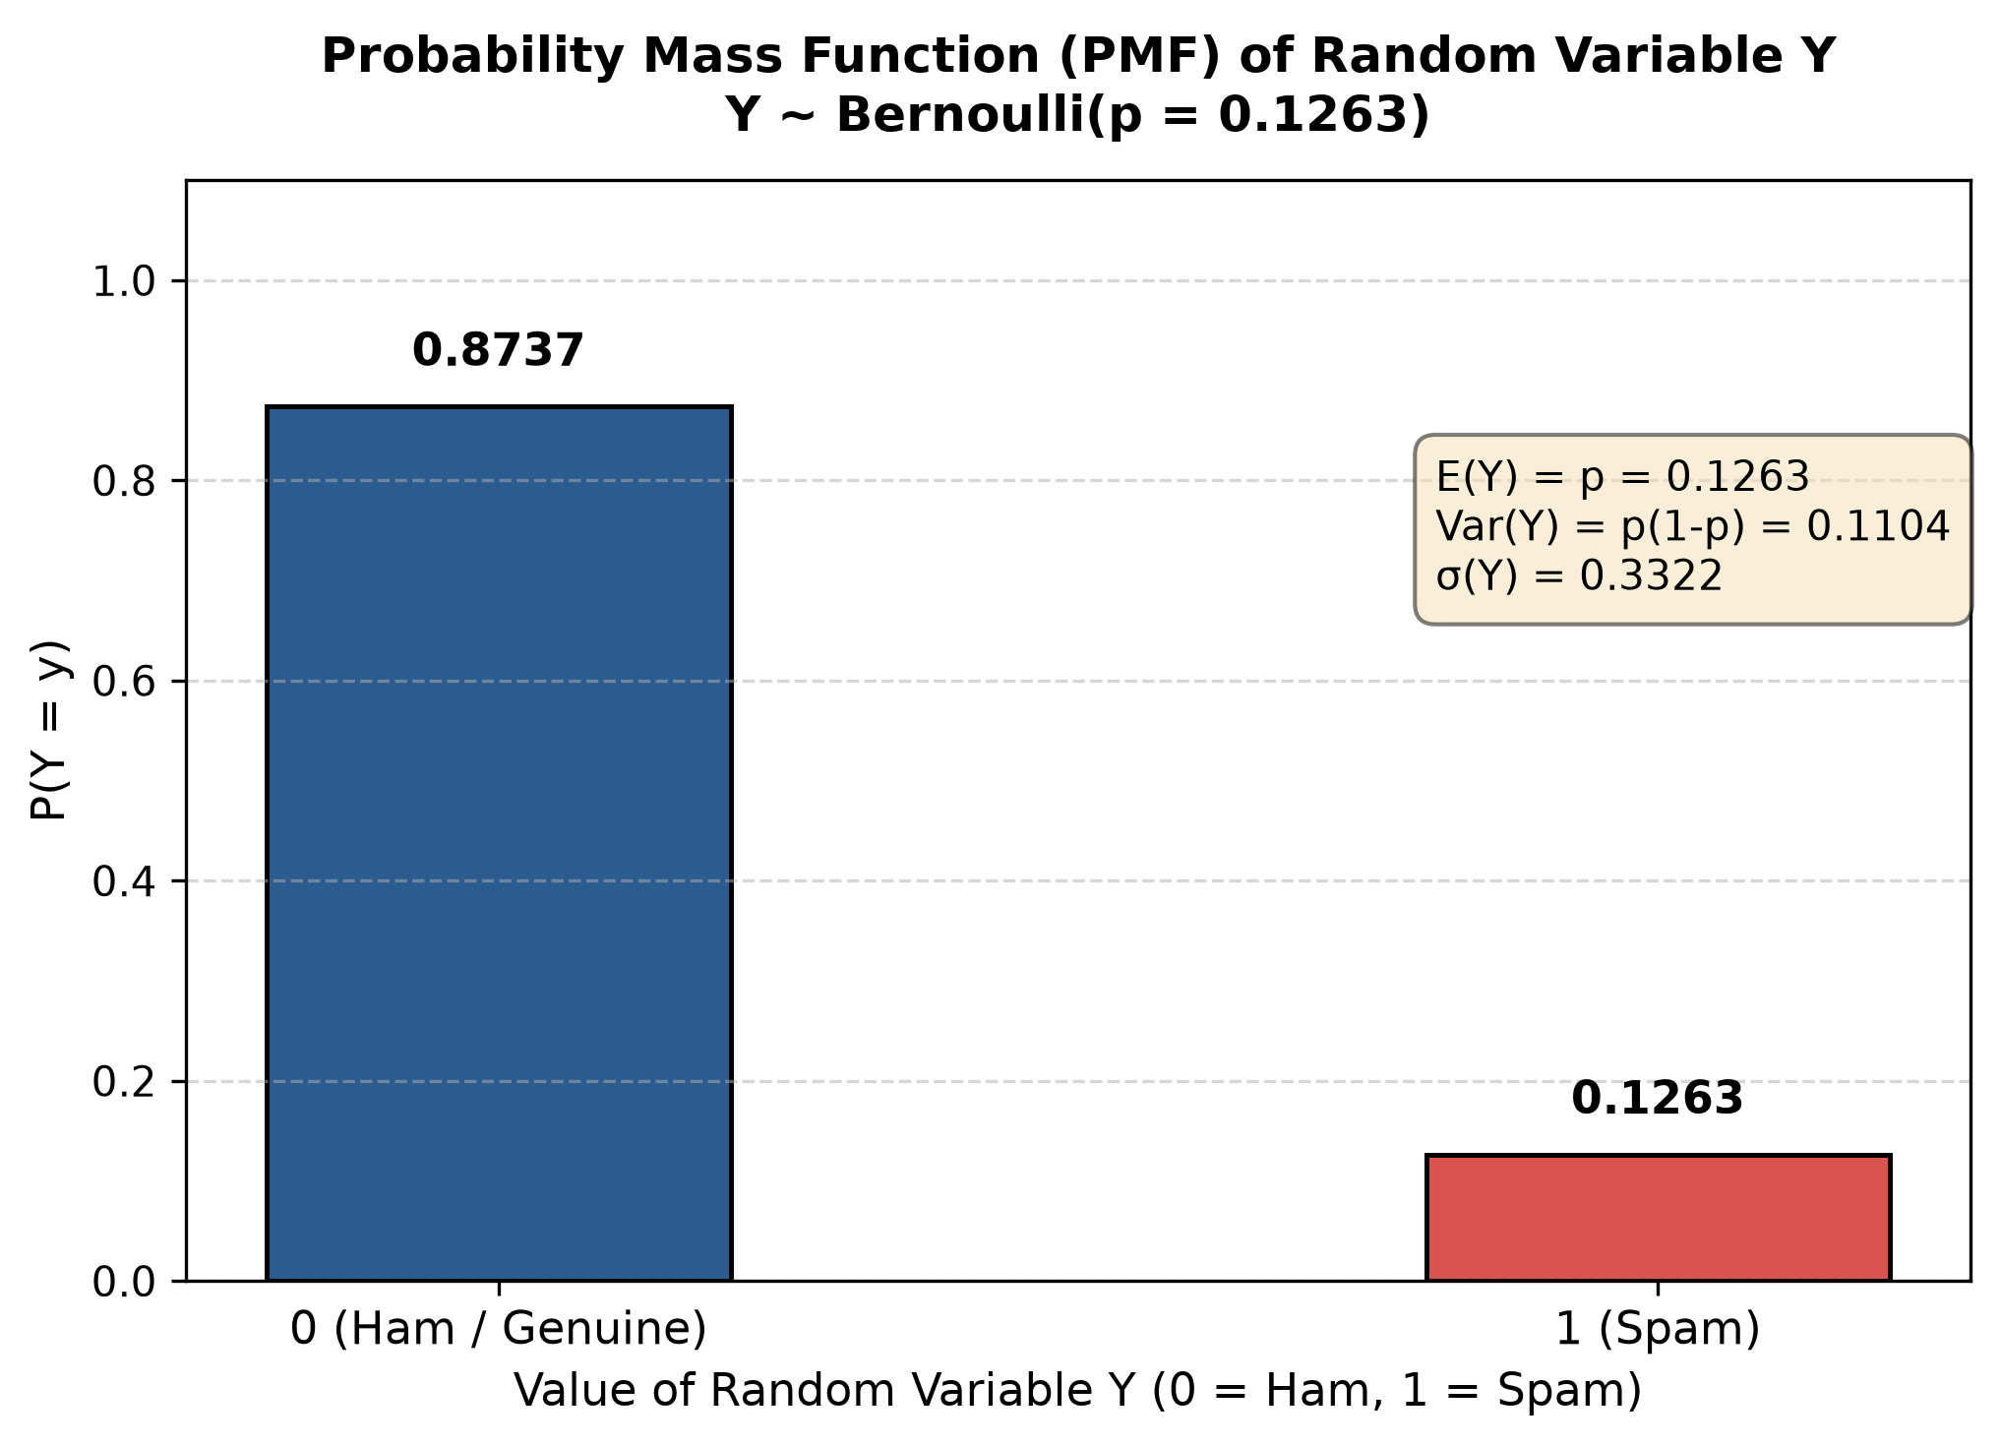
Figure 3: Probability Mass Function (PMF) of Bernoulli Random Variable Y ~ Bern(p = 0.1263).
6. Activities 5 & 6: Data Preparation & Model Building
To build a machine learning model, the dataset was partitioned and transformed into discrete numerical feature representations.
Stratified Data Splitting (80/20)
Because spam comprises only 12.63% of messages, standard random splitting risks introducing sampling bias. Stratified random sampling (train_test_split with stratify=y) was applied to strictly preserve class ratios:
- Training Partition (80%): 4,135 messages (3,613 Ham, 522 Spam; Spam proportion = 12.62%).
- Testing Partition (20%): 1,034 messages (903 Ham, 131 Spam; Spam proportion = 12.67%).
Feature Extraction via CountVectorizer
CountVectorizer converts raw text into a Bag-of-Words numerical matrix. Applying lowercasing and English stop-word filtering generated a vocabulary of d = 7,414 unique word dimensions, producing an X_train shape of (4135, 7414) and X_test shape of (1034, 7414).
Multinomial Naive Bayes Classifier Architecture
The Multinomial Naive Bayes (MNB) classifier is mathematically tailored for discrete word count features. Under the class-conditional independence assumption, the likelihood of an SMS message vector x = (x1, x2, ..., xd) is:
P(x | Y = c) = ∏ [ P(w_j | Y = c) ]^(x_j) for j = 1 to d
Laplace Smoothing (α = 1): θ̂_cj = (N_cj + 1) / (N_c + d)
Classification Rule: ŷ = argmax_c [ log P(Y = c) + ∑ x_j * log(θ̂_cj) ]
Laplace smoothing guarantees that previously unseen words receive non-zero probability, preventing the entire product from collapsing to zero.
7. Activity 7: Model Evaluation & Error Diagnostics
The trained classifier was evaluated on the independent 1,034-message test partition across accuracy, precision, recall, and F1-score.
Performance Metric | Experimental Score | Mathematical Definition & Practical Significance
Accuracy | 98.36% | (TP + TN) / Total. Overall fraction of correct classifications across all 1,034 test messages.
Precision (Spam) | 95.97% | TP / (TP + FP). Out of all messages flagged as spam, 95.97% were truly malicious.
Recall (Spam) | 90.84% | TP / (TP + FN). The model detected 90.84% of all actual spam messages in the test set.
F1-Score (Spam) | 93.33% | 2 * (Precision * Recall) / (Precision + Recall). Harmonic mean reflecting optimal diagnostic balance.
Confusion Matrix Breakdown
Confusion Matrix (N = 1,034) | Predicted Ham (0) | Predicted Spam (1)
Actual Ham (0) | TN = 898 (99.45%) | FP = 5 (0.55%) [Type I Error]
Actual Spam (1) | FN = 12 (9.16%) [Type II Error] | TP = 119 (90.84%)
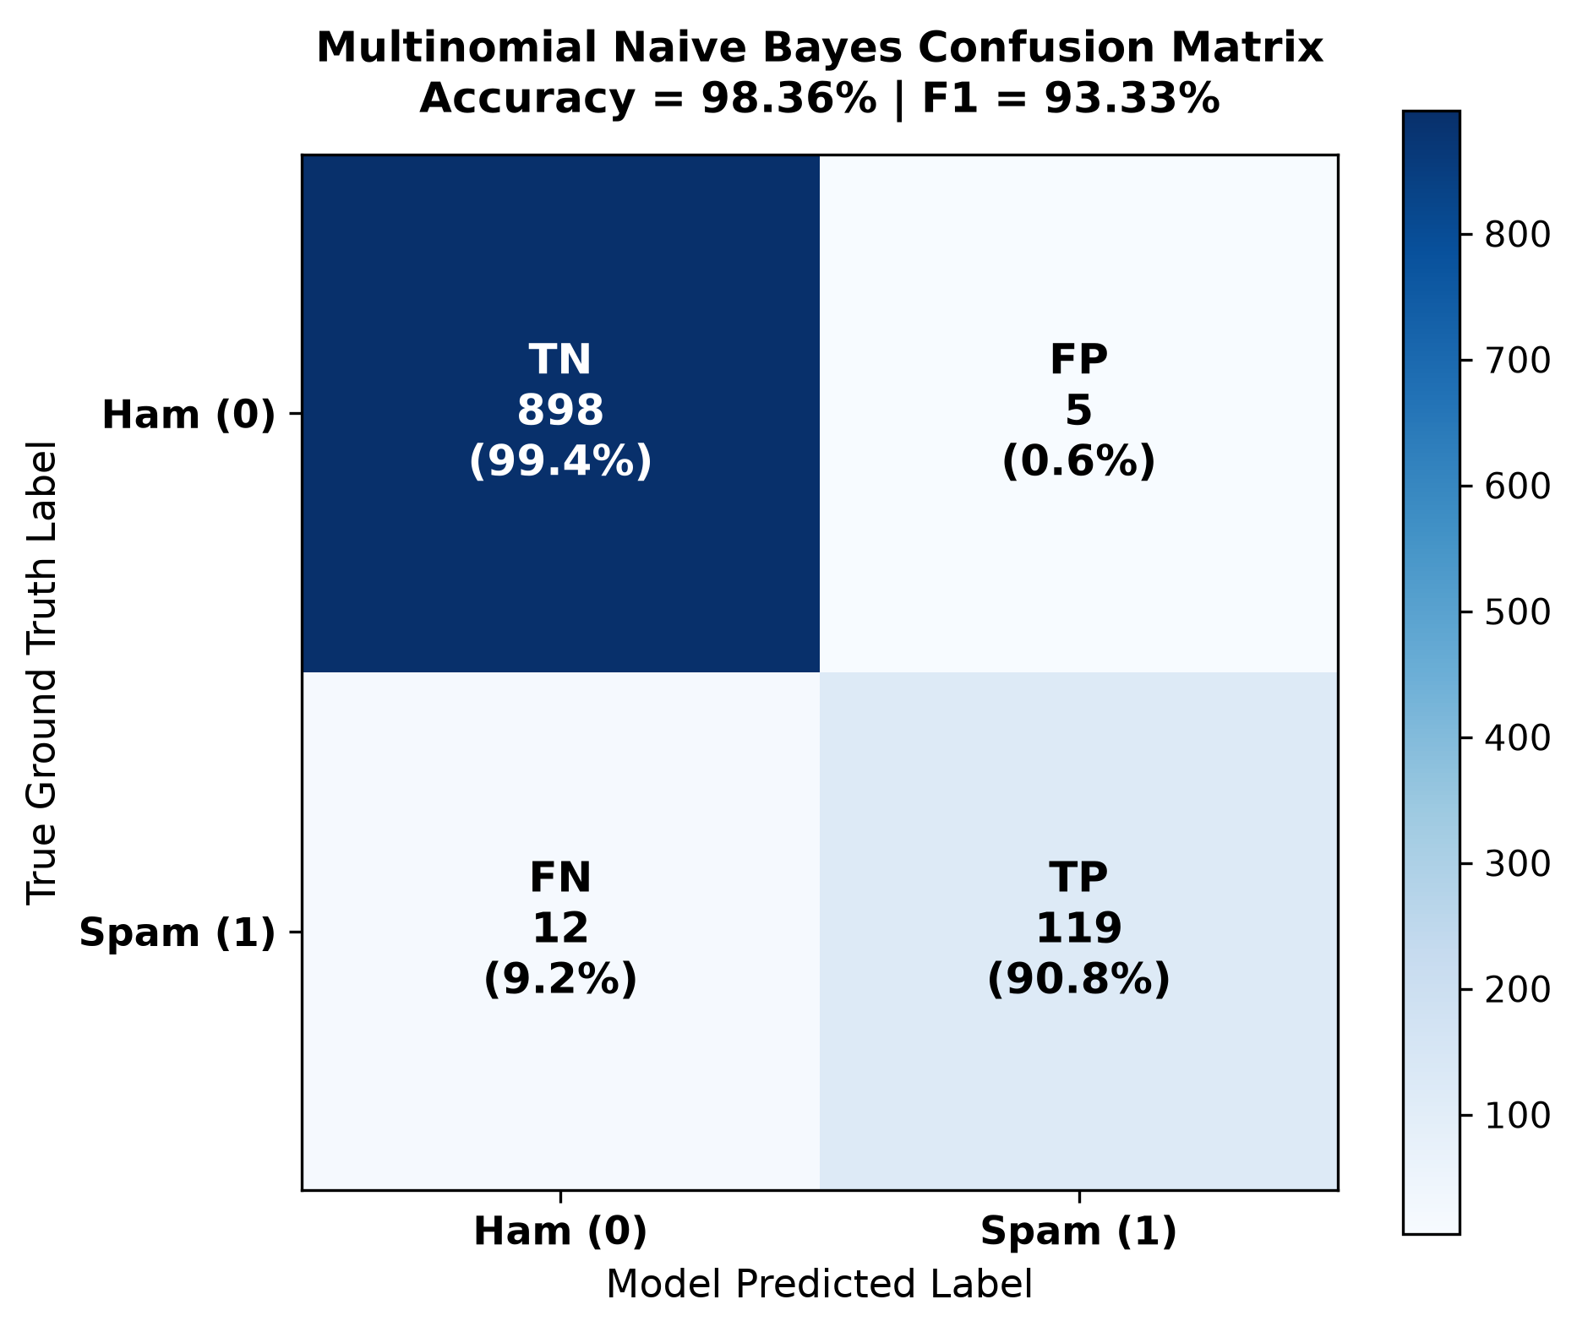
Figure 4: Confusion Matrix Heatmap with Percentage Class Accuracies.
In-Depth Qualitative Misclassification Analysis
The assignment syllabus mandates identifying specific instances where classification failed to understand model limits:
1. Genuine Messages Incorrectly Classified as Spam (False Positives: 5 messages, 0.55% of Ham):
- 'Are you free now?can i call now?' -> P(Spam|Msg) = 0.5250, P(Ham|Msg) = 0.4750. In brief messages, the presence of 'free' overweights the posterior probability just above 0.5.
- 'Unlimited texts. Limited minutes.' -> P(Spam|Msg) = 0.7305, P(Ham|Msg) = 0.2695. The terms 'unlimited', 'texts', and 'minutes' mirror commercial telecommunication promotions.
2. Spam Messages Incorrectly Classified as Genuine (False Negatives: 12 messages, 9.16% of Spam):
- 'Missed call alert. These numbers called but left no message. 07008009200' -> P(Spam|Msg) = 0.0087, P(Ham|Msg) = 0.9913. Designed to mimic legitimate cellular network notifications without conventional promotional tokens.
- 'Hi its LUCY Hubby at meetins all day Fri & I will B alone at hotel U fancy cumin over?...' -> P(Spam|Msg) = 0.0102, P(Ham|Msg) = 0.9898. Employs deliberate spelling alterations ('meetins', 'cumin') that evade standard vocabulary tokens.
8. Activity 8: Real-Time SMS Testing & Prediction Probabilities
The deployed system features a real-time inference function (predict_sms) that outputs class predictions and normalized posterior probabilities P(Spam | Message) and P(Ham | Message).
Required Syllabus Benchmark Test Case:
INPUT MESSAGE:
"Congratulations! You have won a free prize. Claim now."
SYSTEM OUTPUT:
Prediction: Spam
P(Spam | Message) = 1.0000 (100.00%)
P(Ham | Message) = 0.0000 (0.00%)
Multi-Domain Real-Time Benchmark Suite:
# | Test Input SMS Message | Prediction | P(Spam | Msg) | P(Ham | Msg)
1 | Congratulations! You have won a free prize. Claim now. | Spam | 1.0000 | 0.0000
2 | Hey, are we still meeting for lunch at 12:30 today? | Ham | 0.0000 | 1.0000
3 | URGENT! Your bank account has been compromised. Verify immediately. | Spam | 0.9999 | 0.0001
4 | Can you send me the lecture notes for BAMAT207 Probability and Statistics? | Ham | 0.0791 | 0.9209
5 | Exclusive offer: Win $1000 cash prize instantly! Text WIN to 8888 now. | Spam | 1.0000 | 0.0000
9. Conclusion & Digital Portfolio Submission Details
This project successfully synthesizes the core mathematical principles of BAMAT207 with practical computational implementations:
- Bayesian Validation: Demonstrated that Bayes' Theorem exactly computes conditional probabilities on unstructured natural language data.
- Random Variable Theory: Confirmed that discrete Bernoulli distributions accurately model real-world binary classification processes.
- Machine Learning Competence: Constructed an end-to-end Multinomial Naive Bayes pipeline achieving 98.36% accuracy and 93.33% F1-score.
- Open Repository Profile: All code, documentation, figures, and models are published to GitHub for open academic verification.
Official Submission Links:
- GitHub Public Repository: https://github.com/Lucifer-ken07/probabilistic-sms-spam-detection
- Google Colab Notebook: https://colab.research.google.com/github/Lucifer-ken07/probabilistic-sms-spam-detection/blob/main/Probabilistic_SMS_Spam_Detection.ipynb
- Local Project Directory: c:\Users\Aakash\AG-1\ESA-Project1\sms_spam_detection\

